Problem Statement:

Write a hive UDAF to find the largest integer in a column. Use your own dataset for the above problem statement and attach the steps performed, codes used with the result.

UDAF class:

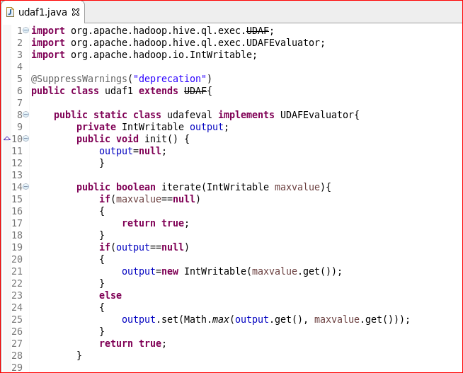

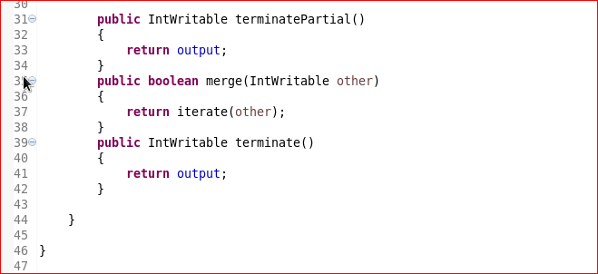

Creating table and loading data into table:

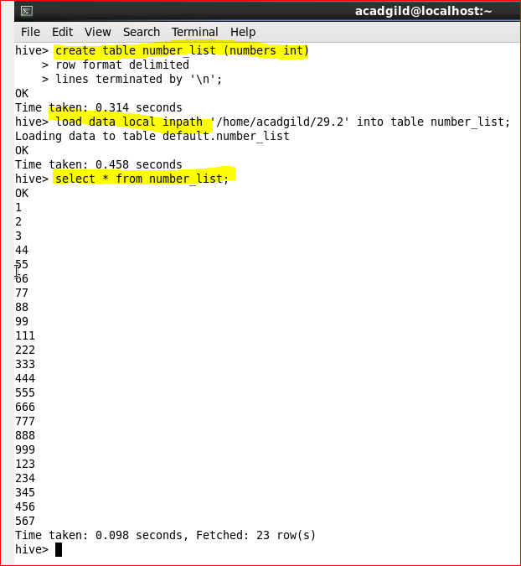

Adding jar and creating temporary function:

