Problem Statement:

● Use Hbase shell for performing the following operations

● Create the table customer with two column families

● Personal details and order details as column families. Create a unique number as row key (ssn/Aadhar no. etc.) Insert at least 10 records to each column Insert following values for personal details column family Name, age, city, state

● Insert following values for order details column family

● Order no., order quantity, and order amount

● Use put command to insert the values for each record. Use get command, to retrieve all the records of single customer.

**Creating the table in HBase**

**Syntax: create ‘<table-name>’,’<column-family1>’ ,’<column-family2>’ …….**

HBase data model, columns are grouped into column families, which must be defined during table creation. We should at least have one column family

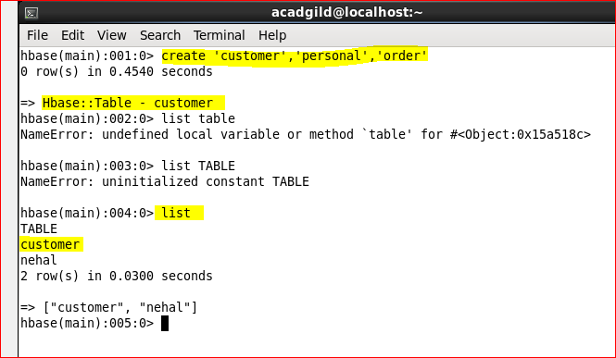

**Inserting the data into HBase**

We can insert the data using PUT command

**Syntax: put ‘<table-name>’,’row-key’,’columnfamily:columnname’,’value’**

Row-key is mandatory field which serves as the unique identifier for every record.

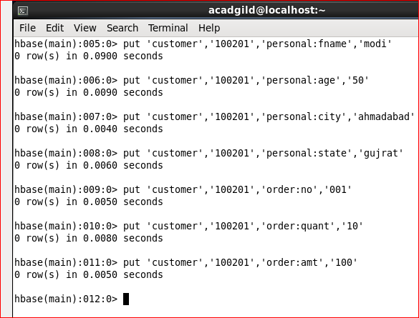

Similarly we inserted 10 records in table.

Scan will display all the records from table.

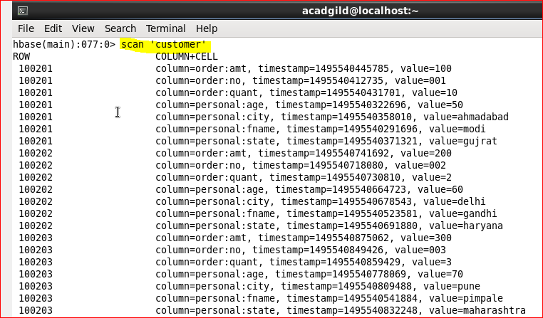

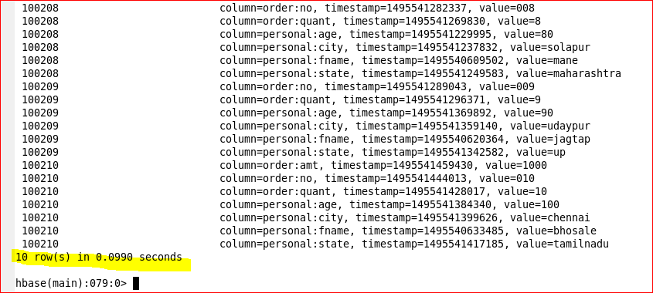

**Getting single record from table**

We should use GET command to retrieve single record from HBase table,

**Syntax: get ‘<table-name>’,’<row-key>’,’<column-family>’**

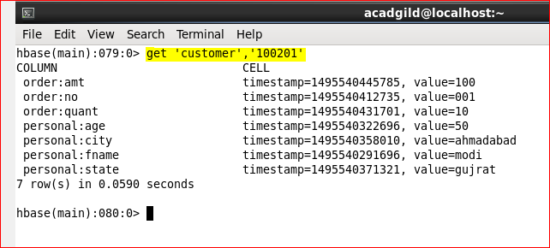

Retrieving only personal information of customer 100202:

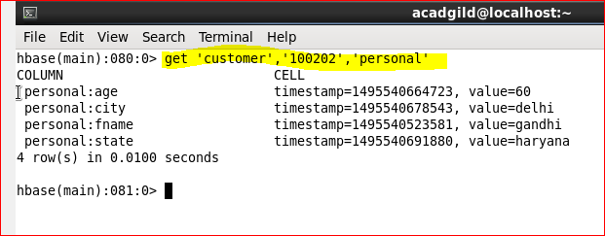

Retrieving only order information of customer 100210:

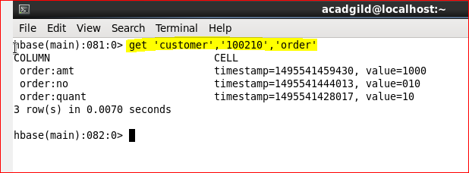

Retrieving order amount of customer 100208 and family name of 100202:

