Problem Statement:

● Write a Java client API to perform following operations:

● Use HBaseAdmin class and create the table named company with one column family name details.

● Create the method name insert and use put class to insert records to company table.

Solution:

Q1. Use HBaseAdmin class and create the table named company with one column family name details.

Java API:

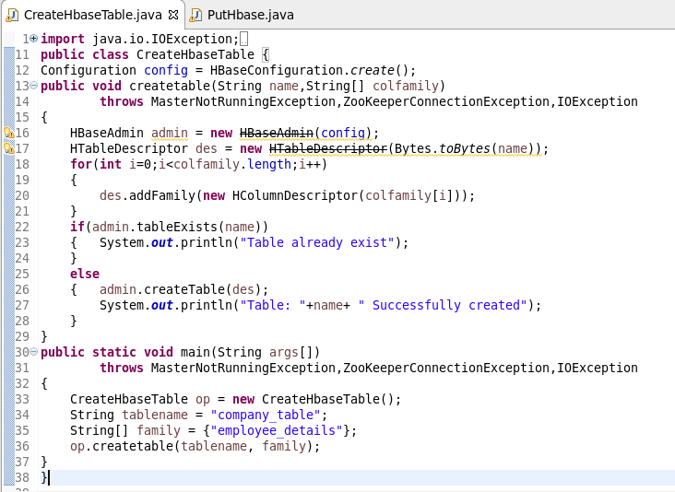

Console output:

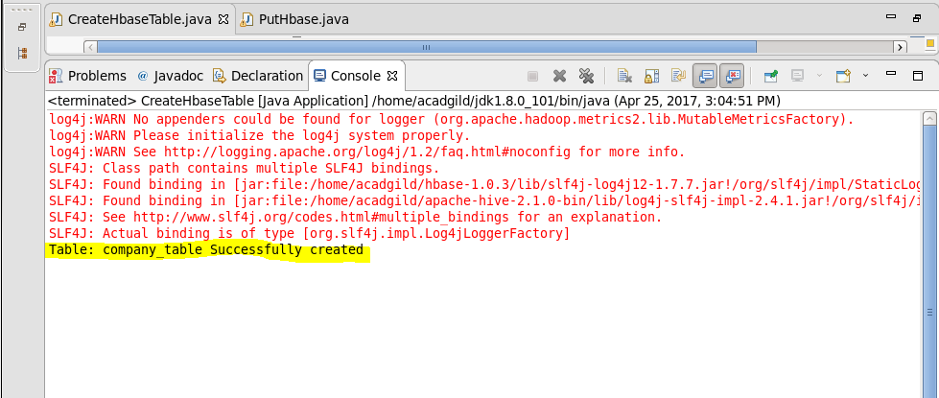

Q2. Create the method name insert and use put class to insert records to company table.

Java API:

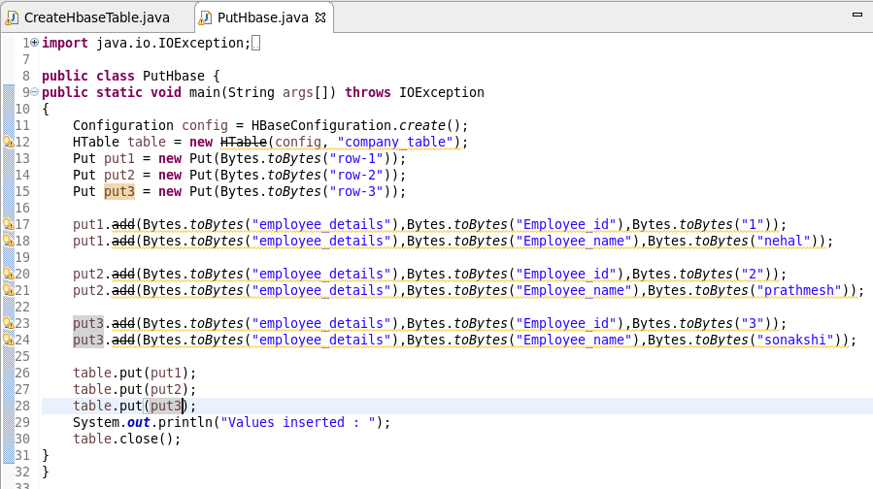

Console output:

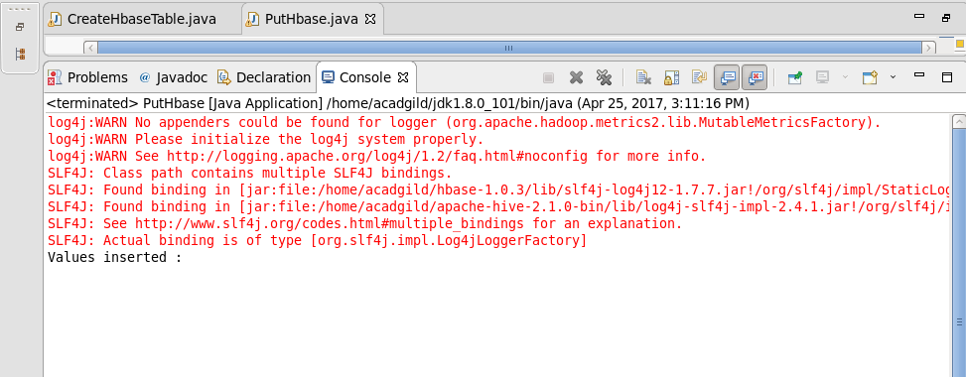

HBASE TABLE:

