Problem Statement:

● Write Java client API to perform following operations:

● Create the method name get record and use get class to retrieve one record at a time record from company table.

● Create the method name display and use scan class to display all records from company table.

Java API to create table in HBASE:

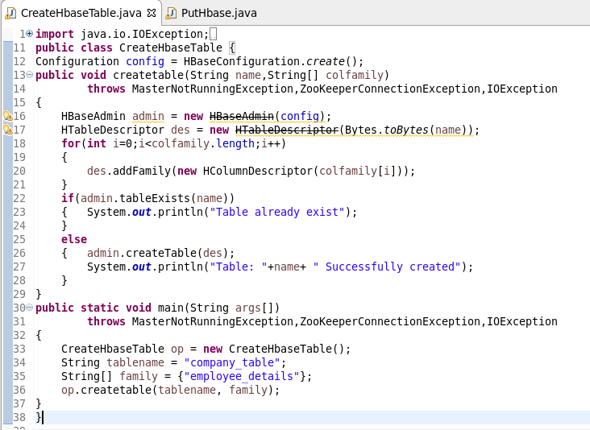

Console output:

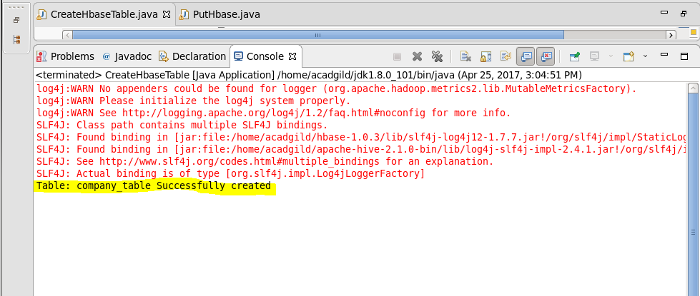

Java API to insert records into table:

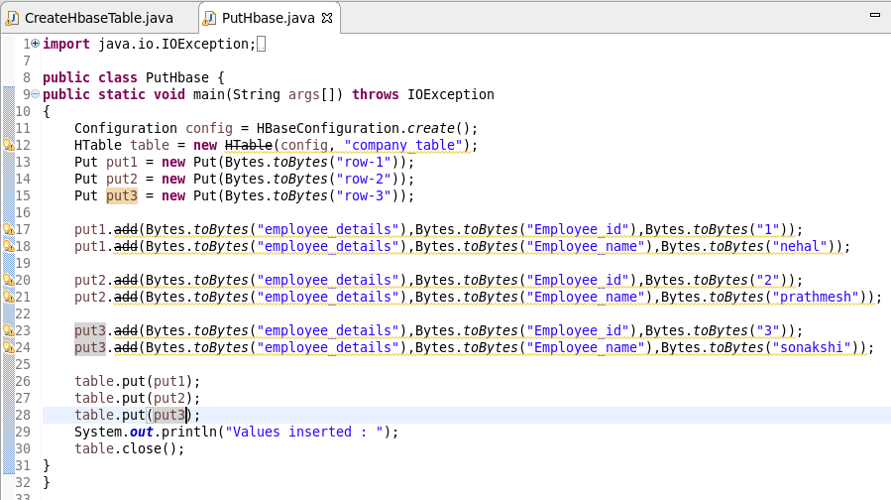

Console output:

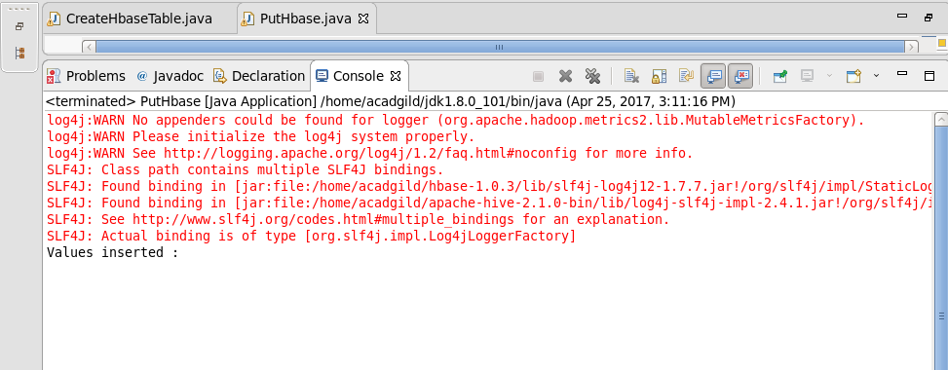

HBASE TABLE:

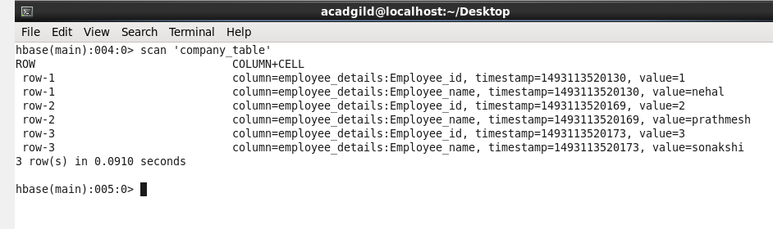

Q1. Create the method name get record and use get class to retrieve one record at a time record from company table.

Java API:

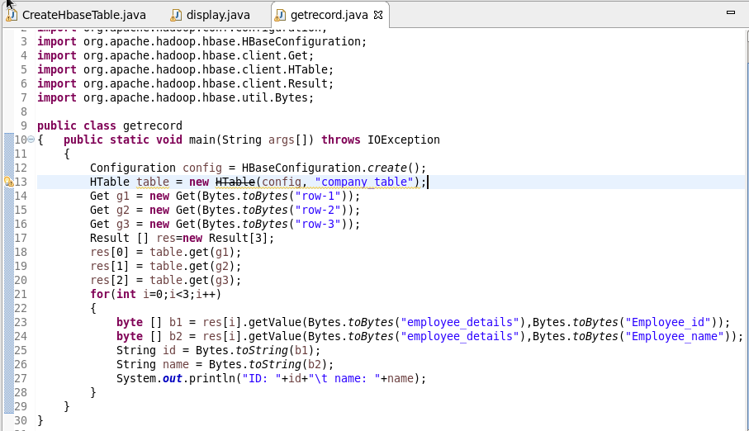

Solution:

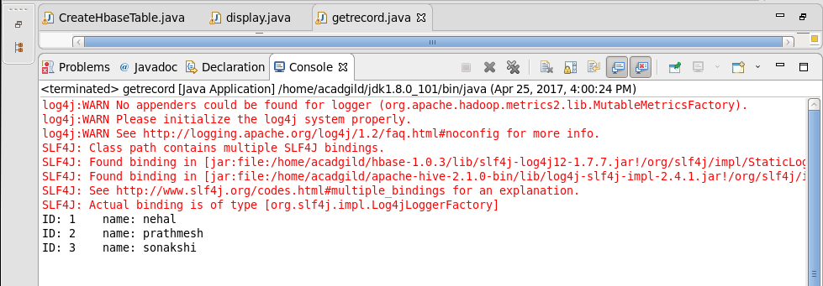

Q2. Create the method name display and use scan class to display all records from company table.

Java API:

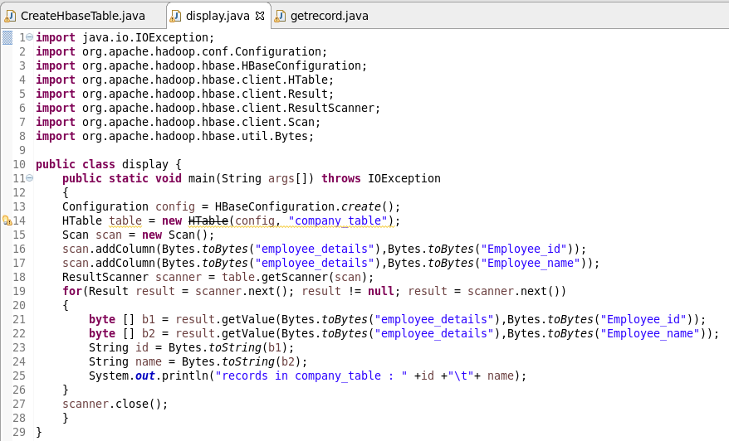

Solution:

