Problem Statement 1:

Write a Java program to display the content of a file in HDFS on screen.

Code:

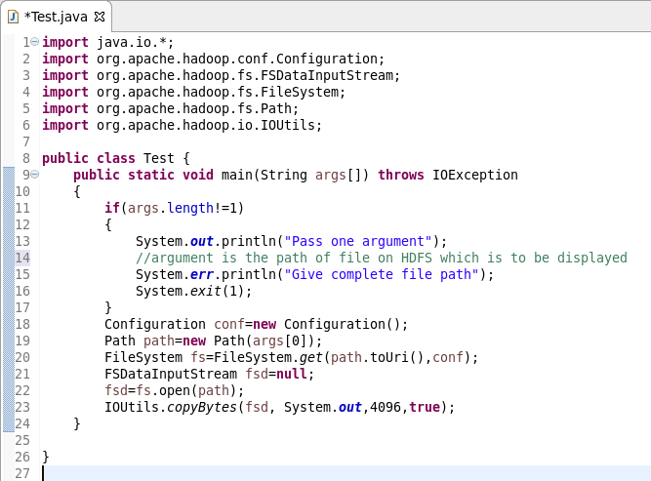

Output:

