Problem Statement 2:

Write a Java program to copy a file from local file system to HDFS.

Code:

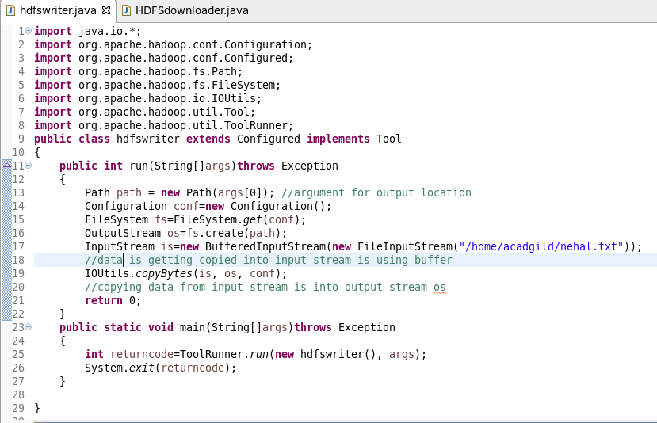

Output:

