Sales of different TV Task 1:

Write a Map Reduce program to filter out the invalid records. The output of this program will act as input for subsequent tasks. Map only job will fit for this context.

Code :

Task class:

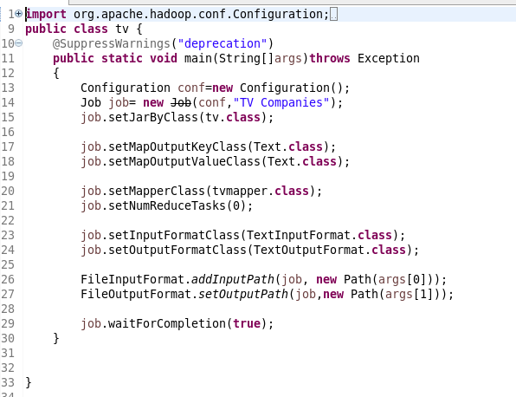

Mapper Class:

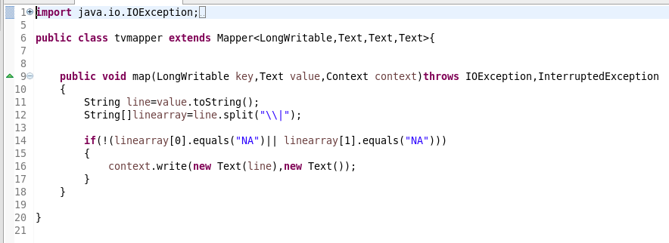

Running jar:

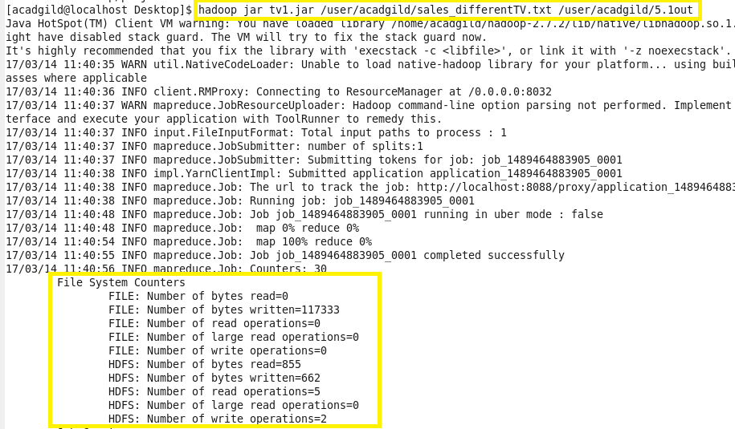

Output:

