Sales of different TV Task 2:

Write a Map Reduce program to calculate the total units sold for each Company. Sales of different TV

Sales of different TV Task 3:

Write a Map Reduce program to calculate the total units sold in each state for Onida company.

Code:

Task class:

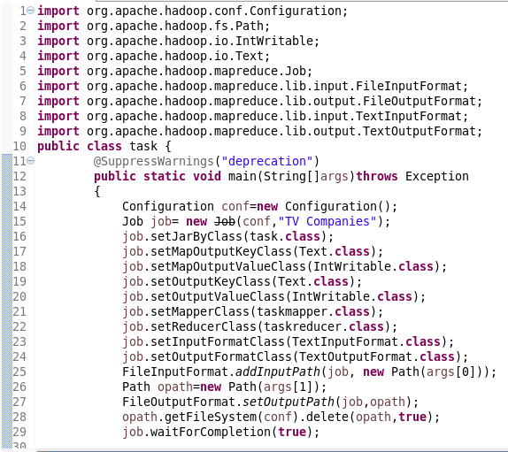

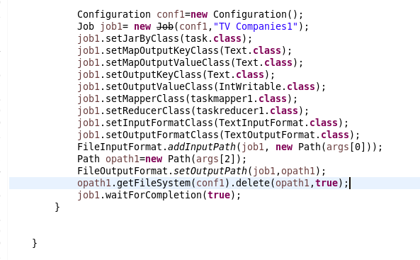

Mapper class for task 2:

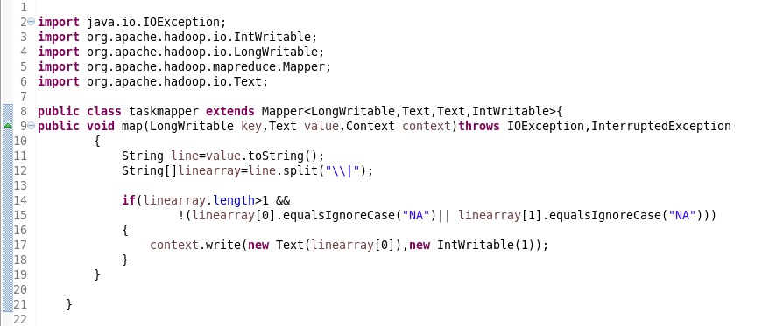

Mapper class for task 3:

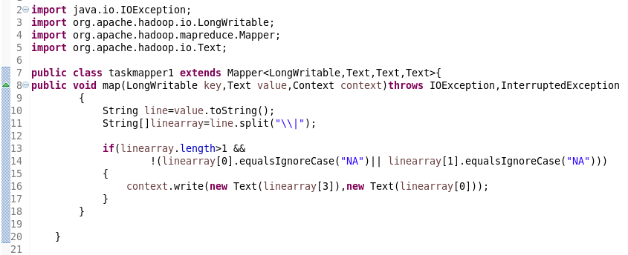

Reducer class for task 2:

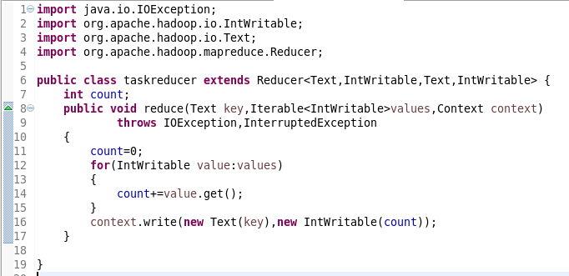

Reducer class for task 3 :

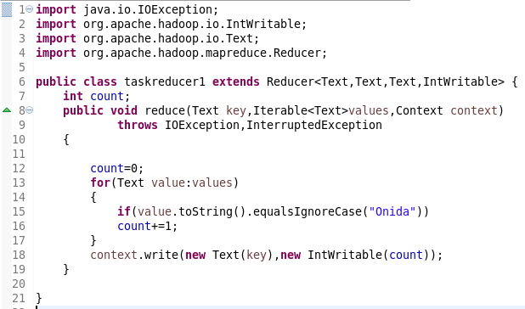

Running Jar:

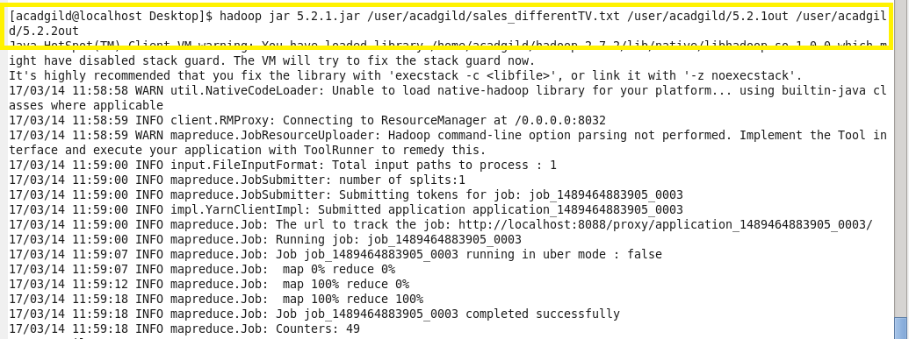

Output Task 2:

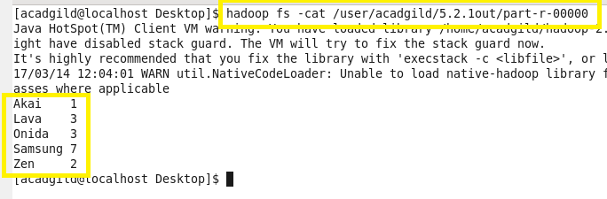

Output Task 3:

