Problem statement 1:

Find the number of ratings given by each user.

Problem statement 2:

Find the number of ratings received by each movie.

Code:

Task class :

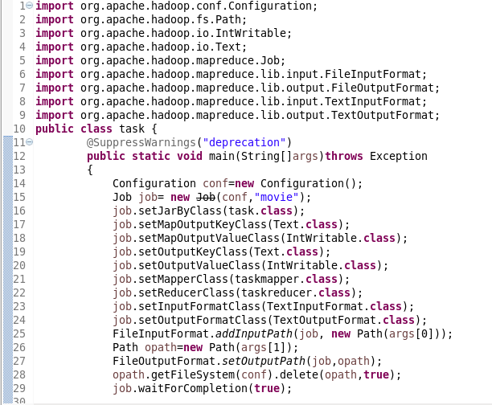

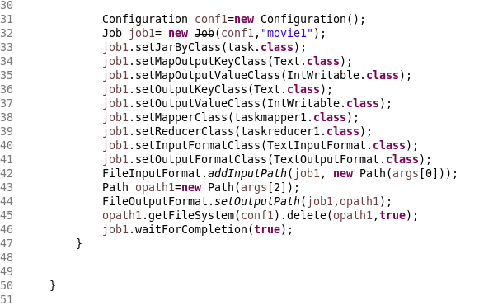

Mapper class for problem statement 1:

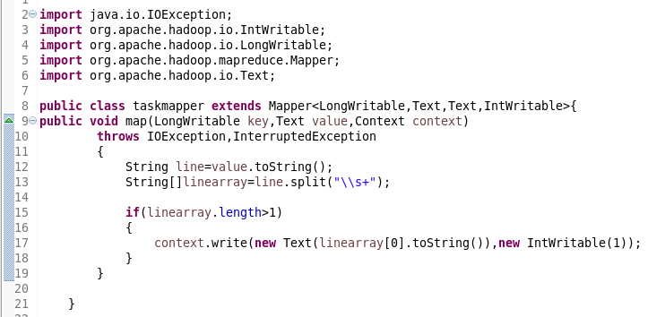

Mapper class for problem statement 2:

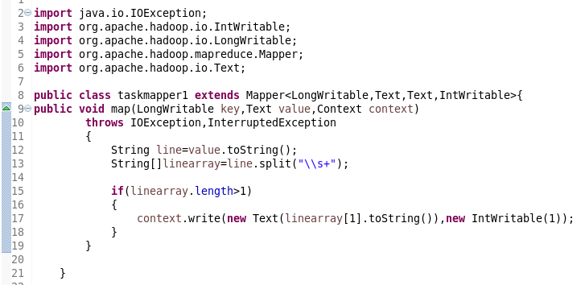

Reducer class for problem statement 1:

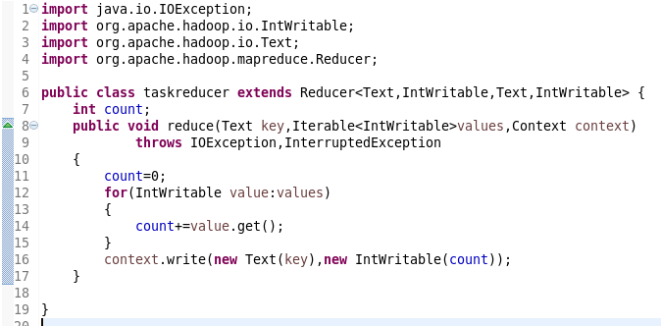

Reducer class for problem statement 2:

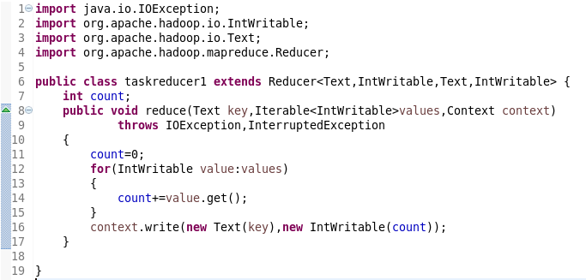

Running jar:

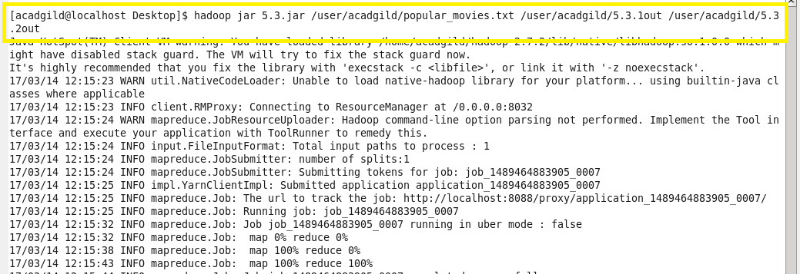

Output problem 1:

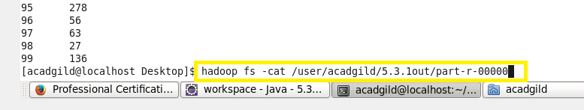

Output problem 2:

