Titanic Data Analysis

Write a map reduce program to find the total number of people travelled in titanic.

Code:

Task class:

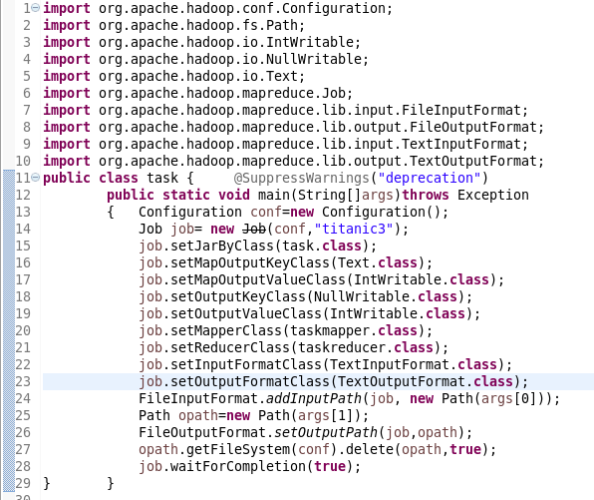

Mapper class:

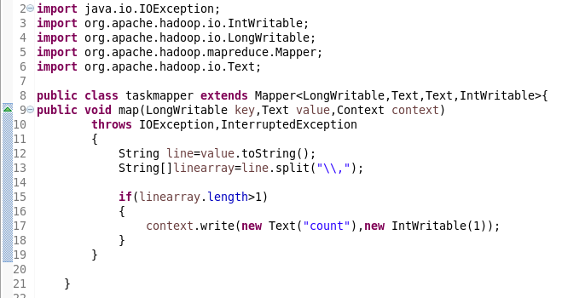

Reducer class:

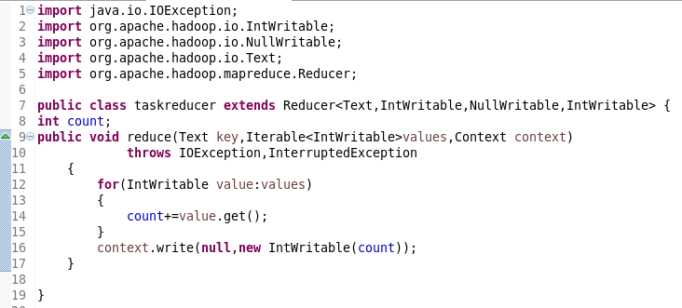

Running jar:

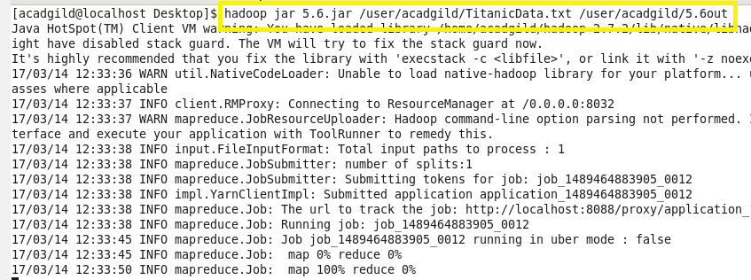

Output:

