Problem statement 1:

Find out how many people has chosen their destination as MIA and MCO

Problem statement 2:

Find out the number of people undertaken the trips from the places MIA and HOU

Problem statement 3:

Find out how many people has chosen airline mode of travel for the places LAS and LAX

Code:

Task class:

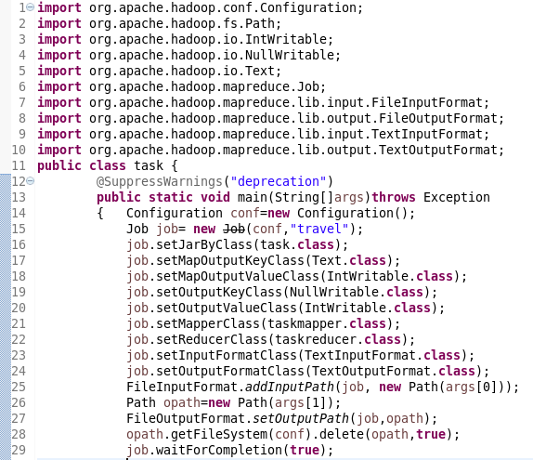

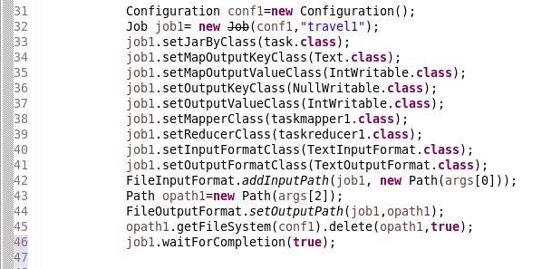

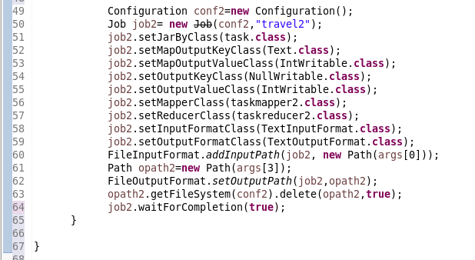

Mapper class:

Problem statement 1:

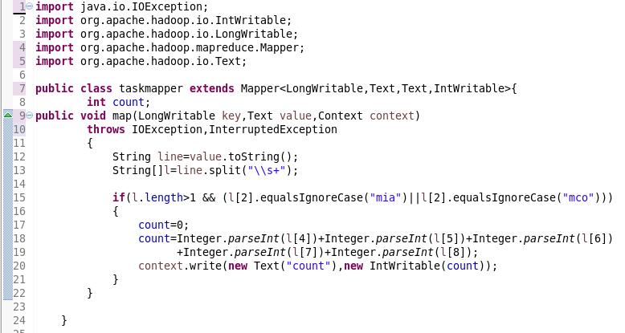

Problem statement 2:

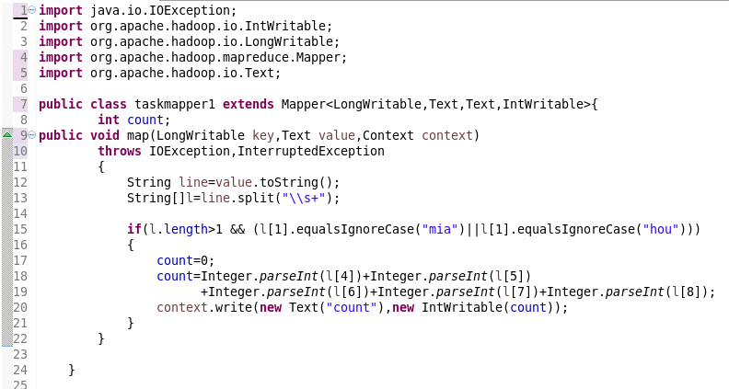

Problem statement 3:

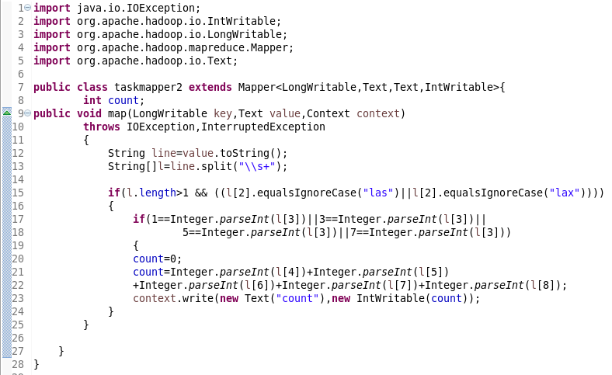

Reducer class:

Problem statement 1:

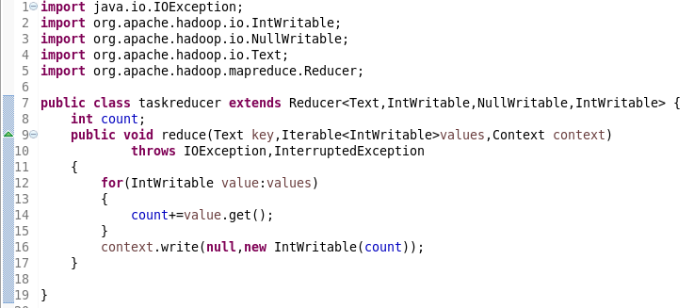

Problem statement 2:

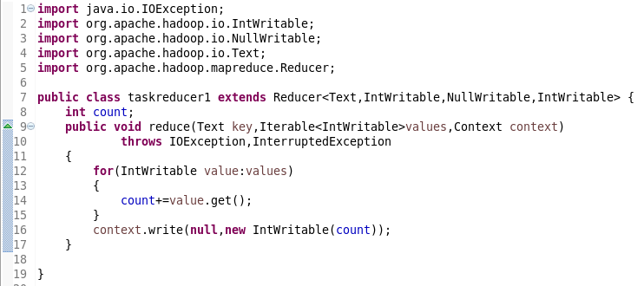

Problem statement 3:

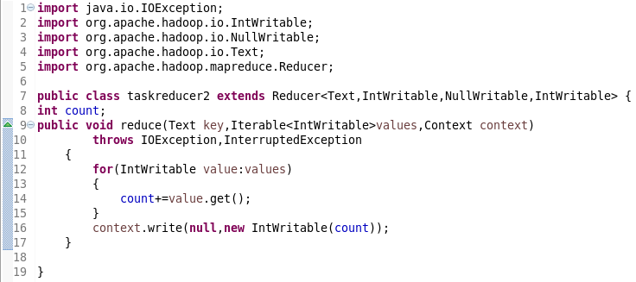

Running jar:

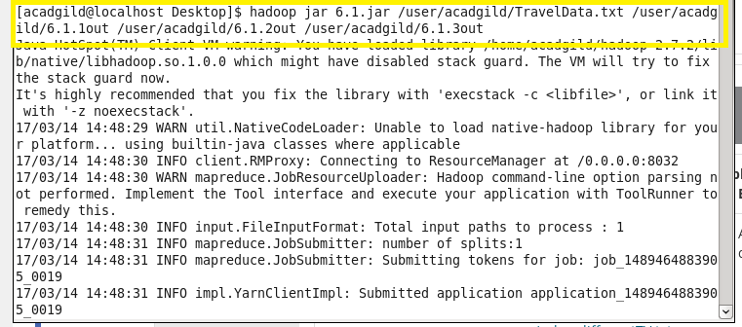

Output:

Problem statement 1:

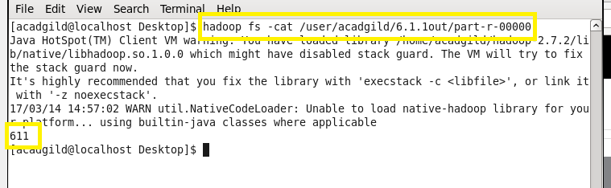

Problem statement 2:

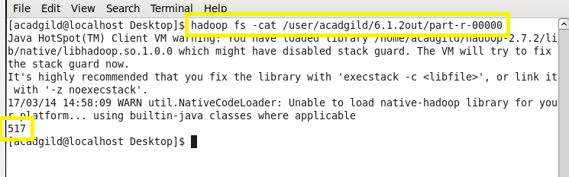

Problem statement 3:

