Problem Statement:

Use key value output format to save the output of Session 6 – Assignment 1(Travel Data analysis) and save the output as comma (,) separated instead of tab(\t) separated.

Code:

Task class:

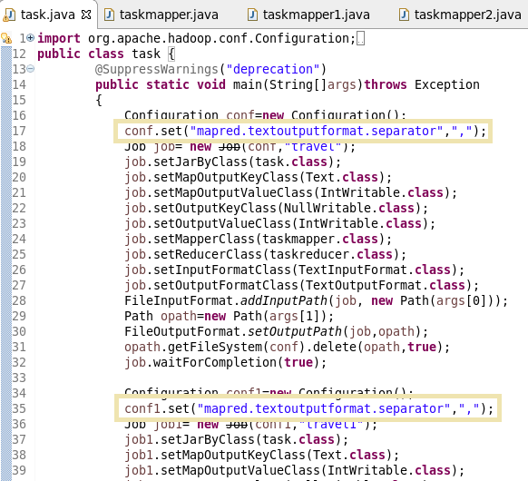

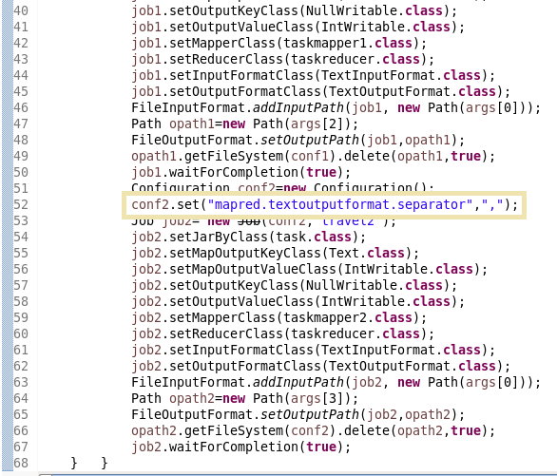

Mapper class for problem 1:

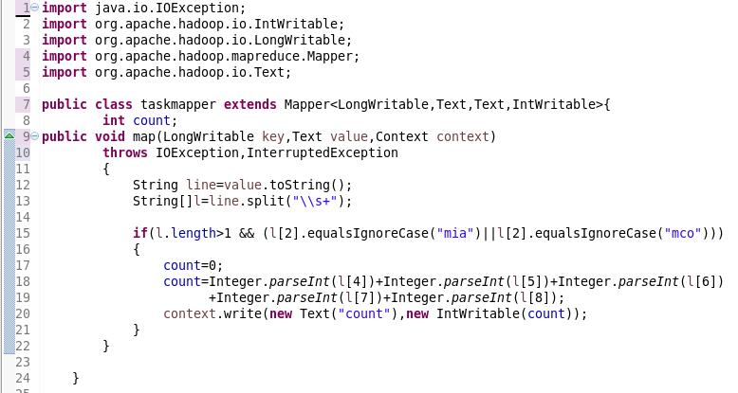

Mapper class for problem 2:

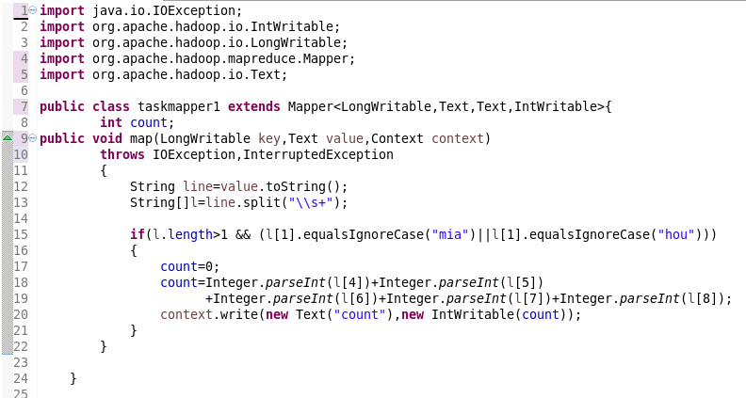

Mapper class for problem 3:

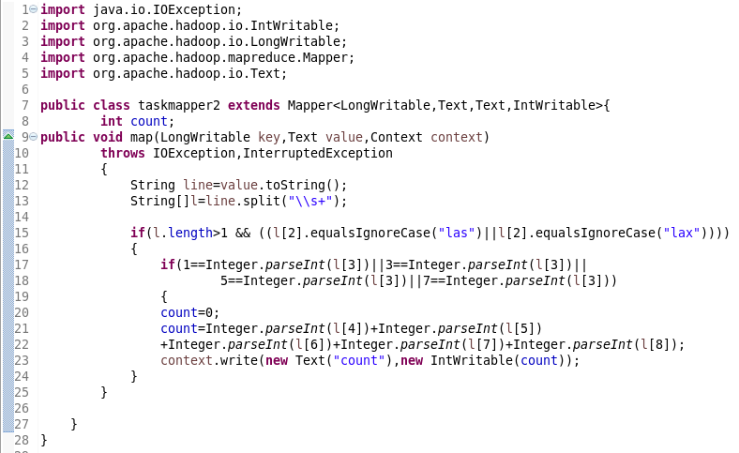

Reducer class for problem 1:

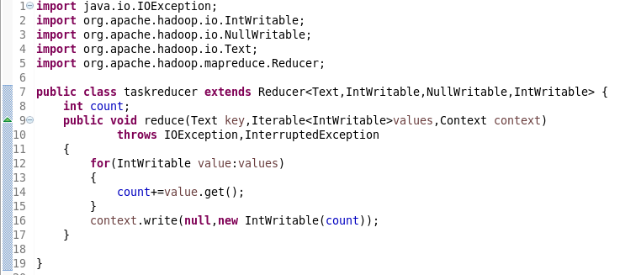

Reducer class for problem 2:

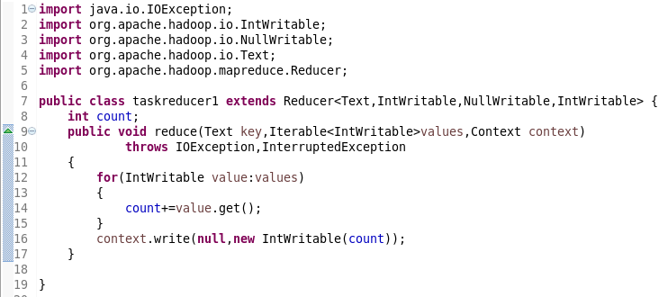

Reducer class for problem 3:

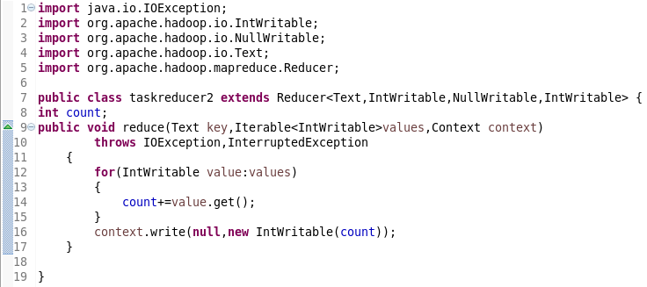

Running jar:

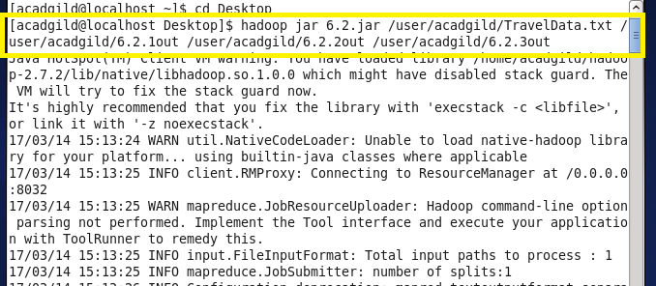

Output of problem 1:

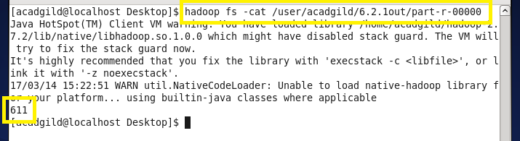

Output of problem 2:

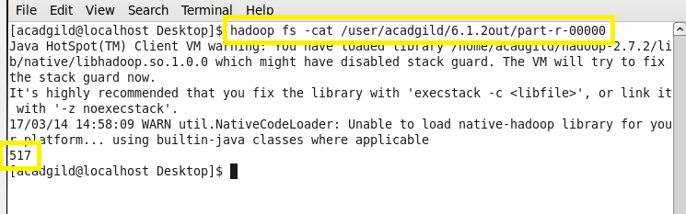

Output of problem 3:

