Problem statement1:

Find the number of GoogleKnowlege_Occupation people who were guests in the show, in a particular time period. Take the time period as 1/11/99 to 6/11/99 i.e., 6 months

Problem statement2:

Find the number of GoogleKnowledge occupation types in each group, who have been guests on the show.

Code:

Task:

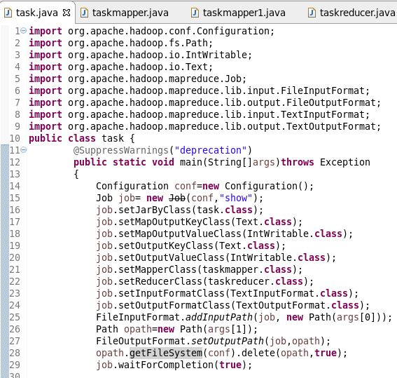

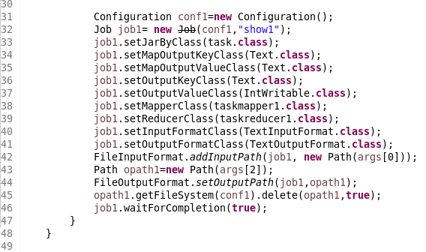

Mapper class for problem 1:

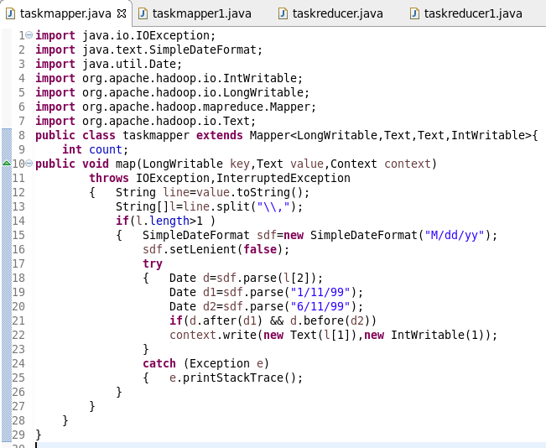

Mapper class for problem 2:

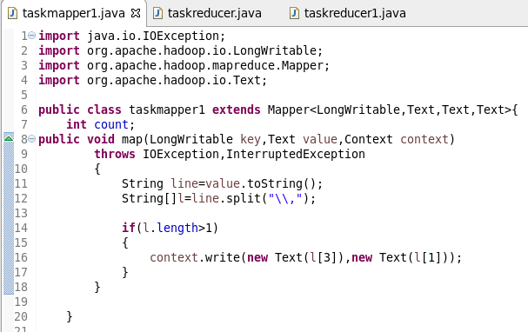

Reducer class for problem 1:

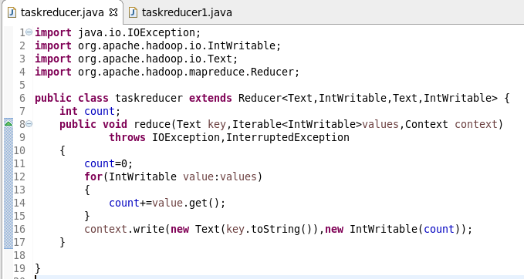

Reducer class for problem 2:

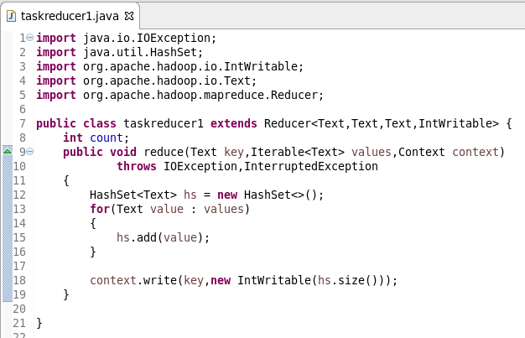

Running jar:

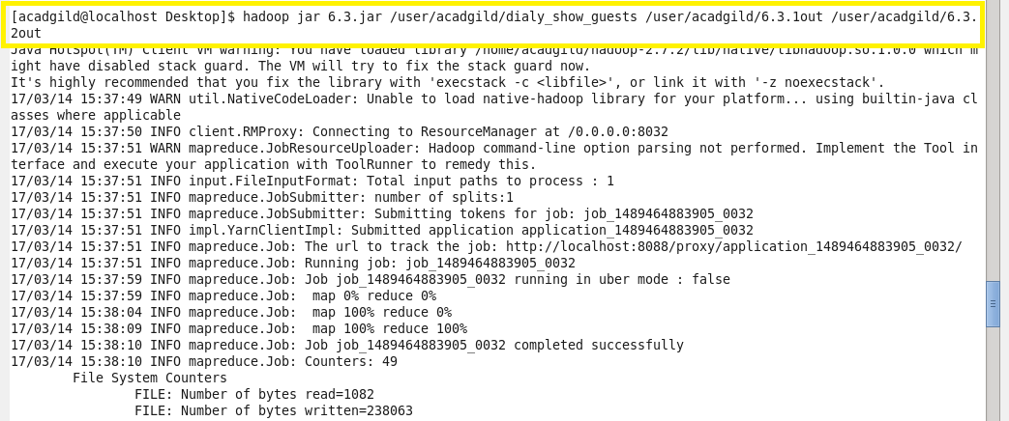

Output of problem 1:

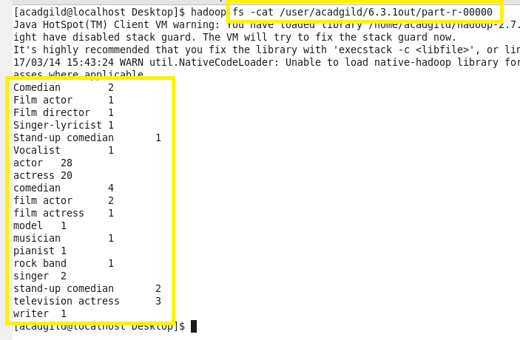

Output of problem 2:

