Problem Statement

Titanic Data Analysis

Write a map reduce program to find out number of males and females died in the titanic tragedy and save the output in Key Value Output format.

Code:

Task class:

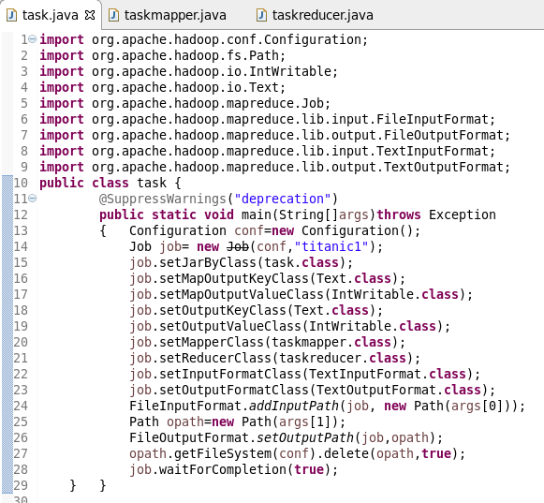

Mapper class:

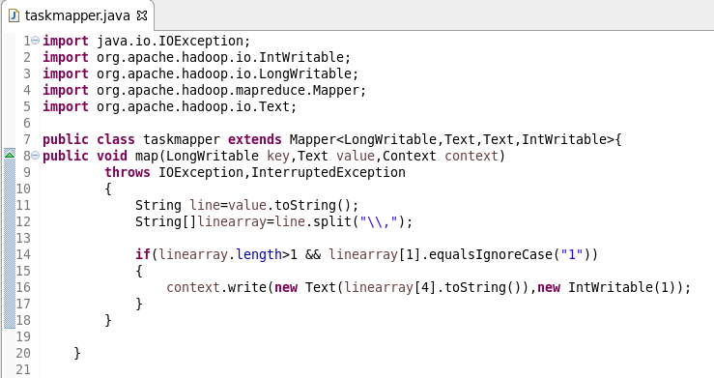

Reducer class:

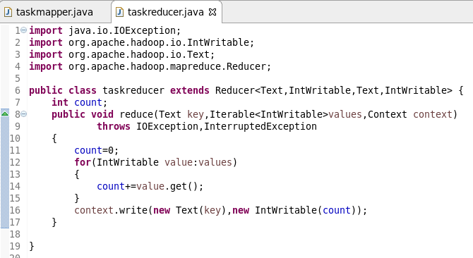

Running jar:

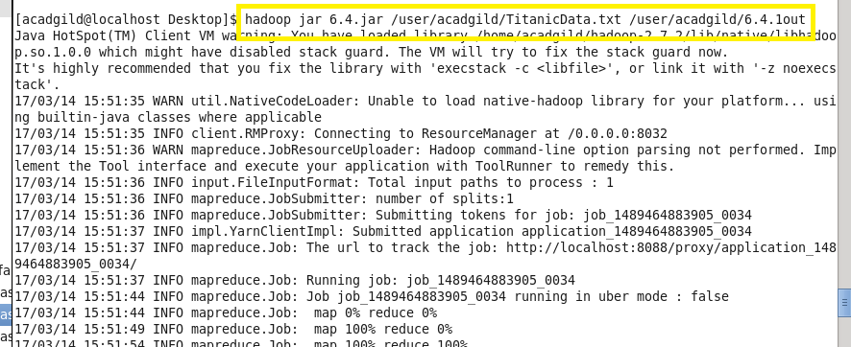

Output:

