Problem Statement:

Titanic Data Analysis

Write a mapreduce code to find out number of males and females survived in the titanic tragedy and save the output in sequence file output format.

Code:

Task class:

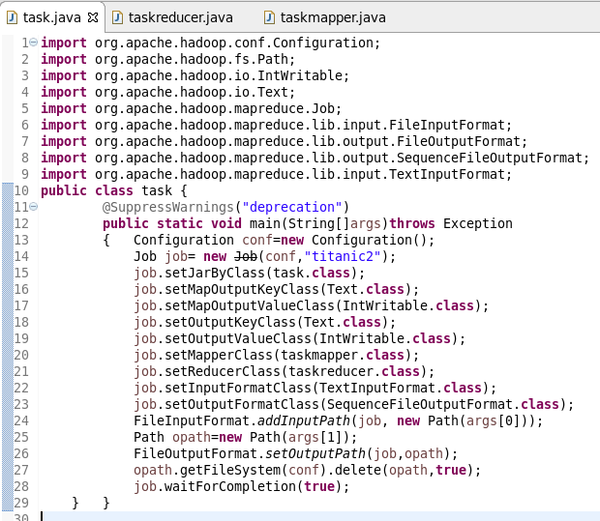

Mapper class:

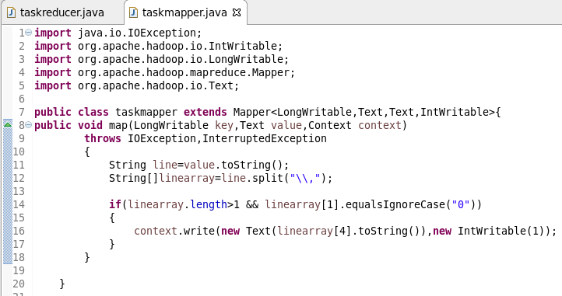

Reducer class:

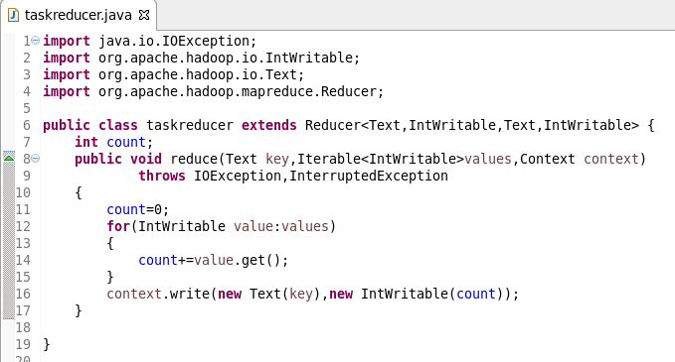

Running jar:

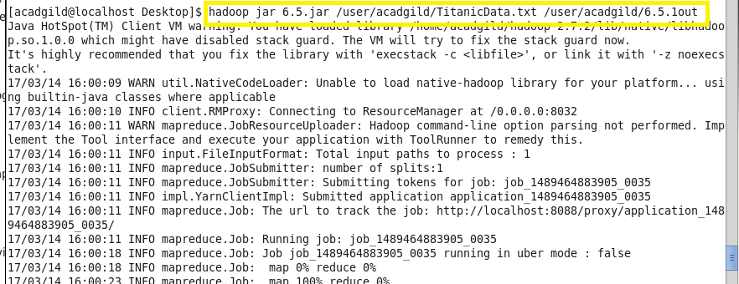

Output:

