Problem Statement:

Write a map reduce program to use Sequence file as input and save the output in key value output format.

Note:

You can use the sequence file output which you have got in the earlier assignment of the same session.

Code:

Task class:

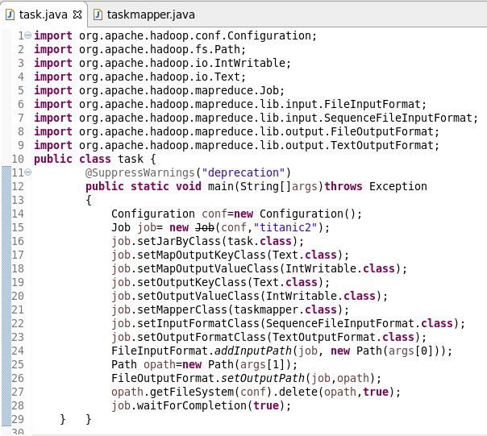

Mapper class:

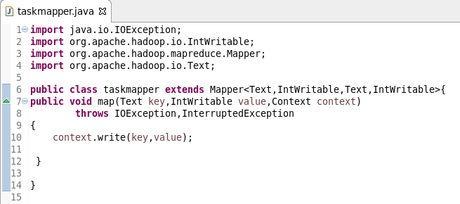

Running jar:

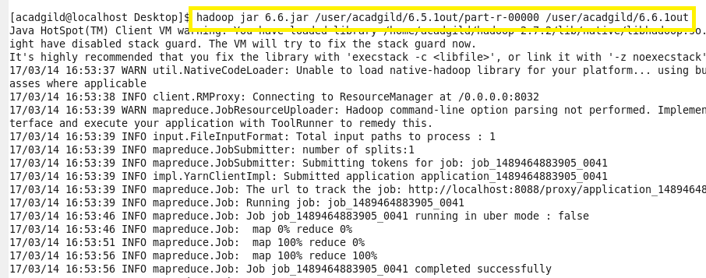

Output:

