Sales of different TV Task 4:

Write a Mapreduce program to modify Sales of different TV Task 2 (refer session 5 assignment 2) to use a custom partitioner with 4 reducers. Make sure that all records whose company name starts with A-F (upper or lower case) should go to 1st reducer, those starting with G-L to 2nd reducer, those starting with M-R to 3rd reducer and others to 4th reducer.

Sales of different TV Task 5:

Modify Sales of different TV Task 2 (refer session 5, assignment 2) to take advantage of Combiner.

Code:

Task class:

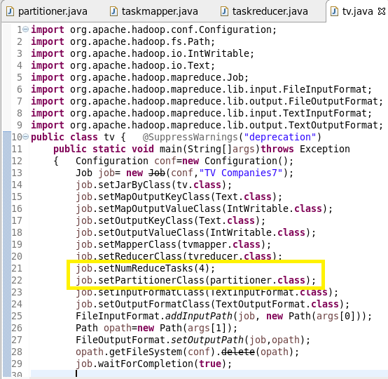

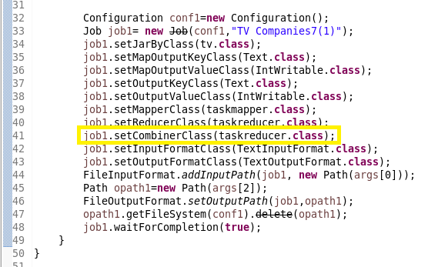

Partitioner class:

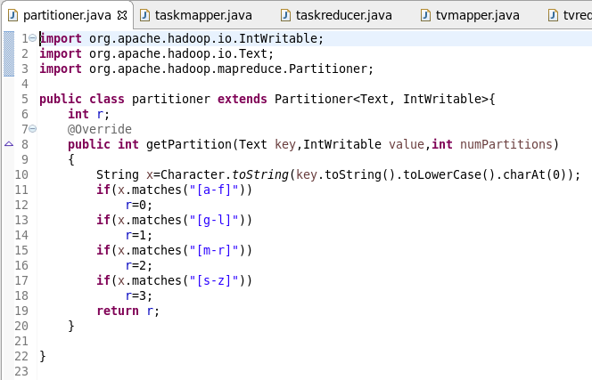

Mapper class for problem 1:

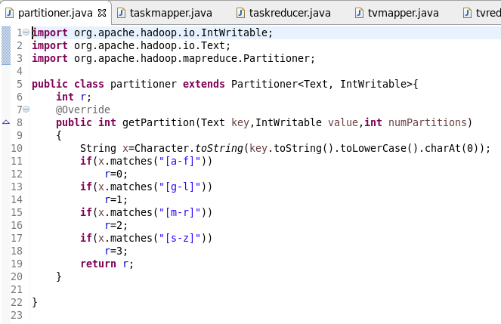

Mapper class for problem 2:

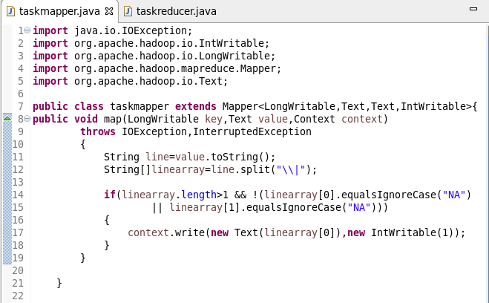

Reducer class for problem 1:

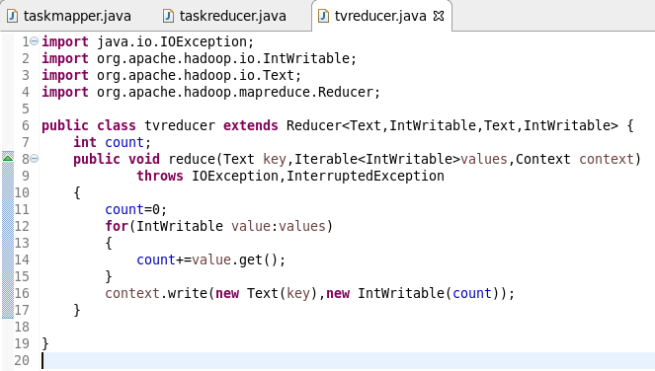

Reducer class for problem 2:

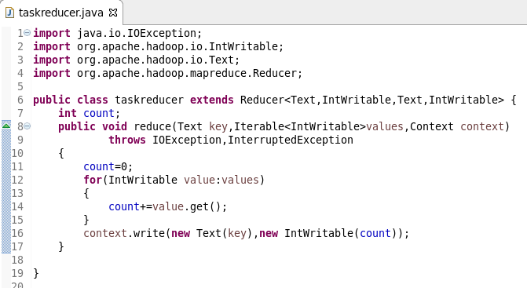

Running jar:

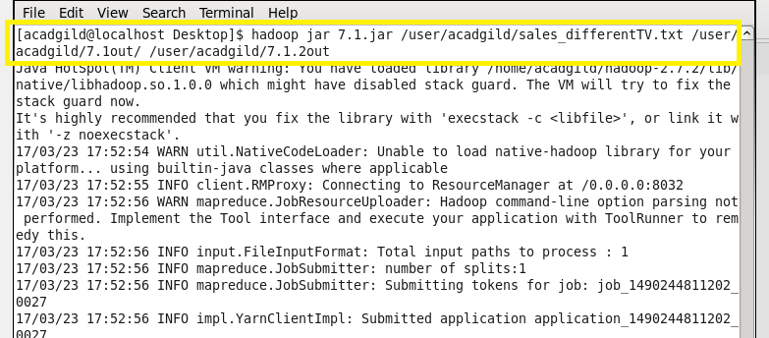

Output of problem 1:

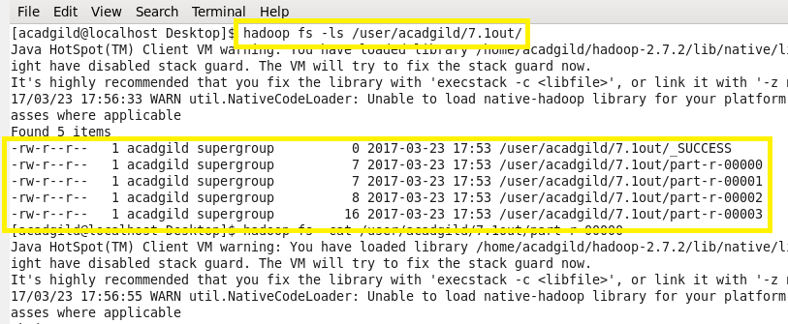

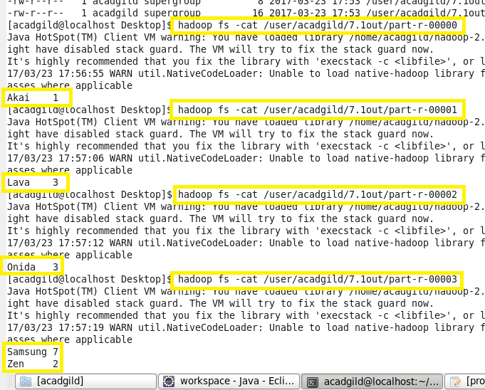

Output of problem 2:

