Assignment 7.2:

Problem 1:

Sales of different TV Task 6:

Modify Sales of different TV Task 3 (refer session 5, assignment 2) to take advantage of Combiner.

Task class:

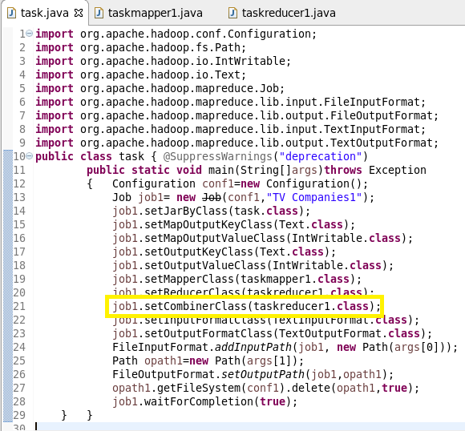

Mapper class:

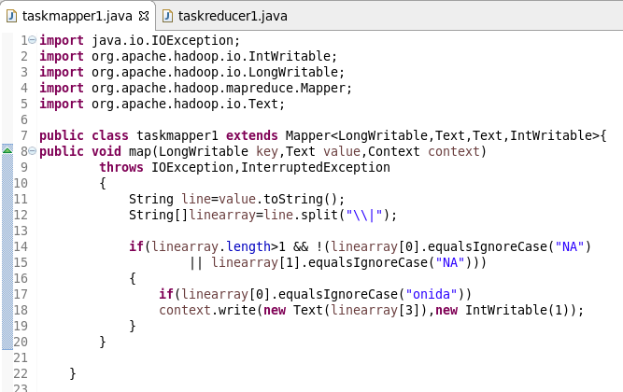

Reducer class:

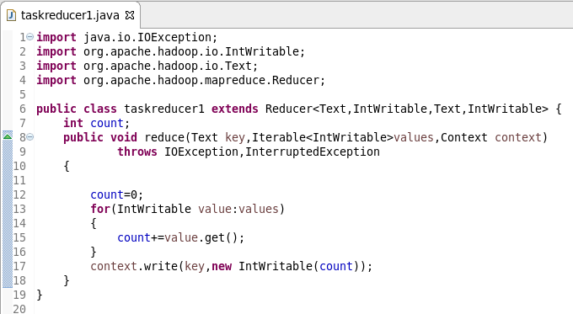

Running jar:

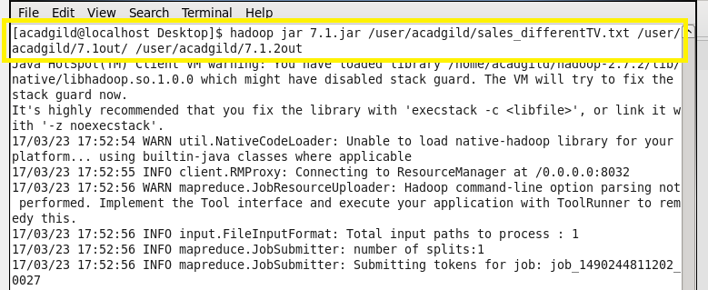

Output:



Problem 2:

Sales of different TV Task 7:

Write a Mapreduce program to view the total sales for each product for every Company corresponding to each size. Make sure that all records for a single company goes to a single reducer and inside every reducer, keys must be sorted in descending order of the size. You may write a custom WritableComparable for this purpose. "

Task class:

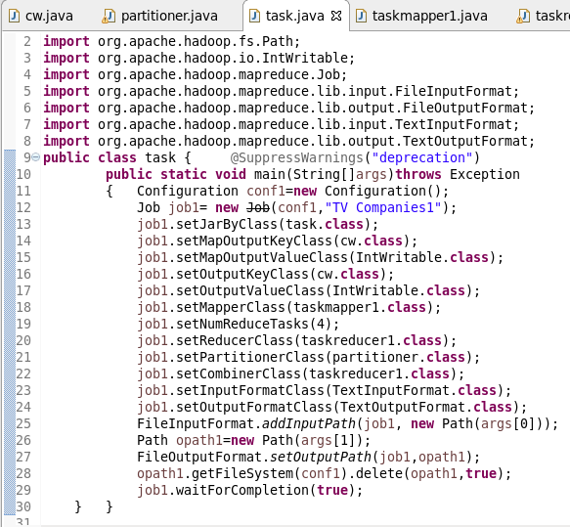

Writable comparable class:

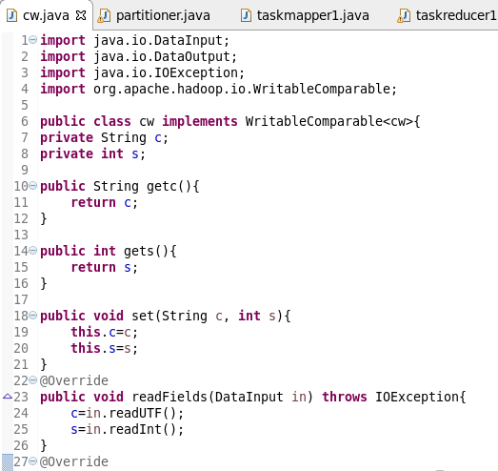

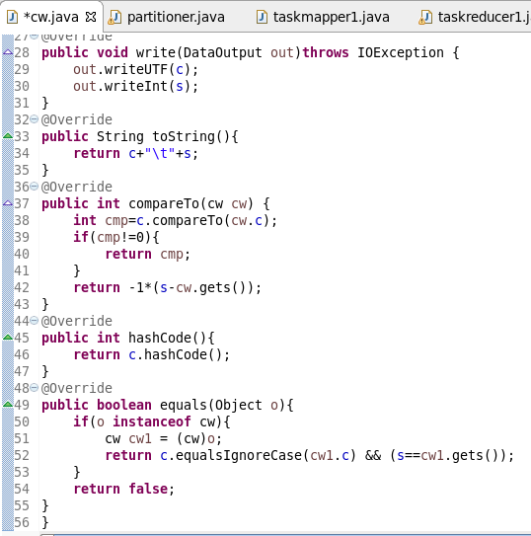

Partitioner class:

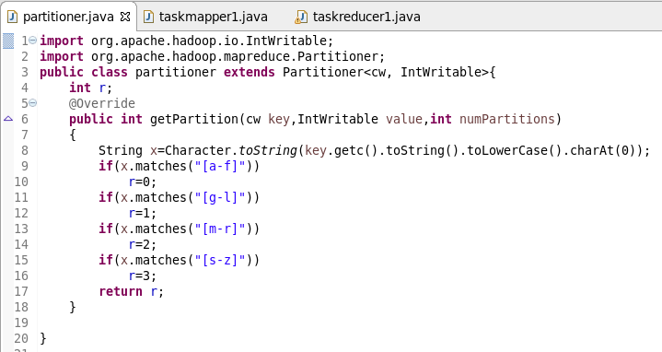

Mapper class:

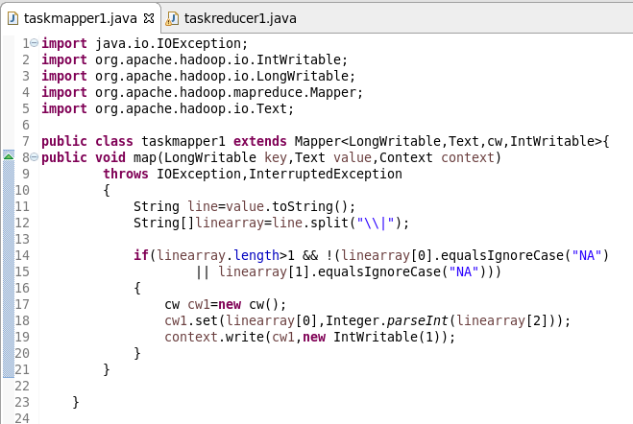

Reducer class:

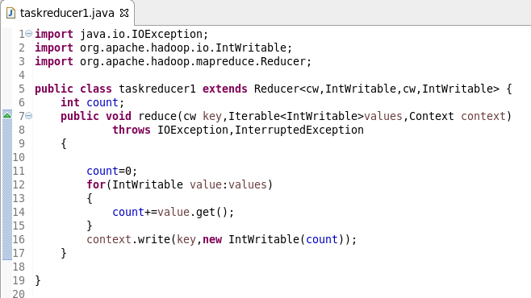

Running jar:

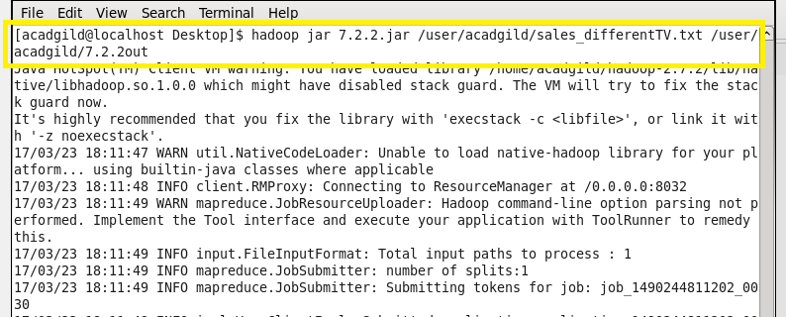

Output:

