Problem Statement:

Write a word count program using partitioner and implement the following logic in the partitioner words with length 5 should go into reducer 1 and words with length 6 should go into reduer 2 and the rest of the words should go into reducer 3.

Note:

You can use the dataset of your choice.

Code:

Dataset:

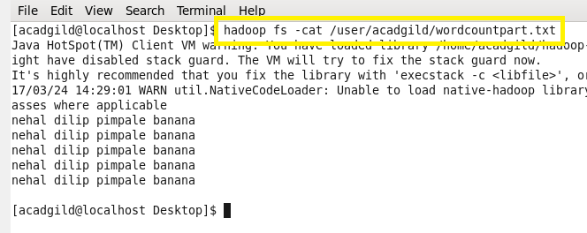

Task class:

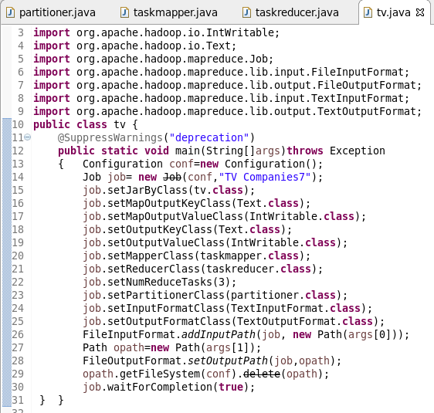

Partitioner class:

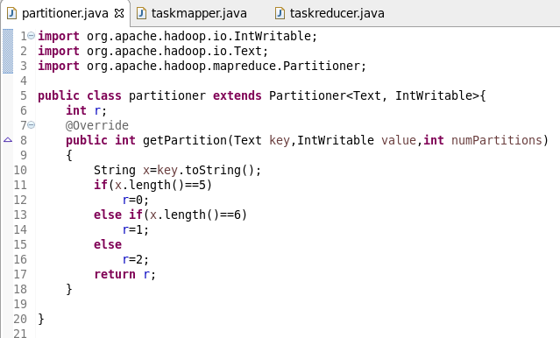

Mapper class:

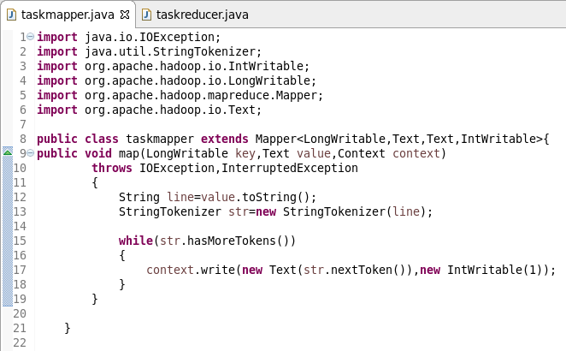

Reducer class:

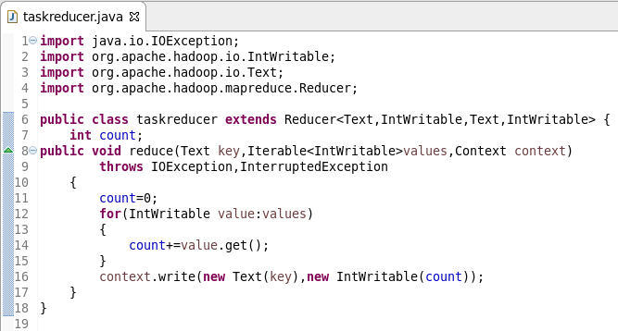

Running jar:

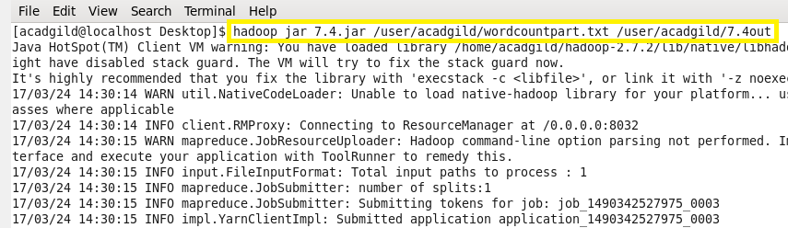

Output:

