Problem statement:

Write a map only job for the word count program and set the output format as sequence file.

Note:

You can use the dataset of your choice.

Dataset:

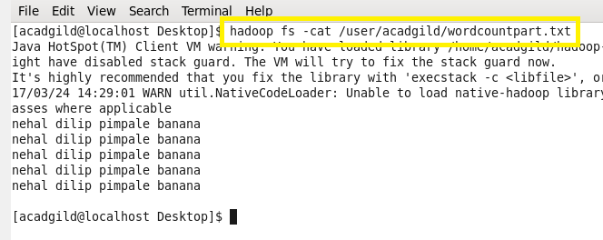

Codes:

Task class:

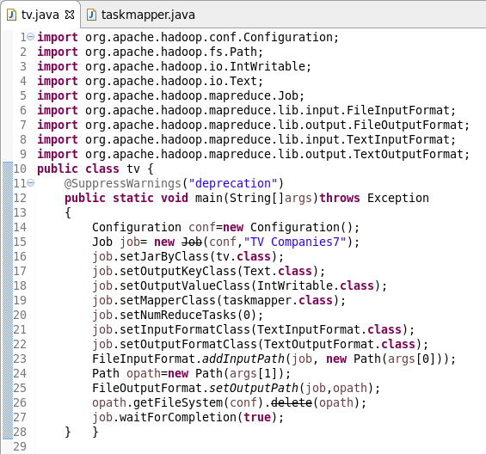

Mapper class:

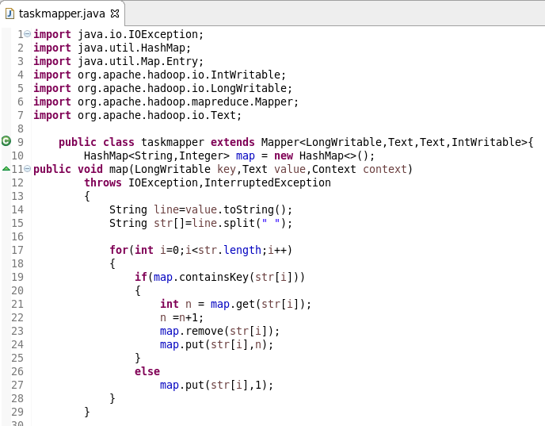

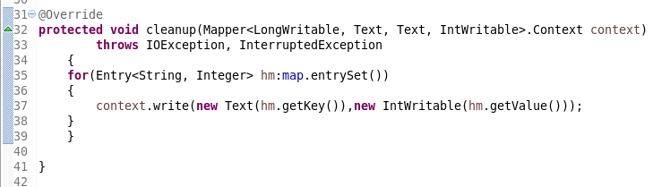

In mapper class we are adding unique keys and their respective values to a hashmap in map method. After processing all the data by map method, cleanup method is getting executed. In cleanup method, we are writing all the unique words and their occurrences into a text file with the help of context.write().

Running jar:

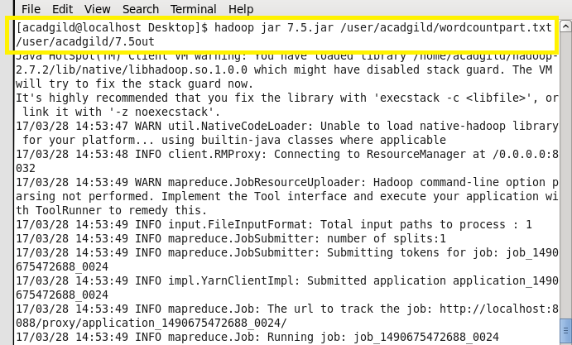

Output:

