Problem Statement:

Write a map reduce program save the output of the word count program in XML format. You need to write a custom writable to save the output in XML format.

Note:

You can use any data set of your choice for executing this program.

Dataset:

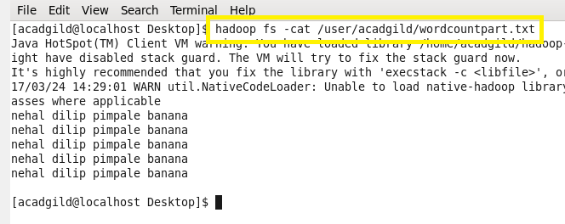

Codes:

Task class:

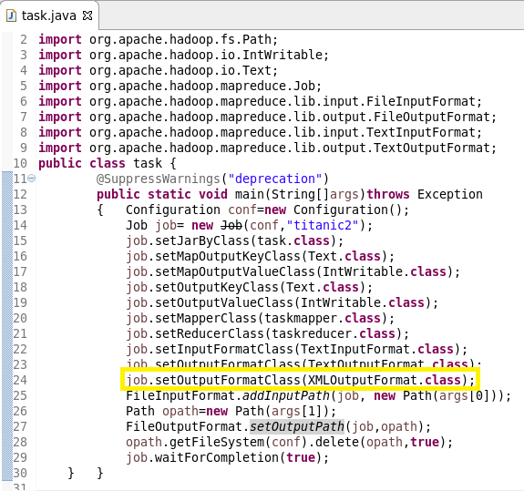

Mapper class:

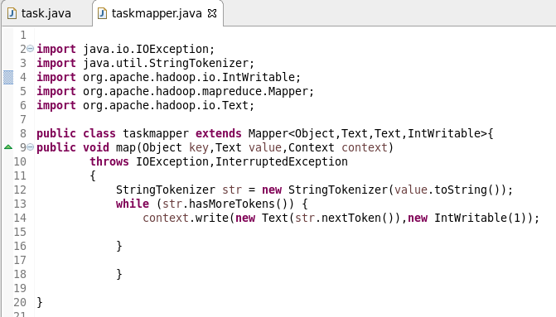

Reducer class:

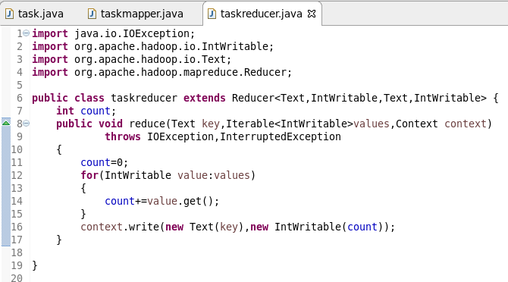

XMLOutputFormat class:

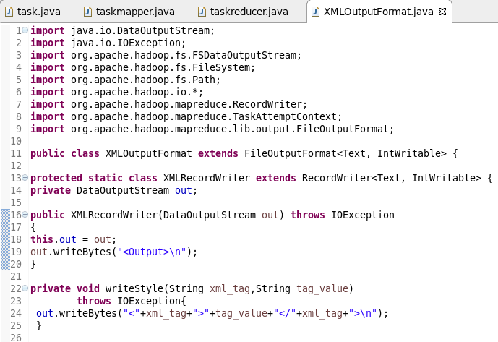

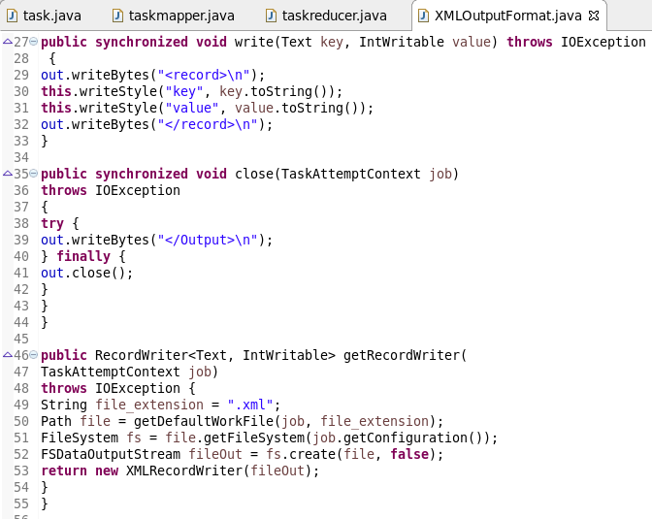

Running jar:

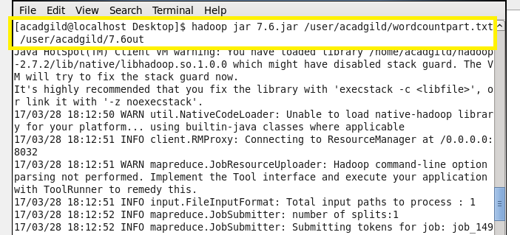

Output:

