Problem Statement 1:

Write a mapreduce program to find the total amount of petrol in volume sold by every distributor.

Problem Statement 2:

Write a mapreduce program to find which are the top 10 distributors ID's for selling petrol and also display the amount of petrol sold in volume.

Codes:

Task class:

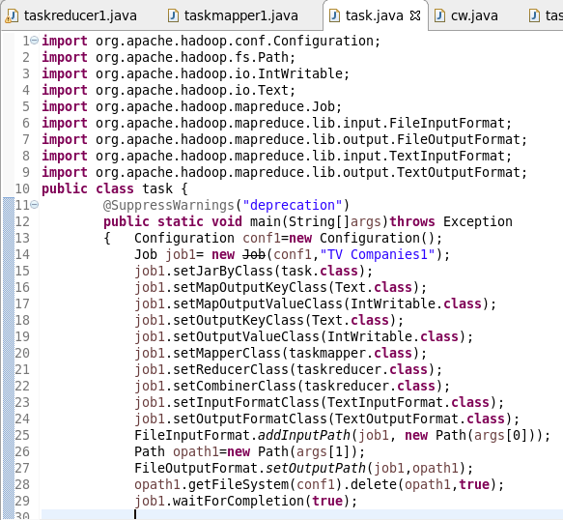

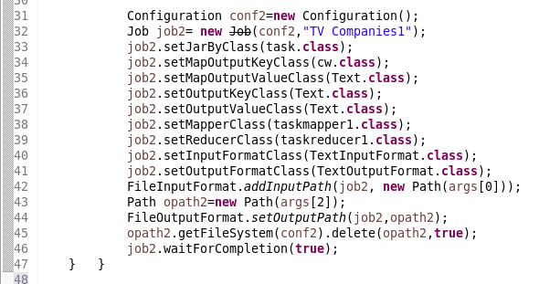

Mapper class for problem 1:

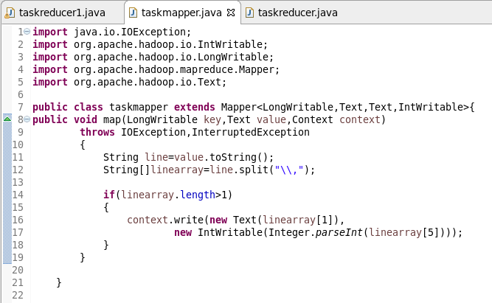

Mapper class for problem 2:

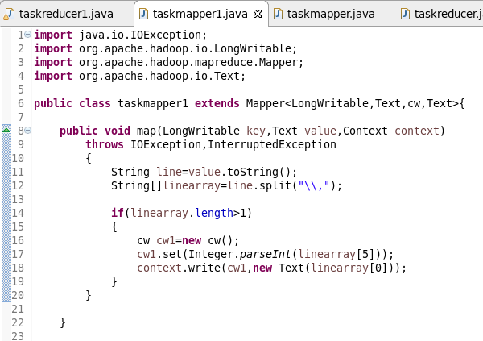

Reducer class for problem 1:

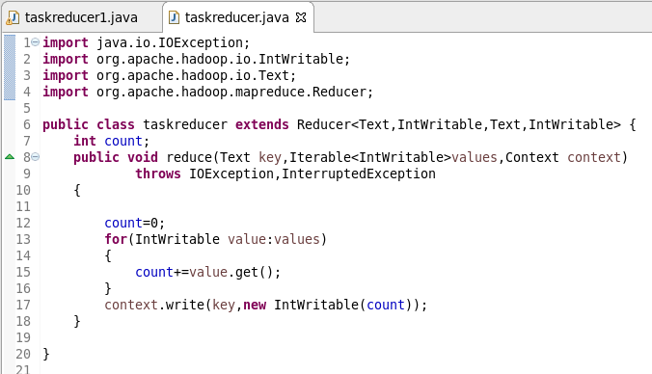

Reducer class for problem 2:

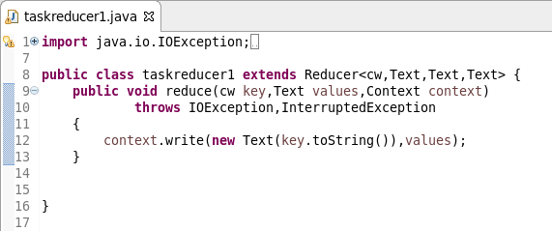

Writable comparable class for composite key:

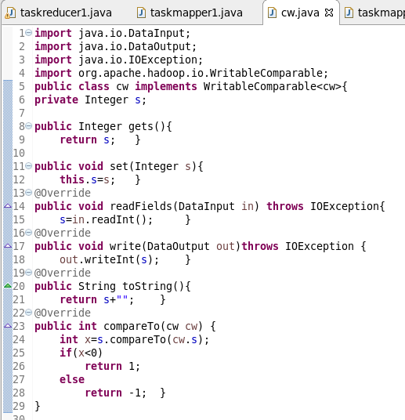

Running jar:

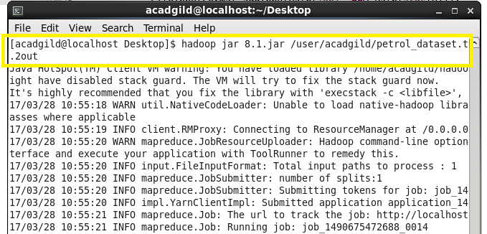

Output of problem 1:

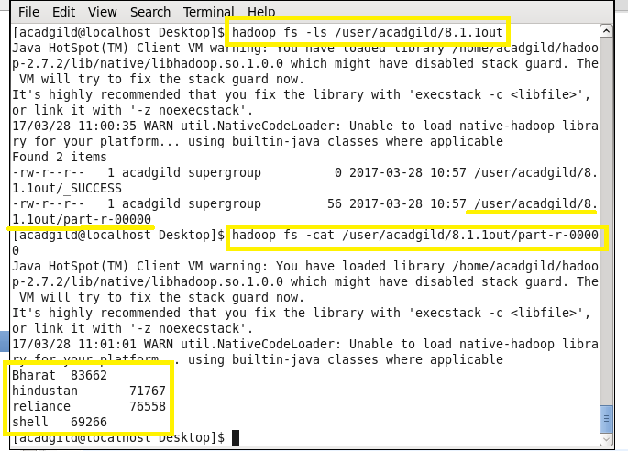

Output of problem 2:

