Create two datasets employee and department of file type text where the columns are delimited by tab (‘\t’), and use these datasets to perform below Join operations:

● SELF JOIN

● INNER JOIN

● LEFT OUTER JOIN

● RIGHT OUTER JOIN

● FULL OUTER JOIN

Load employee details and employee expenses:

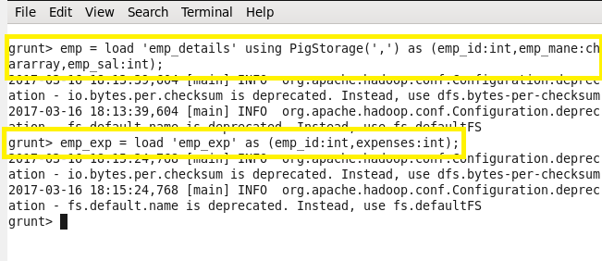

Display employee details:

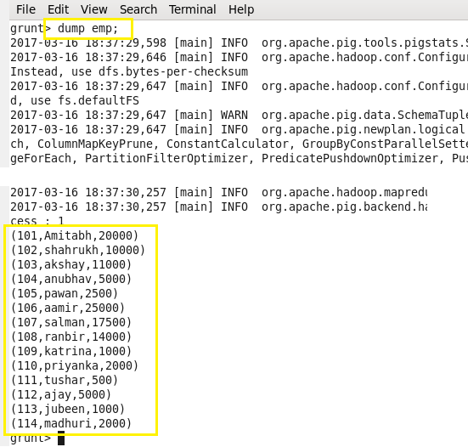

Display employee expenses:

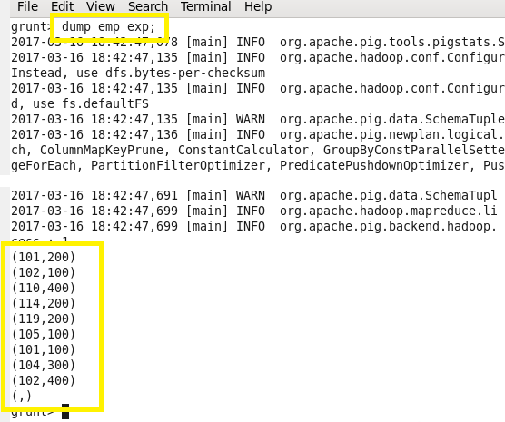

Left outer join:

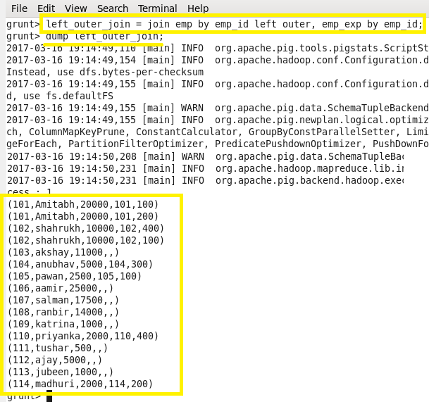

Right outer join:

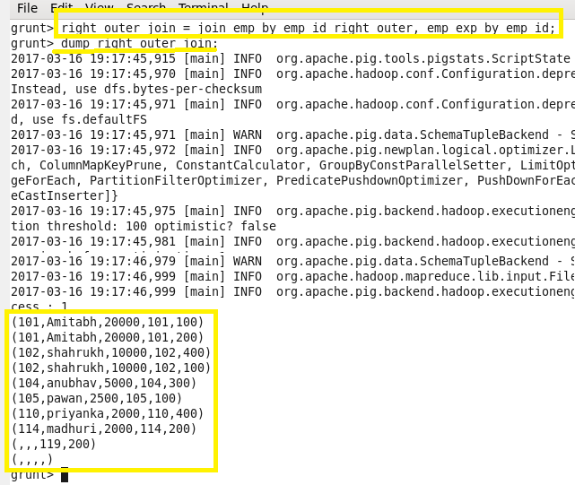

Full outer join:

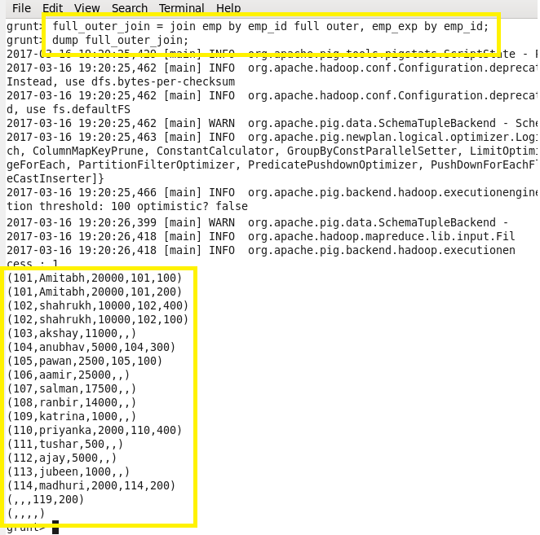

Self join:

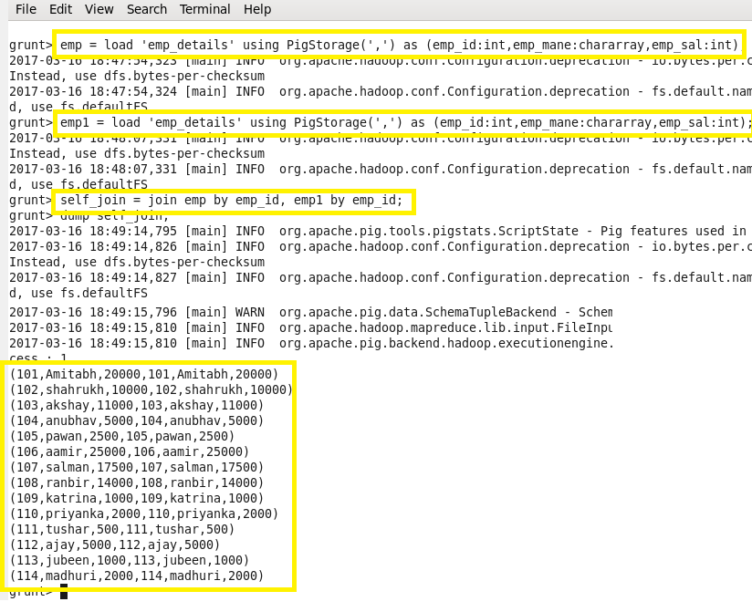

Inner join:

