Problem Statement 1.

Practice the relational operators in pig by following the steps in the below blog <https://acadgild.com/blog/relational-operators-in-pig/>

1. LOAD

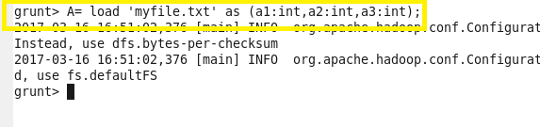

1. LIMIT

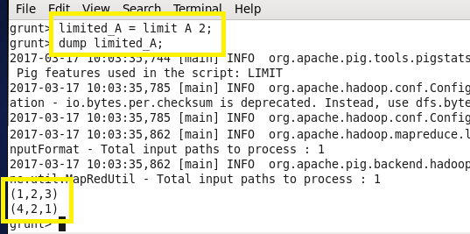

1. ORDER BY

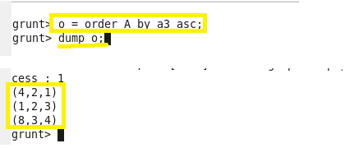

1. GROUP BY

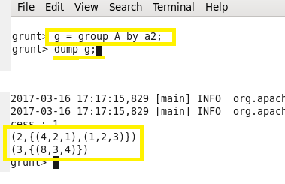

1. FOREACH

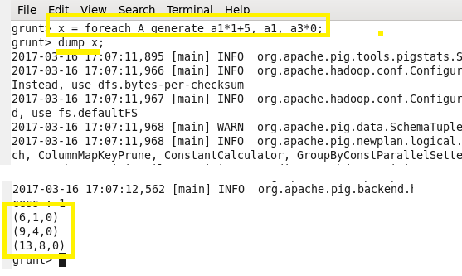

1. FILTER

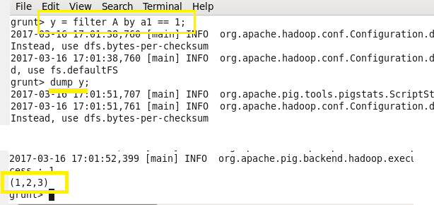

1. STORE

