Name: ___Neha Moorthy__________
Student ID: __1228438018_______
Date: ____12/2/2025___

Instructions: Congratulations, you made it to the end of the course! Use the following to have a written discussion about your experience in the course and the final project. After you answer the questions below, insert a screenshot of each of the pages you have completed so far (remember, you should have at least 4 and the CSS file). Do NOT screenshot the html code because we can’t run the code. Save the file to yourasurite – Project – Assignment 5.docx file and yourasurite – Project – Assignment 5.pdf file.

Before submitting this document and all your project files, make sure you meet all of these requirements listed in the CIS300 Project Instructions.pdf file.

Discussion Questions
- Now that you are finished with your project, your original concept of your project might have changed a lot. Discuss in detail the differences between your initial project design and your final product. Why did you make these changes (if you had any)? (5 points)
When I first began this project, I imagined creating a very simple fitness website with only a few pages and minimal features. My original idea did not include videos, a downloadable PDF, meta tags, or detailed navigation panels. As I worked through the course content, my project evolved into a much more structured and polished site than I expected. I ended up adding a workout table, form elements, descriptive meta tags, navigation sidebars, embedded videos, external resources, and a downloadable progress tracker. I made these changes because I gained a better understanding of HTML and CSS and wanted my website to look more professional and complete. The requirements of the project also guided me to expand each page and refine the layout. Overall, the final product is more organized, functional, and visually appealing than my initial design.

- Describe in detail why you chose the design layout you did. Are you happy with the outcome? Did you run into any issues with your design while developing your site? What did you do to overcome those issues? Would you do anything differently the next time you designed a website? (5 points)
I chose a clean, colorful layout because I wanted FitWeek to feel motivating and approachable for people looking to improve their fitness routines. I used soft blues, purples, and yellows to create a friendly, high-energy look. I am happy with the result because the layout feels consistent and the pages are easy to navigate. One issue I ran into was getting the videos, images, and sidebar layout to display properly on different screen sizes. I solved this by adjusting widths and using media queries to improve responsiveness. Another challenge was ensuring that each page stayed balanced visually and didn't feel crowded. If I were to design another website in the future, I would start with a wireframe beforehand, and I would focus more on mobile optimization from the beginning.

- You likely encountered challenges while working on your final project. In detail, describe the challenges you encountered and what you did to overcome them. (5 points)
One major challenge was understanding how to correctly embed videos using both <iframe> and <video> tags. I overcame this by reviewing examples and testing multiple formats until they displayed correctly. Another challenge was organizing the navigation, so all links stayed consistent across every page. I solved that by copying a uniform header into each file and double-checking all URLs. Creating the downloadable PDF was also new to me, but I learned how to link it and make it accessible from the Motivation page. Lastly, making sure every requirement from the project rubric was met took time, so I created a checklist and verified each item one by one.
- Describe several concepts that you learned during this course that you found interesting and useful. Where there any concepts that you wish more time was spent on? Is there anything you would have like to incorporate into your final project that wasn’t covered during this course? (5 points)

Throughout this course, I learned many useful concepts, including writing clean HTML structure, building responsive layouts with CSS, creating forms, embedding multimedia, and adding meta tags for better descriptions and search relevance. I also learned how to use GitHub Pages to host a website, which was something I had never done before. I found CSS layout design and video embedding the most interesting. I wish we had more time spent on responsive design and mobile layouts, because that is an important part of real-world web development. I also would have liked to learn a little about JavaScript so I could have added interactive features to my site.

- List your project website's GitHub URL. (3 points)

URL: https://neham23.github.io/

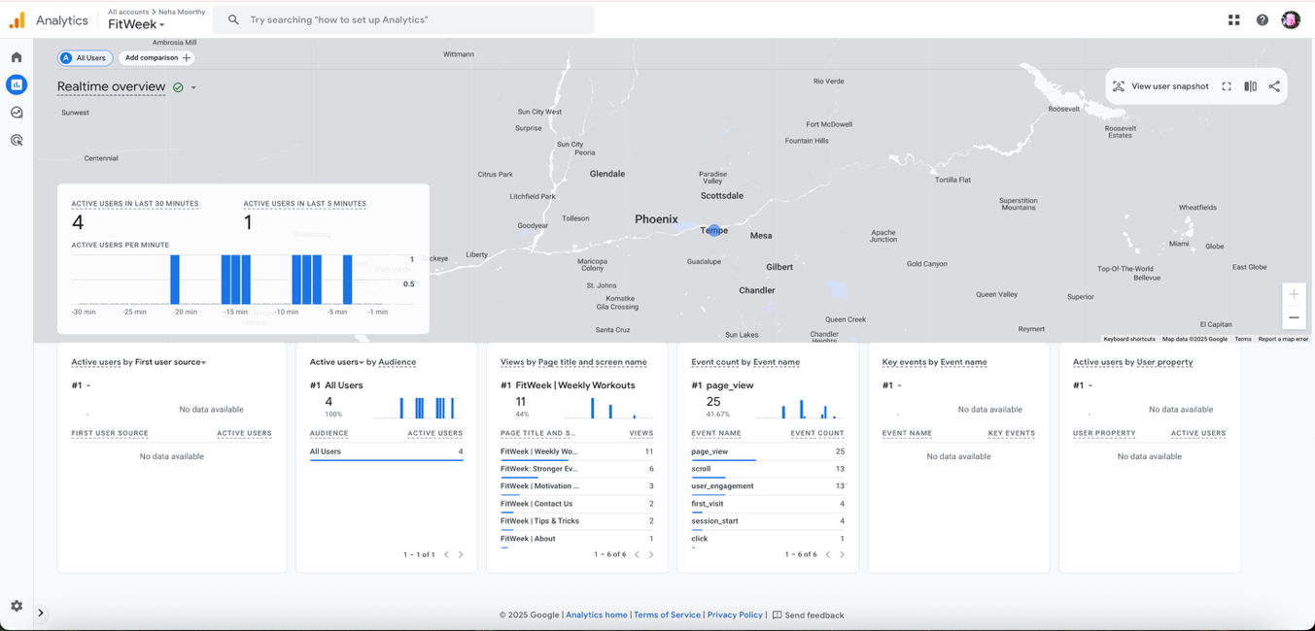
- Insert your website’s Google Analytics Realtime Overview Screenshot below (10 points)
- While trying to be as objective and unbiased as possible, please go through and critique your own site using the attached rubric. In the student critique column, indicate which score you should receive for each category (outstanding, average, or needs improvement) and write a short (1 or two sentence max) justification of that score. (5 points)
Student Critique
 | Outstanding | Average | Needs Improvement | Student Critique
EXAMPLE | You did everything! | You did a few things. | You did nothing… | Outstanding – I believe I did everything correctly because of x, y, and z.
Visual Appeal | Use of color, contrast, text, graphics is appealing to target audience | Appealing to target audience in all but one area. | Not appealing to target audience in more than one area | Outstanding – I believe I did everything correctly because my color scheme, layout, images, and text styles are consistent across all pages and visually appropriate for a fitness website.
Navigation | Easy to use, consistent | Inconsistent or difficult to use | Missing | Outstanding – My navigation menu appears the same on every page, is easy to use, and includes clear links to all major sections of the site.
Page Titles/ Logo Area | Descriptive and include the site/company name | -- | Missing or does not include the site/company name | Outstanding – Every page includes a descriptive page title, and the FitWeek logo/header is consistently displayed at the top of all pages.
Table | Present and correct syntax | -- | Missing or incorrect syntax | Outstanding – I included a properly formatted table with headers and multiple rows that displays workout information clearly.
Video | Present and correct syntax | -- | Missing or incorrect syntax | Outstanding – I met the requirement by including one video using the <video> tag and an additional YouTube embed, both coded correctly.
E-mail Link | Present and correct syntax | -- | Missing or incorrect syntax | Outstanding – My site includes a working email link (“fitweekcontact@gmail.com”) that appears on the contact page and footer.
Outside Link | Present and correct syntax | -- | Missing or incorrect syntax | Outstanding – I added a correct external link to an outside fitness resource (Darebee.com) on multiple pages.
Meta tag | Correct syntax (description meta tags), excellent selection of keywords and meaningful description | Correct syntax (description meta tags), adequate selection of keywords and description | Missing or incorrect syntax | Outstanding – Every page contains proper meta description tags with meaningful descriptions and relevant keywords.
Form Coding | Contains 4 or more form fields, correct syntax, and meaningful form element names | Does not contain the required 4 form fields, incorrect syntax, or names of fields don’t make sense. | Missing | Outstanding – My contact form includes more than four fields, uses correct syntax, and has clear and meaningful labels.
Form Processing | Form uses # as the action. | -- | Form not configured correctly. | Outstanding – The form uses action="#" exactly as required and does not attempt any server-side processing.

Web page browser view screenshot of Home Page
This page includes _0_ video, _1_ form, _1_ table, _1_ email, or _1_ external links.

Web page browser view screenshot of Page #1
This page includes _0_ video, _0_ form, _1_ table, _1_ email, or _1_ external links.
Web page browser view screenshot of Page #2
This page includes _2_ video, _0_ form, _0_ table, _1_ email, or _1_ external links.

Web page browser view screenshot of Page #3
This page includes _1_ video, _0_ form, _0_ table, _1_ email, or _1_ external links.

Web page browser view screenshot of Page #4 (if it available)
This page includes _0_ video, _0_ form, _0_ table, _1_ email, or _1_ external links.

