Q.1 what is SDLC ?

Software development life cycle is a series of steps or phases that provides the model of development.

It is the life cycle management for the piece of software or application .

Phases of SDLC

1. PLANNING
2. IMPLEMENTATION
3. TESTING
4. DOCUMENT
5. DEPLOYMENT
6. ONGOING MAINTAINANCE AND SUPPORT.

Q.2 WHAT IS TESTING ?

* Testing is the process of evaluating a system or its components with the intent to find that whether its satisfies the specified requirments or not.
* Testing is a process rather than a single activity.
* It is an activity in which we check whether the actual output mathches the expected output.
* It is a process used to identify the correctness, completencess and quality of developed computer software.

Q.3 what is agile methodology?

Agile SDLC model is a combination of iterative and incremental process models with focus on process adaptability and customer satisfaction by rapid delivery of working software product.

* Agile methods break the product in to small incemental builds.

Q.4 Explain working methodology of agile model and also write pros and cons.

Pros of agile model:

* Is a very realistic approach to software development.
* Promotes team work and cross training .
* Functionality can be developed rapidly and demonstrated.
* Resource requirments are minimum.
* Little or no planning required.
* Easy to manage.
* Gives flexibility to devlopers.

Cons of agile model.

* There is very high individual dependets since there minimum documentation generated.
* Transfer of technology to new team members may be quite challenging due to lack of documentation

Q.5 What is SRS ?

A software requirement specification (SRS) is a complete description of the behaviour of the system to be developed.

It includes a set of use cases that describe all of the interaction that the users will have with the software.

Q.6 Write SDLC phases with basic introduction ?

SDLC phases:

1. Requirement gathering Establish & customer needs.
2. Analysis model and specify the requirments “What”.
3. Design model and specify a solution”why”.
4. Implimantation Construct a solution in software.
5. Testing validate the solution against the requirments.
6. Maintanance Repair defect and adapt the solution to the

New requirement.

Q.7 What is oops?

Object oriented programming is way of writing the programms in organized way object are like a black box where data are hidden.

Security

Less space occupy

Less code redundancy

Q.8 write basic concept of oops?

1. Class

2.Object

3. Inheritence

4. Polymorphism

* Over riding
* Over loding

5.Encapsulation

6.Abstraction

Q.9 what is class?

* Class is a collection of data member and member function.

Q.10 what is object?

* Object gives the permission to access functionality of class.

Q.11 what is encapsulation?

* The process wrapping the data in a single unit to secure the data from outside world.

Q.12 Whan at is inheritance?

* Making a class from existing class. Deriving the attribute of some other class.

Q.13 What is Abstraction?

* Hiding detail showing only essential information.

Q.14 What is polymorphism ?

* One name multiple firm.
* Type: over riding
* Same name of function with same parameter but definition will be different.
* Over loading
* 1.function overloading: same function name but different parameter.
* 2.constructor overloading: same constructor name but different parameter.
* 3.operator overloading. Using the operator to add the object instead of variable operands.

Q.15 Write agile manifesto principles.

- Accommodate changing requirements throghtout the development process.

- Frequent delivery of working software.

- Collaboration between the business stake holders and developers throughout the project.

- better decision are made when business and technical team are aligned.

- support, trust and motivate the people involved.

- working software is the primary measure of progress.

- Agile process to support a consistent development pace.

- Attention to technical detail and design enhance agibility.

- simplicity develop just enough to get the job done for right now.

- self- aorganized teams encourage great architecturs , requirments, and design.

- Regular reflections how to become more effective.

- Self improvement process improvement advancing skills and techniques help team members work more efficiently.

Q.16 Write phases of spiral model.

1. Planning:

Determination of objectives , alternatives and constraints.

1. Risk analysis :

Analysis of alternatives and identification / resolution of risk.

Risk = something that will delay project or increase its cost.

1. Engineering = development of the “next level”product.
2. Customer Evaluation=

Assessment of the results of engineering.

Q.17 • Draw Usecase on Online book shopping

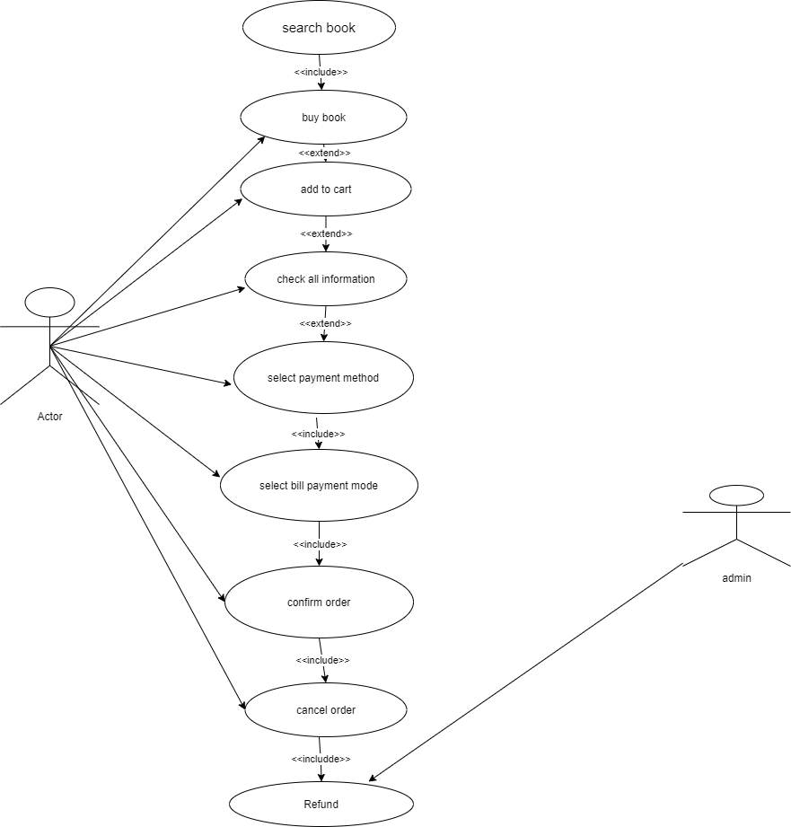

Q.18 Draw use case on online bill payment.

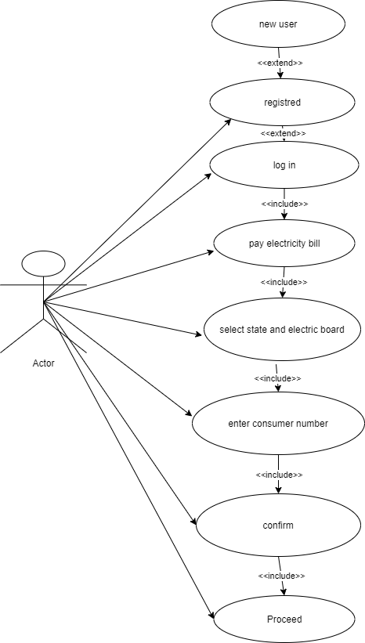

Q.19l draw use case on online shopping product using on COD .

