**Q.1 what is SDLC ?**

Software development life cycle is a series of steps or phases that provides the model of development.

It is the life cycle management for the piece of software or application .

Phases of SDLC

1. PLANNING
2. IMPLEMENTATION
3. TESTING
4. DOCUMENT
5. DEPLOYMENT
6. ONGOING MAINTAINANCE AND SUPPORT.

**Q.2 WHAT IS TESTING ?**

* Testing is the process of evaluating a system or its components with the intent to find that whether its satisfies the specified requirments or not.
* Testing is a process rather than a single activity.
* It is an activity in which we check whether the actual output mathches the expected output.
* It is a process used to identify the correctness, completencess and quality of developed computer software.

**Q.3 what is agile methodology?**

Agile SDLC model is a combination of iterative and incremental process models with focus on process adaptability and customer satisfaction by rapid delivery of working software product.

* Agile methods break the product in to small incemental builds.

**Q.4 Explain working methodology of agile model and also write pros and cons**.

Pros of agile model:

* Is a very realistic approach to software development.
* Promotes team work and cross training .
* Functionality can be developed rapidly and demonstrated.
* Resource requirments are minimum.
* Little or no planning required.
* Easy to manage.
* Gives flexibility to devlopers.

Cons of agile model.

* There is very high individual dependets since there minimum documentation generated.
* Transfer of technology to new team members may be quite challenging due to lack of documentation

**Q.5 What is SRS ?**

A software requirement specification (SRS) is a complete description of the behaviour of the system to be developed.

It includes a set of use cases that describe all of the interaction that the users will have with the software.

**Q.6 Write SDLC phases with basic introduction ?**

SDLC phases:

1. Requirement gathering - Establish & customer needs.
2. Analysis - model and specify the requirments “What”.
3. Design - model and specify a solution”why”.
4. Implimantation - Construct a solution in software.
5. Testing - validate the solution against the requirments.
6. Maintanance - Repair defect and adapt the solution to the

New requirement.

**Q.7 What is oops?**

Object oriented programming is way of writing the programms in organized way object are like a black box where data are hidden.

Security

Less space occupy

Less code redundancy

**Q.8 write basic concept of oops?**

1.Class

2.Object

3. Inheritence

4. Polymorphism

* Over riding
* Over loding

5.Encapsulation

6.Abstraction

**Q.9 what is class?**

* Class is a collection of data member and member function.

**Q.10 what is object?**

* Object gives the permission to access functionality of class.

**Q.11 what is encapsulation?**

* The process wrapping the data in a single unit to secure the data from outside world.

**Q.12 Whan at is inheritance?**

* Making a class from existing class. Deriving the attribute of some other class.

**Q.13 What is Abstraction?**

* Hiding detail showing only essential information.

**Q.14 What is polymorphism ?**

* One name multiple firm.
* Type: over riding
* Same name of function with same parameter but definition will be different.
* Over loading
* 1.function overloading: same function name but different parameter.
* 2.constructor overloading: same constructor name but different parameter.
* 3.operator overloading. Using the operator to add the object instead of variable operands.

**Q.15 Write agile manifesto principles.**

- Accommodate changing requirements throghtout the development process.

- Frequent delivery of working software.

- Collaboration between the business stake holders and developers throughout the project.

- better decision are made when business and technical team are aligned.

- support, trust and motivate the people involved.

- working software is the primary measure of progress.

- Agile process to support a consistent development pace.

- Attention to technical detail and design enhance agibility.

- simplicity develop just enough to get the job done for right now.

- self- organized teams encourage great architecturs , requirments, and design.

- Regular reflections how to become more effective.

- Self improvement process improvement advancing skills and techniques help team members work more efficiently.

**Q.16 Write phases of spiral model.**

1. Planning:

Determination of objectives , alternatives and constraints.

1. Risk analysis :

Analysis of alternatives and identification / resolution of risk.

Risk = something that will delay project or increase its cost.

1. Engineering = development of the “next level”product.
2. Customer Evaluation=

Assessment of the results of engineering.

**Q.17 • Explain Phases of the waterfall model.**

The classical software life cycle models the software development as a step by step “waterfall” between the various development phases.

1. Requirment collection
2. Analysis
3. Design
4. Implementation
5. Testing
6. Maintenance

1.Requirement gathering - Establish & customer needs.

1. Analysis - model and specify the requirments “What”.
2. Design - model and specify a solution”why”.
3. Implimantation - Construct a solution in software.
4. Testing - validate the solution against the requirments.
5. Maintanance - Repair defect and adapt the solution to the

New requirement.

**Q.17 • Draw Usecase on Online book shopping**

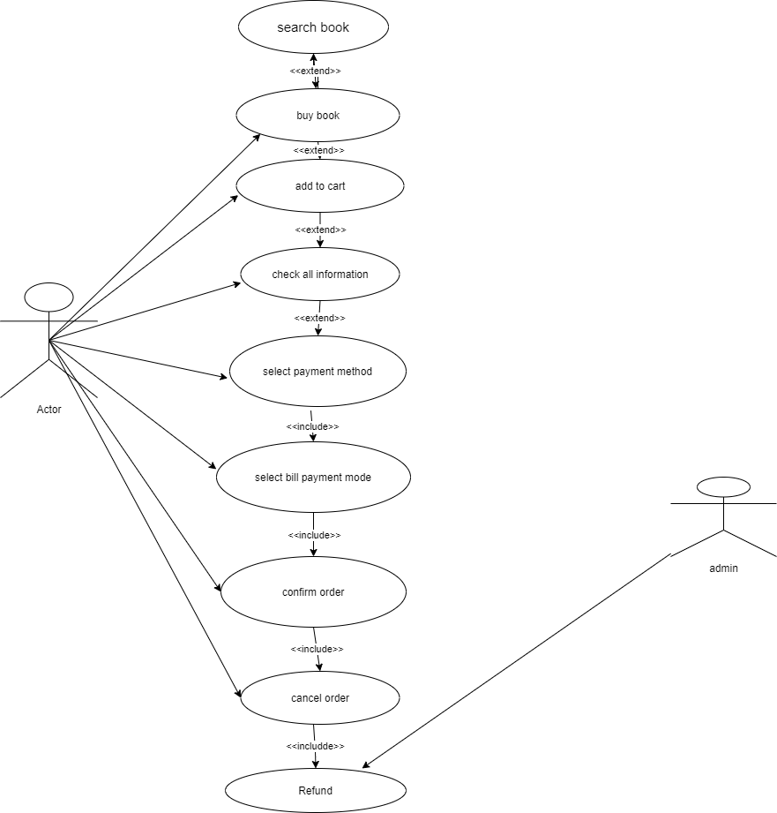

**Q.18 Draw use case on online bill payment.**

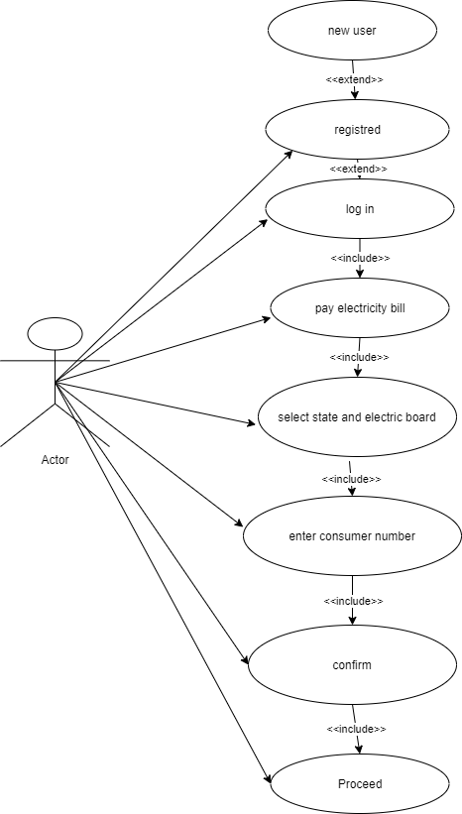

**Q.19l draw use case on online shopping product using on COD .**

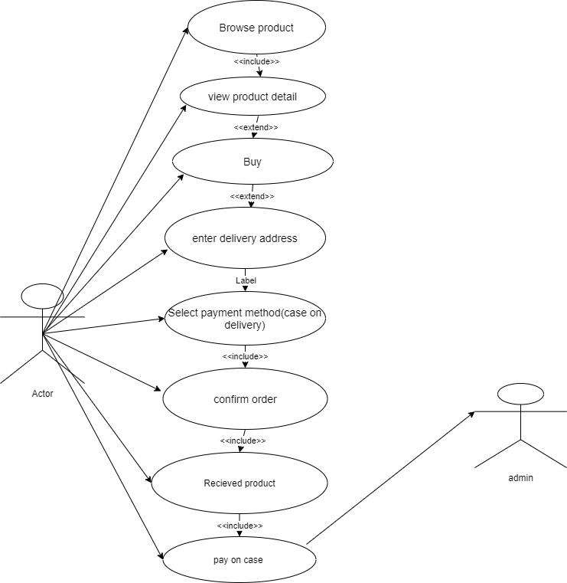

**Q.20 Draw usecase on Online shopping product using payment gateway.**

