EMBEDDED DEVELOPMENT CHALLENGES
## Challenge 1
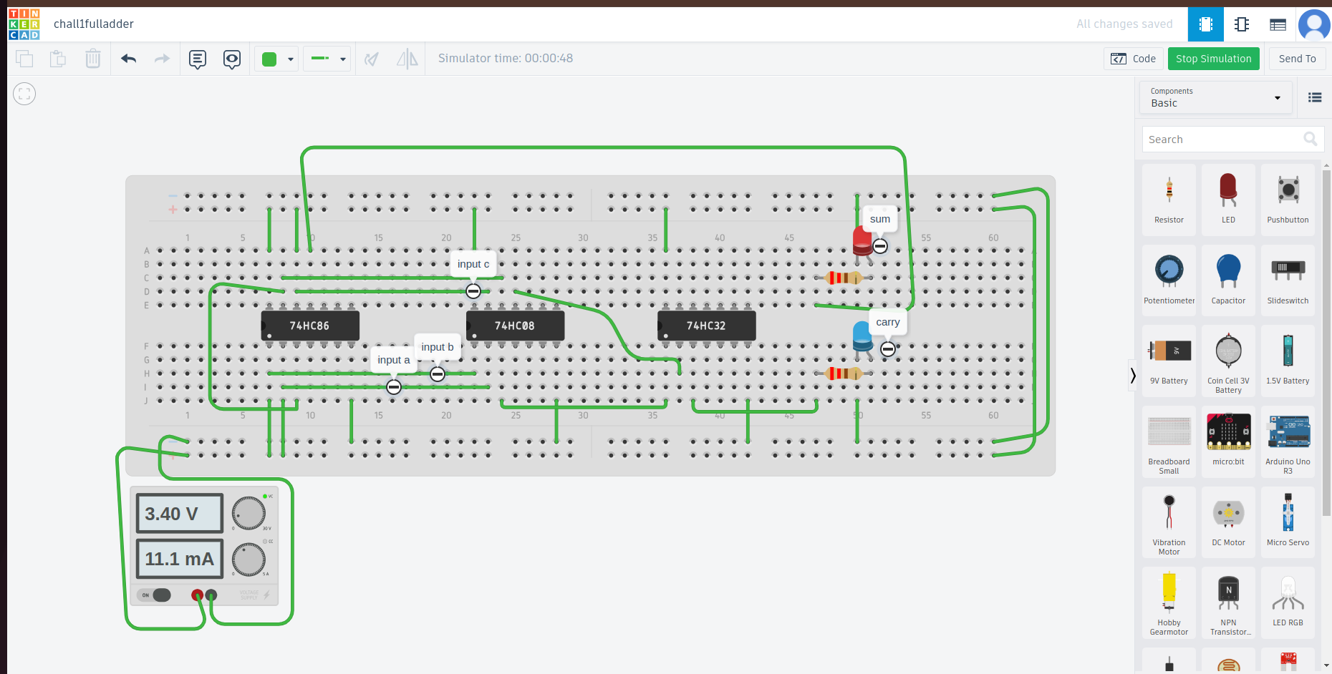
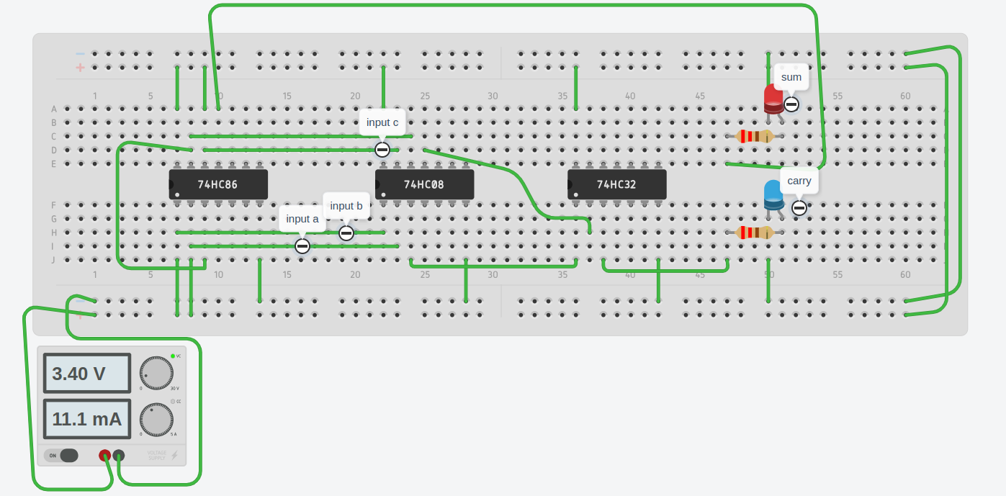
.
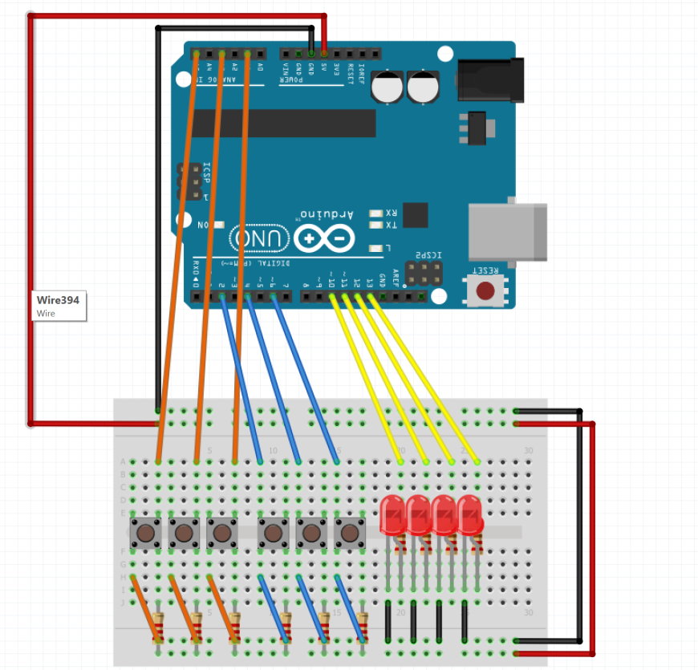

#CHALLENGE 2
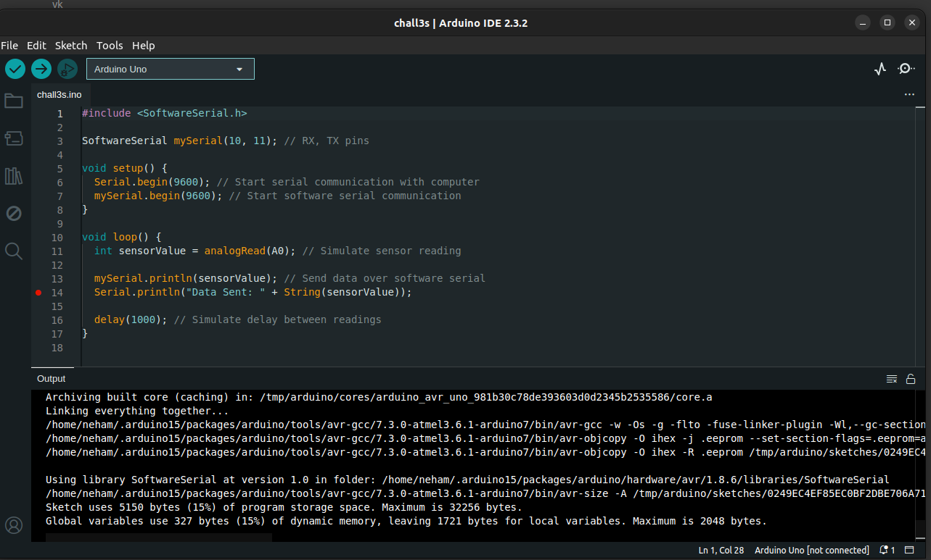
#CHALLENGE 3
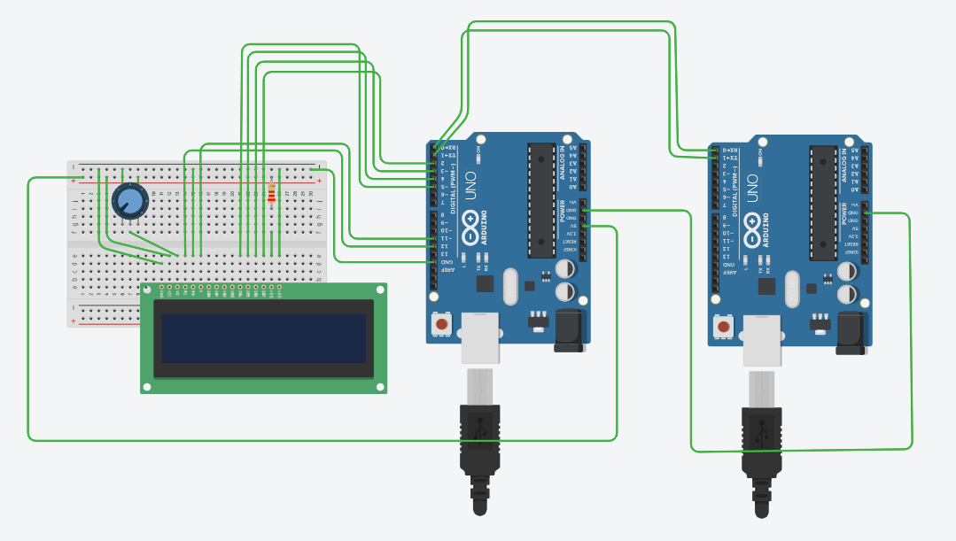
#include <LiquidCrystal.h>

char mystr[8];
byte row;
const int rs = 12, en = 11, d4 = 5, d5 = 4, d6 = 3, d7 = 2;
LiquidCrystal lcd(rs, en, d4, d5, d6, d7);

void setup() {
row = 0;
Serial.begin(9600);
lcd.begin(16, 2);
}

void loop() {
Serial.readBytes(mystr, 8);
lcd.clear();
lcd.setCursor(0, row);
lcd.print(mystr);
row = !row;
delay(1000);
}
#CHALLENGE 4
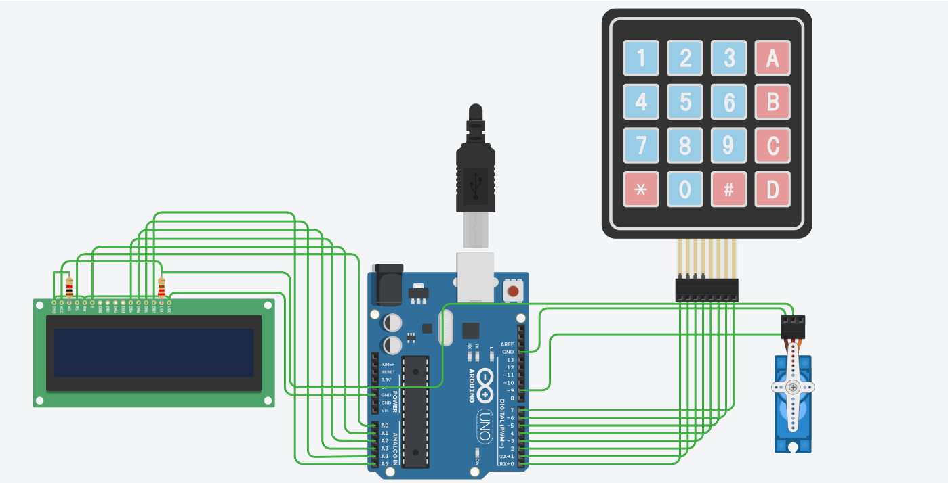
#include <Keypad.h>
#include <LiquidCrystal.h>
#include <Servo.h>

#define Password_Length 5

Servo myservo;
LiquidCrystal lcd(A0, A1, A2, A3, A4, A5);

int pos = 0;

char Data[Password_Length];
char Master[Password_Length] = "1234";
byte data_count = 0, master_count = 0;

bool Pass_is_good;
bool door = false;
char customKey;

/*---preparing keypad---*/

const byte ROWS = 4;
const byte COLS = 4;
char keys[ROWS][COLS] = {
{'1', '2', '3', 'A'},
{'4', '5', '6', 'B'},
{'7', '8', '9', 'C'},
{'*', '0', '#', 'D'}
};

byte rowPins[ROWS] = {0, 1, 2, 3};
byte colPins[COLS] = {4, 5, 6, 7};

Keypad customKeypad( makeKeymap(keys), rowPins, colPins, ROWS, COLS);

/*--- Main Action ---*/
void setup()
{
myservo.attach(9, 2000, 2400);
ServoClose();
lcd.begin(16, 2);
lcd.print("Secure lock");
loading("Loading");
lcd.clear();
}

void loop()
{
if (door == true)
{
customKey = customKeypad.getKey();
if (customKey == '#')
{
lcd.clear();
ServoClose();
lcd.print("Door is closed");
delay(3000);
door = false;
}
}
else
Open();

}

void loading (char msg[]) {
lcd.setCursor(0, 1);
lcd.print(msg);

for (int i = 0; i < 9; i++) {
delay(1000);
lcd.print(".");
}
}

void clearData()
{
while (data_count != 0)
{
Data[data_count--] = 0;
}
return;
}

void ServoClose()
{
for (pos = 90; pos >= 0; pos -= 10) {
myservo.write(pos);
}
}

void ServoOpen()
{
for (pos = 0; pos <= 90; pos += 10) {
myservo.write(pos);
}
}

void Open()
{
lcd.setCursor(0, 0);
lcd.print("Enter Password");

customKey = customKeypad.getKey();
if (customKey)
{
Data[data_count] = customKey;
lcd.setCursor(data_count, 1);
lcd.print(Data[data_count]);
data_count++;
}

if (data_count == Password_Length - 1)
{
if (!strcmp(Data, Master))
{
lcd.clear();
ServoOpen();
lcd.print(" Door is Open ");
door = true;
delay(5000);
loading("Waiting");
lcd.clear();
lcd.print(" Time is up! ");
delay(1000);
ServoClose();
door = false;
}
else
{
lcd.clear();
lcd.print(" Wrong Password ");
door = false;
}
delay(1000);
lcd.clear();
clearData();
}
}
#CHALLENGE 5
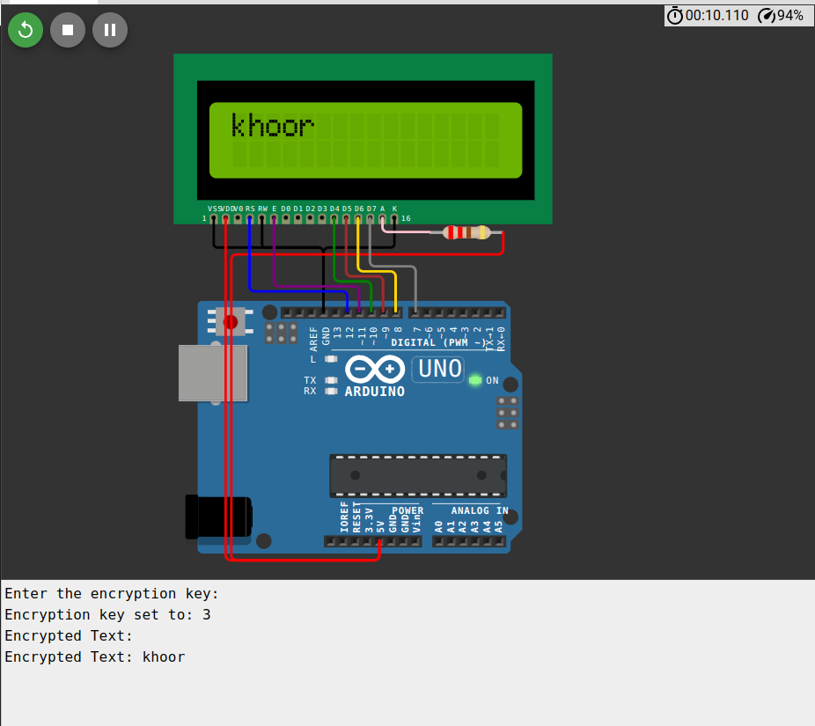
#include <LiquidCrystal.h>

char inChar;
String inputText = "";
String encryptedText = "";
int key;

LiquidCrystal lcd(12, 11, 10, 9, 8, 7);

void setup() {
Serial.begin(9600);
lcd.begin(16, 2);

Serial.println("Enter the encryption key:");
while (!Serial.available()) {}

key = Serial.parseInt();
Serial.println("Encryption key set to: " + String(key));
}

void loop() {
if (Serial.available() > 0) {
inChar = Serial.read();

if (inChar != '\n') {
inputText += inChar;
} else {
encryptText();
lcd.clear();
lcd.setCursor(0, 0);
lcd.print("" + encryptedText);
Serial.println("Encrypted Text: " + encryptedText);

inputText = "";
encryptedText = "";
}
}
}

void encryptText() {
for (char character : inputText) {
if (isAlpha(character)) {
char encryptedChar = encryptChar(character, key);
encryptedText += encryptedChar;
} else {
encryptedText += character;
}
}
}

char encryptChar(char character, int shift) {
if (isUpperCase(character)) {
return (character - 'A' + shift) % 26 + 'A';
} else if (isLowerCase(character)) {
return (character - 'a' + shift) % 26 + 'a';
} else {
return character;
}
}

bool isUpperCase(char character) {
return (character >= 'A' && character <= 'Z');
}

bool isLowerCase(char character) {
return (character >= 'a' && character <= 'z');
}
#CHALLENGE 6
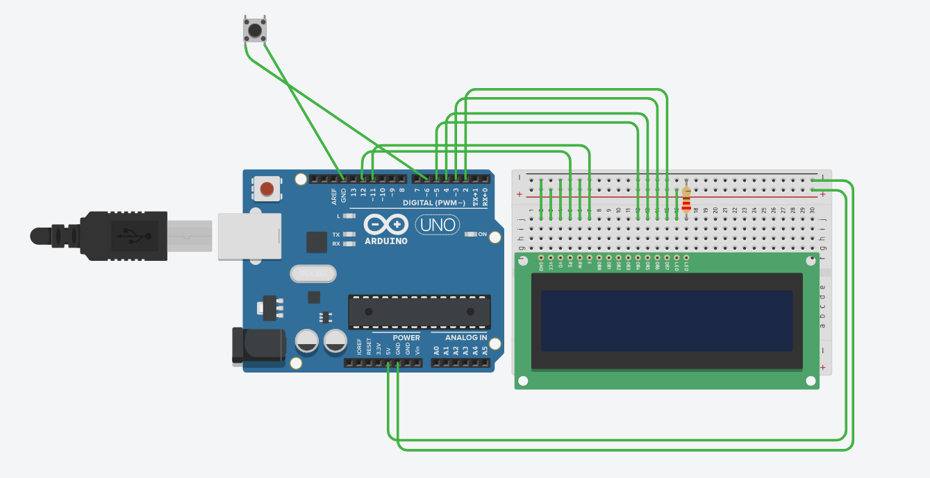
#include <LiquidCrystal.h>

LiquidCrystal lcd(12, 11, 5, 4, 3, 2);
const int switchPin = 6; // Pin for the switch

void setup() {
lcd.begin(16, 2);
pinMode(switchPin, INPUT_PULLUP); // Use internal pull-up resistor for the switch
}

void loop() {
if (digitalRead(switchPin) == LOW) {
displayText(); // Display text only if the switch is pressed
delay(500); // Debounce delay
} else {
lcd.clear(); // Clear the LCD if the switch is not pressed
}
}

void displayText() {
lcd.setCursor(0, 0);
lcd.print(" bi0sHardware");
lcd.setCursor(2, 1);
lcd.print(" ");
}

