**What is a Version Control System? TYPES?**

The Git version control system, as the name suggests, is a system that records all the modifications made to a file or set of data so that a specific version may be called up later if needed. The system makes sure that all the team members are working on the file’s latest version, and everyone can work simultaneously on the same project. A version control system is a software that tracks changes to a file. It also allows you to work together with other programmers.

In short, The version control system is a collection of software tools that help a team to manage changes in a source code. It uses a special kind of database to keep track of every modification to the code. Developers can compare earlier versions of the code with an older version to fix the mistakes. The Version Control System is very helpful and beneficial in software development; developing software without using version control is unsafe. It provides backups for uncertainty. Version control systems offer a speedy interface to developers. It also allows software teams to preserve efficiency and agility according to the team scales to include more developers. To deal with this issue, programmers developed local VCSs that had a simple database. Such databases kept all the changes to files under revision control. A local version control system keeps local copies of the files. The major drawback of Local VCS is that it has a single point of failure.

* Localized version Control System
* Centralized version control systems
* Distributed version control systems

**Localized version Control System :=**The localized version control method is a common approach because of its simplicity. But this approach leads to a higher chance of error. In this approach, you may forget which directory you're in and accidentally write to the wrong file or copy over files you don't want to. A local version control system keeps local copies of the files. the major drawback of Local VCS is that it has a single point of failure.

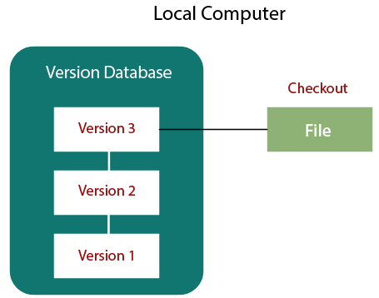

**Centralized version control**

With centralized version control systems, you have a single “central” copy of your project on a server and commit your changes to this central copy. You pull the files that you need, but you never have a full copy of your project locally. The developers needed to collaborate with other developers on other systems. The localized version control system failed in this case. To deal with this problem, Centralized Version Control Systems were developed. These systems have a single server that contains the versioned files, and some clients to check out files from a central place.

Centralized version control systems have many benefits, especially over local VCSs.

* Everyone on the system has information about the work what others are doing on the project.
* Administrators have control over other developers.
* It is easier to deal with a centralized version control system than a localized version control system.
* A local version control system facilitates with a server software component which stores and manages the different versions of the files.

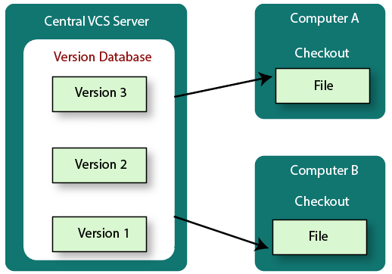

It also has the same drawback as in local version control system that it also has a single point of failure. The popular tools of CVCS are **SVN** (Subversion) and **CVS**

## **Distributed version control**

With distributed version control systems (DVCS), you don't rely on a central server to store all the versions of a project’s files. Instead, you clone a copy of a repository locally so that you have the full history of the project. In short, Distributed version control systems contain multiple repositories. Each user has their own repository and working copy. Just committing your changes will not give others access to your changes. This is because commit will reflect those changes in your local repository and you need to push them in order to make them visible on the central repository. Similarly, When you update, you do not get other’s changes unless you have first pulled those changes into your repository.

To make your changes visible to others, 4 things are required:

* You commit
* You push
* They pull
* They update

Centralized Version Control System uses a central server to store all the database and team collaboration. But due to single point failure, which means the failure of the central server, developers do not prefer it. Next, the Distributed Version Control System is developed.

It speeds up of most operations except pushing and pulling. DVCS enhances the ability to work offline and does not rely on a single location for backups. If any server stops and other systems were collaborating via it, then any of the client repositories could be restored by that server. Every checkout is a full backup of all the data.

The most popular distributed version control systems are Git, and Mercurial. They help us overcome the problem of single point of failure

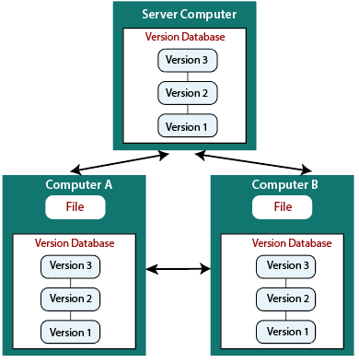

In Git, a repository refers to a storage location where your project's version control history and files are stored. There are two main types of repositories: local repositories and remote repositories.

1. Local Repository: A local repository is a repository that resides on your local machine or computer. When you initialize a Git repository in a directory, it creates a local repository in that location. This repository contains all the project files and the entire history of commits made to the project. You can work on your project, make changes, and commit them to the local repository.

The local repository allows you to perform various Git operations, such as creating branches, committing changes, viewing commit history, and reverting changes. It provides you with a local copy of the project and enables you to work offline without the need for a network connection.

1. Remote Repository: A remote repository, as the name suggests, is a repository located on a remote server or another machine. It acts as a central storage location for your project, allowing multiple developers to collaborate and share their changes. Remote repositories are typically hosted on services like GitHub, GitLab, or Bitbucket, which provide a platform for hosting and managing Git repositories.

By connecting your local repository to a remote repository, you can push your local commits to the remote repository and pull changes made by other collaborators. This enables you to synchronize your work with others, review and merge changes, and access the project from different machines. Remote repositories facilitate collaboration, version control, and backup of your project.

In summary, a local repository is a repository stored on your local machine, where you make changes and commit your work. A remote repository is a repository hosted on a server, which allows you to collaborate with others, share your changes, and access the project from different locations.

**What do u mean by staging area and how can you add file to working repository?**

In Git, the staging area, also known as the index, is an intermediate step between the working directory and the repository. It is a place where you can prepare and organize your changes before committing them to the repository.

When you make changes to files in your working directory, Git allows you to selectively choose which changes should be included in the next commit. The staging area acts as a holding area where you can review and validate your changes before making them a part of the project history.

To add a file to the staging area, you can use the git add command. For example, to add the file myfile.txt to the staging area, you would run the following command:

git add myfile.txt

Once you've added a file to the staging area, it will be included in your next commit. You can view the contents of the staging area by running the git status command.

To add all modified files to the staging area, you can use the git add -A command. This is useful if you've made a lot of changes and want to commit them all at once.

To remove a file from the staging area, you can use the git reset command. For example, to remove the file myfile.txt from the staging area, you would run the following command:

git reset myfile.txt

Once you've removed a file from the staging area, it will not be included in your next commit.

To add a file to the working repository, you can use the git commit command. This will take all of the changes that are in the staging area and save them to your local repository.

For example, to commit the changes to the file myfile.txt, you would run the following command:

git commit myfile.txt

You can also use the git commit -a command to commit all of the changes that are in the staging area, including changes to untracked files.

Once you've committed your changes, they will be stored in your local repository. You can then push them to a remote repository, such as GitHub or GitLab, so that other people can access them.

**What is the use of story card? Template of user story card**

A story card is a physical or digital card that represents a user story. It is used in agile software development to capture the requirements of a user story in a concise and easy-to-understand format. A story card, also known as a user story card, is a tangible representation of a user story in Agile software development. It is a physical or digital card that captures the essence of a specific user requirement or feature.The use of story cards is prevalent in Agile methodologies like Scrum or Kanban, where user stories are used to define and prioritize work. The story card serves as a concise

and easily understandable representation of the user story, providing essential information for the development team to understand and implement the feature.

The template of a user story card typically includes the following elements:

1. Title: A brief and descriptive title that summarizes the user story.
2. User Story: A simple statement that describes the user's need or goal in a concise and user-centric manner. It often follows the format: "As a [role], I want [feature] so that [benefit]."
3. Acceptance Criteria: A set of specific conditions or criteria that define when the user story is considered complete and meets the expected functionality. These criteria help in verifying that the implemented feature fulfills the requirements.
4. Priority: An indication of the relative importance or urgency of the user story compared to others. It helps the development team to understand the order in which the stories should be tackled.
5. Estimation: An estimation of the effort or complexity involved in implementing the user story. This can be in the form of story points, time units, or any other agreed-upon estimation scale.
6. Dependencies: Any dependencies or prerequisites that need to be resolved before working on the user story, such as technical dependencies, external integrations, or other features that need to be completed first.
7. Notes: Additional information or clarifications that may be useful for the development team or stakeholders.

* Title: A short, descriptive title that summarizes the user story.
* As a: The persona of the user who will benefit from the user story.
* I want: The goal of the user story.
* So that: The benefit that the user will receive by achieving the goal.
* Acceptance criteria: A set of specific criteria that must be met in order to consider the user story complete.

Story cards can be used in a variety of ways, such as:

* To communicate user stories to the development team: Story cards can be used to help the development team understand the requirements of the user stories and to prioritize them.
* To track the progress of user stories: Story cards can be used to track the progress of user stories as they are worked on by the development team.
* To collaborate on user stories: Story cards can be used to facilitate collaboration between the development team, the product owner, and other stakeholders.

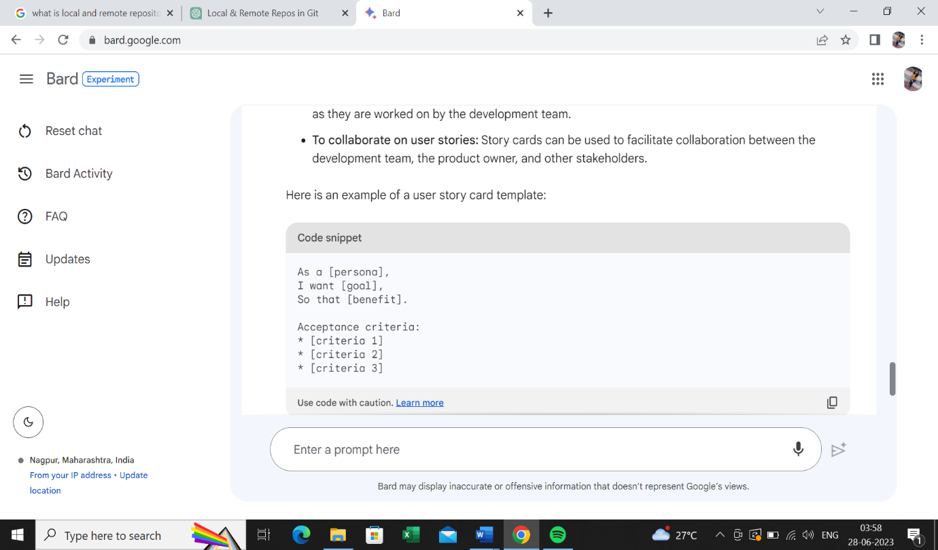

The specific elements of a story card template may vary depending on the project or team, but the basic elements listed above are common to most user story cards.

**Name different agile processes.**

Here are some of the most popular agile processes:

* Scrum: Scrum is a lightweight framework for project management and software development. It is characterized by short sprints, daily stand-ups, and iterative development.
* Kanban: Kanban is a visual system for managing work. It is based on the idea of visualizing work, limiting work-in-progress, and continuously improving the flow of work.
* Extreme Programming (XP): XP is an agile methodology that emphasizes simplicity, testing, and continuous refactoring. It is known for its 12 practices, which are designed to improve the quality and maintainability of software.
* Lean Software Development: Lean software development is a set of principles and practices that are inspired by the lean manufacturing movement. It focuses on eliminating waste and improving efficiency.
* Crystal: Crystal is a family of agile methodologies that are tailored to the specific needs of a project. It is based on the idea of "fit for purpose" and emphasizes flexibility and adaptability.
* Feature-Driven Development (FDD): FDD is an agile methodology that focuses on delivering working software in feature increments. It is based on the idea of breaking down a project into features, and then developing and delivering those features one at a time.
* Dynamic Systems Development Method (DSDM): DSDM is an agile methodology that is designed for projects that require rapid development and deployment. It is based on the idea of iterative development and continuous user involvement.
* Adaptive Software Development (ASD): ASD is an agile methodology that is designed for projects that are characterized by uncertainty and change. It is based on the idea of responding to change quickly and effectively.

Each methodology has its own unique characteristics, practices, and principles, allowing teams to choose the approach that best suits their project's needs and goals.

**What are the Agile Principles and Manifestos?**

The Agile Manifesto is a document that identifies four key values and 12 principles that its authors believe software developers should use to guide their work. Formally called the *Manifesto for Agile Software Development*, it was produced by 17 developers during an outing on Feb. 11-13, 2001, at The Lodge at Snowbird ski resort in Utah.

In February 2001, at the Snowbird resort in Utah, a team of 17 software developers met to discuss lightweight development methods. The result of their meeting was the following Agile Manifesto for software development:-

We are uncovering the better ways of developing software by doing it and helping others to do it. Through this meeting, we have come to value

-o Individuals and interactions over Processes and tools.

o Working software over comprehensive documentation.

o Customers are collaboration over contact negotiation.

o Responding to change over following a plan.

So that, while there is value in the items on the right, we value the items on the left more.

**The Twelve Principle of Agile Manifesto**

1. **Customer Satisfaction:** Manifesto provides high priority to satisfy the costumer's requirements. This is done through early and continuous delivery of valuable software.
2. **Welcome Change:** Making changes during software development is common and inevitable. Every changing requirement should be welcome, evenin the late development phase. Agile process works to increase the customers' competitive advantage.
3. **Deliver the Working Software:** Deliver the working software frequently, ranging from a few weeks to a few months with considering the shortest time period.
4. **Collaboration:** Business people (Scrum Master and Project Owner) and developers must work together during the entire life of a project development phase.
5. **Motivation:** Projects should be build around motivated team members. Provide such environment that supports individual team members and trust them. It makes them feel responsible for getting the job done thoroughly.
6. **Face-to-face Conversation:** Face-to-face conversation between Scrum Master and development team and between the Scrum Master and customers for the most efficient and effective method of conveying information to and within a development team.
7. **Measure the Progress as per the Working Software:** The working software is the key and primary measure of the progress.
8. **Maintain Constant Pace:** The aim of agile development is sustainable development. All the businesses and users should be able to maintain a constant pace with the project.
9. **Monitoring:** Pay regular attention to technical excellence and good design to maximize agility.
10. **Simplicity:** Keep things simple and use simple terms to measure the work that is not completed.
11. **Self-organized Teams:** The Agile team should be self-organized. They should not be depending heavily on other teams because the best architectures, requirements, and designs emerge from self-organized teams.
12. **Review the Work Regularly:** The work should be reviewed at regular intervals, so that the team can reflect on how to become more productive and adjust its behavior accordingly.

Traditional software development is a waterfall approach that follows a linear sequence of phases:

1. Requirements gathering: The requirements of the software are gathered from the stakeholders. The initial phase involves gathering and documenting all the requirements for the software project. This typically involves extensive analysis, interviews with stakeholders, and documentation of the project's scope.
2. Design: In this phase, the system's architecture and high-level design are planned. It involves creating a detailed technical design specification based on the gathered requirements.The software is designed based on the requirements.
3. Development: The software is developed according to the design.

Implementation/Coding: The implementation phase focuses on writing code based on the design specifications. Developers work on their assigned tasks individually, typically without direct involvement from end-users or stakeholders.

1. Testing: Once the coding phase is complete, the software is handed over to the testing team. Testing activities include functional, integration, and system testing, with the aim of identifying and fixing any defects or issues. The software is tested to ensure that it meets the requirements.
2. Deployment: After successful testing, the software is deployed to the production environment or made available to end-users. This phase may involve activities such as data migration, installation, and configuration.The software is deployed to production.
3. Maintenance: Once the software is deployed, ongoing maintenance and support activities are performed to address bugs, provide updates, and address user issues.The software is maintained to fix bugs and add new features.

The traditional approach is often used for large, complex projects where the requirements are well-defined and stable. It is also used for projects where there is a high degree of risk involved.

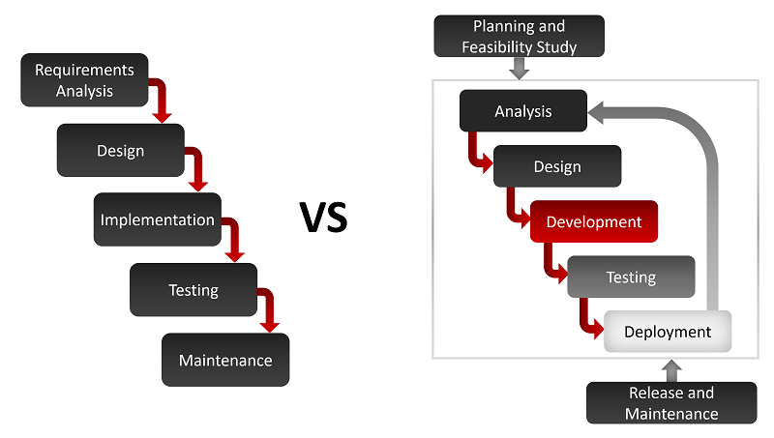

The main advantages of the traditional approach are:

* It is a well-defined and structured approach that can be used to manage large, complex projects.
* It is a predictable approach that can help to minimize risk.
* It is a repeatable approach that can be used for similar projects in the future.

The main disadvantages of the traditional approach are:

* It can be slow and inflexible, especially for projects with changing requirements.
* It can be difficult to involve stakeholders in the development process.
* It can be difficult to maintain the software over time.

In recent years, the traditional approach has been challenged by agile development methodologies, which are designed to be more flexible and responsive to change. However, the traditional approach is still a valid option for some projects, especially those where the requirements are well-defined and stable.

**Explain the Agile methodology to develop Software.**

**Explain the Test Driven Development and Pair programming.**

Test Driven Development (TDD) and Pair Programming are two practices commonly used in Agile software development.

1. Test Driven Development (TDD): Test Driven Development is a development approach that emphasizes writing tests before writing the actual code. It follows a cycle of writing a failing test, writing the minimum amount of code to pass the test, and then refactoring the code to improve its design and maintainability. The process can be summarized in the following steps:

* Write a test: The developer writes a test that describes the desired behavior or functionality of the code. Initially, this test will fail since the code to fulfill the functionality doesn't exist yet.
* Write the minimum code: The developer writes the minimum amount of code required to make the test pass. The focus is on writing only what is necessary to meet the requirements of the test.
* Run the test: The test is executed to validate that it passes, indicating that the code meets the desired functionality.
* Refactor the code: The developer refactors the code to improve its design, eliminate duplication, and enhance maintainability while ensuring that the tests continue to pass.

This cycle is repeated for each new feature or change, resulting in a test suite that continuously verifies the correctness of the code. TDD helps ensure that the code is more reliable, easily maintainable, and properly tested.

1. Pair Programming: Pair Programming is a practice where two programmers work collaboratively on the same task at the same workstation. One person, known as the "driver," writes the code, while the other person, known as the "navigator," actively reviews the code and provides feedback. The roles can be switched periodically.

Pair Programming offers several benefits:

* Improved code quality: The code is reviewed in real-time, leading to fewer errors and improved code quality.
* Shared knowledge: Pairing allows for the sharing of knowledge and expertise, increasing the team's collective skills and understanding of the codebase.
* Better solutions: Collaboration often leads to better problem-solving and more innovative solutions.
* Reduced debugging time: Issues are often caught early during the development process, reducing the time spent on debugging and troubleshooting.
* Enhanced team communication: Pair Programming encourages active communication and collaboration, fostering a shared understanding of the code and promoting knowledge transfer.

Pair Programming also helps reduce the knowledge silos within a team and improves collaboration and morale.

Both TDD and Pair Programming are Agile practices that promote collaboration, code quality, and adaptability, ultimately leading to more efficient and higher-quality software development.

Story-card Maturity Model (SMM) is a process improvement framework for agile software development. It is based on the idea of using story cards to capture the requirements of user stories.

SMM provides a set of assessment criteria for each level of maturity. Teams can use these criteria to assess their own maturity and identify areas for improvement.

SMM can be used to improve the quality of requirements, the efficiency of development, and the overall success of agile software projects.

Here are some of the benefits of using SMM:

* Improved requirements quality: SMM can help teams to define more complete and accurate requirements. This can lead to fewer defects and a better user experience.
* Increased efficiency: SMM can help teams to track progress and collaborate on requirements more effectively. This can lead to shorter development cycles and a more predictable outcome.
* Improved quality: SMM can help teams to measure quality and identify areas for improvement. This can lead to higher-quality software that is more reliable and maintainable.
* Continuous improvement: SMM is a continuous improvement framework. This means that teams can use it to assess their maturity and identify areas for improvement on an ongoing basis.

If you are using agile software development, I encourage you to learn more about SMM. It can be a valuable tool for improving the quality, efficiency, and overall success of your projects.

**Explain the roles of product owner and scrum master.**

* Product Owner: The product owner is responsible for the product vision and backlog. They work with stakeholders to gather requirements and prioritize them. The product owner also works with the development team to ensure that the product is developed according to the vision and backlog.
* Scrum Master: The scrum master is responsible for facilitating the scrum process. They ensure that the team is following scrum practices and that they are working effectively. The scrum master also helps to resolve any issues that may arise during the scrum process.

Here are some of the specific responsibilities of the Product Owner and Scrum Master:

* Product Owner:
  + Defines the product vision and backlog
  + Gathers requirements from stakeholders
  + Prioritizes the backlog
  + Works with the development team to ensure that the product is developed according to the vision and backlog
  + Accepts or rejects work from the development team

1. Their key responsibilities include:

* Defining and prioritizing the product backlog: The Product Owner works closely with stakeholders to gather requirements, define features, and create a prioritized list called the product backlog. They ensure that the backlog items are clear, actionable, and aligned with the overall product vision.
* Setting the product roadmap and vision: The Product Owner establishes a clear vision for the product and communicates it to the development team. They provide guidance on the product's direction, market considerations, and customer needs.
* Collaborating with stakeholders: The Product Owner engages with stakeholders to gather feedback, understand their needs, and communicate updates on the product's progress. They facilitate discussions and manage stakeholder expectations.
* Making decisions: The Product Owner makes timely and informed decisions regarding the product backlog, including adding, removing, or reprioritizing items. They consider various factors such as business value, market conditions, and technical feasibility.
* Sprint planning and review: The Product Owner actively participates in sprint planning meetings to discuss and clarify requirements with the development team. They also collaborate in sprint reviews to provide feedback on the completed work and potentially release increments to stakeholders.
* Scrum Master:
  + Facilitates the scrum process
  + Ensures that the team is following scrum practices
  + Helps to resolve any issues that may arise during the scrum process
  + Coaches the team on agile principles and practices
  + Promotes communication and collaboration within the team
  + Protects the team from distractions

1. Their primary responsibilities include:

* Facilitating Scrum events: The Scrum Master organizes and facilitates various Scrum ceremonies, including daily stand-up meetings, sprint planning, sprint reviews, and retrospectives. They ensure that these events are productive, timeboxed, and focused on achieving the desired outcomes.
* Guiding the team: The Scrum Master supports the development team by removing any obstacles or impediments that may hinder their progress. They facilitate effective communication, collaboration, and self-organization within the team.
* Promoting Scrum values and principles: The Scrum Master acts as a guardian of Scrum values and principles, helping the team understand and embrace them. They guide the team in adopting Agile practices, promoting transparency, and fostering a culture of continuous improvement.
* Coaching and mentoring: The Scrum Master provides guidance and coaching to the Scrum team members, helping them enhance their understanding of Scrum and Agile principles. They may assist with skills development, facilitate problem-solving, and promote a positive team dynamic.
* Facilitating self-organization: The Scrum Master encourages the team to be self-organizing, empowering them to make decisions and take ownership of their work. They promote collaboration, trust, and accountability within the team.

The Product Owner and Scrum Master are essential roles in agile software development. They work together to ensure that the product is developed according to the vision and that the team is working effectively.

It's important to note that while the Product Owner and Scrum Master have distinct roles and responsibilities, they collaborate closely throughout the development process to ensure alignment, effective communication, and successful product delivery.

**What does the terms mean: knowledge acquisition, refinement, distribution, development?**

The terms "knowledge acquisition," "refinement," "distribution," and "development" are commonly used in the context of knowledge management and represent different aspects of the knowledge lifecycle within an organization. Here's an explanation of each term:

* Knowledge acquisition: The process of capturing and storing knowledge. This can be done through a variety of methods, such as surveys, interviews, observations, and document reviews. Knowledge acquisition refers to the process of obtaining new knowledge or information. It involves identifying, capturing, and assimilating knowledge from various sources, such as research, training, external experts, or internal expertise. Knowledge acquisition can occur through activities such as conducting surveys, interviews, literature reviews, or attending workshops and conferences.
* Knowledge refinement: The process of organizing and structuring knowledge so that it is more accessible and useful. This can involve activities such as categorization, indexing, and tagging. Knowledge refinement involves the process of improving the quality, accuracy, and relevance of existing knowledge within an organization. It includes activities such as organizing and structuring knowledge, removing redundancies or outdated information, and enhancing its usability. Knowledge refinement may involve analyzing and synthesizing information, updating documentation, and incorporating feedback from users or subject matter experts
* Knowledge distribution: The process of making knowledge available to those who need it. This can be done through a variety of channels, such as documentation, training, and online repositories. Knowledge distribution refers to the dissemination of knowledge to the relevant individuals or groups within an organization. It involves sharing knowledge in a timely and accessible manner to enable informed decision-making, problem-solving, and innovation. Knowledge distribution methods can include documentation, training sessions, intranet portals, wikis, mentoring programs, or collaboration platforms. The goal is to ensure that knowledge is available and easily accessible to those who need it.
* Knowledge development: The process of creating new knowledge. This can be done through research, experimentation, and collaboration. Knowledge development refers to the continuous growth and creation of new knowledge within an organization. It involves activities aimed at generating innovative ideas, conducting research and experiments, exploring new technologies or processes, and fostering a culture of learning and knowledge creation. Knowledge development can be driven by initiatives such as research and development projects, cross-functional collaboration, knowledge-sharing sessions, or continuous improvement practices.

These four processes are essential for managing knowledge in any organization. By effectively acquiring, refining, distributing, and developing knowledge, organizations can improve their decision-making, problem-solving, and innovation capabilities.

Here are some examples of each process:

* Knowledge acquisition: A company might conduct surveys of its customers to learn about their needs and preferences.
* Knowledge refinement: A university might create a taxonomy of its academic knowledge so that students can easily find the information they need.
* Knowledge distribution: A government agency might publish a report on the state of the economy so that businesses can make informed decisions.
* Knowledge development: A research lab might conduct experiments to develop new drugs.

The four processes of knowledge management are not always linear. In some cases, knowledge development may lead to new knowledge acquisition activities. For example, a research lab might develop a new drug that leads to new questions about its safety and efficacy. This would require the lab to conduct additional research and acquire new knowledge.

The four processes of knowledge management are also not always independent. In some cases, they may overlap or be interconnected. For example, a company might develop new knowledge through research and experimentation. This new knowledge might then be refined and distributed to employees through training and documentation.

The four processes of knowledge management are essential for any organization that wants to effectively manage its knowledge. By understanding these processes and how they work together, organizations can improve their ability to make decisions, solve problems, and innovate.

These terms collectively represent the ongoing lifecycle of knowledge within an organization. By acquiring, refining, distributing, and developing knowledge effectively, organizations can harness their collective knowledge assets, promote learning, and drive innovation and success.

**What do you mean by Knowledge sharing?**

Knowledge sharing refers to the process of exchanging information, insights, expertise, and experiences among individuals or groups within an organization or community. It involves the dissemination of knowledge from one person to another, enabling others to benefit from the knowledge, skills, and perspectives of individuals or teams.   
Knowledge sharing is the process of transferring knowledge from one person or group to another. It can be done through a variety of methods, such as formal training, informal conversations, and online repositories.

Knowledge sharing is important for a number of reasons. First, it can help to improve communication and collaboration within an organization. When people share their knowledge, they are able to learn from each other and build relationships. This can lead to better decision-making and problem-solving.

Second, knowledge sharing can help to reduce duplication of effort. When people share their knowledge, others do not have to reinvent the wheel. This can save time and money.

Third, knowledge sharing can help to improve innovation. When people share their knowledge, they are able to see new connections and possibilities. This can lead to the development of new products, services, and processes.

Knowledge sharing can occur through various channels and methods, including:

1. Informal Communication: Informal conversations, discussions, and interactions among colleagues or team members provide opportunities for spontaneous knowledge sharing. These informal exchanges can take place in person, through email, instant messaging, or other communication tools.
2. Documentation and Knowledge Repositories: Sharing knowledge through documentation, such as manuals, guidelines, best practices, or standard operating procedures, allows individuals to access and refer to information when needed. Knowledge repositories, such as intranet portals, wikis, or shared folders, provide a centralized platform for storing and accessing organizational knowledge.
3. Training and Workshops: Formal training sessions, workshops, or seminars offer structured opportunities for sharing knowledge and expertise. Subject matter experts or experienced individuals can conduct training sessions to impart specific skills or knowledge to others.
4. Communities of Practice: Communities of Practice (CoPs) bring together individuals with shared interests or expertise in a particular domain. CoPs provide a platform for knowledge sharing, collaboration, and learning, enabling members to exchange ideas, ask questions, and share experiences.
5. Mentoring and Coaching: Mentoring and coaching programs facilitate the transfer of knowledge from experienced individuals to those who are less experienced or new to a particular role or domain. Mentors and coaches provide guidance, support, and knowledge sharing opportunities to help mentees or learners develop their skills and expertise.

There are a number of benefits to knowledge sharing. Here are a few examples:

* Improved communication and collaboration: When people share their knowledge, they are able to learn from each other and build relationships. This can lead to better decision-making and problem-solving.
* Reduced duplication of effort: When people share their knowledge, others do not have to reinvent the wheel. This can save time and money.
* Improved innovation: When people share their knowledge, they are able to see new connections and possibilities. This can lead to the development of new products, services, and processes.

Benefits of knowledge sharing include:

* Increased efficiency and productivity: Sharing knowledge allows individuals to learn from others' experiences, avoid reinventing the wheel, and find solutions more efficiently.
* Enhanced innovation and problem-solving: Exchanging knowledge fosters creativity, encourages new ideas, and enables teams to collaboratively tackle complex problems.
* Continuous learning and development: Knowledge sharing creates a learning culture within an organization, empowering individuals to acquire new skills, expand their knowledge, and grow professionally.
* Improved decision-making: Access to shared knowledge and diverse perspectives enables better-informed decision-making, as decisions can be based on a broader range of insights and experiences.

There are a number of ways to encourage knowledge sharing. Here are a few examples:

* Create a culture of trust and openness: People are more likely to share their knowledge if they feel safe and respected.
* Provide opportunities for people to share their knowledge: This could include formal training sessions, informal conversations, or online repositories.
* Reward people for sharing their knowledge: This could include public recognition, financial incentives, or other forms of appreciation.

Knowledge sharing is an important part of any organization that wants to be successful. By encouraging knowledge sharing, organizations can improve communication, collaboration, innovation, and productivity. Overall, knowledge sharing plays a crucial role in fostering collaboration, facilitating learning, and driving organizational success by leveraging the collective intelligence and expertise of individuals within an organization or community.

**Explain SRCUM framework.**

Scrum is an Agile framework used for managing complex projects, primarily in software development but also in various other domains. It follows an iterative and incremental approach, enabling teams to deliver value in short iterations called sprints. **Scrum is a framework** that helps agile teams to work together. Using it, the team members can deliver and sustain the complex product. It encourages the team to learn through practice, self-organize while working on the problem. Scum is a work done through the framework and continuously shipping values to customers. It is the most frequent software that is used by the development team. Its principle and lessons can be applied to

all kinds of teamwork. Its policy and experiences is a reason of popularity of Scrum framework. The Scrum describes a set of tools, meetings, and roles that help the teams structure. It also manages the work done by the team

Here are the key components of the Scrum framework:

1. Scrum Team: The Scrum Team consists of three main roles:

* Product Owner: The Product Owner represents the stakeholders and ensures that the team is building the right product. They define and prioritize the product backlog, collaborate with stakeholders, and make decisions on behalf of the customer.
* Scrum Master: The Scrum Master is responsible for ensuring that the Scrum framework is understood and followed. They act as a facilitator, coach, and servant leader, helping the team remove obstacles, promote self-organization, and continuously improve.
* Development Team: The Development Team is responsible for delivering the product increment. It consists of professionals with the required skills to complete the work, collaborate, and self-organize to meet the goals of the sprint.

1. Product Backlog: The Product Backlog is a prioritized list of user stories or product requirements, representing the work to be done. It is managed and maintained by the Product Owner and is continually refined and updated throughout the project.
2. Sprint: A Sprint is a timeboxed iteration typically lasting 2-4 weeks, during which the Scrum Team works to deliver a potentially shippable product increment. The work to be completed in a Sprint is planned during the Sprint Planning meeting.
3. Sprint Planning: In the Sprint Planning meeting, the Product Owner and the Development Team collaborate to determine which backlog items to work on during the Sprint. The team selects items based on priority, estimates effort, and defines the Sprint Goal.
4. Daily Scrum: The Daily Scrum is a short daily meeting where the Development Team synchronizes its activities. Each team member answers three questions: What did I do yesterday? What will I do today? Are there any impediments? The focus is on coordination, progress, and identifying any obstacles.
5. Sprint Review: At the end of each Sprint, a Sprint Review is conducted to demonstrate the completed work to stakeholders. The Product Owner reviews and accepts the work done, and stakeholders provide feedback. Insights gained during the review inform future iterations.
6. Sprint Retrospective: The Sprint Retrospective is a meeting held after the Sprint Review, where the Scrum Team reflects on the previous Sprint. They discuss what went well, what could be improved, and actions to enhance their processes and performance in the next Sprint.

These components are interconnected and form a cyclical process that continues throughout the project. The Scrum framework promotes transparency, inspection, and adaptation, allowing teams to respond to changes and deliver incremental value with each Sprint.

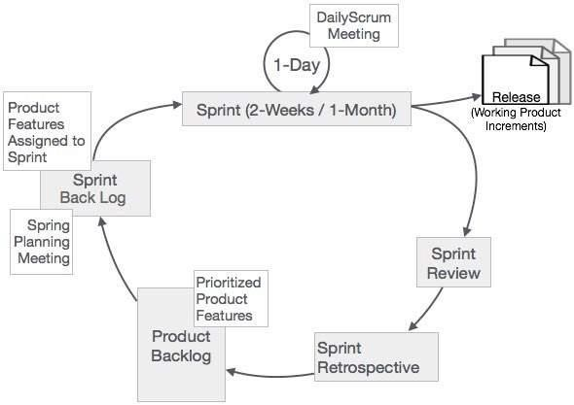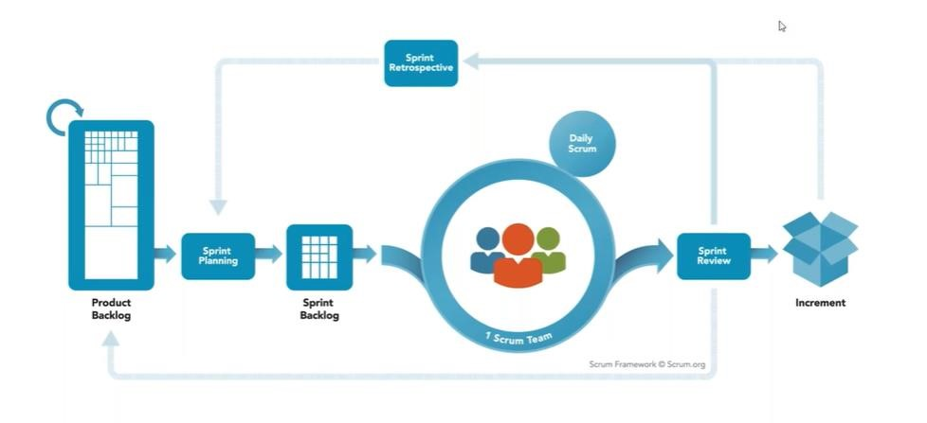

**What is Daily stand ups, sprint, product backlog, sprint planning, sprint review and retrospective?**

1. **Daily stand up:** A daily stand up is a short meeting that takes place at the beginning of each day during a sprint. The purpose of the daily stand up is for the development team to **communicate** and **synchronize** their work. The Daily Stand-up is a short, timeboxed meeting held by the Scrum Team every day during a sprint. It is a coordination and synchronization meeting, typically lasting around 15 minutes. During the Daily Stand-up, each team member answers three questions:

* What did I do yesterday?
* What will I do today?
* Are there any obstacles or impediments in my way?

The purpose of the Daily Stand-up is to keep the team aligned, identify any challenges or blockers, and ensure transparency and collaboration within the team

* **Sprint:** A sprint is a short period of time (usually 1-4 weeks) during which the development team works on a specific set of user stories. A Sprint is a timeboxed iteration in Scrum, usually lasting between 1 to 4 weeks. It represents a specific timeframe during which the Scrum Team works to deliver a potentially shippable product increment. The length of the Sprint is determined by the team based on factors such as project complexity and business needs.
* **Product backlog:** The product backlog is a list of all the features and functionality that the product should have. The product backlog is prioritized by the product owner. The Product Backlog is an ordered list of all the desired features, enhancements, and requirements for the product. It is created and managed by the Product Owner and represents the work to be done. The Product Backlog is continuously refined and updated based on feedback, changing priorities, and emerging requirements
* **Sprint planning:** Sprint planning is a meeting that takes place at the beginning of each sprint. The purpose of sprint planning is for the development team and the product owner to **agree** on which user stories will be worked on during the sprint. Sprint Planning is a collaborative meeting that occurs at the beginning of each sprint. It involves the Product Owner and the Development Team. During the meeting, the team selects a set of Product Backlog items that they will work on during the upcoming sprint. The team determines the sprint goal and breaks down the selected items into actionable tasks.
* **Sprint review:** A sprint review is a meeting that takes place at the end of each sprint. The purpose of the sprint review is for the development team to **demonstrate** the work that they have completed to the product owner and other stakeholders. The Sprint Review is a meeting held at the end of each sprint to review and demonstrate the completed work to stakeholders, customers, and the Product Owner. The Development Team showcases the work they have done during the sprint, and feedback is gathered from stakeholders. The Product Owner assesses the increment and determines whether it meets the acceptance criteria and the overall product goals.
* **Sprint retrospective:** A sprint retrospective is a meeting that takes place at the end of each sprint. The purpose of the sprint retrospective is for the development team to **reflect** on the sprint and **identify** areas for improvement. The Sprint Retrospective is a meeting that occurs after the Sprint Review and before the start of the next sprint. It is a dedicated time for the Scrum Team to reflect on the past sprint and identify improvements for the upcoming sprints. The team discusses what went well, what challenges they faced, and potential areas for improvement. The retrospective is a crucial opportunity for continuous improvement and team learning.

**List out the challenges faced while migrating to agile methodologies? Explain.**

Migrating to agile methodologies can bring several benefits, such as increased flexibility, faster delivery, and improved customer satisfaction. However, organizations may also encounter various challenges during the migration process. Here are some common challenges and their explanations:

1. Resistance to Change: Agile methodologies require a shift in mindset and work practices, which can be met with resistance from team members and stakeholders accustomed to traditional approaches. Overcoming resistance to change and fostering a culture of agility and collaboration may require clear communication, training, and involvement of all stakeholders.
2. Organizational Culture: Agile methodologies thrive in an environment that values collaboration, trust, and empowerment. However, organizations with a hierarchical or command-and-control culture may struggle to embrace the self-organizing and cross-functional nature of agile teams. Aligning the organizational culture with agile principles may require leadership support, role modeling, and cultural transformation efforts.
3. Lack of Agile Knowledge and Skills: Agile methodologies introduce new practices, roles, and techniques that team members may be unfamiliar with. Lack of knowledge and skills in agile frameworks, such as Scrum or Kanban, can hinder the effective adoption of agile practices. Providing adequate training and coaching to the team members can help bridge the skills gap and facilitate a smooth transition.
4. Dependencies and Integration: In complex projects or organizations with interdependent systems or teams, managing dependencies and ensuring smooth integration can be challenging. Agile methodologies emphasize autonomous teams and incremental delivery, requiring careful coordination and collaboration between teams and stakeholders. Identifying and managing dependencies through effective communication and synchronization can mitigate this challenge.
5. Changing Requirements and Priorities: Agile methodologies embrace changing requirements and prioritize delivering value to customers. However, frequent changes in requirements and shifting priorities can introduce uncertainty and impact project timelines and scope. Agile practices such as backlog refinement, iterative planning, and continuous stakeholder involvement can help manage changing requirements effectively.
6. Measurement and Metrics: Traditional project management often relies on metrics such as effort estimation, task completion rates, and adherence to a predetermined schedule. Agile methodologies focus on delivering value and outcomes rather than strict adherence to predefined plans and metrics. Establishing new metrics aligned with agile principles, such as velocity, lead time, or customer satisfaction, and adapting the measurement and reporting practices can address this challenge.
7. Distributed or Remote Teams: Agile methodologies thrive on face-to-face collaboration and open communication. When teams are distributed geographically or work remotely, maintaining effective communication, collaboration, and transparency can be more challenging. Leveraging collaboration tools, video conferencing, and adopting agile practices tailored for remote work can help address this challenge.

* **Culture change:** Agile methodologies require a significant change in culture. This can be difficult for organizations that are used to more traditional waterfall methodologies.
* **Training and education:** Agile methodologies require a different set of skills and knowledge than traditional waterfall methodologies. This can make it difficult for organizations to find and train staff with the necessary skills.
* **Resistance to change:** Some people may resist change, especially if they are comfortable with the way things are currently done. This can make it difficult to implement agile methodologies.
* **Unclear requirements:** Agile methodologies rely on iterative development, which means that requirements are constantly evolving. This can make it difficult to plan and estimate projects.
* **Technical debt:** Agile methodologies can lead to technical debt if not properly managed. This is the accumulation of technical problems that can make it difficult to maintain and evolve the software.
* **Communication:** Agile methodologies require effective communication between all stakeholders. This can be difficult if stakeholders are not located in the same place or if they have different communication styles.
* **Metrics:** Agile methodologies can be difficult to measure, which can make it difficult to track progress and identify areas for improvement.
* **Process customization:** Agile methodologies are flexible and can be customized to fit the specific needs of the organization. However, this can make it difficult to implement and manage agile methodologies.
* **Tool support:** There are a number of tools that can support agile methodologies. However, not all of these tools are created equal, and it can be difficult to find the right tool for the organization.

It is important to address these challenges before migrating to agile methodologies. By doing so, organizations can increase the chances of success.

Here are some tips for overcoming these challenges:

* **Start small:** Don't try to implement agile methodologies across the entire organization all at once. Start with a small project or team and gradually scale up as you gain experience.
* **Get buy-in from stakeholders:** Agile methodologies require the support of all stakeholders. Make sure that everyone understands the benefits of agile methodologies and is willing to make the necessary changes.
* **Provide training and education:** Make sure that everyone involved in the project understands the agile methodology that you are using. This includes training on the specific tools and techniques that you will be using.
* **Create a culture of continuous improvement:** Agile methodologies are not a one-size-fits-all solution. Be prepared to adapt and improve your processes as you go.
* **Use a project management tool:** A project management tool can help you to track progress, manage tasks, and communicate with stakeholders.
* **Get help from an expert:** If you are struggling to implement agile methodologies, consider getting help from an expert. An agile coach can help you to identify and address the challenges that you are facing.

each organization may face unique challenges based on their context, culture, and specific project requirements. Addressing these challenges requires a combination of leadership support, team empowerment, continuous improvement, and a willingness to adapt to changing circumstances.

**What is Requirement engineering?**

Requirements engineering provides the mechanism for understanding what the customer wants, analyzing need, assessing feasibility, negotiating a solution, specifying the solution, validating the specification, and managing the requirements. The goal of requirements engineering is to ensure that the system have been specified to meet the customer’s needs and to satisfy the customer’s expectations. The overall process for traditional requirements engineering includes four high-level subprocesses. These are concerned with evaluating the business usefulness of the system (feasibility study), discovering requirements (elicitation and analysis), converting requirements into some standard form (specification), and checking that the requirements define the system as customer wants (validation).

Requirements Engineering (RE) can be summarized as a set of activities that ensures a team is building the right product. In the field of Software Engineering, hence, it seeks the **correct** and **suitable** *software* deliverable.

Requirement engineering, also known as requirements engineering, is the process of eliciting, analyzing, documenting, and managing the requirements for a system or software project. It involves understanding and defining the needs, goals, and constraints of stakeholders to ensure that the final product meets their expectations.

The primary goal of requirement engineering is to identify and document what the system or software should do, how it should behave, and what constraints or limitations it should adhere to. This information serves as a foundation for the subsequent stages of the software development lifecycle.

Requirement engineering (RE) is the process of defining, documenting, and managing the requirements of a software system. It is a critical process in software engineering that ensures that the system meets the needs of the users and stakeholders.

The RE process typically involves the following steps:

1. Elicitation: This is the process of gathering requirements from users and stakeholders. This can be done through a variety of methods, such as interviews, surveys, and focus groups. Eliciting requirements involves gathering information from stakeholders, including users, customers, and domain experts. Various techniques such as interviews, workshops, surveys, and observations are employed to understand their needs, expectations, and constraints.
2. Analysis: This is the process of understanding the requirements that have been gathered. This includes identifying the different types of requirements, such as functional and non-functional requirements. Once the requirements are collected, they are analyzed to ensure their correctness, consistency, and completeness. Ambiguities or conflicts are resolved, and the requirements are documented in a clear and unambiguous manner. Documentation may include use cases, functional requirements, non-functional requirements, business rules, and user stories.
3. Specification: This is the process of documenting the requirements. This documentation should be clear, concise, and complete.
4. Validation: This is the process of ensuring that the requirements are correct and complete. This can be done through a variety of methods, such as reviews and testing. The documented requirements are then validated and verified to ensure that they accurately represent the stakeholders' needs. This involves reviewing the requirements with stakeholders, conducting requirement walkthroughs, and performing various validation techniques such as prototyping, simulations, or formal inspections.
5. Management: This is the process of tracking and managing the requirements throughout the development process. This includes ensuring that the requirements are kept up-to-date and that they are communicated to all stakeholders. Requirements are managed throughout the software development process to handle changes, traceability, and version control. A requirements management system or tools are often employed to track changes, prioritize requirements, and ensure proper communication and coordination among stakeholders.

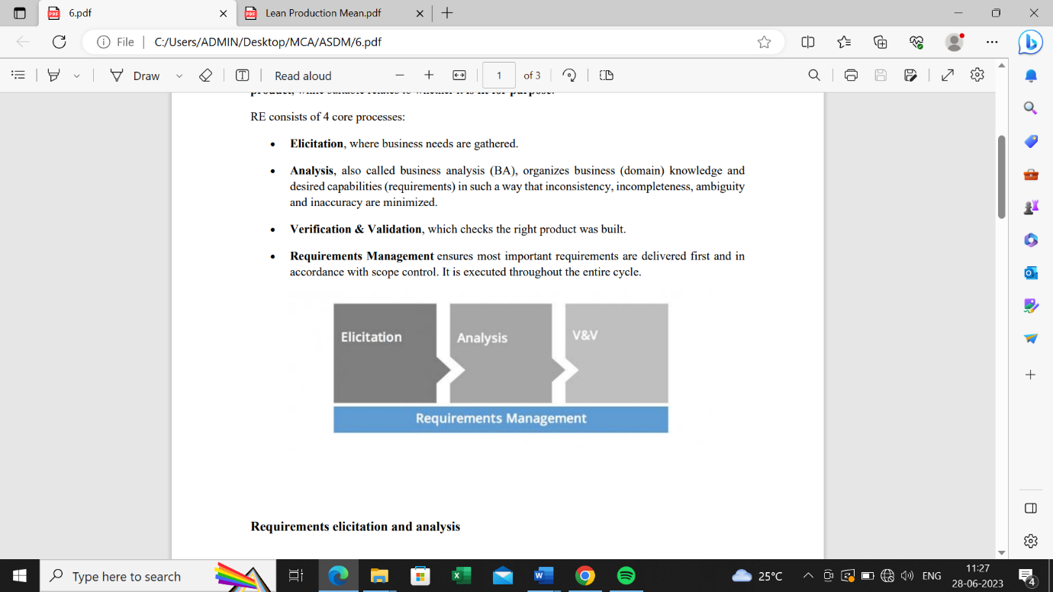

RE is an iterative process, meaning that it is repeated throughout the development process. This is because requirements can change as the project progresses and as new information becomes available.

RE is an important process that can help to ensure the success of a software project. By following the steps involved in the RE process, organizations can improve the chances that the software system will meet the needs of the users and stakeholders.

**Explain the terms: requirements elicitation, requirements prioritization, specification and requirements management.**

* Requirements elicitation: The process of gathering requirements from users and stakeholders. This can be done through a variety of methods, such as interviews, surveys, and focus groups. Requirements elicitation is the first step in the requirement engineering process. The goal of requirements elicitation is to gather as much information as possible about the system that the users and stakeholders want to build. This information can be gathered through a variety of methods, such as interviews, surveys, and focus groups. Requirements elicitation is the process of gathering and capturing requirements from stakeholders. It involves techniques such as interviews, workshops, brainstorming sessions, surveys, and observations to identify stakeholders' needs, expectations, and constraints. The goal is to collect comprehensive and accurate information about what the system or software should do.
* Requirements prioritization: The process of ranking requirements in order of importance. This helps to ensure that the most important requirements are addressed first. Once the requirements have been gathered, they need to be prioritized. This means ranking them in order of importance. The most important requirements should be addressed first, and the less important requirements can be addressed later. Requirements prioritization involves determining the relative importance or urgency of requirements. Since it may not be feasible to address all requirements simultaneously, prioritization helps in making decisions about which requirements to focus on first. Prioritization criteria may include business value, stakeholder impact, technical feasibility, regulatory compliance, or project constraints. It ensures that the most critical or valuable requirements are addressed early in the development process.
* Specification: The process of documenting the requirements. This documentation should be clear, concise, and complete. The requirements specification is a document that describes the system's requirements in detail. It should be clear, concise, and complete. The requirements specification should be written in a way that is understandable to both the users and the developers. Requirements specification is the process of documenting the identified requirements in a clear, unambiguous, and structured manner. It involves capturing functional requirements (what the system should do) and non-functional requirements (quality attributes, performance, usability, etc.). The specification may include various artifacts such as use cases, user stories, system requirements documents, business rules, data models, and interface specifications. The goal is to provide a comprehensive and unambiguous description of the expected behavior and characteristics of the system.
* Requirements management: The process of tracking and managing the requirements throughout the development process. This includes ensuring that the requirements are kept up-to-date and that they are communicated to all stakeholders. Requirements management is the process of tracking and managing the requirements throughout the development process. This includes ensuring that the requirements are kept up-to-date and that they are communicated to all stakeholders. Requirements management is important because it helps to ensure that the system meets the needs of the users and stakeholders. Requirements management encompasses the activities involved in tracking, documenting, prioritizing, and controlling changes to the requirements throughout the software development lifecycle. It ensures that requirements remain accurate, consistent, and aligned with stakeholder needs. Requirements management involves establishing a requirements baseline, maintaining traceability between requirements and other project artifacts, conducting impact analysis on proposed changes, and ensuring effective communication and coordination among stakeholders. Requirements management tools and processes support the effective handling of requirement changes, version control, and stakeholder collaboration.

These are the four main steps in the requirement engineering process. By following these steps, organizations can improve the chances that the software system will meet the needs of the users and stakeholders.

**What is lean production?**

Lean production is a way of organizing work that focuses on getting the job done as efficiently as possible, without wasting time or resources. It was first used in manufacturing by Toyota and has since been adopted by businesses across many different industries. By using lean production methods, companies can reduce waste, increase productivity, and deliver higher-quality products or services to their customers.

Lean production, also known as lean manufacturing or simply lean, is a systematic approach to production management that aims to minimize waste and maximize value for the customer. It originated from the Toyota Production System (TPS) and has since been adopted and adapted by numerous industries worldwide.

The key principle of lean production is to eliminate non-value-adding activities or waste, which are defined as any activity that does not directly contribute to creating value for the customer. Waste can manifest in various forms, including overproduction, waiting time, unnecessary movement, inventory excess, defects, and underutilization of resources.

Lean production focuses on creating a smooth and efficient flow of work, reducing lead times, and continuously improving processes. Here are some key principles and techniques associated with lean production:

1. Value Stream Mapping: Value stream mapping is a technique used to visually map and analyze the flow of materials and information required to deliver a product or service to the customer. It identifies value-adding and non-value-adding activities, allowing organizations to target areas for improvement and waste reduction.
2. Just-in-Time (JIT): JIT is a strategy that aims to produce items at the exact time they are needed in the production process. By reducing inventory and carrying costs, JIT helps minimize waste, improve efficiency, and increase responsiveness to customer demand.
3. Kanban System: Kanban is a visual signaling system that helps manage the flow of work in lean production. It uses cards or signals to indicate the need for production or replenishment of materials. Kanban systems enable organizations to maintain optimal inventory levels, improve production flow, and minimize waste.
4. Continuous Improvement (Kaizen): Continuous improvement is a fundamental aspect of lean production. It involves ongoing efforts to identify and eliminate waste, streamline processes, and improve quality. Kaizen encourages all employees to contribute to improvement initiatives and promotes a culture of continuous learning and innovation.
5. Pull Production: Pull production is a concept where work is initiated based on actual customer demand. Instead of pushing products through the production process based on forecasts or predetermined schedules, pull production focuses on replenishing items as they are consumed or requested by the downstream processes or customers.
6. Total Productive Maintenance (TPM): TPM is a proactive approach to equipment maintenance aimed at maximizing equipment effectiveness, minimizing downtime, and reducing defects. It involves routine maintenance, operator involvement, and continuous monitoring to prevent equipment failures and ensure optimal performance.

Lean production emphasizes the importance of collaboration, employee empowerment, and waste reduction to achieve operational excellence. By focusing on delivering value, eliminating waste, and continuously improving processes, organizations can improve efficiency, quality, and customer satisfaction while reducing costs and lead times.

Lean production is based on five key principles:

* Value: Identify the value that customers place on the product or service.
* Value stream: Identify all the steps involved in creating the product or service, from raw materials to finished product.
* Flow: Eliminate waste and bottlenecks in the value stream.
* Pull: Produce products or services only when they are needed.
* Perfection: Strive for continuous improvement.

Lean production can be applied to any type of manufacturing or service organization. It has been shown to be effective in reducing costs, improving quality, and increasing productivity.

Here are some of the benefits of lean production:

* Reduced costs: Lean production can help to reduce costs by eliminating waste and inefficiencies in the production process.
* Improved quality: Lean production can help to improve quality by reducing defects and ensuring that products are produced to the correct specifications.
* Increased productivity: Lean production can help to increase productivity by reducing lead times and improving the flow of materials and information through the production process.
* Improved customer satisfaction: Lean production can help to improve customer satisfaction by providing products and services that meet their needs and expectations.
* Increased employee morale: Lean production can help to increase employee morale by creating a more efficient and productive work environment.

Lean production is a complex and challenging system to implement, but it can be very effective in improving the performance of manufacturing and service organizations.

**Explain the Crystal, Feature Driven Development, Adaptive Software Development, and Extreme Programming.**

* Crystal: Crystal is a family of agile software development methodologies that are designed to be flexible and adaptable to the specific needs of the project. The Crystal methodologies are named after different colors, each of which represents a different level of risk and uncertainty. Crystal is a family of agile software development methodologies that emphasize simplicity, frequent delivery, and team collaboration. It recognizes that different projects have varying characteristics, team sizes, and priorities, and provides a set of methodologies tailored to address those differences. Crystal methodologies promote communication, shared understanding, and close interaction between developers and stakeholders. They focus on flexibility and adaptability to accommodate project-specific needs and requirements.
* Feature-Driven Development (FDD): FDD is an iterative and incremental software development methodology that focuses on the development of features. FDD is based on the following four phases: planning, analysis, design, and construction. Feature Driven Development is an iterative and incremental software development methodology that emphasizes feature-centric development. FDD breaks down development into five key activities: developing an overall model, building a feature list, planning by feature, designing by feature, and building features incrementally. FDD promotes the creation of a strong domain model, emphasizes clear communication among team members, and uses short iterations to deliver working features. It focuses on feature progress tracking, timely status reporting, and early identification and resolution of risks and issues.
* Adaptive Software Development (ASD): ASD is an agile software development methodology that is based on the principles of continuous adaptation. ASD is designed to be flexible and adaptable to change. Adaptive Software Development is an agile methodology that emphasizes collaboration, continuous learning, and evolutionary development. ASD recognizes that software development is a complex and uncertain process and adapts to changes by emphasizing feedback, reflection, and adaptation. It consists of three phases: speculation (planning and requirements), collaboration (building and iterating), and learning (reflection and adaptation). ASD promotes flexibility, responsiveness to change, and a focus on delivering the most valuable features and functionality.
* Extreme Programming (XP): Extreme Programming is an agile software development methodology that emphasizes collaboration, simplicity, and high-quality code. XP is known for its practices, which include continuous integration, test-driven development, pair programming, frequent releases, and customer involvement. XP promotes short, timeboxed iterations, frequent communication, and a close partnership between developers and customers. It encourages a high level of developer involvement in all aspects of the project, promotes collective code ownership, and emphasizes automated testing and refactoring. XP is an agile software development methodology that is known for its emphasis on simplicity, communication, and feedback. XP is based on the following twelve practices:
  + Planning: XP teams use a very short planning process to identify the features that will be developed in the next iteration.
  + Coding: XP teams write code that is simple, easy to understand, and easy to maintain.
  + Testing: XP teams write unit tests for all of their code.
  + Refactoring: XP teams regularly refactor their code to improve its readability and maintainability.
  + Pair programming: XP teams use pair programming, which is a practice where two programmers work together on the same code.
  + Continuous integration: XP teams integrate their code frequently, usually daily.
  + Continuous delivery: XP teams deliver working software frequently, usually every few weeks.
  + Customer involvement: XP teams have close customer involvement throughout the development process.
  + Coding standards: XP teams have strict coding standards that are enforced by the team.
  + Simple design: XP teams strive for simple designs that are easy to understand and maintain.
  + Personal responsibility: XP teams believe that each individual is responsible for their own work.

**Explain the Feature driven development(FDD) with financial and Production Metrics in FDD.**

Feature-Driven Development (FDD) is an iterative and incremental software development methodology that focuses on the development of features. FDD is based on the following four phases:

1. Planning: The team defines the overall scope of the project and identifies the features that need to be developed.
2. Analysis: The team analyzes each feature in detail and identifies the objects and classes that will be needed to implement the feature.
3. Design: The team designs the architecture of the system and the individual classes.
4. Construction: The team implements the classes and integrates them into the system.

FDD uses a number of financial and production metrics to track the progress of the project and to ensure that the project is meeting its goals. Some of the financial metrics that FDD uses include:

* Budget: The total cost of the project.
* Cost per feature: The cost of developing each feature.

1. Time to market: The time it takes to deliver the finished product to the customer. Budget Variance: This metric compares the actual project expenditure with the planned budget. It helps in identifying any deviations and allows project managers to take corrective actions if the project is exceeding the allocated budget.
2. Return on Investment (ROI): ROI measures the financial benefits or value generated by the software project compared to the investment made. It helps in assessing the project's financial viability and its contribution to the organization's overall goals.
3. Cost of Delay: Cost of Delay calculates the financial impact of delaying the implementation of a feature or functionality. It helps in prioritizing features based on their potential revenue generation or cost savings, ensuring that high-value features are delivered early.

Some of the production metrics that FDD uses include:

* Number of features delivered: The number of features that have been completed and delivered to the customer.
* Number of defects: The number of defects that have been found in the software.
* Code coverage: The percentage of the code that has been tested.
* Feature Completion Rate: This metric tracks the percentage of features that have been completed and delivered. It provides insights into the progress of feature development and helps in identifying any bottlenecks or delays.
* Feature Defect Rate: Feature Defect Rate measures the number of defects or issues found in completed features. It helps in assessing the quality of delivered features and identifying areas for improvement in the development process.
* Feature Cycle Time: Feature Cycle Time measures the time taken from the start to the completion of a feature. It helps in identifying areas where the development process can be optimized and provides visibility into the efficiency of feature delivery.
* Feature Lead Time: Feature Lead Time measures the time taken from the identification of a feature to its delivery. It helps in understanding the time required to analyze, design, develop, and test a feature. By monitoring feature lead time, the team can identify opportunities to reduce delays and streamline the development process.

FDD is a relatively new software development methodology, but it has been used successfully on a number of large and complex projects. FDD is a good choice for projects where the requirements are well-defined and where the team needs to track the progress of the project closely. These financial and production metrics in FDD provide objective data for project managers and stakeholders to assess the project's progress, quality, and financial impact. By regularly monitoring these metrics, the team can make informed decisions, identify areas for improvement, and ensure the project is on track to meet its objectives.