**TOLL CUSTOMISED SOLUTIONS – MARS DISTRIBUTION CENTRE**

**Student Name:** Neha Mansinghka (3471739), Hanbo Guo (3440647), Han Zhang (3426650), Jiao Lei (3372523)

**Course Code:** OMGT2145

**Course Name:** Professional Logistics Practice

**Lecturer:** Geoff Rigby

**Date of Submission:** 13th June 2014

**EXECUTIVE SUMMARY**

Toll provides customized logistics solutions to its customers. The Mars Distribution Centre (DC) in Truganina is one such customized solution. Toll has a 7-year contract with Mars to build, equip and run the DC for Mars. It handles the raw material storage and distribution for Mars’ Ballarat manufacturing plant from this DC. It also receives the finished goods from this manufacturing plant and distributes them to Mars’ customers from this DC. Mars shares the production plans of the Ballarat plant and customer orders for finished goods with Toll through monthly meetings and the warehouse management system (WMS) called Tolas. The inventory in the warehouse (raw materials and finished goods) is owned by Mars. The raw materials for making chocolates are mostly imported from overseas, some are purchased locally. Both the imported and locally purchased raw materials get delivered to the DC. They are received, quarantined, sampled in Mars’ QA or micro labs and upon successful clearance stored in a separate room called Raws Room or Raws Warehouse in the DC. Specialized equipment is used to handle the raw materials, they are never handled manually. The finished goods are stored in a high-density satellite storage system, which is 40 pallets deep. This provides great space savings. It is maintained at around 19 degrees and the chocolates that need to be distributed locally are stored in it for 7 days. The chocolates that need to be exported are put away and picked the same day and hand loaded in to refrigerated containers that are maintained at 15 degrees. Counter balanced forklifts, pallet movers, reach trucks are some of the material handling equipment used in the DC. There is a reverse logistics process in place for raw materials and finished goods but for finished goods it’s only for those goods that are picked incorrectly. If the goods are not picked incorrectly the reverse logistics is not handled by Toll. Toll maintains regular KPIs for its receiving, put away and picking operations. These are shared with Mars as well as all the staff in the DC. Toll has also undertaken initiatives to reduce its environment footprint. It strives to continually add value to its clients by reducing waste in its supply chain. It uses the Lean principles and tools for achieving this. There is a room called Think Tank room next to the canteen in the Truganina site, which has all the various Lean tools, and every staff member is welcome to use this room to contribute ideas for further improvement of the DC operations. Toll has a strong culture of safety, teamwork and continuous improvement.

**INTRODUCTION**

Toll started operations in Newcastle, Australia in 1888 and since then has grown into a global business with annual revenue in excess of A$8.5 billion. They have six operating divisions: Toll Global Express, Toll Global Logistics, Toll Global Forwarding, Toll Domestic Forwarding, Toll Global Resources, Toll Specialised & Domestic Freight. This report focuses on the customized solution Toll have built and run for Mars Incorporated, which is part of their Toll Customised Solutions Australia and New Zealand operation. This operation falls under the Toll Global Logistics operating division. (Toll Group, 2014a). Please refer to Appendix A for Toll’s organization chart.

**AIM**

This aim of this document is to report on the visit to Mars Incorporated (Mars Inc.) Distribution Centre (DC) in Truganina, Melbourne, built and run by Toll Customised Solutions (TCS), conducted on 23rd May 2014 as part of RMIT course OMGT2145.

*NOTE: Unless otherwise specified through an in-text citation, the source of the information in this report is the briefing given by TCS staff during the visit to the DC on 23rd May 2014.*

**BACKGROUND ON MARS INCORPORATED**

Mars Inc. Australia is a confectionary company that began operations in 1954. It owns several brands like M&Ms, Wrigleys, Masterfoods, Pedigree, Snickers, Whiskas. It has four business segments; chocolate, petcare, food and Wrigley. (Mars Inc., 2014). It has 21 manufacturing sites all over the world and 5 in Australia.

**RELATIONSHIP BETWEEN MARS INC. AND TOLL**

The warehouse in Truganina is a custom built warehouse for Mars by Toll. Toll has signed a 7-year contract with Mars to equip and run this DC. Toll works closely with Mars to operate it. They have monthly meetings with Mars to go over the KPIs for the previous month. Mars shares information related to production plans at the Ballarat plant, any upcoming sales or promotions with Toll. Mars owns the inventory in the warehouse but not the warehouse itself, it leases that from Toll.

**TRUGANINA DC**

This DC holds both raw materials and finished goods. Figure 1 below shows the flow of raw materials and finished goods in and out of the DC.

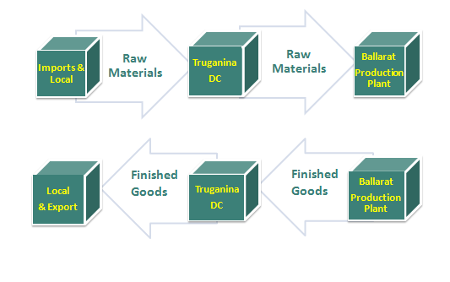

**Figure 1**

Raw materials for making chocolate (for example, cocoa butter and cocoa liquor) are purchased by Mars. Majority of the raw materials are imported from overseas (for example, cocoa from West Africa, lactose from USA) but some are purchased locally (for example, milk powder).

For big customers like Coles, Metcash, the finished goods are delivered to their distribution centers. For small customers, like the small milk bars, the goods are delivered to Mars DC. The finished goods also get exported from this DC (e.g. Brunei, Hong Kong, Japan). There are 5 shuttles running 24 hours a day between the DC and the manufacturing plant. Each shuttle can take 22 pallets. Please refer to Appendix D for a sketch of the DC.

**RECEIVING, PUT AWAY AND PICKING AT THE DC**

**RAW MATERIALS:**

Imported raw materials go through quarantine in the DC before being put away. There is a quarantine area in the DC that is isolated and maintained at a certain light level. For dangerous goods like peanuts, every container is checked. For goods like cocoa butter and cocoa liquor, 1 in every 20 containers is checked. Previously, every load for these raw materials too would be checked. However, now the supplier standards have improved and these items have a clearance rate on them. So only 1 in every 20 containers is checked. This saves both time and money.

The raw materials also undergo sampling before being approved for put away. Samples are sent to Mars’ Quality Assurance labs or micro labs for checking. Samples are also checked at the DC by staff specially trained by Mars for this. Once all the checks have passed, the raw materials are put away in the Raws Room / Warehouse as good stock. This room can hold 4000 pallets.

Raw Materials are handled using specialized equipment. They are not handled manually for the fear of contamination. The DC has counter balanced forklifts on which the equipment can be changed depending on the type of raw material. For example, the equipment used for lactose is different from what they use for drums.

The imported raw materials arrive in shipping containers in boxes. They are not on pallets. The boxes are unloaded on to the pallets and wrapped in the DC. A SSCC label is created using the Warehouse Management System (WMS) and printed using a label printer. This is put on both sides of the pallet for ease of use. Raw materials are booked using the manufactured date, not the receipt date, in the WMS. This is because there is only a finite period for which raw materials will last, for example 3 months, 6 months, or 10 months. In order to keep track of what is still usable the manufactured date is needed. Raw materials are picked using the First In First Out (FIFO) logic based on the manufactured date. This logic is taken care of in the WMS. The manufacturing plant in Ballarat runs 24 hours 5 days a week so the picking at the DC also happens 24 hours 5 days a week.

**FINISHED GOODS:**

Finished goods are received almost the same way as raw materials, except this time they are on pallets, wrapped already and have a bar code. They are put away in a high-density satellite storage system, which provides great space saving. It is 40 pallets deep. The pallet is placed at the start of the line using a reach truck; driver types in the location of the pallet (visible on the reach truck screen) in the remote control device for the storage system. He scans the pallet, which communicates to the WMS the location of the pallet, time it was put away and by whom. A machine, called orbiter, on the satellite storage system sends a signal which results in the pallet being pushed back automatically to its storage spot. The satellite storage system is maintained at around 19 degrees and the chocolates that need to be distributed locally are stored in there for 7 days. This allows the chocolate to come down in temperature slowly to avoid it going white later. Chocolates that need to be exported are put away and picked the same day and put in refrigerated containers that are maintained at 15 degrees. They are hand loaded into these containers. As the exported goods can be in transit for up to 10 days and due to temperature fluctuations around the equator, the container temperature is maintained at 15 degrees. ((Briefing given by TCS / RMIT Visit to TCS Mars DC - 23 May 2014),(SCHAEFER, 2014))

Please refer to Appendices B and C for a flow of the raw materials and finished goods.

**MATERIAL HANDLING EQUIPMENT (MHE) & ICT**

Apart from the MHE already mentioned, pallet movers that can carry 4 pallets at a time are also used in the DC. They are used to move pallets around the DC e.g. when they need to be taken to the warehouse for put away. The WMS used at the DC is Tolas. This is owned by Mars and linked to their internal SAP system. It is used during receiving, put away and picking processes at the DC e.g. customer orders for finished goods come through to Tolas from Mars’ SAP system thus DC staff knows they need to start picking for these orders, which pallets to pick and where the orders need to go to.

**REVERSE LOGISTICS**

If DC staff finds a bug or insect in the raw materials, they will isolate it and inform Mars. Mars gives them a new dispatch code to dispatch the goods out of the system. They are then sent back to the supplier. Finished goods are not approved for return to the DC unless they have been picked incorrectly. The retailer is responsible for proper disposal of finished goods.

**KPIs**

The DC keeps track of the picking accuracies and the number of receipts, put aways and dispatches done on a daily basis. Please refer to Appendix E for a table of these KPIs.

**GREEN LOGISTICS**

Toll is committed to reducing the impact of its environmental footprint. In the short term, Toll is planning to reduce its consumption of non-renewable resources such as petrol, diesel and gas and reduce their associated greenhouse gas emissions by applying new technologies and practices. In the long term, Toll is aiming to reduce the greenhouse gas intensities and develop comprehensive suites of initiatives for the diverse operations to improve environmental performance; it is doing this through ‘Smarter Green’ program launched in 2010. Some smarter green initiatives are smarter driving, which focuses on improving the fuel efficiency by training the drivers, smarter vehicles which use electric motors powered by batteries and capacitor technology. (TOLL GROUP, 2014b).

**CULTURE AT TOLL**

Three aspects of its culture that stood out during the visit were Safety, Teamwork and Continuous Improvement. Toll follows strict procedures for all the work they do to maintain high safety standards. The battery room (shown in the sketch of the DC in Appendix E) is one example of it. As batteries contain acids, any batteries that need to be changed are done in a separate room in the DC. As they handle raw materials there, food safety procedures are also strictly followed there. If any DC staff notices contamination of raw materials, they isolate it and immediately inform the quarantine-approved officers present in the DC, there are two such officers in the DC.

The ‘Think Tank’ room, shown to us during the visit, is an area next to the canteen where staff works on continuous improvement ideas and projects. Any staff member can suggest ideas for improvement. It appears the idea behind keeping the ‘Think Tank’ room next to the canteen is to encourage teamwork, as people congregate in the canteen and end up discussing what works well and what doesn’t, the Think Tank room being there encourages staff to take their ideas further than just a lunchtime chat.

Toll is very proud of its culture and also prefers to work with clients, which have a cultural fit with it.

**LEAN PRINCIPLES & TOOLS**

Lean principles, which involve minimizing waste in order to maximize customer value (Lean Enterprise Institute, 2009), are used at Toll to provide customer value with as few resources as possible. Lean Tools they use are Spaghetti diagrams, Barbed Wire, Value Stream Maps, Plan Do Check Act, Focused Improvement Plans, Fishbone diagrams, Root Cause Analysis, 5S + 1 (the plus one is for Safety). Please refer to Appendix F for a brief introduction to lean principles.

They also use C4 (Concern, Cause, Countermeasure and Confirm), four steps to identify concern, find true root cause, correct the cause with effective countermeasure and confirm the solution worked (Veech and Damodaraswamy, 2014).

These tools are deployed in the Think Tank room. Using these principles and tools, Toll aim to reduce waste in 7 areas - Transport, Inventory, Motion, Waiting, Overproduction, Over-processing and Defects.

*Please refer to Appendix G for some additional points of interest regarding the DC and Toll’s operations.*

**CONCLUSION**

Toll maintains strict quality control and safety procedures in the DC, particularly for the raw materials. It uses specialized equipment to handle the raw materials. There is also a special room to store the raw materials. The finished goods are stored in a high-density satellite storage system, which provides great space savings. The WMS used in the DC is linked with Mars’ internal SAP system thus allowing information sharing between Toll and Mars. Toll is also committed to reducing its environmental footprint and so it has implemented certain green logistics initiatives. Toll has a strong culture of safety, teamwork and continuous improvement. It uses lean principles and tools to provide additional value to Mars by using fewer resources. All staff is encouraged to contribute ideas for continuous improvement and use the lean tools in the Think Tank room.

**APPENDICES**

**APPENDIX A**

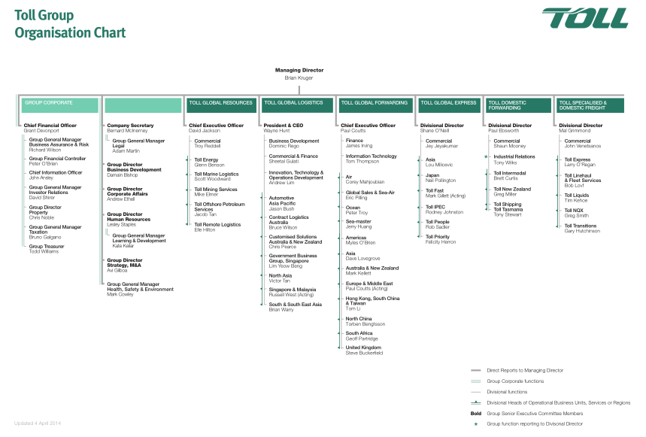

**Figure 2: Toll Organization Chart**

**Source: (Toll Group, 2014a)**

**APPENDIX B**

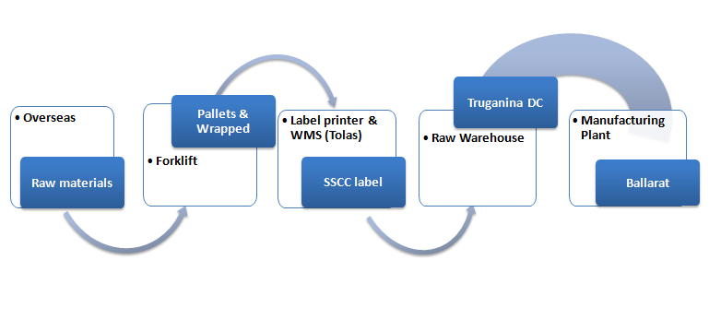

**Figure 3: Flow of raw materials in and out of the DC**

**APPENDIX C**

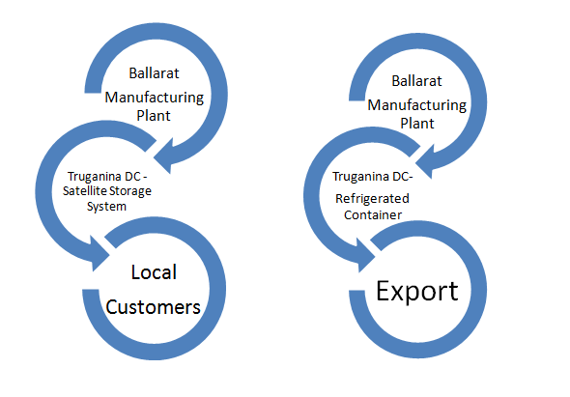

**Figure 4: Flow of finished goods in and out of the DC**

**APPENDIX D**

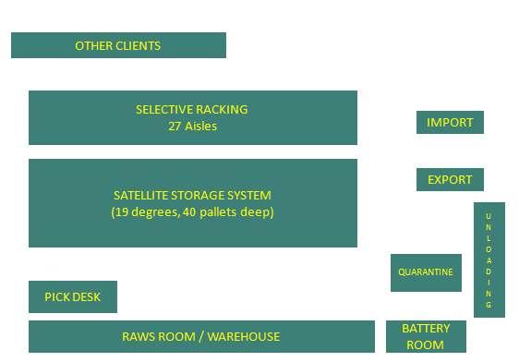

**Figure 5: Sketch of the DC**

The Selective Racking has 27 aisles and is used to store special items that are ordered in small volumes e.g. colour.

There are 9 loading docks in the DC. As pictures were not allowed, we are unable to reproduce the location of these docks on the sketch. There are undercover doors or awnings for unloading. We were unable to get the number of unloading doors during the visit.

The area at the back marked ‘OTHER CLIENTS’ is rented by other clients such as Arnotts and T2.

**APPENDIX E**

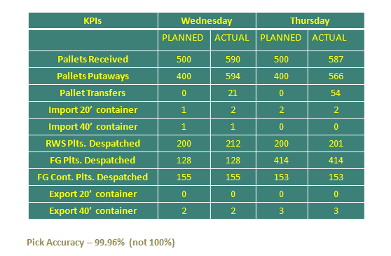

**Figure 6: KPIs at the DC**

RWS - Raw Materials.

FG – Finished Goods

FG Cont. – Carton picks for customers

Import and Export 20’ and 40’ – 20 foot and 40 foot containers.

The pick accuracy is noted below 100% intentionally, the explanation provided for this was, if target is reached too often, then staff might get complacent and start making mistakes. As the tasks in the DC don’t vary a lot from day to day, in order to avoid such complacency, the pick accuracy is noted below 100%. This means there is always room for improvement, something to strive for.

**APPENDIX F**

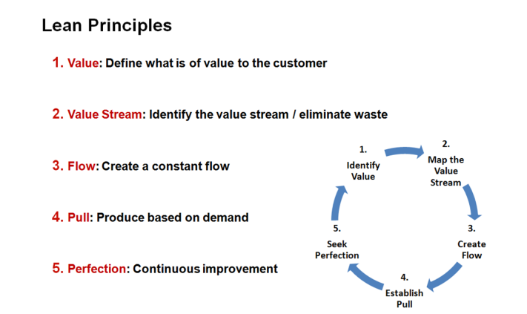

**Figure 7**

**Source: (Lean Enterprise Institute, 2009)**

**APPENDIX G**

Location – The reason behind choosing Truganina as the DC site is to be close to Mars’ customers’ DCs. Building the DC in Ballarat would have made it closer to the manufacturing plant but far from the centricity of Mars’ customer demand. Moreover, the availability of land, greenfield construction site and ability to control the site design made it an attractive location too.

Third Party Logistics Providers (3PLs) – The logistics provider for inbound and outbound deliveries to and from the DC is determined by customer preference. Toll will put a bid in to do both inbound and outbound but may only win the contract to do inbound, in such a case it will work with the 3PL chosen by the customer to do the outbound deliveries. The site at Truganina is a mixed bag i.e. it uses both 3PLs and Toll’s own drivers.

Upgrade Plans – Toll seeks continuous improvement feedback from customers. Any quantum changes are only done upon customer request. Currently there isn’t any such request from Mars.

Relationship with Mars – Along with seeking feedback from Mars, Toll also provides feedback to Mars where relevant to maintain the quality of its service. For example, as the warehouse is designed for a certain capacity to provide optimal throughput, if the inventory in the warehouse exceeds this capacity, Toll makes Mars aware of excess inventory and asks them to reduce it by picking more often or to order less or relax their KPIs until the excess inventory is brought down.

**REFERENCES LIST**

LEAN ENTERPRISE INSTITUTE. 2009. *Principles of Lean* [Online]. Available: <http://www.lean.org/WhatsLean/Principles.cfm> [Accessed 28 May 2014 2014].

MARS INC. 2014. *Mars Australia and New Zealand* [Online]. Mars Inc. Available: <http://www.mars.com/global/about-mars/mars-pia/market-summaries/mars-australia-and-new-zealand.aspx> [Accessed 04 June 2014].

SCHAEFER, S. 2014. *Schaefer Orbiter System* [Online]. SSI SCHAEFER. Available: <http://www.ssi-schaefer.com.au/storage-distribution/pallet-racking-systems/channel-storage-racking/schaefer-orbiter-system.html> [Accessed 07 June 2014].

TOLL GROUP. 2014a. *Structure* [Online]. Toll Holdings Limited. Available: <http://www.tollgroup.com/organisationstructure> [Accessed 04 June 2014].

TOLL GROUP. 2014b. *Supply Chain Solutions* [Online]. Toll Holdings Limited. Available: <http://www.tollgroup.com/supply-chain-solutions> [Accessed 6 June 2014].

VEECH, D. & DAMODARASWAMY, P. 2014. *The C4 Process: Four Vital Steps to Better Work* [Online]. Available: <http://thec4process.com/> [Accessed 29 May 2014].