UNIT 4

1.Explain elastic load balancer creating and verifying elastic load balancer.

Elastic Load Balancing (ELB) **automatically distributes incoming application traffic across multiple targets and virtual appliances in one or more Availability Zones (AZs)**. It monitors the health of its registered targets, and routes traffic only to the healthy targets. Elastic Load Balancing scales your load balancer as your incoming traffic changes over time. It can automatically scale to the vast majority of workloads. Elastic Load Balancing supports the following load balancers: Application Load Balancers, Network Load Balancers, Gateway Load Balancers, and Classic Load Balancers. You can select the type of load balancer that best suits your needs.

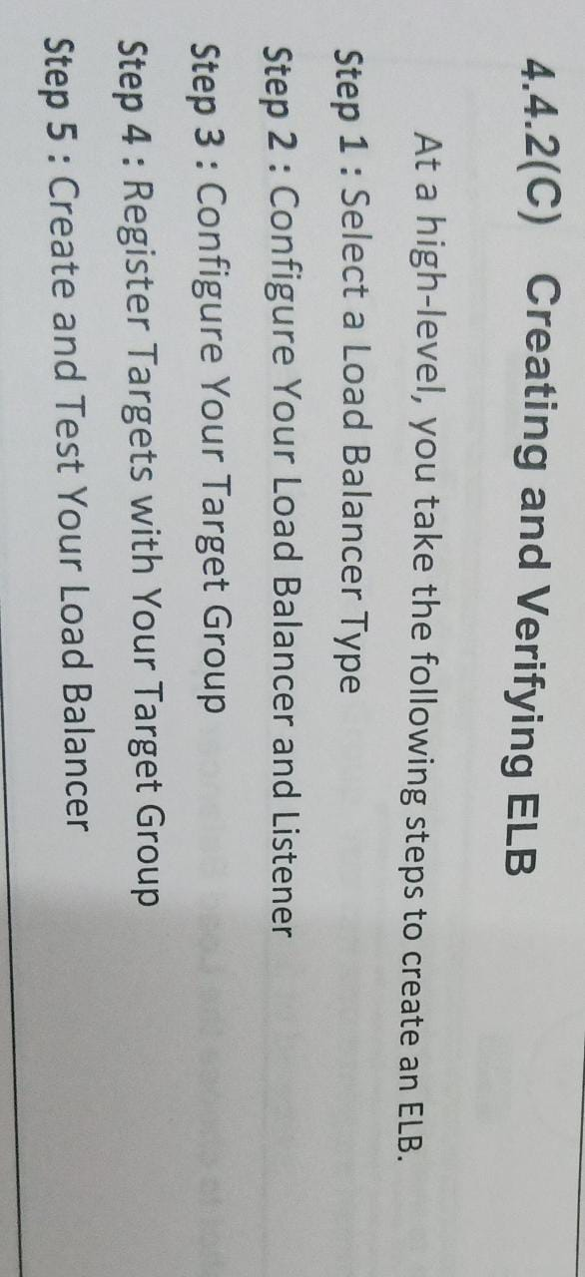

2.Explain in Detail services offered by amazon Hands-on amazon.

* Amazon EC2 - Providing secure compute capacity in the cloud, EC2 is resettable based on the user’s requirements. For instance, in a scenario in which web traffic varies, this service can expand its environment, behind the scenes, to three instances when required and then shrink to just one resource when load decreases.
* Amazon Virtual Private Cloud (Amazon VPC) enables you to launch Amazon resources into a virtual network that you've defined. This virtual network closely resembles a traditional network that you'd operate in your own data center, with the benefits of using the scalable infrastructure of Amazon.

AWS Storage Services

With the sheer amount of data collected by organizations, data storage is in high demand. Amazon Web Services offers several solutions:

* Amazon S3 - S3 can store and retrieve data from anywhere -- websites, mobile apps, IoT sensors and the like. It offers data management flexibility, durability and security for internet storage.
* Amazon Elastic Block Store (EBS) -  EBS provides block store volumes for instances of EC2 and is a reliable storage volume that can be attached to any running instance in the same availability zone.

3.Explain in detail EC2- configuring a server and virtual amazon cloud.

* Login and access to AWS services
* Choose AMI Amazon Machine Image
* Choose EC2 Instance Types
* Configure Instance
* Add Storage
* Tag Instance
* Configure Security Groups
* Review Instances

4.Explain in detail AWS storage and content delivery.

**AWS Storage Services**

With the sheer amount of data collected by organizations, data storage is in high demand. Amazon Web Services offers several solutions:

* **Amazon S3 -**S3 can store and retrieve data from anywhere -- websites, mobile apps, IoT sensors and the like. It offers data management flexibility, durability and security for internet storage.
* **Amazon Glacier -**A cloud storage service for archiving data and long-term backups, Glacier is a low-cost, highly secure option.
* **Amazon Elastic Block Store (EBS) -**  EBS provides block store volumes for instances of EC2 and is a reliable storage volume that can be attached to any running instance in the same availability zone.
* **Amazon Elastic File System (EFS) -**  EFS can be used with the AWS Cloud service and resources. Simple and scalable, it's elastic file storage for on-premise resources. Featuring an intuitive interface, EFS allows users to create and configure file systems without disturbing the application growing and shrinking automatically as files are added and removed.

5.Explain in Detail amazon s3 bucket and associated objects.

A bucket is a container for objects stored in Amazon S3. You can store any number of objects in a bucket and can have up to 100 buckets in your account. Every object is contained in a bucket. For example, if the object named photos/puppy.jpg is stored in the DOC-EXAMPLE-BUCKET bucket in the US West (Oregon) Region, then it is addressable using the URL https://DOC-EXAMPLE-BUCKET.s3.us-west-. When you create a bucket, you enter a bucket name and choose the AWS Region where the bucket will reside. After you create a bucket, you cannot change the name of the bucket or its Region. Bucket names must follow the bucket naming rules.

Objects are the fundamental entities stored in Amazon S3. Objects consist of object data and metadata. The metadata is a set of name-value pairs that describe the object. These pairs include some default metadata, such as the date last modified, and standard HTTP metadata, such as Content-Type. You can also specify custom metadata at the time that the object is stored.

An object is uniquely identified within a bucket by a key (name) and a version ID (if S3 Versioning is enabled on the bucket)

6.Explain in detail amazon elastic block store.

Amazon Elastic Block Store (Amazon EBS) provides block level storage volumes for use with EC2 instances. EBS volumes behave like raw, unformatted block devices. You can mount these volumes as devices on your instances. EBS volumes that are attached to an instance are exposed as storage volumes that persist independently from the life of the instance. You can create a file system on top of these volumes, or use them in any way you would use a block device (such as a hard drive). You can dynamically change the configuration of a volume attached to an instance. It has three types of volume, i.e. General Purpose (SSD), Provisioned IOPS (SSD), and Magnetic. These three volume types differ in performance, characteristics, and cost.

**Amazon EBS Benefits**

* **Reliable and secure storage** − Each of the EBS volume will automatically respond to its Availability Zone to protect from component failure.
* **Secure** − Amazon’s flexible access control policies allows to specify who can access which EBS volumes. Access control plus encryption offers a strong defense-in-depth security strategy for data.
* **Higher performance** − Amazon EBS uses SSD technology to deliver data results with consistent I/O performance of application.
* **Easy data backup** − Data backup can be saved by taking point-in-time snapshots of Amazon EBS volumes

UNIT 5

1.Explain in detail Cloud Trends in Supporting Ubiquitous Computing.

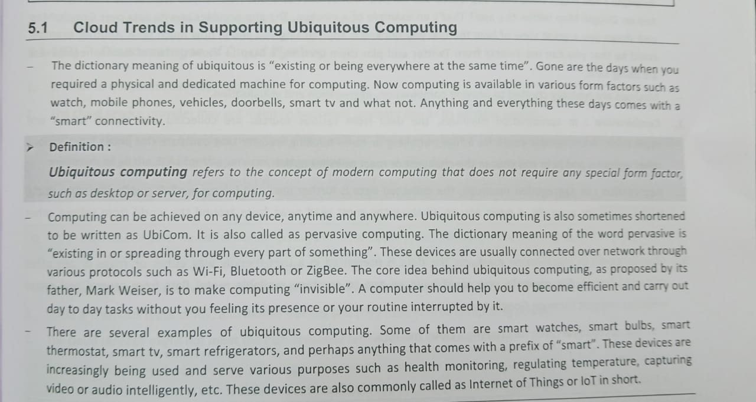

2.what is Enabling Technologies for the Internet of Things explain in detail.

**IoT(internet of things) enabling technologies are**

1. Wireless Sensor Network

A **WSN** comprises distributed devices with sensors which are used to monitor the environmental and physical conditions. A **wireless sensor network** consists of end nodes, routers and coordinators. End nodes have several sensors attached to them where the data is passed to a coordinator with the help of routers. The coordinator also acts as the gateway that connects WSN to the internet.

1. Cloud Computing

It provides us the means by which we can access applications as utilities over the internet. Cloud means something which is present in remote locations.

1. Big Data Analytics

It refers to the method of studying massive volumes of data or big data. Collection of data whose volume, velocity or variety is simply too massive and tough to store, control, process and examine the data using traditional databases.  
Big data is gathered from a variety of sources including social network videos, digital images, sensors and sales transaction records.

1. Communications Protocols

They are the backbone of IoT systems and enable network connectivity and linking to applications. Communication protocols allow devices to exchange data over the network. Multiple protocols often describe different aspects of a single communication. A group of protocols designed to work together is known as a protocol suite; when implemented in software they are a protocol stack.

1. Embedded System

It is a combination of hardware and software used to perform special tasks.  
It includes microcontroller and microprocessor memory, networking units (Ethernet Wi-Fi adapters), input output units (display keyword etc. ) and storage devices (flash memory).  
It collects the data and sends it to the internet.

3.what is Sensor Networks and ZigBee Technology explain in detail.

A **sensor network** is a group of sensors where each sensor monitors data in a different location and sends that data to a central location for storage, viewing, and analysis.

There are many applications for sensor networks, from monitoring a single home, to the surveillance of a large city, to earthquake detection for the whole world.

ZigBee is a IEEE 802.15.4 based, **low power, low data rate supporting wireless networking standard**, which is basically used for two-way communication between sensors and control system. It is a short-range communication standard like Bluetooth and Wi-Fi, covering range of 10 to 100 meters. The difference being while Bluetooth and Wi-Fi are high data rate communications standard supporting transfer of complex structure like media, software etc.,

ZigBee Technology supports transfer of simple data like that from sensors. It supports low data rate of about 250 kbps. The operating frequencies are 868 MHz, 902 to 928 MHz and 2.4 GHz. ZigBee Technology is used mainly for applications requiring low power, low cost, low data rate and long battery life

Home Automation: ZigBee technology proves to be the most reliable technology in realizing home automation. Different applications like controlling and monitoring energy consumption, water management, light control etc. have been made easier through automation using ZigBee technology.

4. Explain in Detail Performance of Distributed Systems and the Cloud.

A distributed cloud is **an architecture where multiple clouds are used to meet compliance needs, performance requirements, or support edge computing while being centrally managed from the public cloud provider**.

<https://www.geeksforgeeks.org/difference-between-cloud-computing-and-distributed-computing/>

|  |  |
| --- | --- |
| Cloud computing refers to providing on demand IT resources/services like server, storage, database, networking, analytics, software etc. over internet. | Distributed computing refers to solve a problem over distributed autonomous computers and they communicate between them over a network. |

5.Explain in detail Innovative Applications of the Internet of Things.

power grid manages the supply and distribution of energy (electricity).

A smart power grid is a modernised grid that enables bidirectional flows of energy and uses two-way communication and control capabilities that creates new functionalities and applications.

Earlier there were only a few power generating plants. The distribution of energy was the sole purpose of the grid.

But now, power generating resources are distributed into solar cells, combustion engines (water turbines), nuclear power plants and energy storage systems.

A smart building is any structure that uses automated processes to automatically control the building's operations including heating, ventilation, air conditioning, lighting, security and other systems

A smart building uses sensors, actuators and microchips. It collects data and manages it according to the functions of be building - a building could be a home, office, hospital, mall or any other establishment.

Retailing and supply chain management involves distributing goods and services to consumers and ensuring the

the supply is adequately matched with respect to demand. loT has brought changes to several areas in retailing and supply chain management such as the following:

Forecasting

Sourcing

Auto ordering

Automated checkout

As more and more devices are becoming "smart" and connected, it is getting harder to distinguish between a computing device and a physical object that is used daily without much thinking.

Cyber-physical systems (CPS) are smart systems that use embed computing intelligence into regularly used physical objects.

These highly interconnected and integrated systems provide new functionalities to improve quality of life and enable technological advances in critical areas, such as personalised health care, automobiles, aircrafts, gaming and entertainment systems, emergency response, traffic flow management, smart manufacturing, national security, and energy supply.

6.Explain in detail Online Social and Professional Networking.

O**nline social networking** is used to interact with different people from different places and find new people. Various algorithms used by the different social networks make it seem uncannily easy to connect with like-minded individuals. A social network usually means a website based communication system in which there are different ways to share content and interact with people. There are personal networks and professional networks. These two types of networks have different purposes and people end up using them in different ways. Facebook and Linkedin are examples of personal and professional networks. By noticing the users’ habits on these social networks we can understand that people behave differently in personal and professional networks

a study conducted by TNS(Research Firm) we can see that the chances of people keeping up with the updates of their professional social networks is 3 times higher than that of their personal social networks. And of course, there is a reason for it. People use their professional network for different purposes than their personal network. They don’t just spend time like they do on the personal social networks rather they treat it as an investment. It is treated as an extension of their resume. They only keep professional content on their profiles and work hard to keep it up to date. As it is a means to not only look for job opportunities for the employees but also for the employers to find the qualified person for the job.

In a personal network, people look for updates on friends, not career. Personal info and identity are more important on these networks. But on professional networks, people look for updates on how to improve themselves professionally. Updates need to be about the brands they are interested to work with and can benefit their careers rather than news about entertainment. They are not looking to express their views and opinions like on their personal networks. The updates on current affairs and brands so that they can make business decision.

UNIT 6

1.Explain in detail Future of Cloud-Based Smart Devices & multimedia cloud.

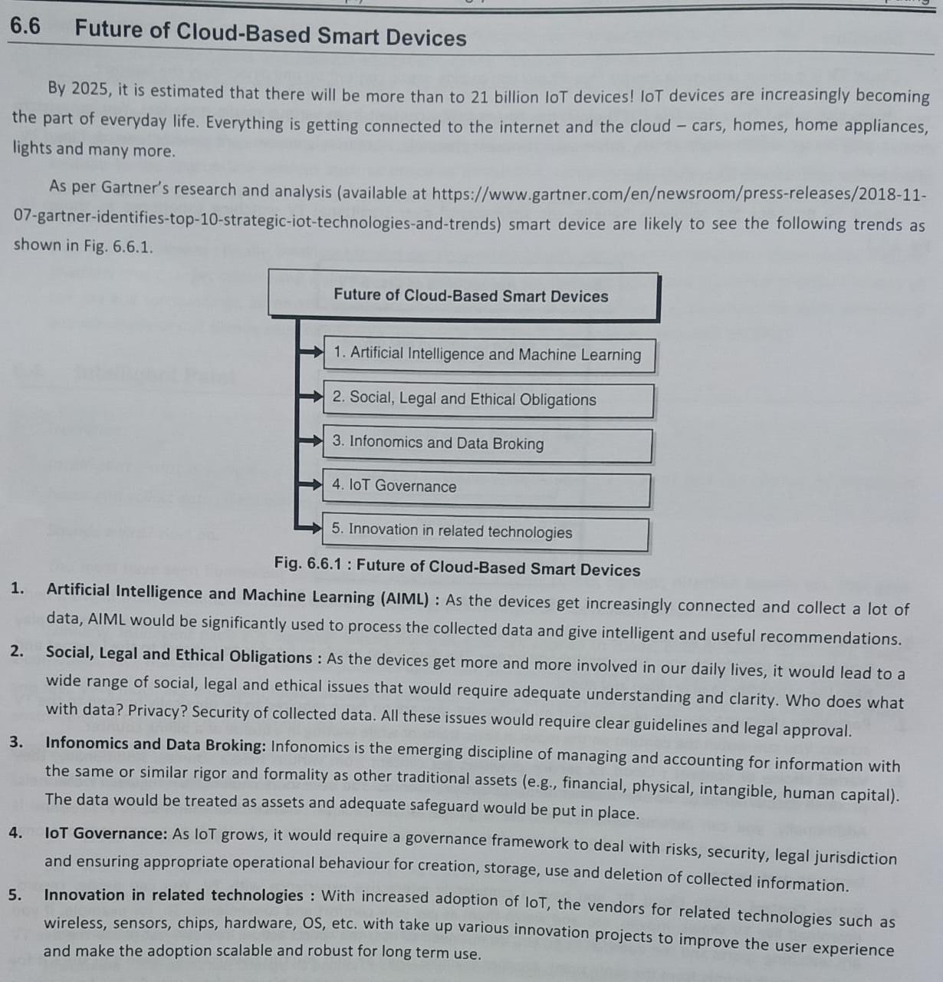

2.Explain in detail Faster Time to Market for Software Applications & jungle computing.

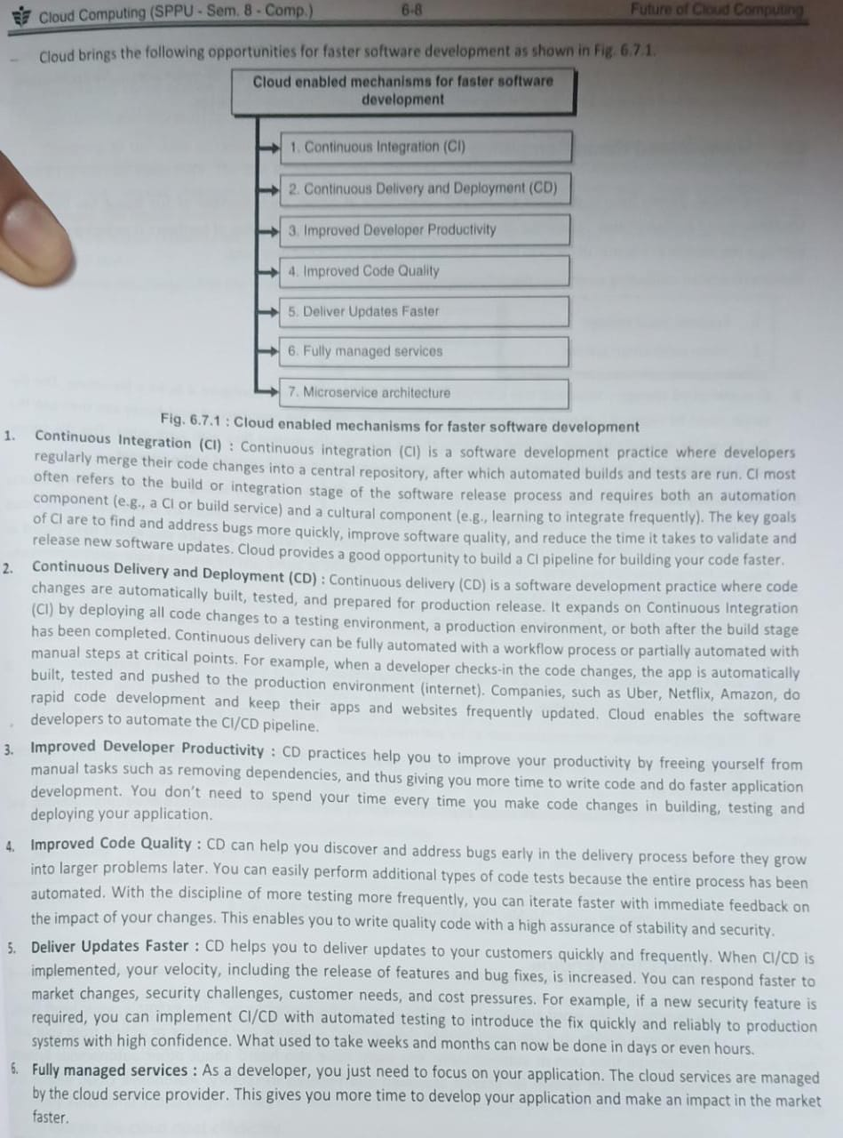

3.Explain in detail Getting the Most from Docker & the Docker Workflow.

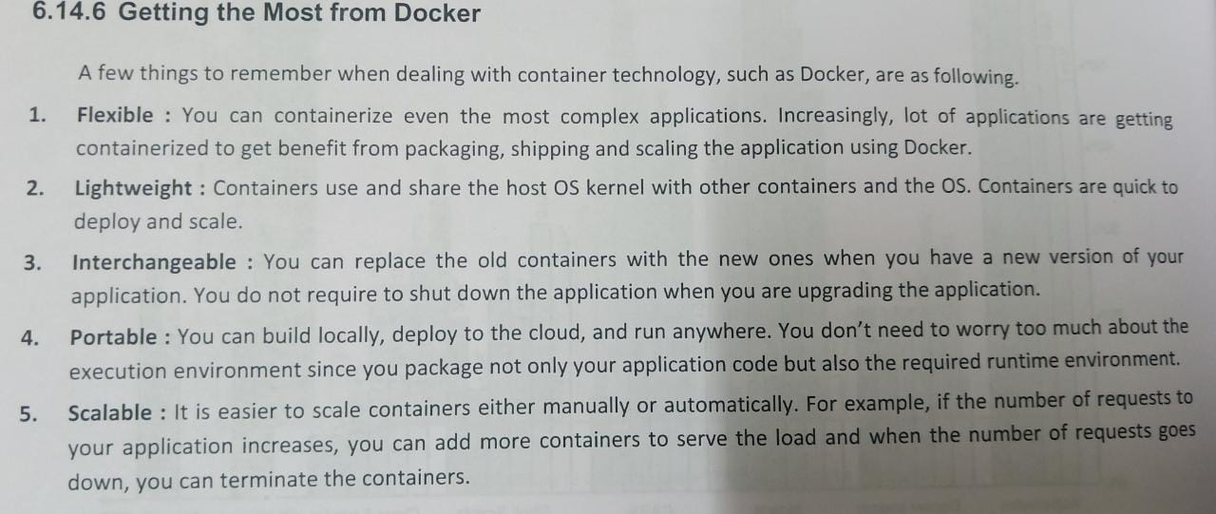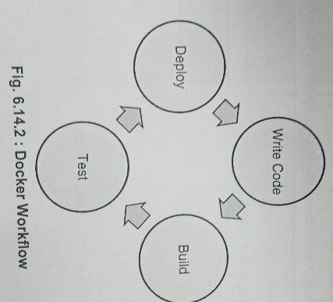

Docker Workflow

With Docker, the entire pipeline, from the developer's code check-in to production deployment, can be automated. Typically, Docker-based applications have the following workflow for development, testing and deployment. This is also called CI/CD pipeline that you read about earlier in this chapter under "Faster Time to Market for Software Applications".

4. Explain in Detail with diagram mobile cloud computing and future of cloud TV.

Cloud Computing offers such smartphones that have rich Internet media support, require less processing and consume less power. In terms of Mobile Cloud Computing (MCC), processing is done in cloud, data is stored in cloud, and the mobile devices serve as media for display.

Today smartphones are employed with rich cloud services by integrating applications that consume web services. These web services are deployed in cloud.

There are several Smartphone operating systems available such as Google's Android, Apple's iOS, RIM BlackBerry, Symbian, and Windows Mobile Phone. Each of these platforms support third-party applications that are deployed in cloud.

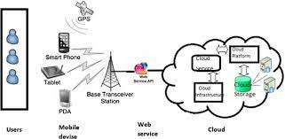 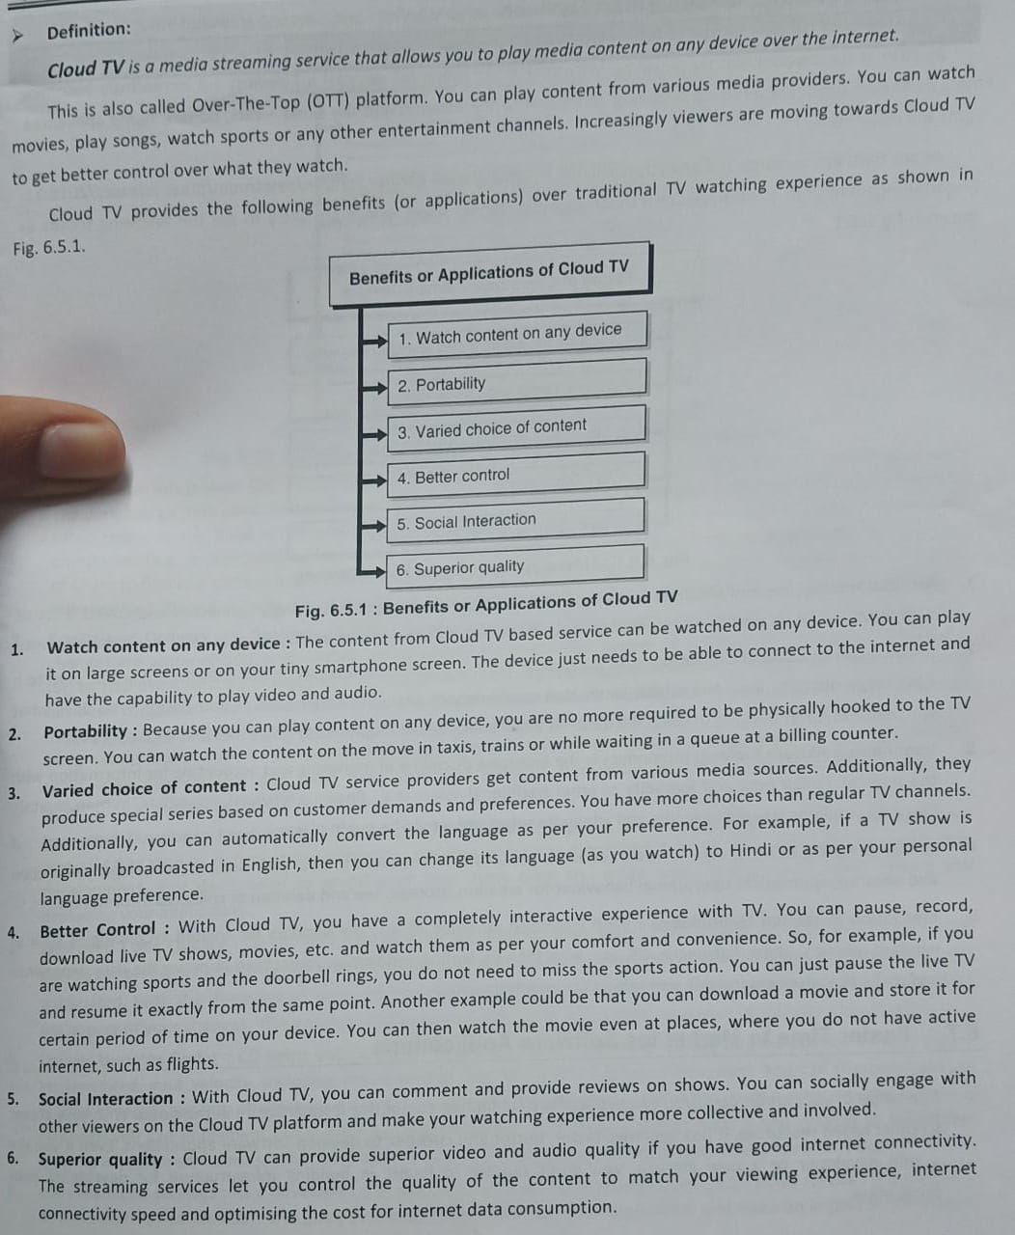

1. Explain in Detail energy aware cloud computing and Future of Cloud-Based Smart Devices.
2. 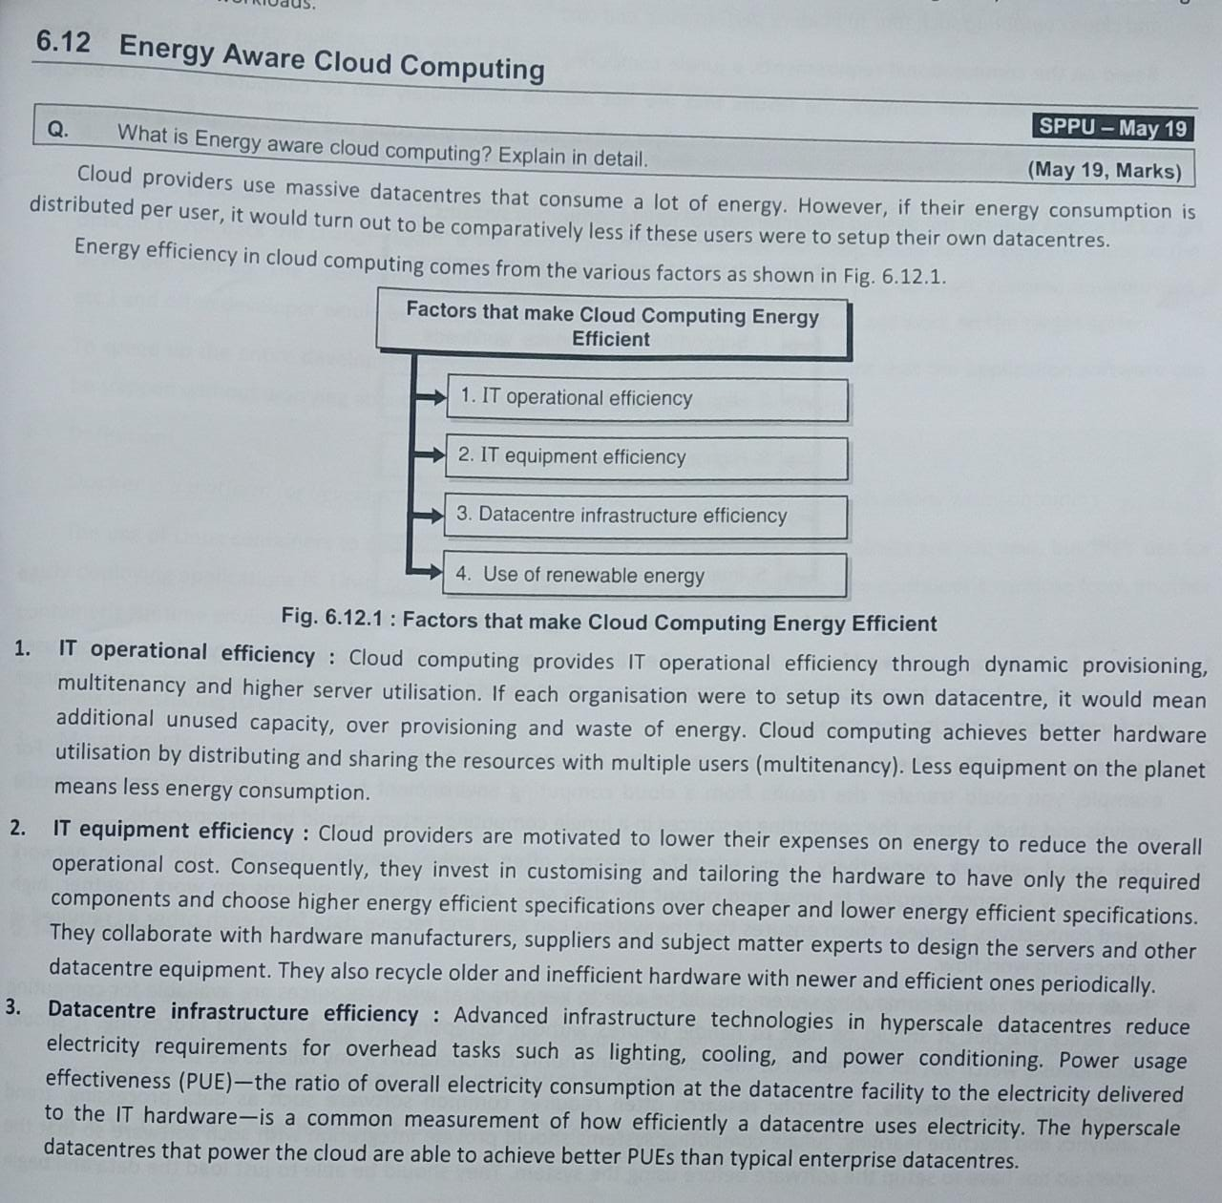

6. Explain in detail Home-Based Cloud Computing & Autonomic Cloud Engine.

