1. /stocks/upload

Uploading file dow_jones_index.csv present in resources , 750 records uploaded successfully .

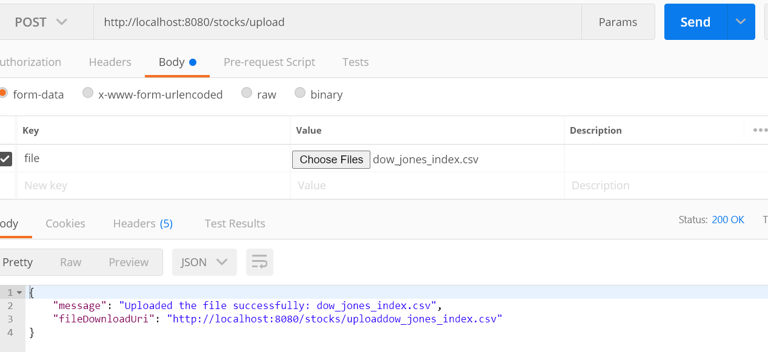

1. /stocks/AA

All the records mapped to ticker Id will be retrieved .

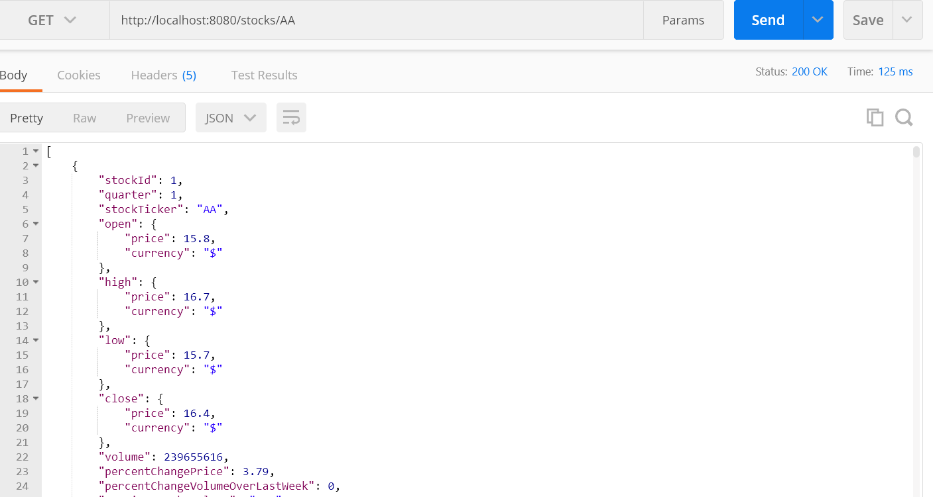

1. /stocks/addStockInfo

Posted stock added successfully . Stock Id is returned .

