Practical No 5
Configuring a Zone-Based Policy Firewall
Network:

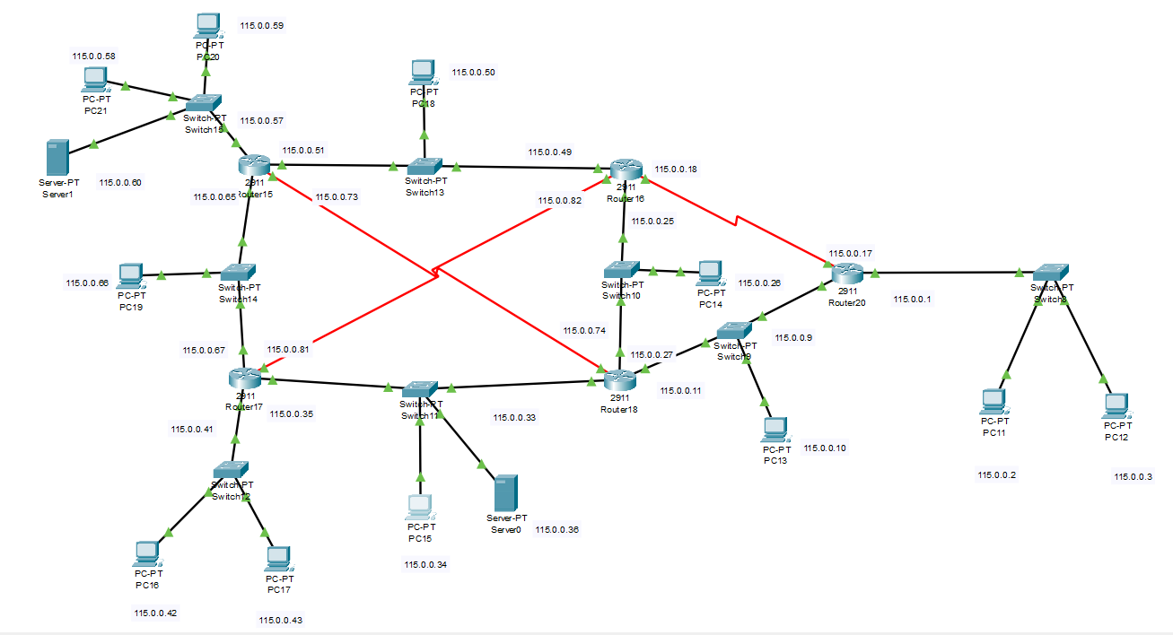

Ssh configuration on router5
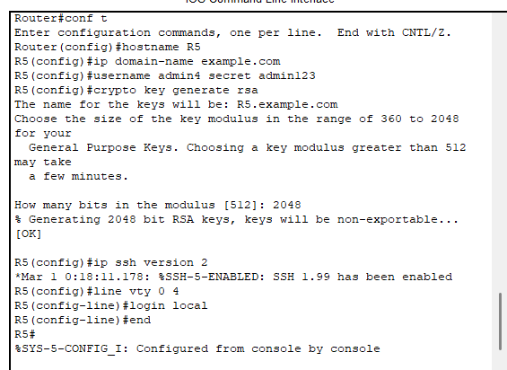

Installing the securityK9 package on router5

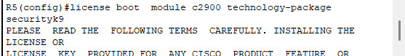

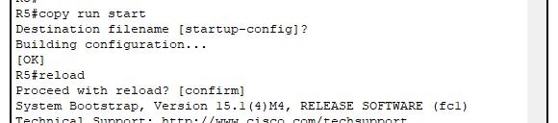

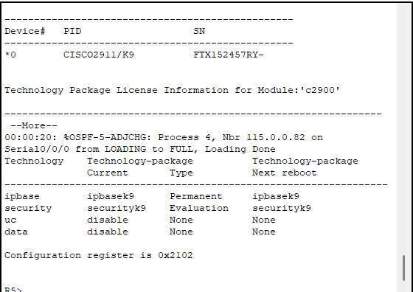
Creating zones for each network.
Router5 has 4 interfaces and for each interface Zone is created with different policies
ZONE-32 denies the icmp(ping) in a network

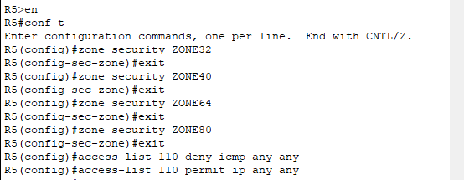

ZONE40 denies the HTTP and FTP service in a network
ZONE64 denies only FTP service in a network
ZONE80 denies the Ssh service in a network

ex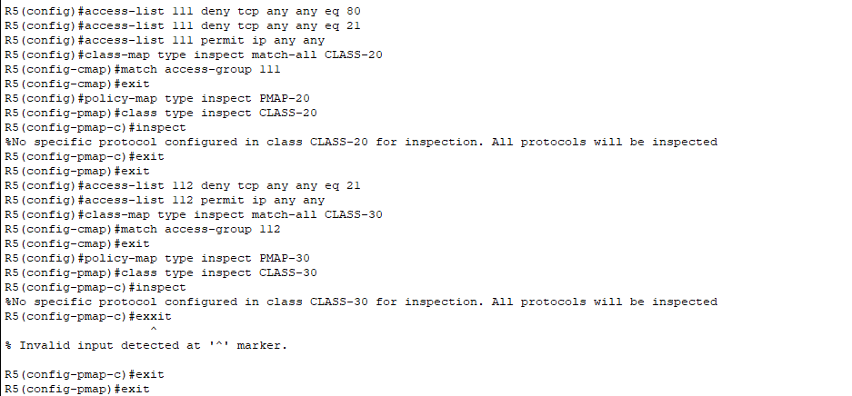

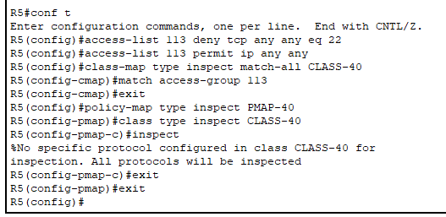
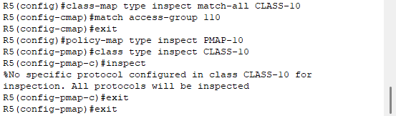

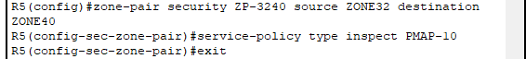

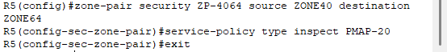

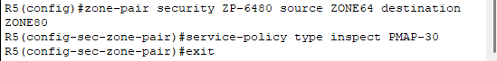

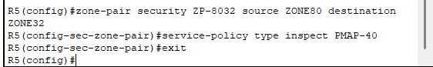

Assigning the zones to the interface

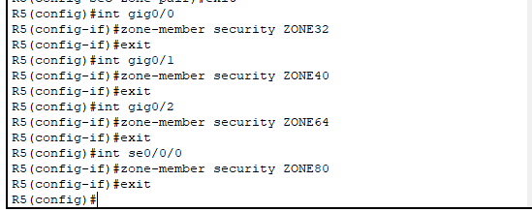

All the policies that are applied on each interface
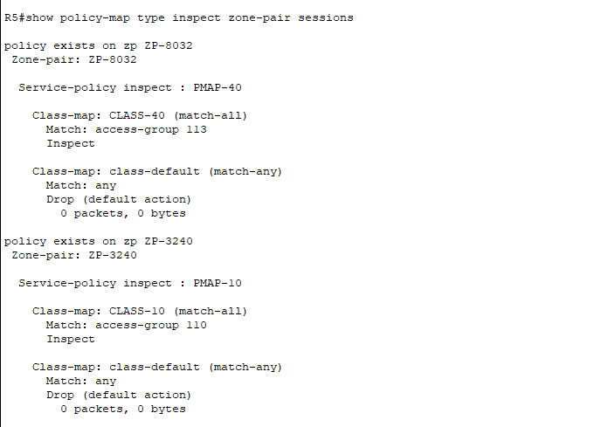
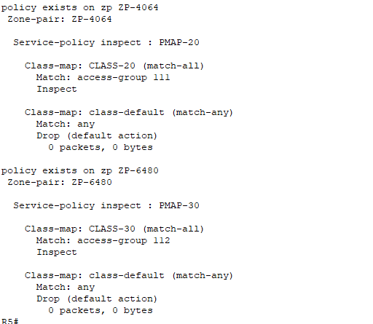

Zone32 policies
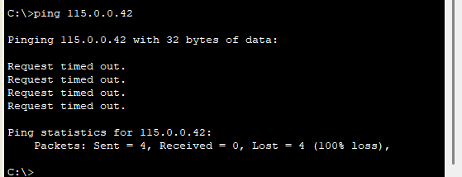

Zone40 policies
Denied the HTTP service
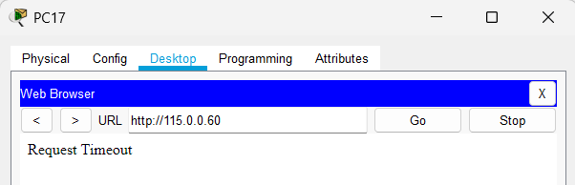

Denied the FTP service from server
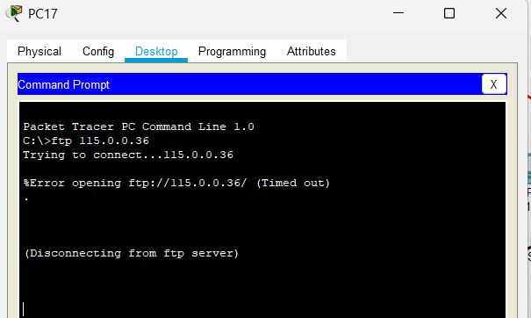

ZONE64
Denied the FTP service from server
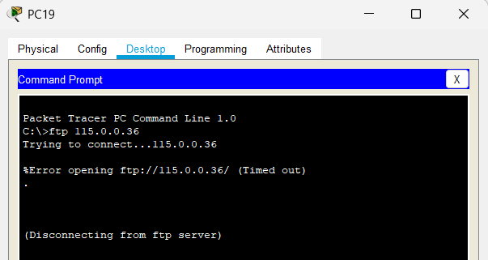

Zone80
Denied the ssh service
