PRACTICAL NO.6

Perform the logistic regression on the given data warehouse data using R/Python.

- Load the File and Display

> mtcars
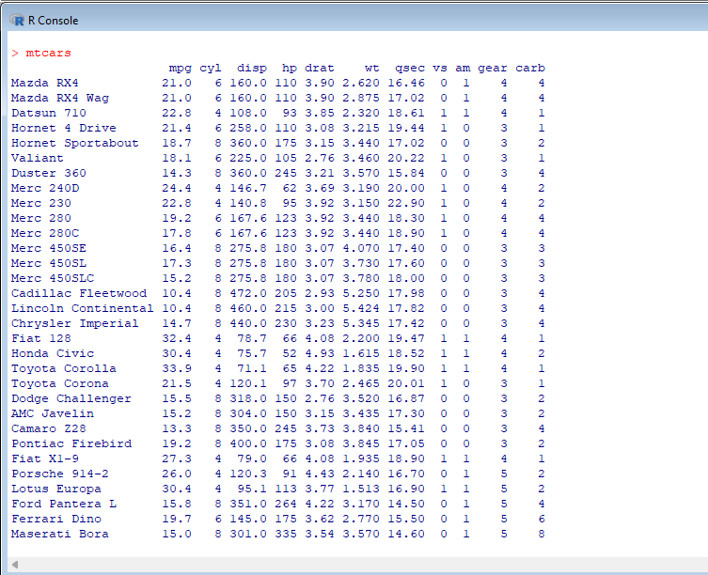

b. Find mean, max, min, median and all binary element of all files
> summary(mtcars)
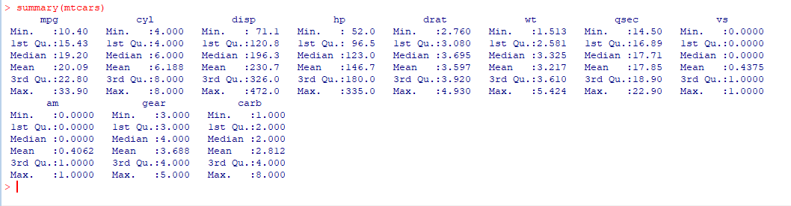

c. Apply GLM on all set of data
> result<-glm(formula= am~hp+wt, data=mtcars, family=binomial)
> summary(result)
- From these we can find the standard deviation, logistic regression, estimated value etc
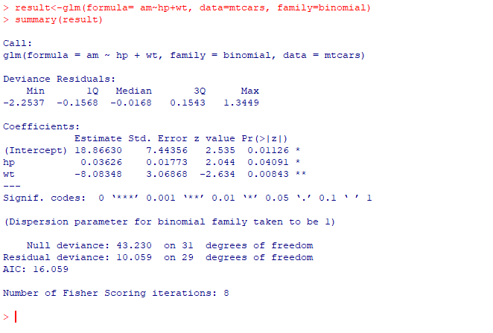

d. Flot graph
>plot(result)
1. Residuals Vs Fitted 2. Norma;Q-Q
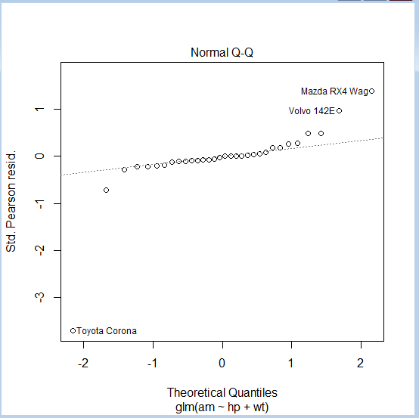
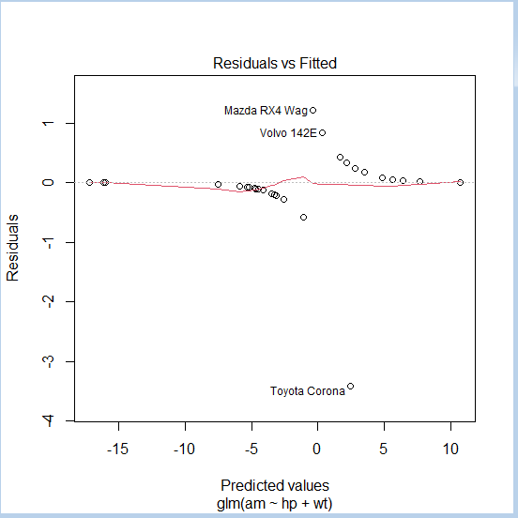

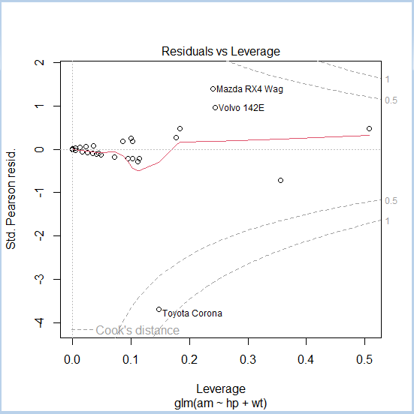
3. Scale Location 4Residuals Vs Leverage
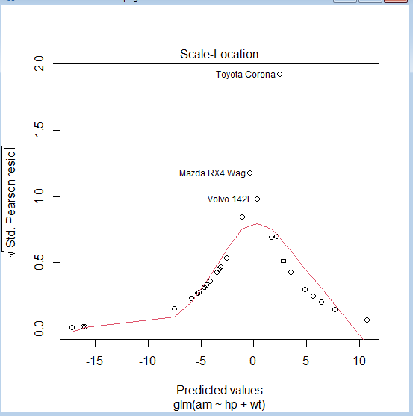

e. Extracting data from csv file
> url<-"D:/Social_Network_Ads.csv"
> input<-read.csv(url)
> head(input)
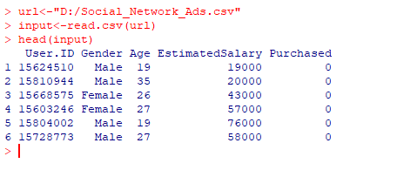

f. To find out mean, max, min of all Columns
> summary(input)
