Practical No.8
Perform data visualization

- Perform data visualization using Python on any sales data
Code:
import pandas as pd
import numpy as np
import matplotlib.pyplot as plt

data = {
'Category': ['Electronics','Clothing', 'Groceries','Furniture'],
'Sales':np.random.randint(500, 2000, 4)
}
df = pd.DataFrame(data)

print("Sales Data:")
print(df)

plt.bar(df['Category'], df['Sales'])
plt.title("Sales by Category")
plt.xlabel("Category")
plt.ylabel("Sales Amount")
plt.show()

Output:

Sales Data:
Category Sales
0 Electronics 1463
1 Clothing 1387
2 Groceries 1481
3 Furniture 1896

Graph:
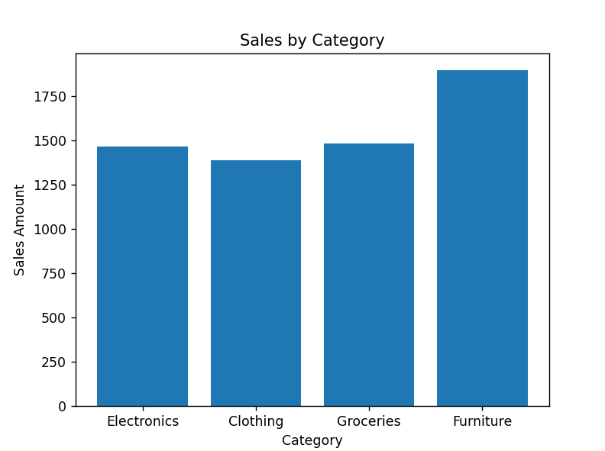

b]Perform data visualization using PowerBI on any sales data :
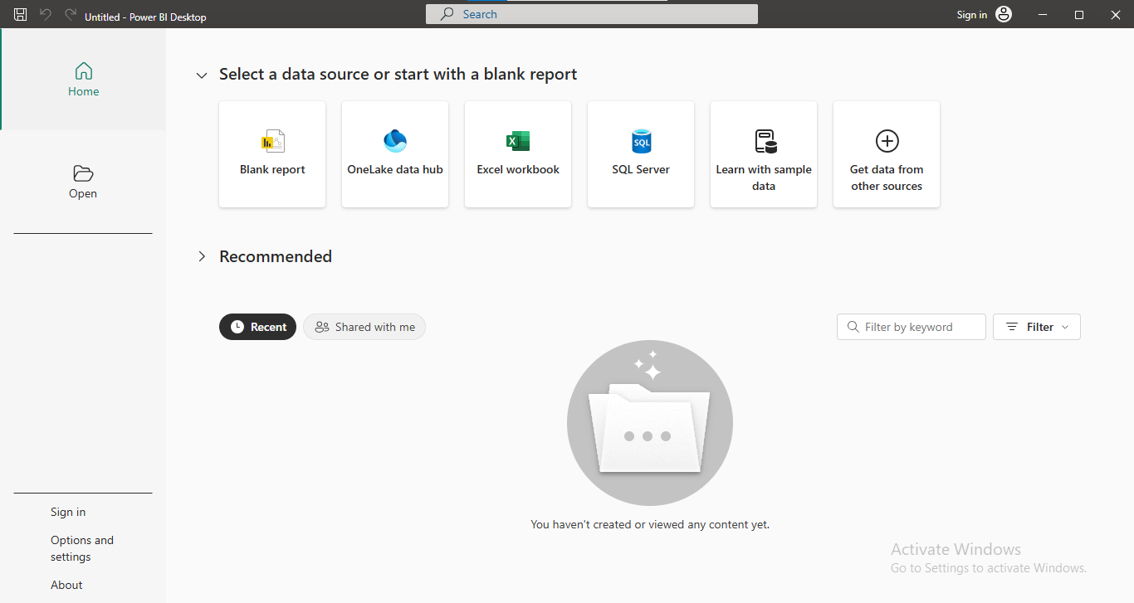
i] Open power BI:

ii] Select the data file:
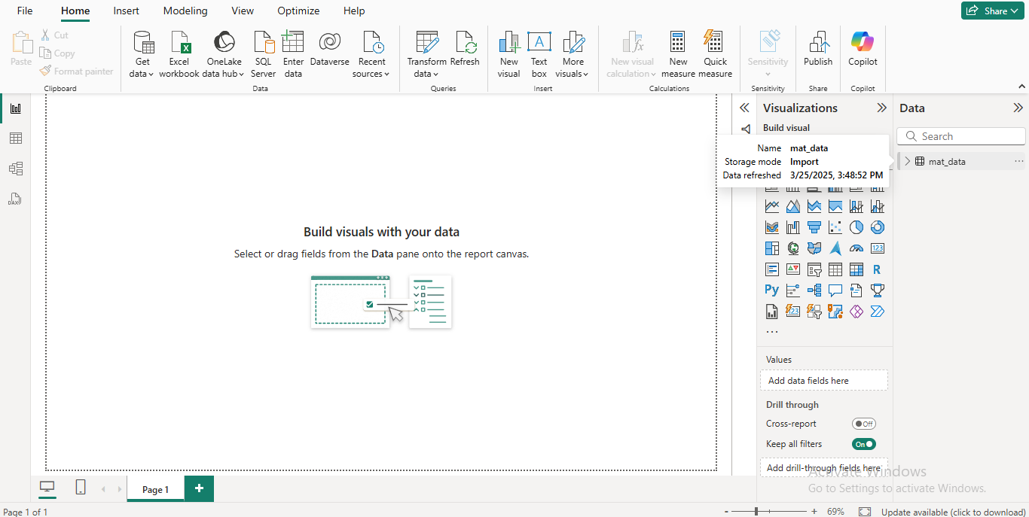
iii] Load the Data:

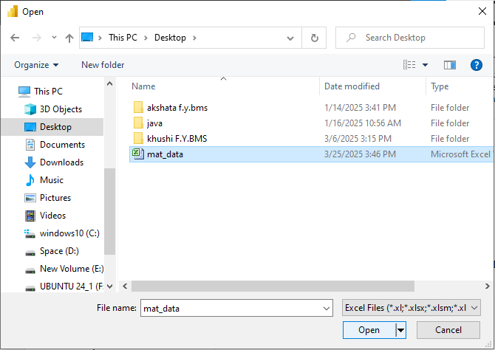
iv] Select the visualization option:
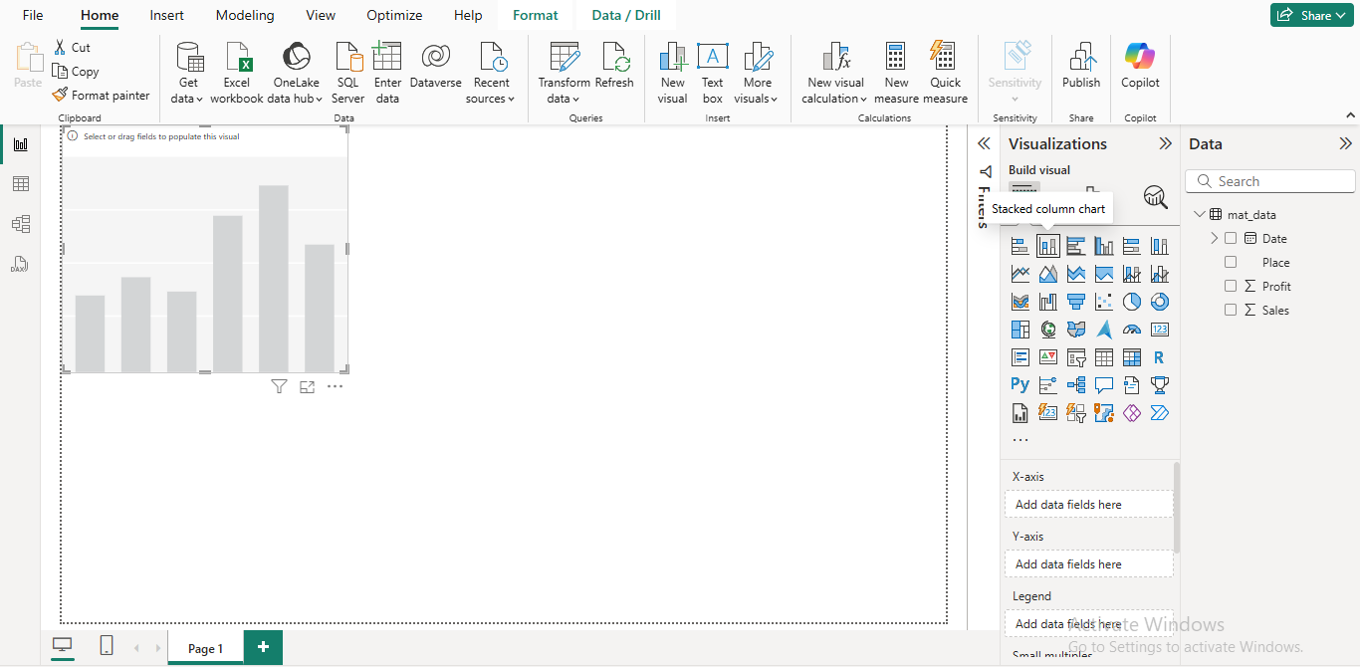
v] Select the fields and configure the component: For place and profit
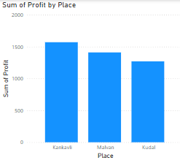
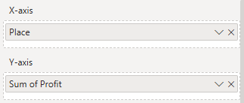

v] Select the fields and configure the component: For Sale according to date
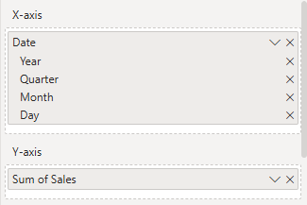
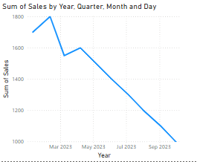

vi] Add some more appropriate graphs and then the final dashboard:
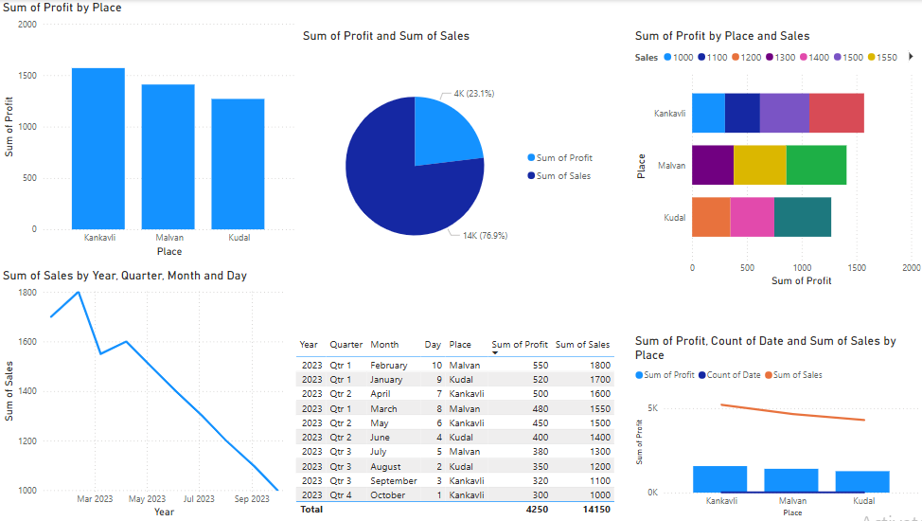

vii]Selection of a feature:

