PRACTICAL NO. 01

A]Android Resources: (Color, Theme, String, Drawable, Dimension, Image)

DESIGN:

<?xml version="1.0" encoding="utf-8"?>
<androidx.constraintlayout.widget.ConstraintLayout xmlns:android="http://schemas.android.com/apk/res/android"
xmlns:app="http://schemas.android.com/apk/res-auto"
xmlns:tools="http://schemas.android.com/tools"
android:layout_width="match_parent"
android:layout_height="match_parent"
android:id="@+id/constraint_layout">
tools:context=".MainActivity">
<ImageView
android:id="@+id/imageView"
android:layout_width="346dp"
android:layout_height="220dp"
android:contentDescription="@string/todo"
app:layout_constraintBottom_toBottomOf="parent"
app:layout_constraintEnd_toEndOf="parent"
app:layout_constraintHorizontal_bias="0.492"
app:layout_constraintStart_toStartOf="parent"
app:layout_constraintTop_toTopOf="parent"
app:layout_constraintVertical_bias="0.272"
app:srcCompat="@drawable/pokemon"
tools:ignore="ImageContrastCheck" />
<Button
android:id="@+id/button"
android:layout_width="wrap_content"
android:layout_height="wrap_content"
android:text="Button"
app:layout_constraintBottom_toBottomOf="parent"
app:layout_constraintEnd_toEndOf="parent"
app:layout_constraintHorizontal_bias="0.498"
app:layout_constraintStart_toStartOf="parent"
app:layout_constraintTop_toTopOf="parent"
app:layout_constraintVertical_bias="0.655" />
</androidx.constraintlayout.widget.ConstraintLayout>

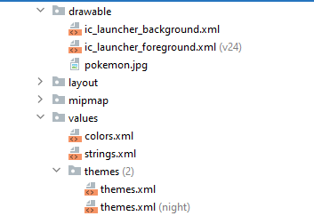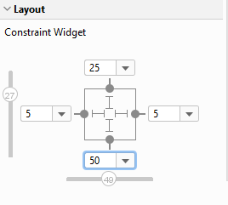

CODE:
package com.example.p2
import android.graphics.Color
import android.os.Bundle
import android.widget.Button
import android.widget.ImageView
import android.widget.TextView
import androidx.appcompat.app.AppCompatActivity
import androidx.constraintlayout.widget.ConstraintLayout
class MainActivity : AppCompatActivity() {
override fun onCreate(savedInstanceState: Bundle?) {
super.onCreate(savedInstanceState)
setContentView(R.layout.activity_main)
val button: Button = findViewById(R.id.button)
val layout: ConstraintLayout = findViewById(R.id.constraint_layout)
val gg = resources.getColor(R.color.gg, theme)
var clr =0
button.setOnClickListener {
if (clr ==0){
layout.setBackgroundColor(Color.BLUE)
clr = 1
}else {
layout.setBackgroundColor(gg)
clr =0
}
}
}
}

OUTPUT:

