Practical No:05
Programming UI elements: AppBar, Fragments, UI Components

1.AppBar
Code:
.kt file code
package com.example.my_fragment
import androidx.appcompat.app.AppCompatActivity
import android.os.Bundle
import android.view.Menu
import android.view.MenuItem
import android.widget.Toast
import kotlinx.android.synthetic.main.activity_main.*
class MainActivity : AppCompatActivity() {
override fun onCreate(savedInstanceState: Bundle?) {
super.onCreate(savedInstanceState)
setContentView(R.layout.activity_main)
setSupportActionBar(mytoolbar)
}
override fun onCreateOptionsMenu(menu: Menu?): Boolean {
super.onCreateOptionsMenu(menu)
menuInflater.inflate(R.menu.mymenu,menu)
return true
}
override fun onOptionsItemSelected(item: MenuItem): Boolean {
if(item.itemId==R.id.one){
Toast.makeText(this,"Folder is clicked",Toast.LENGTH_LONG).show()
}
if(item.itemId==R.id.two){
Toast.makeText(this,"Search is clicked",Toast.LENGTH_LONG).show()
}
if(item.itemId==R.id.s1){
Toast.makeText(this,"This is toast",Toast.LENGTH_LONG).show()
}
return super.onOptionsItemSelected(item)
}
}
.xml file code
<?xml version="1.0" encoding="utf-8"?>
<androidx.constraintlayout.widget.ConstraintLayout xmlns:android="http://schemas.android.com/apk/res/android"
xmlns:app="http://schemas.android.com/apk/res-auto"
xmlns:tools="http://schemas.android.com/tools"
android:layout_width="match_parent"
android:layout_height="match_parent"
tools:context=".MainActivity">
<androidx.appcompat.widget.Toolbar
android:id="@+id/mytoolbar"
android:layout_width="match_parent"
android:layout_height="?attr/actionBarSize"
tools:ignore="MissingConstraints"
android:theme="@style/Theme.AppCompat.DayNight.DarkActionBar"
android:background="@color/teal_700"
app:titleTextColor="@color/white"
android:elevation="4dp"/>
</androidx.constraintlayout.widget.ConstraintLayout>
New .xml file code
<?xml version="1.0" encoding="utf-8"?>
<menu xmlns:android="http://schemas.android.com/apk/res/android"
xmlns:app="http://schemas.android.com/apk/res-auto">
<item android:id="@+id/one" android:title="folder" android:icon="@drawable/ic_baseline_folder_24" app:showAsAction="always"/>
<item android:id="@+id/two" android:title="search" android:icon="@drawable/ic_baseline_search_24" app:showAsAction="always"/>
<item android:id="@+id/main" android:title="Main Menu">
<menu>
<item android:id="@+id/s1" android:title="Toast"/>
<item android:id="@+id/s2" android:title="Exit"/>
</menu>
</item>
</menu>
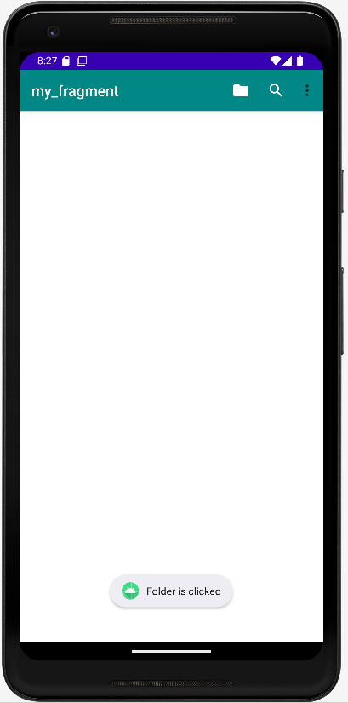
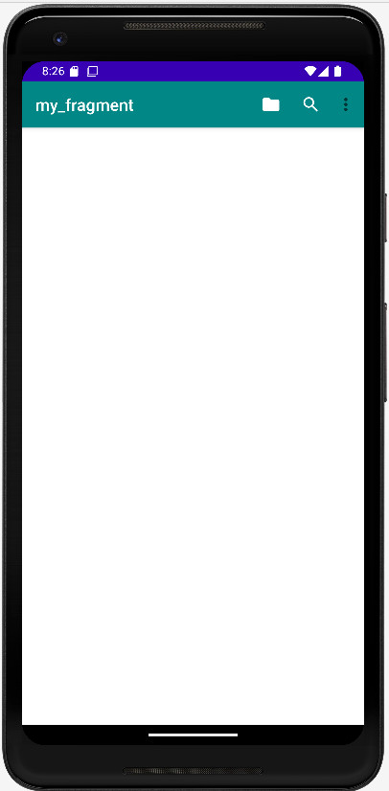
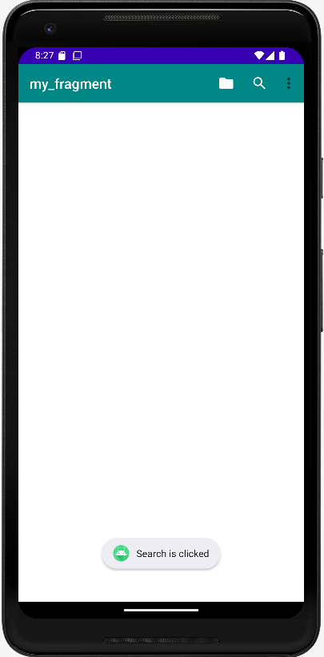
Output:

2.Fragments
Code:
package srm.it.fragmentdemo
import androidx.appcompat.app.AppCompatActivity
import android.os.Bundle
import kotlinx.android.synthetic.main.activity_main.*
class MainActivity : AppCompatActivity() {
override fun onCreate(savedInstanceState: Bundle?) {
super.onCreate(savedInstanceState)
setContentView(R.layout.activity_main)
var state=0
button.setOnClickListener {
if(state==0) {
supportFragmentManager.beginTransaction().replace(R.id.fragmentContainerView,first()).commit()
state=1
}
else
{ supportFragmentManager.beginTransaction().replace(R.id.fragmentContainerView,second()).commit()
state=0
}
} } }
Output:
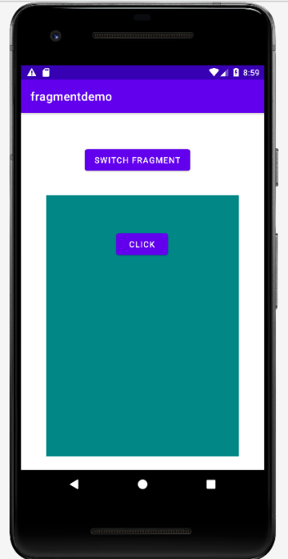
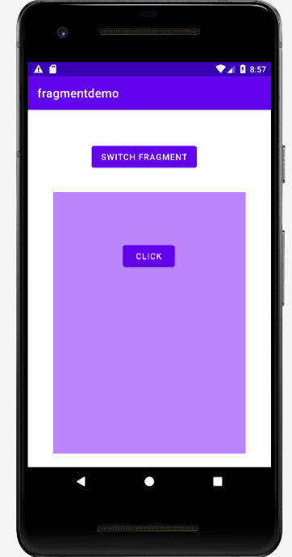

3. UI Components
Code:
package sy.it.ui_component
import androidx.appcompat.app.AppCompatActivity
import android.os.Bundle
import android.widget.RadioButton
import android.widget.Toast
import androidx.appcompat.app.AlertDialog
import kotlinx.android.synthetic.main.activity_main.*
class MainActivity : AppCompatActivity() {
override fun onCreate(savedInstanceState: Bundle?) {
super.onCreate(savedInstanceState)
setContentView(R.layout.activity_main)
button.setOnClickListener {
var name=box1.text.toString()
var email= box2.text.toString()
var dob=box3.text.toString()
var pass=box4.text.toString()
var compass=box5.text.toString()
if(pass!=compass){
Toast.makeText(this,"Password does not match",Toast.LENGTH_SHORT).show()
}
var gen=radioGroup.checkedRadioButtonId
var gs=if (gen == -1) {
Toast.makeText(this, "Select gender", Toast.LENGTH_SHORT).show()
}
else {
findViewById<RadioButton>(gen).text.toString()
}
var term=if(checkBox.isChecked){
checkBox.text.toString()
}else{
Toast.makeText(this, "Please accept our terms and conditions", Toast.LENGTH_SHORT).show()
}
textView7.text = """
$name
$email
$dob
$pass
$gs
$term
""".trimIndent() }}}

Output:
