Practical No.11
Programming Media API, Telephone API, Security and permissions
A. Programming Media API and Telephone API
1. Media API
Code:
package com.example.mediaapi
import android.net.Uri
import androidx.appcompat.app.AppCompatActivity
import android.os.Bundle
import android.widget.MediaController
import kotlinx.android.synthetic.main.activity_main.*
class MainActivity : AppCompatActivity() {
override fun onCreate(savedInstanceState: Bundle?) {
super.onCreate(savedInstanceState)
setContentView(R.layout.activity_main)
var path="android.resource://com.example.mediaapi/"+R.raw.the_fight
videoView.setVideoURI(Uri.parse(path))
videoView.setMediaController(MediaController(this))
videoView.start()
}
}
Output:
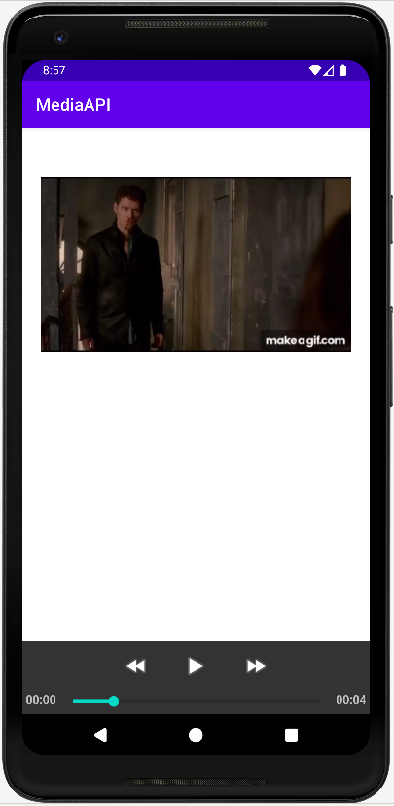

2. Telephone API
Code:
package com.example.callingapi
import android.Manifest
import android.content.Intent
import android.content.pm.PackageManager
import android.net.Uri
import android.os.Bundle
import android.provider.ContactsContract
import android.widget.ArrayAdapter
import androidx.appcompat.app.AppCompatActivity
import androidx.core.app.ActivityCompat
import kotlinx.android.synthetic.main.activity_main.*
class MainActivity : AppCompatActivity() {
override fun onCreate(savedInstanceState: Bundle?) {
super.onCreate(savedInstanceState)
setContentView(R.layout.activity_main)
ActivityCompat.requestPermissions(this, arrayOf(Manifest.permission.READ_CONTACTS), 1)
lv.setOnItemClickListener { adapterView, view, i, l ->
val num = lv.getItemAtPosition(i).toString()
startActivity(Intent(Intent.ACTION_DIAL, Uri.parse("tel:$num")))
}
}
private fun showContacts() {
var list = ArrayList<String>()
var c = contentResolver.query(ContactsContract.CommonDataKinds.Phone.CONTENT_URI,
null, null, null, null)
while (c != null && c.moveToNext()) {
val name = c.getString( c.getColumnIndexOrThrow(ContactsContract.CommonDataKinds.Phone.DISPLAY_NAME))
val number = c.getString(
c.getColumnIndexOrThrow(ContactsContract.CommonDataKinds.Phone.NUMBER))
list.add(name + "\n" + number)
}
lv.adapter = ArrayAdapter(this, android.R.layout.simple_list_item_1, list)
}
override fun onRequestPermissionsResult(
requestCode: Int,
permissions: Array<out String>,
grantResults: IntArray ) {
if (requestCode == 1 && grantResults.isNotEmpty() && grantResults[0] == PackageManager.PERMISSION_GRANTED)
{
showContacts()
super.onRequestPermissionsResult(requestCode, permissions, grantResults)
}
}
}
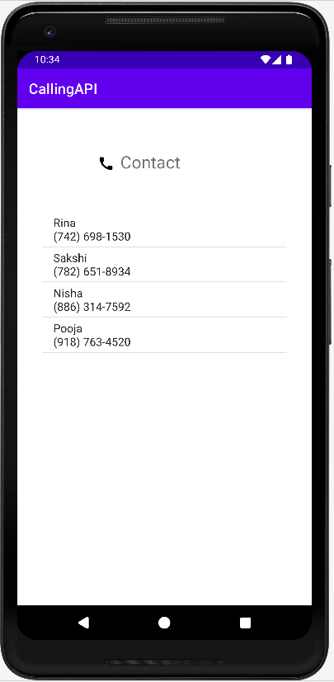
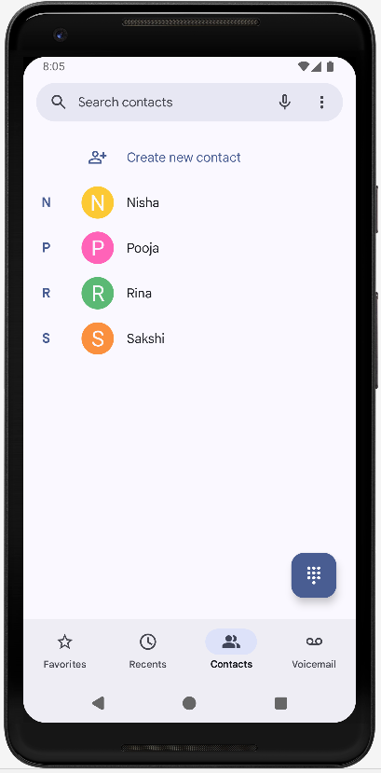
Output:

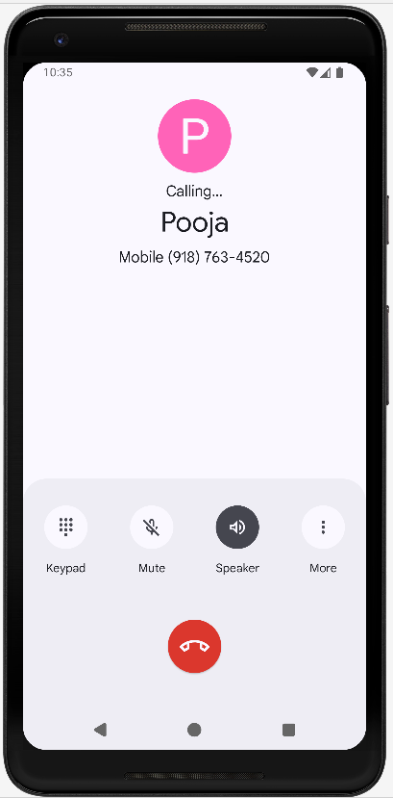
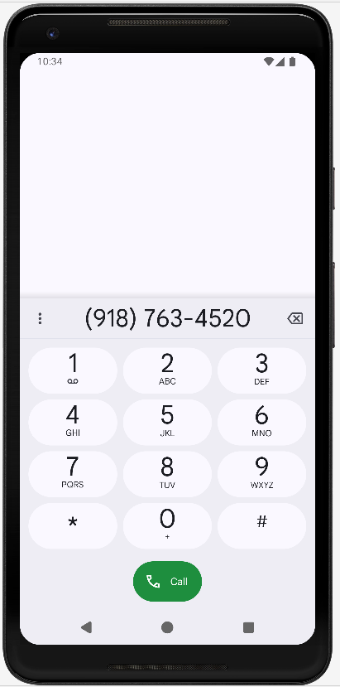

B. Programming Security and permissions
Code:
package com.example.permissions
import android.Manifest
import android.content.pm.PackageManager
import androidx.appcompat.app.AppCompatActivity
import android.os.Bundle
import android.widget.Toast
import androidx.core.app.ActivityCompat
import kotlinx.android.synthetic.main.activity_main.*
class MainActivity : AppCompatActivity() {
override fun onCreate(savedInstanceState: Bundle?) {
super.onCreate(savedInstanceState)
setContentView(R.layout.activity_main)
button.setOnClickListener {
ActivityCompat.requestPermissions(this, arrayOf(Manifest.permission.CALL_PHONE, Manifest.permission.CAMERA,Manifest.permission.READ_EXTERNAL_STORAGE,Manifest.permission.READ_SMS),1)
}
}
override fun onRequestPermissionsResult(
requestCode: Int,
permissions: Array<out String>,
grantResults: IntArray){
if (requestCode==1){
if (grantResults.size>0 && grantResults[0]==PackageManager.PERMISSION_GRANTED){
Toast.makeText(this,"Granted",Toast.LENGTH_LONG).show()
}
else{
Toast.makeText(this,"Not Granted",Toast.LENGTH_LONG).show()
}
}
super.onRequestPermissionsResult(requestCode, permissions, grantResults)
}
}

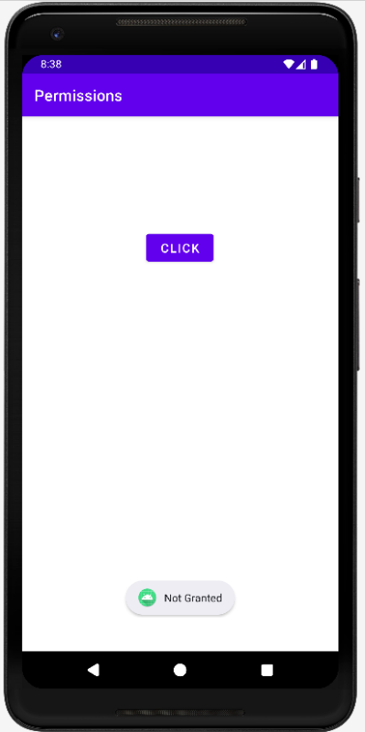
Output:
