Practical no:06
Programming menus, dialog, dialog fragments
1.Menu
Code:
.kt file code:
package srm.it.menu
import androidx.appcompat.app.AppCompatActivity
import android.os.Bundle
import android.view.Menu
import android.view.MenuItem
import android.widget.PopupMenu
import android.widget.Toast
import kotlinx.android.synthetic.main.activity_main.*
class MainActivity : AppCompatActivity() {
override fun onCreate(savedInstanceState: Bundle?) {
super.onCreate(savedInstanceState)
setContentView(R.layout.activity_main) }
override fun onCreateOptionsMenu(menu: Menu?): Boolean {
menuInflater.inflate(R.menu.resource_file,menu)
return super.onCreateOptionsMenu(menu)
}
override fun onOptionsItemSelected(item: MenuItem): Boolean {
if (item.itemId==R.id.one)
{
Toast.makeText(this,"this is profile",Toast.LENGTH_LONG).show()
}
if (item.itemId==R.id.two)
{
System.exit(0)
}
if (item.itemId==R.id.three)
{
Toast.makeText(this,"this is home",Toast.LENGTH_LONG).show()
}
if (item.itemId==R.id.four)
{
Toast.makeText(this,"this is About us",Toast.LENGTH_LONG).show()
}
if (item.itemId==R.id.five)
{
Toast.makeText(this,"this is contact us",Toast.LENGTH_LONG).show()
}
return super.onOptionsItemSelected(item)
}
}
Xml file code:
<?xml version="1.0" encoding="utf-8"?>
<menu xmlns:android="http://schemas.android.com/apk/res/android"
xmlns:app="http://schemas.android.com/apk/res-auto">
<item android:title="main_menu">
<menu>
<item android:id="@+id/one" android:title="Profile"></item>
<item android:id="@+id/two" android:title="logout"></item>
</menu>
</item>
<item android:id="@+id/three" android:title="Home" app:showAsAction="always"></item>
<item android:id="@+id/four" android:title="About Us" app:showAsAction="always"></item>
<item android:id="@+id/five" android:title="Contact Us" app:showAsAction="always"></item>
</menu>
Output:
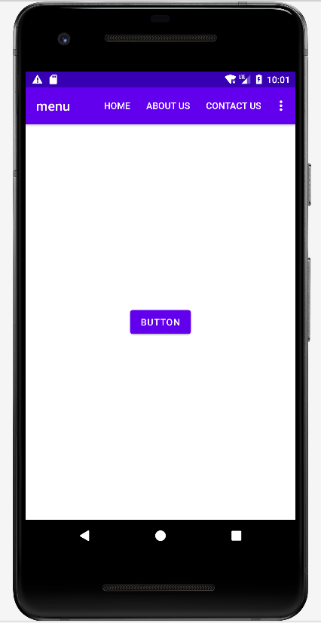
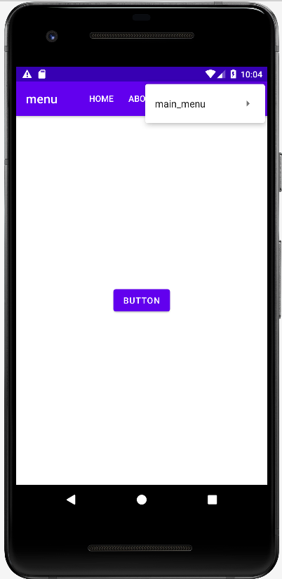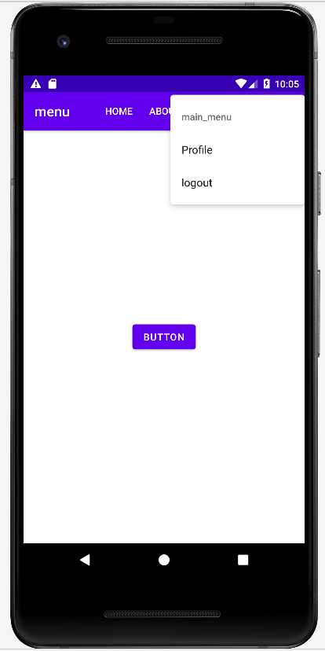

2) POP UP Menu
Code:
package srm.it.menu
import androidx.appcompat.app.AppCompatActivity
import android.os.Bundle
import android.view.Menu
import android.view.MenuItem
import android.widget.PopupMenu
import android.widget.Toast
import kotlinx.android.synthetic.main.activity_main.*
class MainActivity : AppCompatActivity() {
override fun onCreate(savedInstanceState: Bundle?) {
super.onCreate(savedInstanceState)
setContentView(R.layout.activity_main)
button.setOnClickListener {
var pm:PopupMenu= PopupMenu(this,button)
pm.menuInflater.inflate(R.menu.resource_file,pm.menu)
pm.setOnMenuItemClickListener { it
if (it.itemId==R.id.one)
{
Toast.makeText(this,"this is profile",Toast.LENGTH_LONG).show()
}
if (it.itemId==R.id.two)
{
System.exit(0)
}
if (it.itemId==R.id.three)
{
Toast.makeText(this,"this is home",Toast.LENGTH_LONG).show()
}
if (it.itemId==R.id.four)
{
Toast.makeText(this,"this is About us",Toast.LENGTH_LONG).show()
}
if (it.itemId==R.id.five)
{
Toast.makeText(this,"this is contact us",Toast.LENGTH_LONG).show()
}
true
}
pm.show()
}
}
override fun onCreateOptionsMenu(menu: Menu?): Boolean {
menuInflater.inflate(R.menu.resource_file,menu)
return super.onCreateOptionsMenu(menu)
}
override fun onOptionsItemSelected(item: MenuItem): Boolean {
if (item.itemId==R.id.one)
{
Toast.makeText(this,"this is profile",Toast.LENGTH_LONG).show()
}
if (item.itemId==R.id.two)
{
System.exit(0)
}
if (item.itemId==R.id.three)
{
Toast.makeText(this,"this is home",Toast.LENGTH_LONG).show()
}
if (item.itemId==R.id.four)
{
Toast.makeText(this,"this is About us",Toast.LENGTH_LONG).show()
}
if (item.itemId==R.id.five)
{
Toast.makeText(this,"this is contact us",Toast.LENGTH_LONG).show()
}
return super.onOptionsItemSelected(item)
}
}

Output:
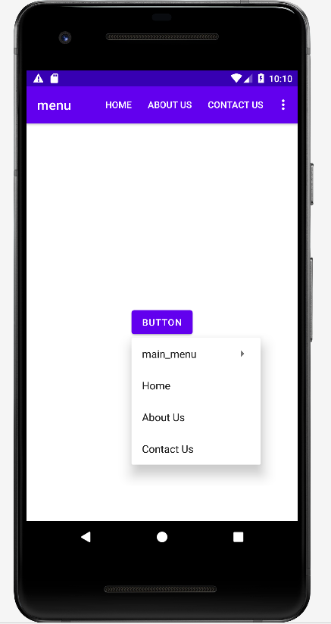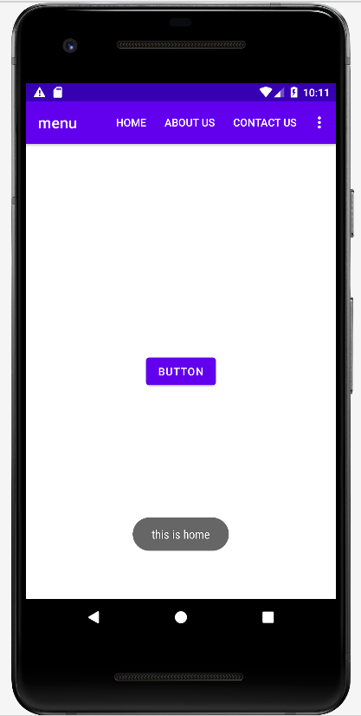
2)Dialog
Code:
package srm.it.dialog
import androidx.appcompat.app.AppCompatActivity
import android.os.Bundle
import android.widget.Toast
import androidx.appcompat.app.AlertDialog
import kotlinx.android.synthetic.main.activity_main.
class MainActivity : AppCompatActivity() {
override fun onCreate(savedInstanceState: Bundle?) {
super.onCreate(savedInstanceState)
setContentView(R.layout.activity_main)
button.setOnClickListener {
var mydialog=AlertDialog.Builder(this)
mydialog.setTitle("Hello")
mydialog.setMessage("do you want to exit ?...")
mydialog.setPositiveButton("Yes"){dialog,which->
Toast.makeText(this,"you click yes",Toast.LENGTH_LONG).show()
}
mydialog.setNegativeButton("No"){dialog,which->
Toast.makeText(this,"you click No",Toast.LENGTH_LONG).show()
}
mydialog.setNeutralButton("cancel"){dialog,which->
Toast.makeText(this,"you click No",Toast.LENGTH_LONG).show()
}
mydialog.show()
}
}
override fun onBackPressed() {
var mydialog=AlertDialog.Builder(this)
mydialog.setTitle("Hello")
mydialog.setMessage("do you want to exit ?...")
mydialog.setPositiveButton("Yes"){dialog,which->
Toast.makeText(this,"you click yes",Toast.LENGTH_LONG).show()
}
mydialog.setNegativeButton("No"){dialog,which->
Toast.makeText(this,"you click No",Toast.LENGTH_LONG).show()
}
mydialog.setNeutralButton("cancel"){dialog,which->
Toast.makeText(this,"you click No",Toast.LENGTH_LONG).show()
}
mydialog.show()
}
}
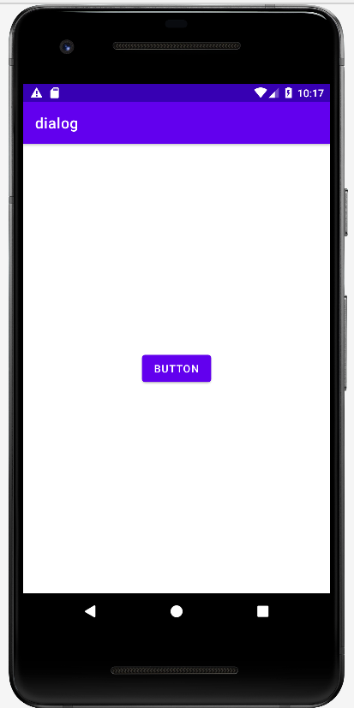
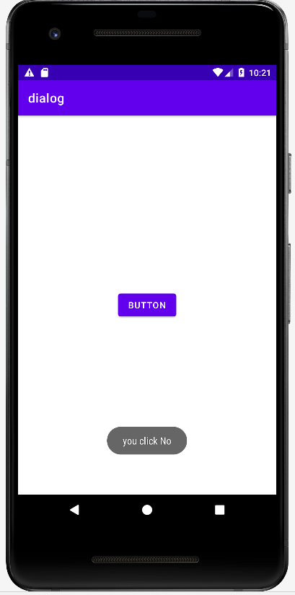
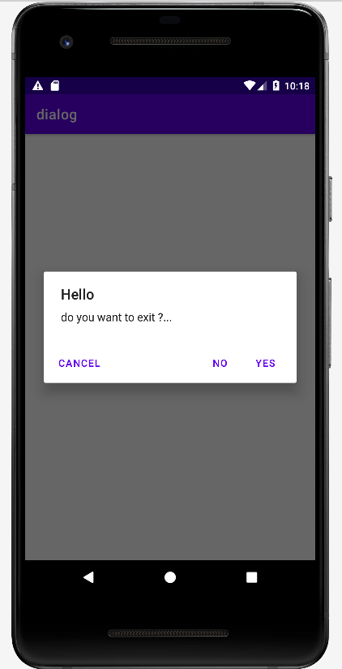
Output:

3)Dialog fragments
Code:
.kt file code:
package com.example.dialogfragment
import androidx.appcompat.app.AppCompatActivity
import android.os.Bundle
import kotlinx.android.synthetic.main.activity_main.*
class MainActivity : AppCompatActivity() {
override fun onCreate(savedInstanceState: Bundle?) {
super.onCreate(savedInstanceState)
setContentView(R.layout.activity_main)
button.setOnClickListener {
var obj=Myclass()
obj.show(supportFragmentManager,"tyit")
}
}
}
.xml file code:
<?xml version="1.0" encoding="utf-8"?>
<androidx.constraintlayout.widget.ConstraintLayout xmlns:android="http://schemas.android.com/apk/res/android"
xmlns:app="http://schemas.android.com/apk/res-auto"
xmlns:tools="http://schemas.android.com/tools"
android:layout_width="match_parent"
android:layout_height="match_parent"
tools:context=".MainActivity">
<Button
android:id="@+id/button"
android:layout_width="wrap_content"
android:layout_height="wrap_content"
android:text="Click"
app:layout_constraintBottom_toBottomOf="parent"
app:layout_constraintEnd_toEndOf="parent"
app:layout_constraintStart_toStartOf="parent"
app:layout_constraintTop_toTopOf="parent" />
</androidx.constraintlayout.widget.ConstraintLayout>
second .kt file code:
package com.example.dialogfragment
import android.os.Bundle
import android.view.LayoutInflater
import android.view.View
import android.view.ViewGroup
import android.widget.Toast
import androidx.fragment.app.DialogFragment
import kotlinx.android.synthetic.main.mylayout.view.*
class Myclass:DialogFragment() {
override fun onCreateView(
inflater: LayoutInflater,
container: ViewGroup?,
savedInstanceState: Bundle?
): View? {
var s=inflater.inflate(R.layout.mylayout,container)
s.btn.setOnClickListener {
var d=s.text.text.toString()
Toast.makeText(context,"Welcome",Toast.LENGTH_LONG).show()
}
return s
}
}
second .xml file code:
<?xml version="1.0" encoding="utf-8"?>
<RelativeLayout xmlns:android="http://schemas.android.com/apk/res/android"
android:layout_width="match_parent"
android:layout_height="match_parent">
<EditText
android:layout_width="match_parent"
android:layout_height="wrap_content"
android:id="@+id/text"
android:hint="@string/app_name"/>
<Button
android:layout_width="wrap_content"
android:layout_height="wrap_content"
android:layout_below="@+id/text"
android:id="@+id/btn"
android:text="submit"/>
</RelativeLayout>
Output:
