Practical No.08
Programs on Services, Notification and Broadcast receivers
1. Services
Code:
package com.example.service
import android.content.Intent
import android.media.MediaPlayer
import androidx.appcompat.app.AppCompatActivity
import android.os.Bundle
import android.widget.SeekBar
import kotlinx.android.synthetic.main.activity_main.*
class MainActivity : AppCompatActivity() {
override fun onCreate(savedInstanceState: Bundle?) {
super.onCreate(savedInstanceState)
setContentView(R.layout.activity_main)
var mp: MediaPlayer = MediaPlayer.create(this, R.raw.jalebi_baby)
seekBar.max=mp.duration
button.setOnClickListener {
mp.start()
}
button2.setOnClickListener {
mp.pause()
}
seekBar.setOnSeekBarChangeListener(object : SeekBar.OnSeekBarChangeListener
{
override fun onProgressChanged(p0: SeekBar?, p1: Int, p2: Boolean) {
if (p2){
mp.seekTo(p1)
}
}
override fun onStartTrackingTouch(p0: SeekBar?) {
}
override fun onStopTrackingTouch(p0: SeekBar?) {
}
})
}
}

Output:
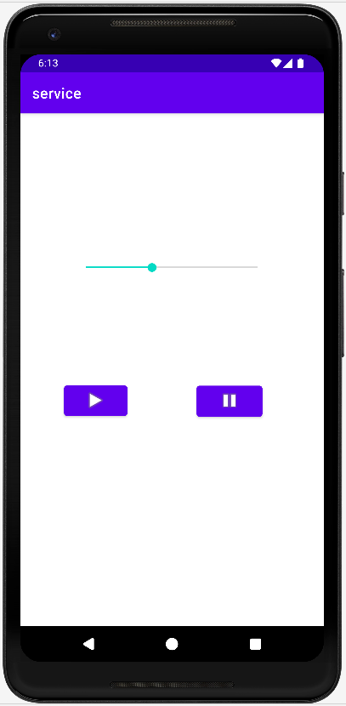
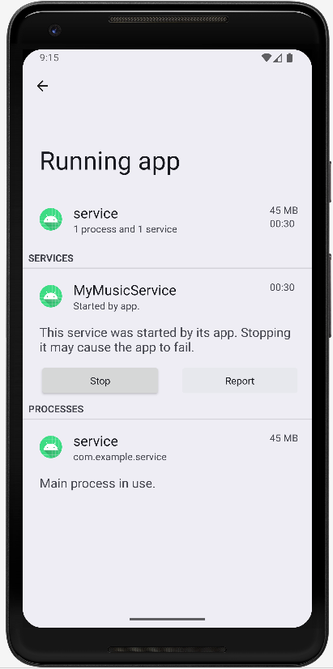
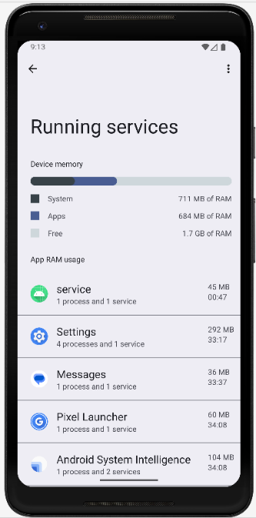

2.Notification
Code:
main.kt
package com.example.notification
import android.app.NotificationChannel
import android.app.NotificationManager
import android.app.PendingIntent
import android.content.Context
import android.content.Intent
import android.os.Build
import androidx.appcompat.app.AppCompatActivity
import android.os.Bundle
import androidx.core.app.NotificationCompat
import androidx.core.app.NotificationManagerCompat
import kotlinx.android.synthetic.main.activity_main.*
class MainActivity : AppCompatActivity() {
var nchid="TYIT"
override fun onCreate(savedInstanceState: Bundle?) {
super.onCreate(savedInstanceState)
setContentView(R.layout.activity_main)
createNotificationChannel()
button.setOnClickListener {
createNotification()
}
}
fun createNotificationChannel(){
if(Build.VERSION.SDK_INT>=Build.VERSION_CODES.O){
var ch=NotificationChannel(nchid,"SRM",NotificationManager.IMPORTANCE_HIGH)
var mg=getSystemService(Context.NOTIFICATION_SERVICE) as NotificationManager
mg.createNotificationChannel(ch)
}
}
fun createNotification(){
val i = Intent(this, whatsapp::class.java)
val pi = PendingIntent.getActivity(this, 0, i, PendingIntent.FLAG_UPDATE_CURRENT )
var n=NotificationCompat.Builder(this,nchid)
.setSmallIcon(com.google.android.material.R.drawable.ic_clock_black_24dp)
.setContentTitle("Whatsapp")
.setContentText("You have new Message")
.setPriority(NotificationManager.IMPORTANCE_HIGH)
.setContentIntent(pi)
.build()
NotificationManagerCompat.from(this).notify(1,n)
}
}
whatsapp.xml
<?xml version="1.0" encoding="utf-8"?>
<androidx.constraintlayout.widget.ConstraintLayout xmlns:android="http://schemas.android.com/apk/res/android"
xmlns:app="http://schemas.android.com/apk/res-auto"
xmlns:tools="http://schemas.android.com/tools"
android:layout_width="match_parent"
android:layout_height="match_parent"
tools:context=".whatsapp">
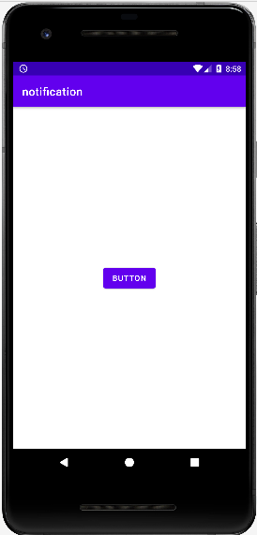
<ImageView
android:id="@+id/imageView"
android:layout_width="287dp"
android:layout_height="283dp"
app:layout_constraintBottom_toBottomOf="parent"
app:layout_constraintEnd_toEndOf="parent"
app:layout_constraintStart_toStartOf="parent"
app:layout_constraintTop_toTopOf="parent"
app:srcCompat="@drawable/wtp2" />
</androidx.constraintlayout.widget.ConstraintLayout>
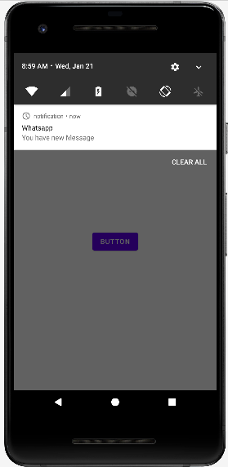
Output:
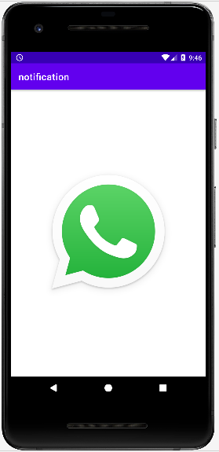

3. Broadcast receivers
Code:
package com.tyit.broadcast
import android.content.BroadcastReceiver
import android.content.Context
import android.content.Intent
import android.content.IntentFilter
import androidx.appcompat.app.AppCompatActivity
import android.os.Bundle
import android.widget.Toast
class MainActivity : AppCompatActivity() {
var br =object :BroadcastReceiver(){
override fun onReceive(p0: Context?, p1: Intent?)
{
if (p1?.action==Intent.ACTION_AIRPLANE_MODE_CHANGED) {
var flag =p1.getBooleanExtra("state",false)
if (flag){
Toast.makeText(p0, "Airplane Mode ON", Toast.LENGTH_LONG).show()
}
else{
Toast.makeText(p0, "Airplane Mode OFF", Toast.LENGTH_LONG).show()
}
}
}
}
override fun onStart() {
super.onStart()
registerReceiver(br, IntentFilter(Intent.ACTION_AIRPLANE_MODE_CHANGED))
}
override fun onStop() {
super.onStop()
unregisterReceiver(br)
}
override fun onCreate(savedInstanceState: Bundle?) {
super.onCreate(savedInstanceState)
setContentView(R.layout.activity_main)
}
}

Output:
Airplane Mode ON
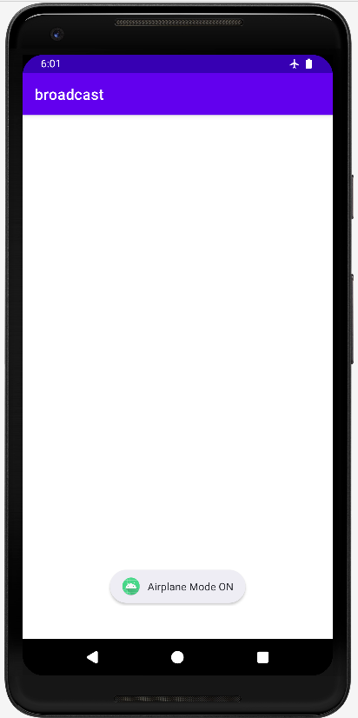
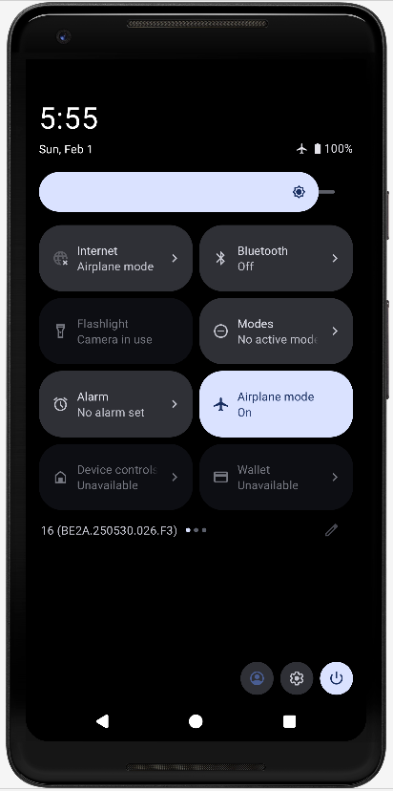

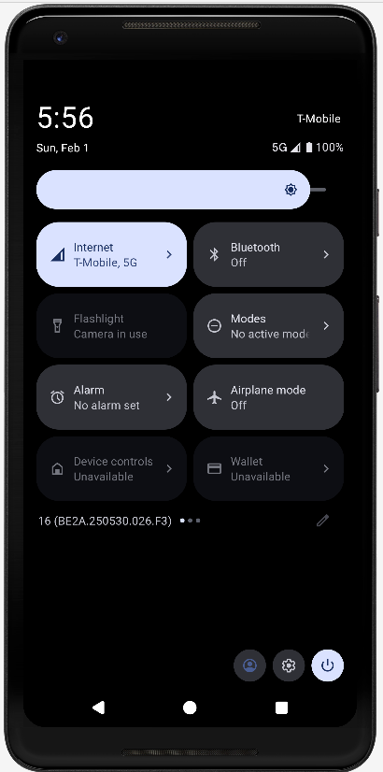
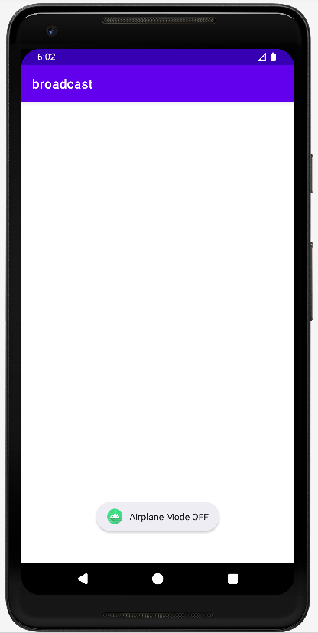
Airplane Mode OFF

