Practical No.09
Database Programming with SQLite
Code:
Main.kt file:
package com.example.databaseconnection
import androidx.appcompat.app.AppCompatActivity
import android.os.Bundle
import android.widget.ArrayAdapter
import kotlinx.android.synthetic.main.activity_main.*
class MainActivity : AppCompatActivity() {
lateinit var db: MyDb
var oldId = ""
override fun onCreate(savedInstanceState: Bundle?) {
super.onCreate(savedInstanceState)
setContentView(R.layout.activity_main)
db = MyDb(this)
button.setOnClickListener {
db.increRec(data3.text.toString(), data1.text.toString(),data2.text.toString())
readData()
clearFields()
}
button2.setOnClickListener {
val newId = data3.text.toString()
val fn = data1.text.toString()
val ln = data2.text.toString()
db.updateRec(oldId, newId, fn, ln)
oldId = newId
readData()
clearFields()
}
lv.setOnItemClickListener { AdapterView, view, i, l ->
val item = lv.getItemAtPosition(i).toString()
val parts = item.split(" ")
oldId = parts[0]
data3.setText(parts[0])
data1.setText(parts[1])
data2.setText(parts[2])
}
lv.setOnItemLongClickListener {AdapterView, view, i, l ->
val item = lv.getItemAtPosition(i).toString()
val id = item.split(" ")[0]
db.deleteRec(id)
readData()
true
}
readData()
}
fun readData() {
val tdata = db.readData()
lv.adapter = ArrayAdapter(this, android.R.layout.simple_list_item_1, tdata)
}
fun clearFields() {
data3.setText("")
data1.setText("")
data2.setText("")
}
}

MyDB.kt file :
package com.example.databaseconnection
import android.content.ContentValues
import android.content.Context
import android.database.sqlite.SQLiteDatabase
import android.database.sqlite.SQLiteOpenHelper
import android.widget.Toast
class MyDb(var ctx: Context) : SQLiteOpenHelper(ctx, "TYIT2026", null, 2) {
override fun onCreate(db: SQLiteDatabase?) {
db?.execSQL(
"create table Student(" +
"id text primary key, " +
"fname text, " +
"lname text)"
)
}
override fun onUpgrade(db: SQLiteDatabase?, oldVersion: Int, newVersion: Int) {
db?.execSQL("DROP TABLE IF EXISTS Student")
onCreate(db)
}
fun increRec(id: String, fn: String, ln: String) {
val db = this.writableDatabase
val cv = ContentValues()
cv.put("id", id)
cv.put("fname", fn)
cv.put("lname", ln)
val res = db.insert("Student", null, cv)
if (res > 0)
Toast.makeText(ctx, "Record Inserted", Toast.LENGTH_LONG).show()
else
Toast.makeText(ctx, "ID Already Exists", Toast.LENGTH_LONG).show()
}
fun readData(): ArrayList<String> {
val db = this.readableDatabase
val data = ArrayList<String>()
val cursor = db.rawQuery("SELECT * FROM Student", null)
if (cursor.moveToFirst()) {
do {
data.add(cursor.getString(0) + " " +
cursor.getString(1) + " " +
cursor.getString(2))
} while (cursor.moveToNext())
}
cursor.close()
return data
}
fun deleteRec(id: String) {
val db = this.writableDatabase
val res = db.delete("Student", "id=?", arrayOf(id))
if (res > 0)
Toast.makeText(ctx, "Record Deleted", Toast.LENGTH_LONG).show()
else
Toast.makeText(ctx, "Delete Failed", Toast.LENGTH_LONG).show()
}
fun updateRec(oldId: String, newId: String, fn: String, ln: String) {
val db = this.writableDatabase
val cv = ContentValues()
cv.put("id", newId)
cv.put("fname", fn)
cv.put("lname", ln)
val res = db.update("Student", cv, "id=?", arrayOf(oldId))
if (res > 0)
Toast.makeText(ctx, "Record Updated", Toast.LENGTH_LONG).show()
else
Toast.makeText(ctx, "Update Failed", Toast.LENGTH_LONG).show()
}
}

Output:
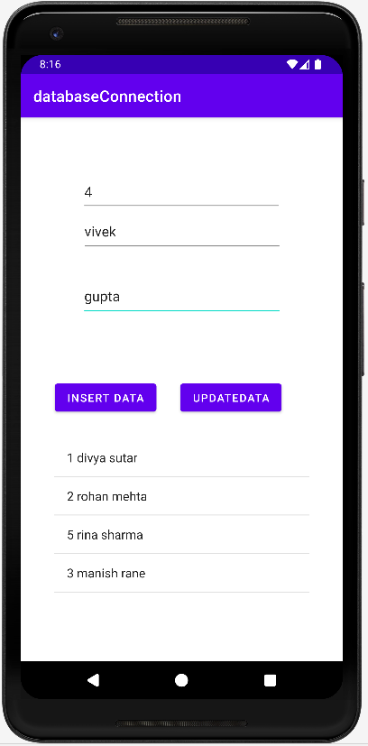
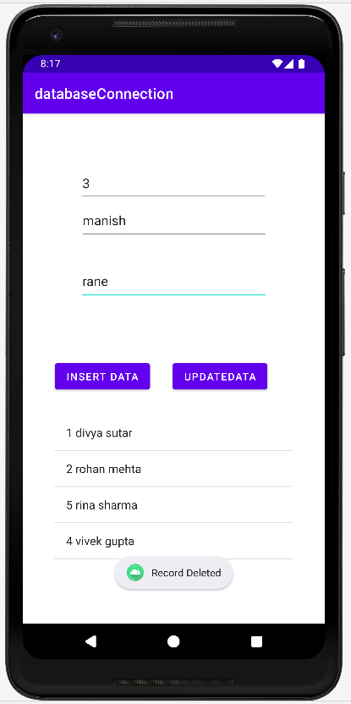
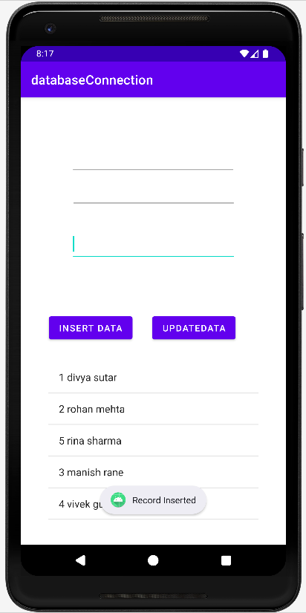
Insert operation Delete operation

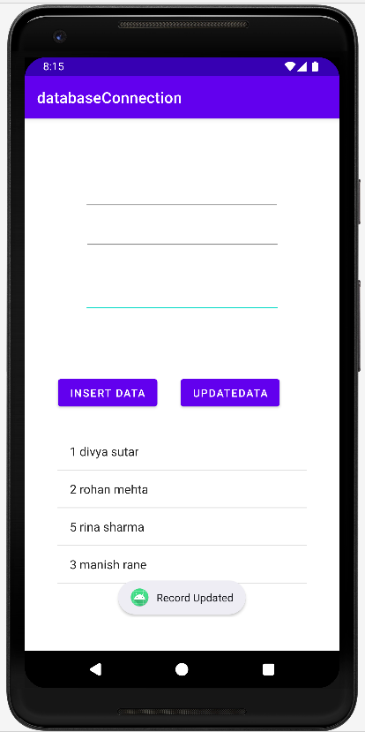
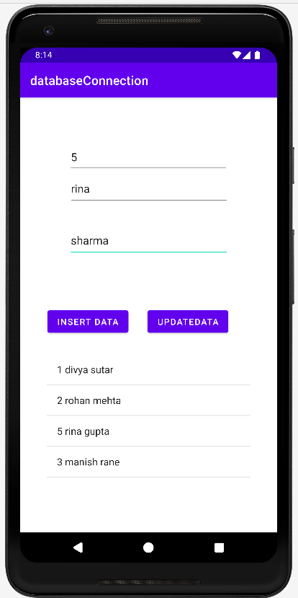
Update operation

