PRACTICAL NO.07
Programs on Intents, Events, Listeners and Adapters
The Android Intent Class, Using Events and Event ListenersS
1.Intent
Code:
package com.example.intent
import android.content.Intent
import androidx.appcompat.app.AppCompatActivity
import android.os.Bundle
import kotlinx.android.synthetic.main.activity_main.*
class MainActivity : AppCompatActivity() {
override fun onCreate(savedInstanceState: Bundle?) {
super.onCreate(savedInstanceState)
setContentView(R.layout.activity_main)
button.setOnClickListener {
var u="Hello Userw"
var o=Intent(Intent.ACTION_SEND)
o.putExtra(Intent.EXTRA_TEXT,u)
o.type="text/plain"
var s=Intent.createChooser(o,null)
startActivity(s)
}
}}
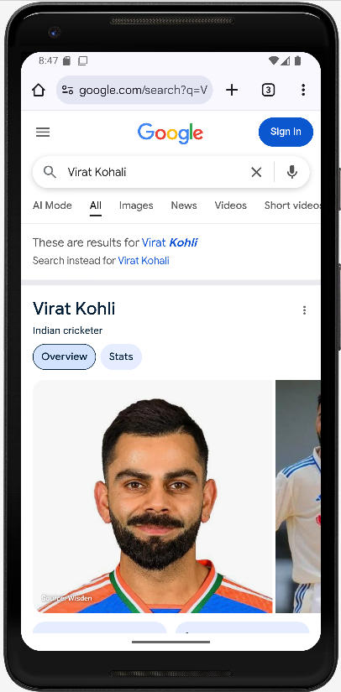
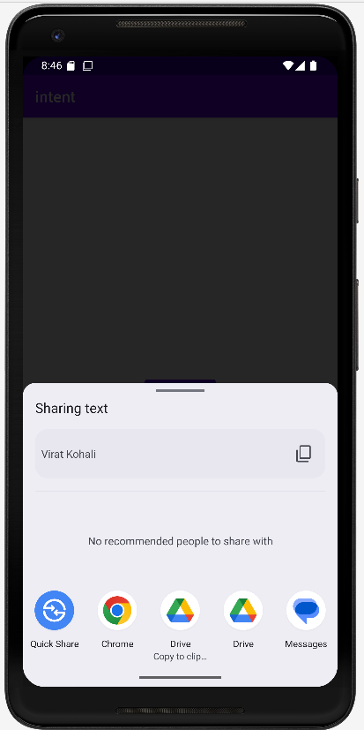
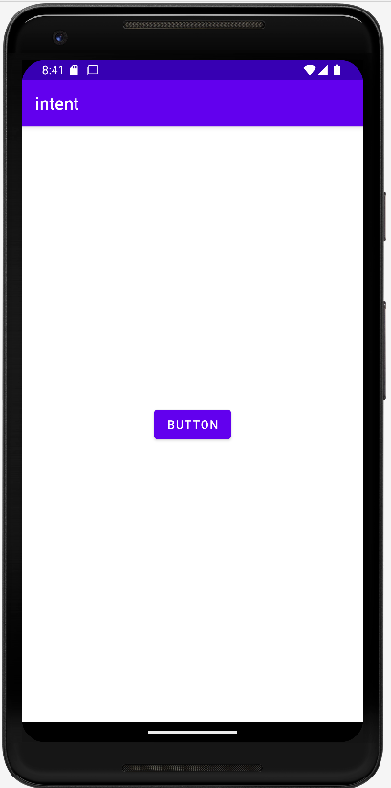
Output:

2.Event and Event Listener
A.Button
Code:
package com.example.event
import android.graphics.Color
import androidx.appcompat.app.AppCompatActivity
import android.os.Bundle
import android.widget.Toast
import kotlinx.android.synthetic.main.activity_main.*
class MainActivity : AppCompatActivity() {
override fun onCreate(savedInstanceState: Bundle?) {
super.onCreate(savedInstanceState)
setContentView(R.layout.activity_main)
button.setOnClickListener {
textView.text="single click"
}
button.setOnLongClickListener {
bgcolor.setBackgroundColor(Color.YELLOW)
true
}
}
}
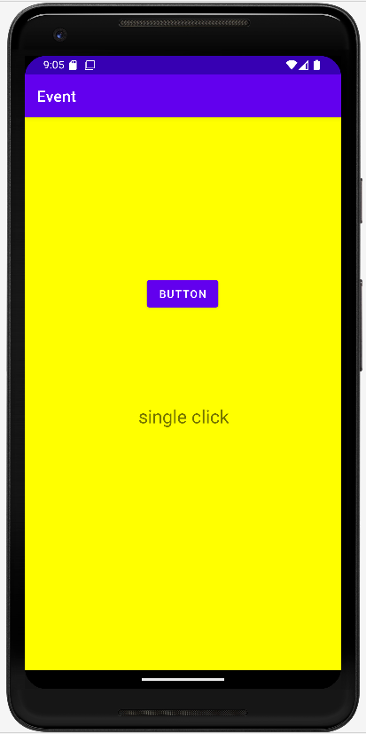
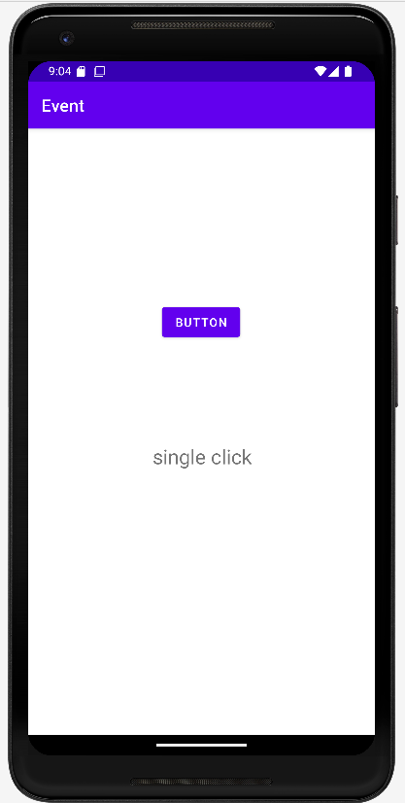
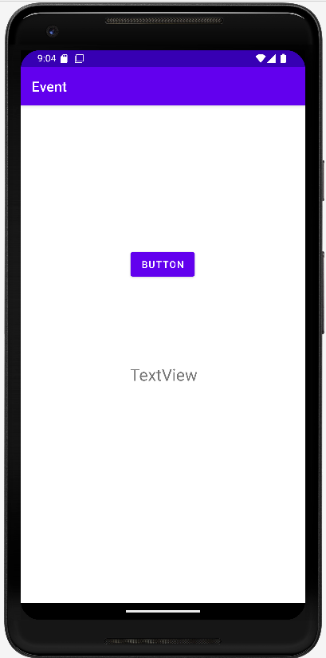
Output:

B.Image
1)touch
Code:
package com.example.event
import android.graphics.Color
import androidx.appcompat.app.AppCompatActivity
import android.os.Bundle
import android.view.MotionEvent
import android.widget.Toast
import kotlinx.android.synthetic.main.activity_main.*
class MainActivity : AppCompatActivity() {
override fun onCreate(savedInstanceState: Bundle?) {
super.onCreate(savedInstanceState)
setContentView(R.layout.activity_main)
imageView.setOnTouchListener { view, motionEvent ->
when(motionEvent.action){
MotionEvent.ACTION_DOWN ->textView.text="Action down"
MotionEvent.ACTION_UP ->textView.text="Action up"
}
true
}
}
}
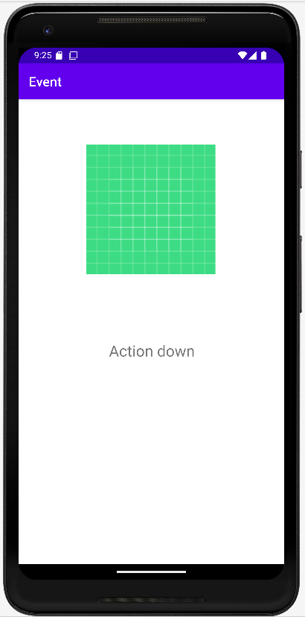
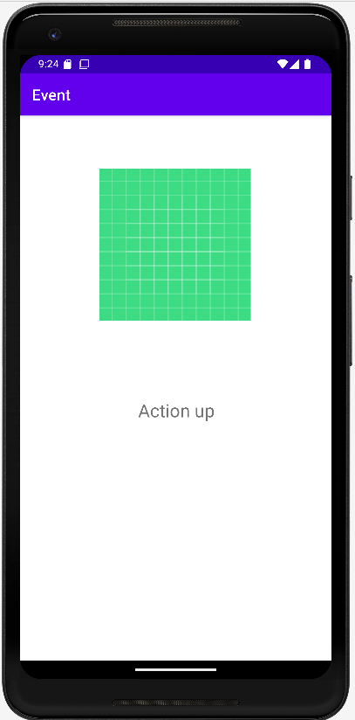
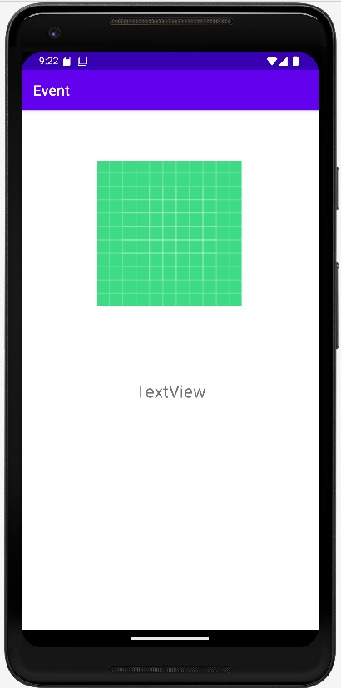
Output:

2.Click
Code:
package com.example.event
import android.graphics.Color
import androidx.appcompat.app.AppCompatActivity
import android.os.Bundle
import android.view.MotionEvent
import android.widget.Toast
import kotlinx.android.synthetic.main.activity_main.*
class MainActivity : AppCompatActivity() {
override fun onCreate(savedInstanceState: Bundle?) {
super.onCreate(savedInstanceState)
setContentView(R.layout.activity_main)
imageView.setOnClickListener {
textView.text="Image Clicked"
}
}
}
Output:
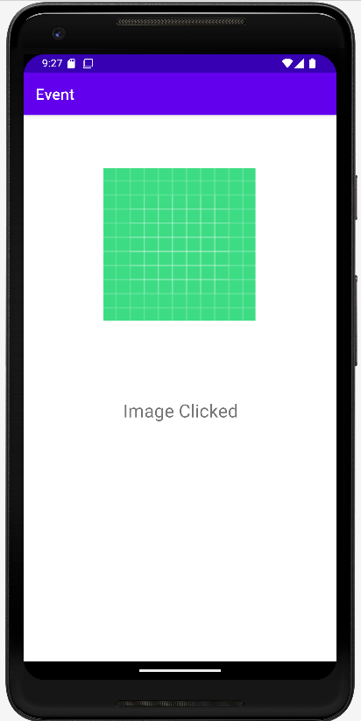

3.Plaintext
Code:
package com.example.event
import android.graphics.Color
import androidx.appcompat.app.AppCompatActivity
import android.os.Bundle
import android.view.KeyEvent
import android.view.MotionEvent
import android.widget.Toast
import kotlinx.android.synthetic.main.activity_main.*
class MainActivity : AppCompatActivity() {
override fun onCreate(savedInstanceState: Bundle?) {
super.onCreate(savedInstanceState)
setContentView(R.layout.activity_main)
udata.setOnKeyListener { view, i, keyEvent ->
if(keyEvent.keyCode==KeyEvent.KEYCODE_ENTER){
textView.text="You Clicked on Enter"
}
true
}
}
}
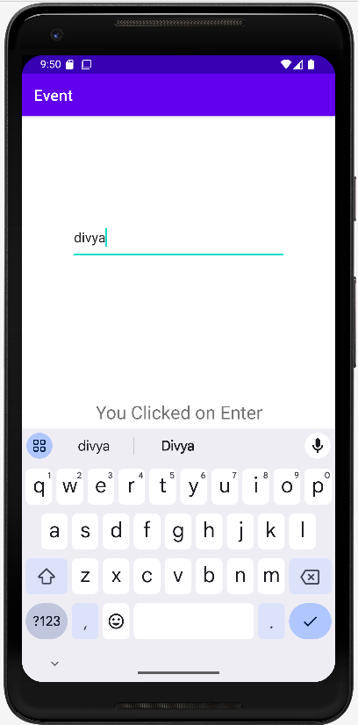
Output:
