Practical No:02
Programming Activity And Fragment

- Activity Life Cycle:
Code:
package example.it.prac2
import androidx.appcompat.app.AppCompatActivity
import android.os.Bundle
import android.widget.Toast
class MainActivity : AppCompatActivity()
{
override fun onCreate(savedInstanceState: Bundle?) {
super.onCreate(savedInstanceState)
Toast.makeText(this,"Oncreate",Toast.LENGTH_LONG).show()
setContentView(R.layout.activity_main)
}
override fun onPause()
{
Toast.makeText(this,"OnPause",Toast.LENGTH_LONG).show()
super.onPause()
}
override fun onStart()
{
Toast.makeText(this,"OnStart",Toast.LENGTH_LONG).show()
super.onStart()
}
override fun onRestart()
{
Toast.makeText(this,"OnRestart",Toast.LENGTH_LONG).show()
super.onRestart()
}
override fun onStop()
{
Toast.makeText(this,"OnStop",Toast.LENGTH_LONG).show()
super.onStop()
}
override fun onDestroy()
{
Toast.makeText(this,"OnDestroy",Toast.LENGTH_LONG).show()
super.onDestroy()
}
override fun onResume()
{
Toast.makeText(this,"OnResume",Toast.LENGTH_LONG).show()
super.onResume()
}
}

Output:
onCreate onStart
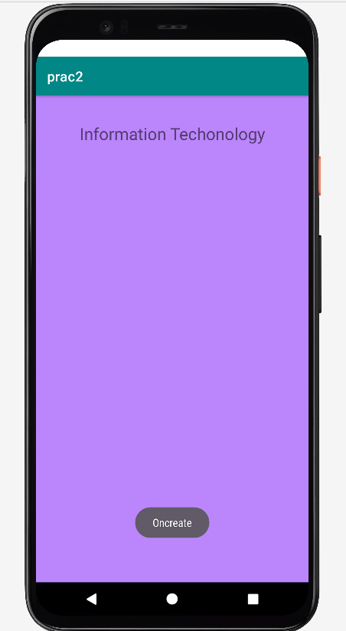
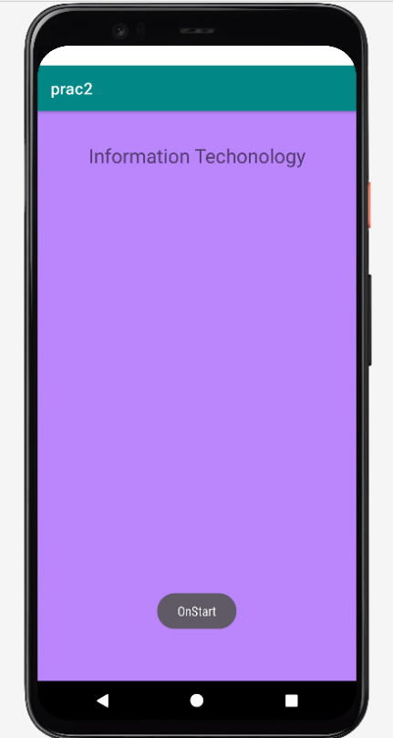

onResume onPause
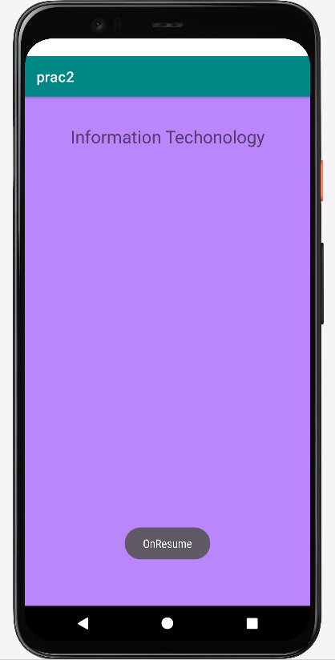
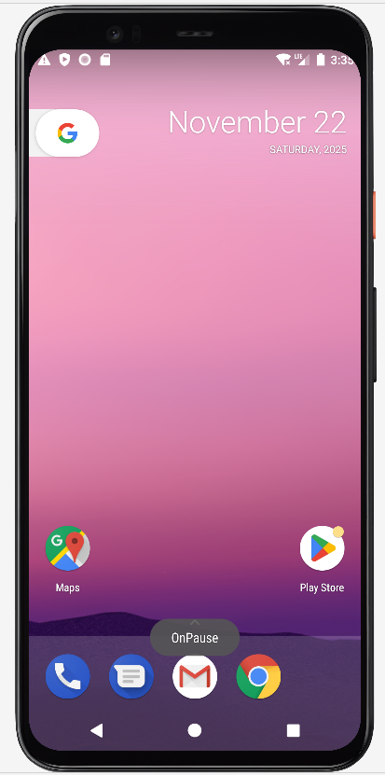

onStop onRestart
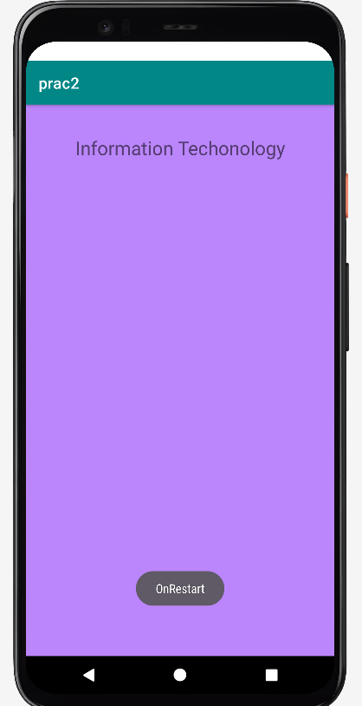
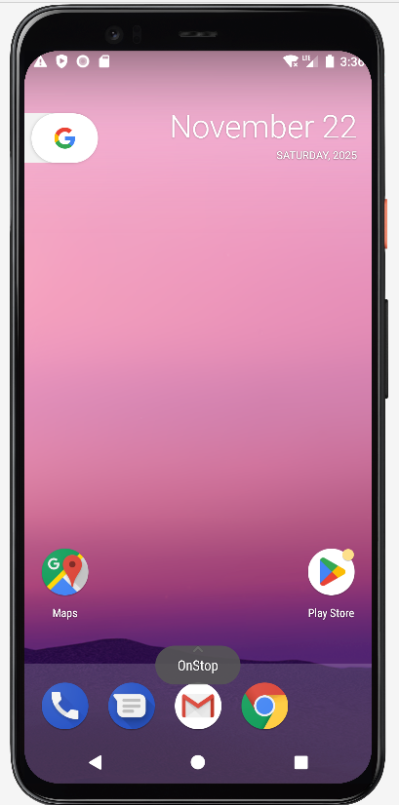

onDestroy
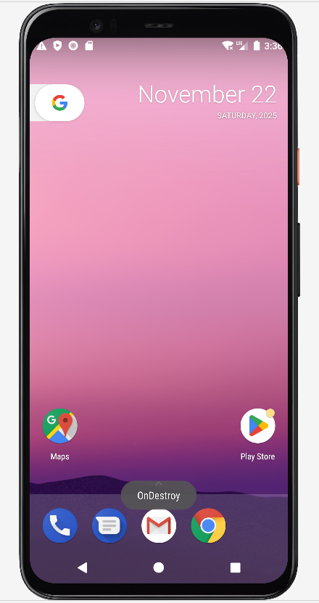

b. Fragment Life Cycle
Code:
package example.it.prac2
import android.content.Context
import android.os.Bundle
import androidx.fragment.app.Fragment
import android.view.LayoutInflater
import android.view.View
import android.view.ViewGroup
import android.widget.Toast
class fragment1 : Fragment() {
override fun onCreate(savedInstanceState: Bundle?) {
Toast.makeText(context,"onCreate",Toast.LENGTH_LONG).show()
super.onCreate(savedInstanceState)
}
override fun onCreateView(
inflater: LayoutInflater, container: ViewGroup?,
savedInstanceState: Bundle?
): View? {
return inflater.inflate(R.layout.fragment_fragment1, container, false)
}
override fun onPause() {
Toast.makeText(context,"onPause",Toast.LENGTH_LONG).show()
super.onPause()
}
override fun onStart() {
Toast.makeText(context,"onStar",Toast.LENGTH_LONG).show()
super.onStart()
}
override fun onResume() {
Toast.makeText(context,"onResume",Toast.LENGTH_LONG).show()
super.onResume()
}
override fun onStop() {
Toast.makeText(context,"onStop",Toast.LENGTH_LONG).show()
super.onStop()
}
override fun onDestroy() {
Toast.makeText(context,"onDestory",Toast.LENGTH_LONG).show()
super.onDestroy()
}
override fun onAttach(context: Context) {
Toast.makeText(context,"onAttach",Toast.LENGTH_LONG).show()
super.onAttach(context)
}
override fun onDetach() {
Toast.makeText(context,"onDetach",Toast.LENGTH_LONG).show()
super.onDetach()
}
}

Output:
onDetach onAttach
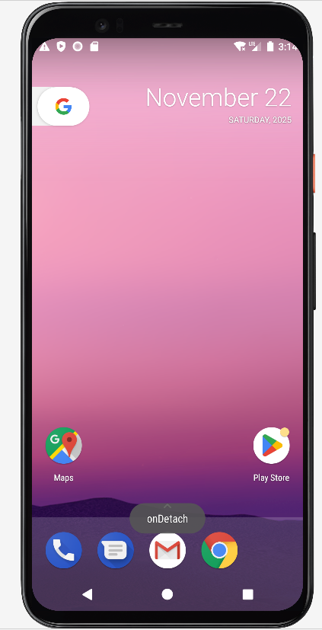
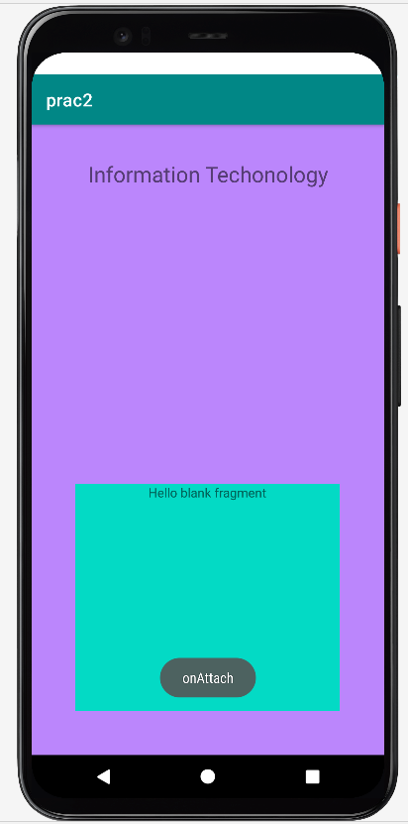

onCreate onStart
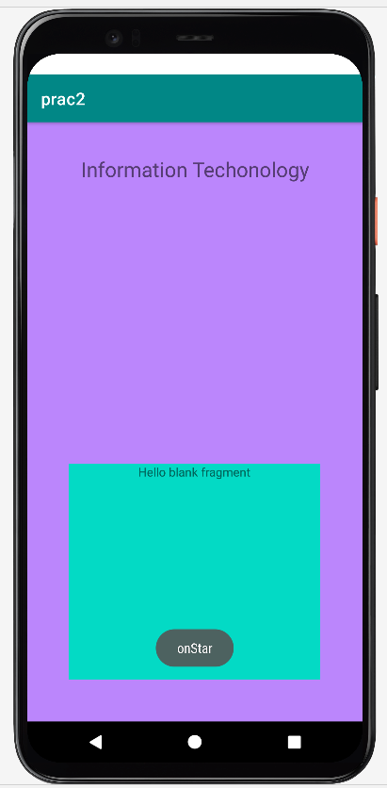
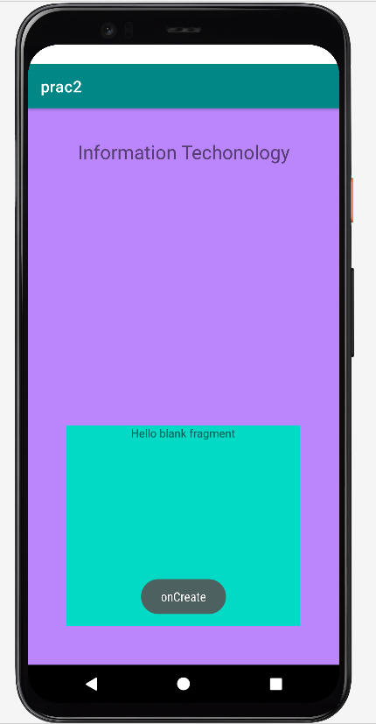

onResume onPause
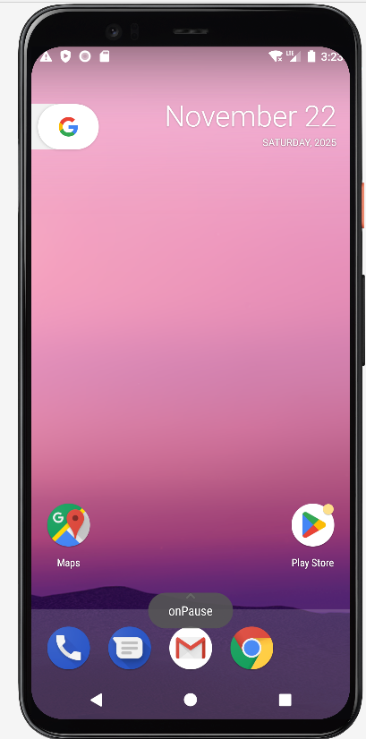
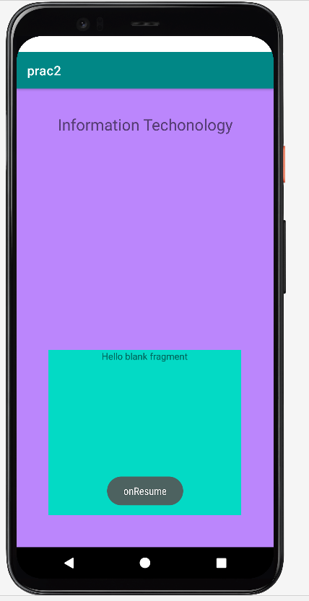

onStop onDestroy
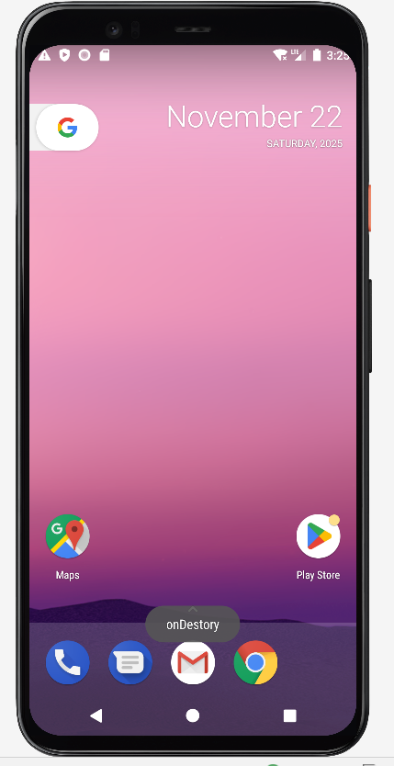
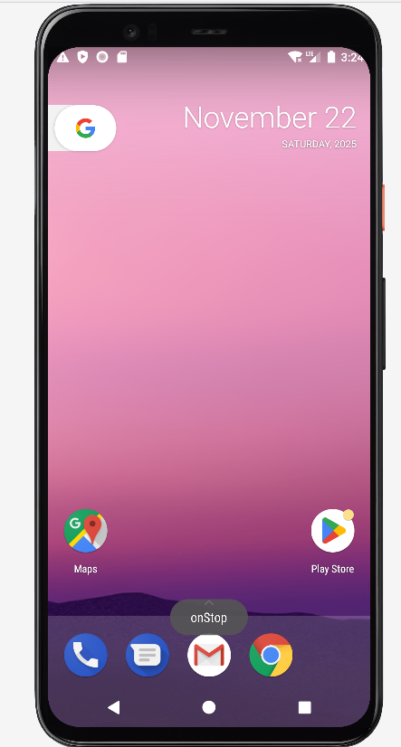

c. Multiple Activity
first.kt
package com.example.firstacitivity
import android.content.Intent
import androidx.appcompat.app.AppCompatActivity
import android.os.Bundle
import kotlinx.android.synthetic.main.activity_main.*
class MainActivity : AppCompatActivity() {
override fun onCreate(savedInstanceState: Bundle?) {
super.onCreate(savedInstanceState)
setContentView(R.layout.activity_main)
btn.setOnClickListener {
var newp= Intent(this,SecondActivity::class.java)
var udata=textbox.text.toString()
newp.putExtra("my_data",udata)
startActivity(newp)
}
}
}
second.kt
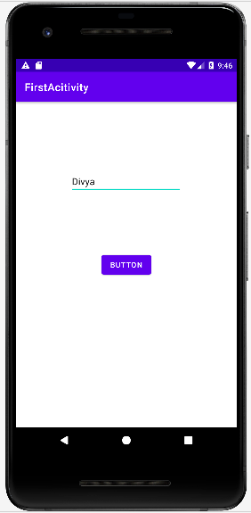
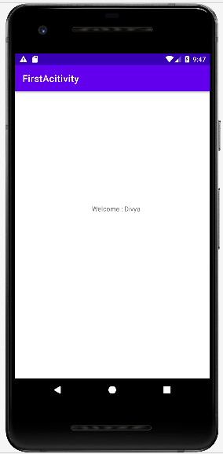
package com.example.firstacitivity
import androidx.appcompat.app.AppCompatActivity
import android.os.Bundle
import kotlinx.android.synthetic.main.activity_second.*
class SecondActivity : AppCompatActivity() {
override fun onCreate(savedInstanceState: Bundle?) {
super.onCreate(savedInstanceState)
setContentView(R.layout.activity_second)
var data =intent.getStringExtra("my_data")
textView.text="Welcome : $data"
}
}
Output:

d. Multiple Fragment
mainActivity
package srm.it.fragmentdemo
import androidx.appcompat.app.AppCompatActivity
import android.os.Bundle
import kotlinx.android.synthetic.main.activity_main.*
class MainActivity : AppCompatActivity() {
override fun onCreate(savedInstanceState: Bundle?) {
super.onCreate(savedInstanceState)
setContentView(R.layout.activity_main)
var state=0
button.setOnClickListener {
if(state==0) {
supportFragmentManager.beginTransaction().replace(R.id.fragmentContainerView,first()).commit()
state=1
}
else{ supportFragmentManager.beginTransaction().replace(R.id.fragmentContainerView,second()).commit()
state=0
} } } }
first Fragment
package srm.it.fragmentdemo
import android.os.Bundle
import androidx.fragment.app.Fragment
import android.view.LayoutInflater
import android.view.View
import android.view.ViewGroup
import android.widget.Toast
import kotlinx.android.synthetic.main.fragment_first.*
import kotlinx.android.synthetic.main.fragment_first.view.*
class first : Fragment() {
override fun onCreate(savedInstanceState: Bundle?) {
super.onCreate(savedInstanceState)
}
override fun onCreateView(
inflater: LayoutInflater, container: ViewGroup?,
savedInstanceState: Bundle?
): View? {
var root=inflater.inflate(R.layout.fragment_first, container, false)
root.button2.setOnClickListener {
Toast.makeText(context,"Fragment One",Toast.LENGTH_LONG).show()
}
return root
} }

second Fragment
package srm.it.fragmentdemo
import android.os.Bundle
import androidx.fragment.app.Fragment
import android.view.LayoutInflater
import android.view.View
import android.view.ViewGroup
import android.widget.Toast
import kotlinx.android.synthetic.main.fragment_second.*
import kotlinx.android.synthetic.main.fragment_second.view.*
class second : Fragment() {
override fun onCreate(savedInstanceState: Bundle?) {
super.onCreate(savedInstanceState)
}
override fun onCreateView(
inflater: LayoutInflater, container: ViewGroup?,
savedInstanceState: Bundle?
): View? {
var root=inflater.inflate(R.layout.fragment_second, container, false)
root.button3.setOnClickListener {
Toast.makeText(context,"Fragment Second",Toast.LENGTH_LONG).show()
}
return root
} }

Output:
First Fragment second Fragment
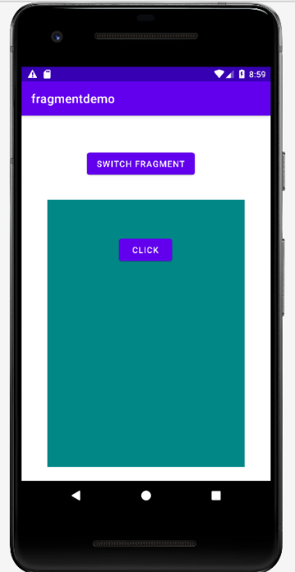
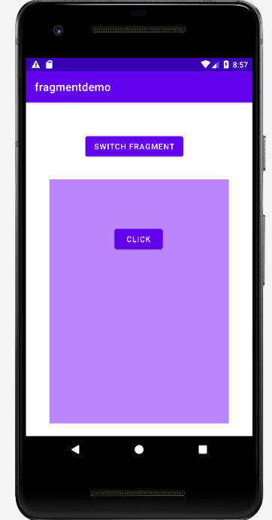

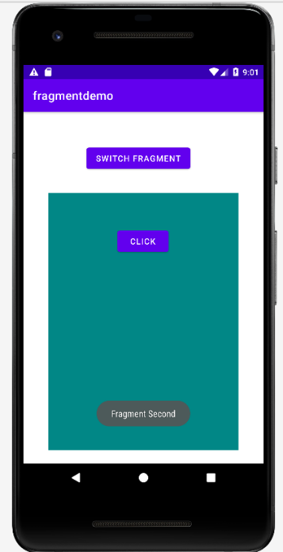
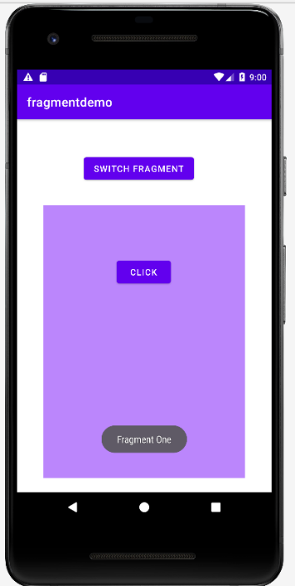
Inside firstFragment Inside secondFragment

