PRACTICAL NO:01

Step1: Open QGIS-> Select Project→ New Project

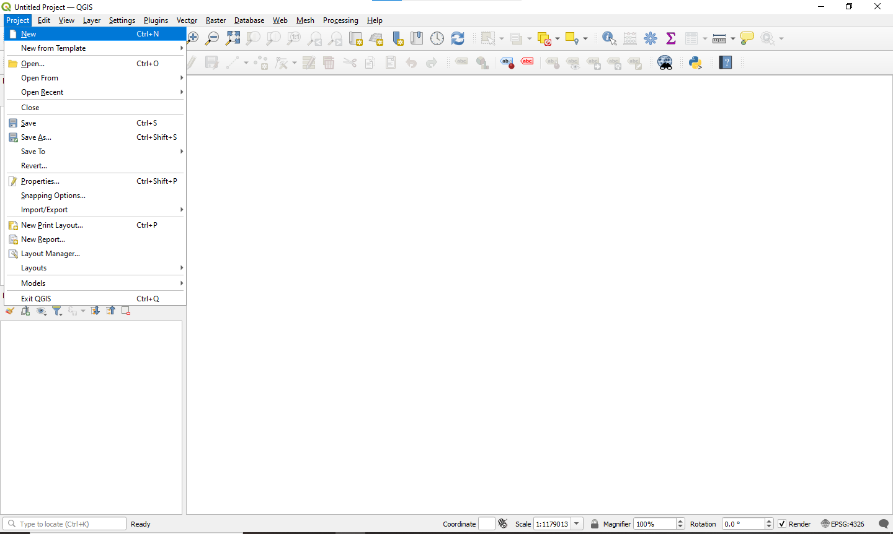

Step2: Select Layer → Create Layer → New Shapefile Layer

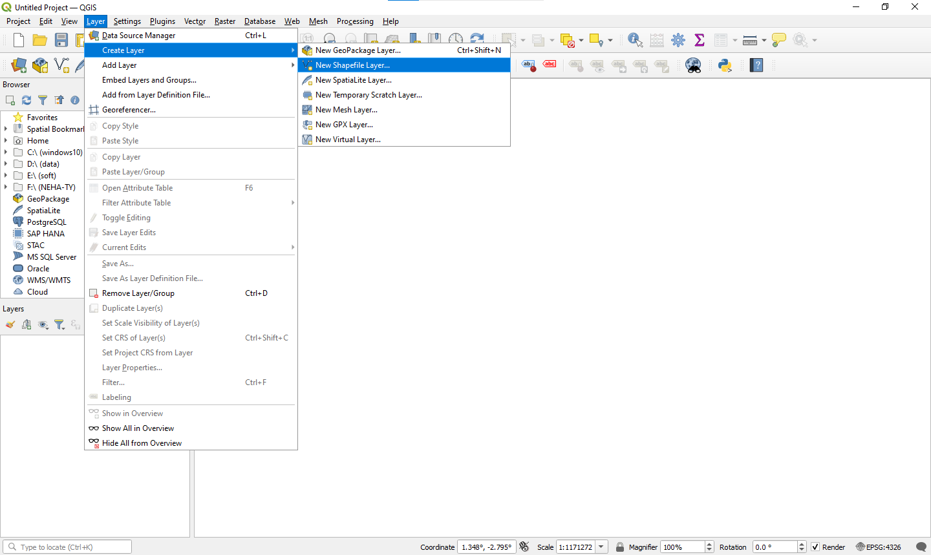

Step 3: Set File name:kudal, Select Geometry type:polygoan, Set CRS: EPSG:4326 – WGS 84 New Field- add column name, set data type and length.

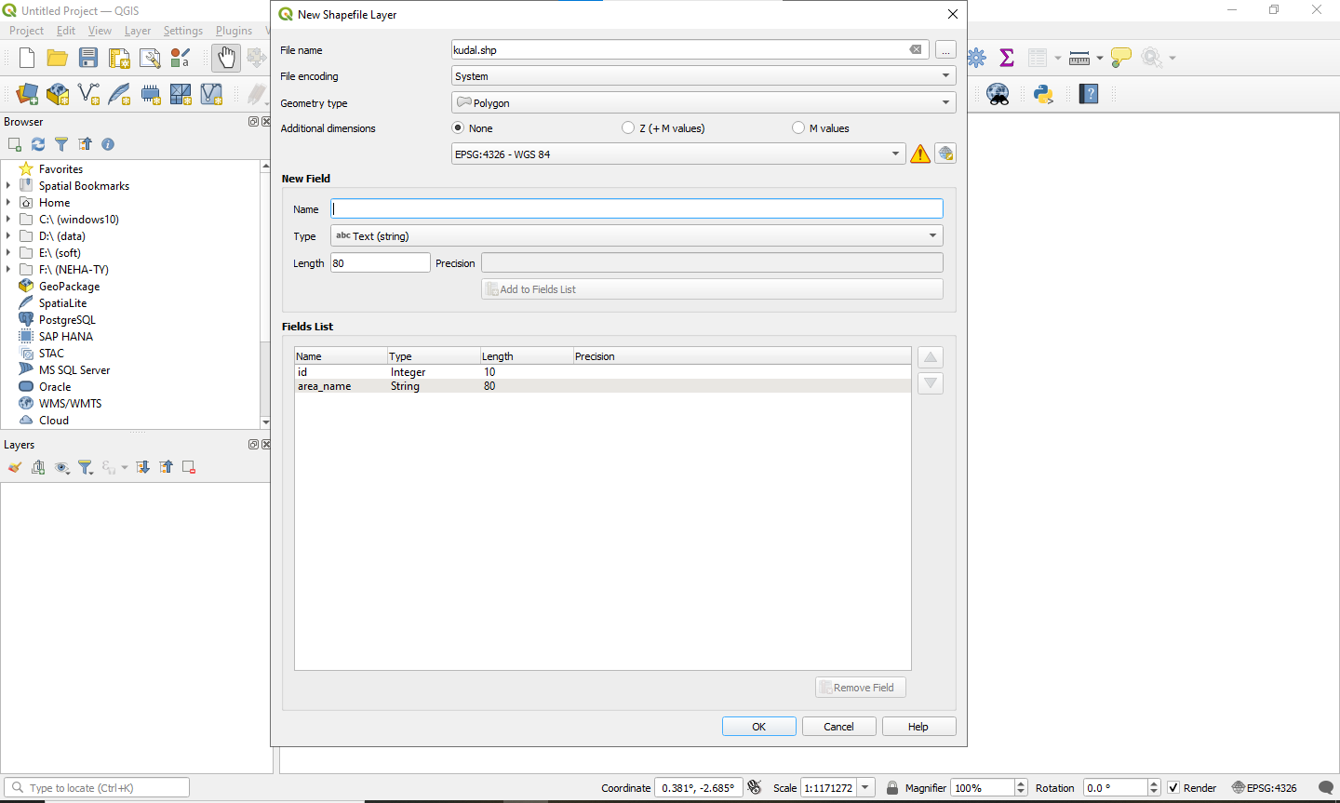

Step 4: To plot Polygon features -> Select the Polygon Feature from layer -> Click Toggle Editing Button → Click on Add Polygon-> set attribute values.

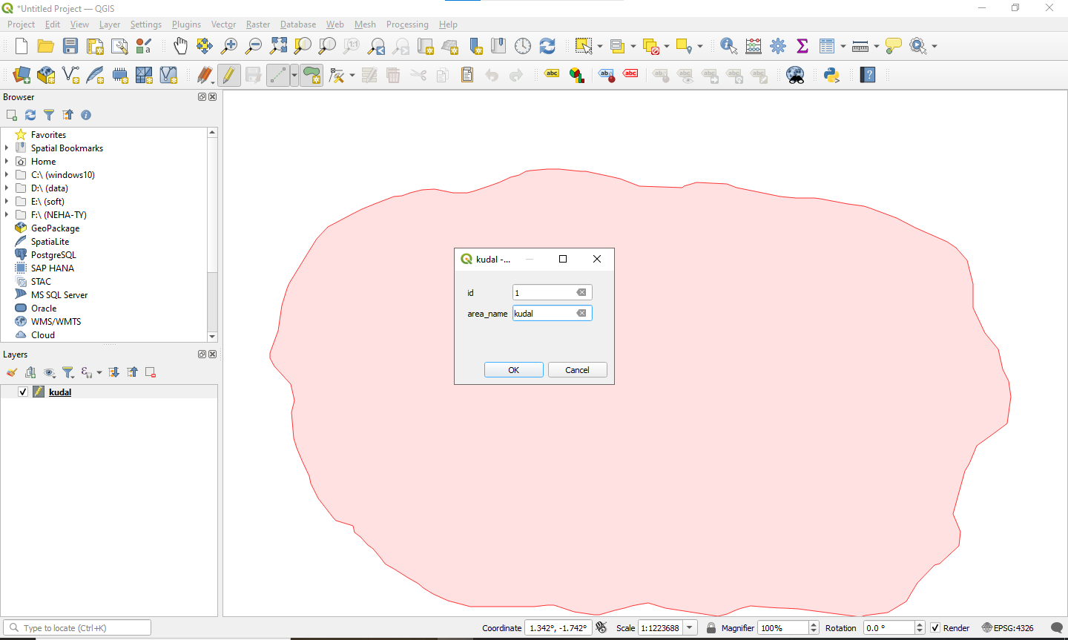

Step 5: To set Style property -> Right click on layer -> click on control feature Symbology -> select pattern or set color -> ok

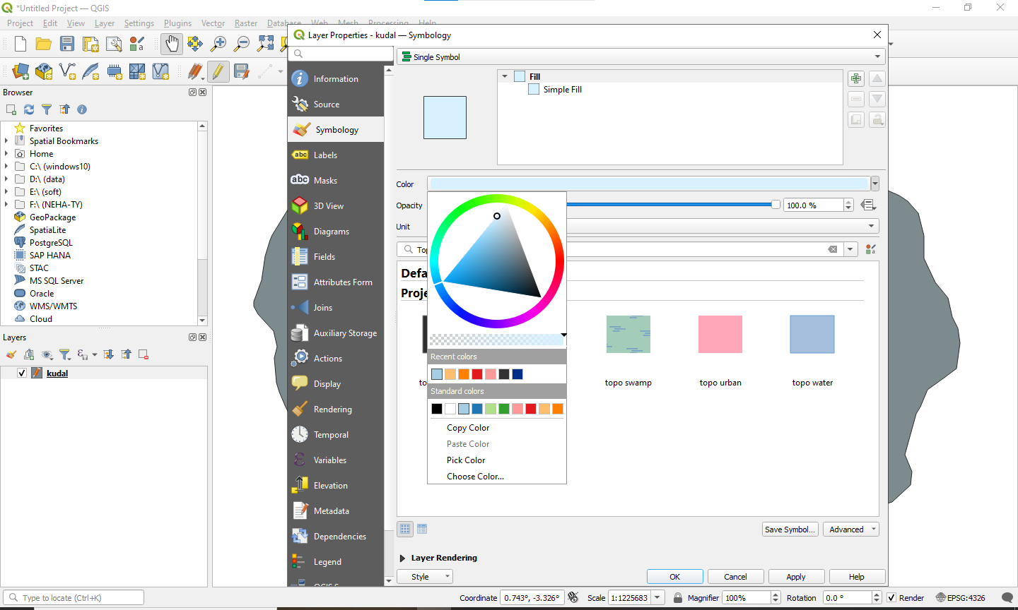

Step 6: Right click on layer -> click on control feature labeling -> select Single Labels -> set value=area_name ->ok

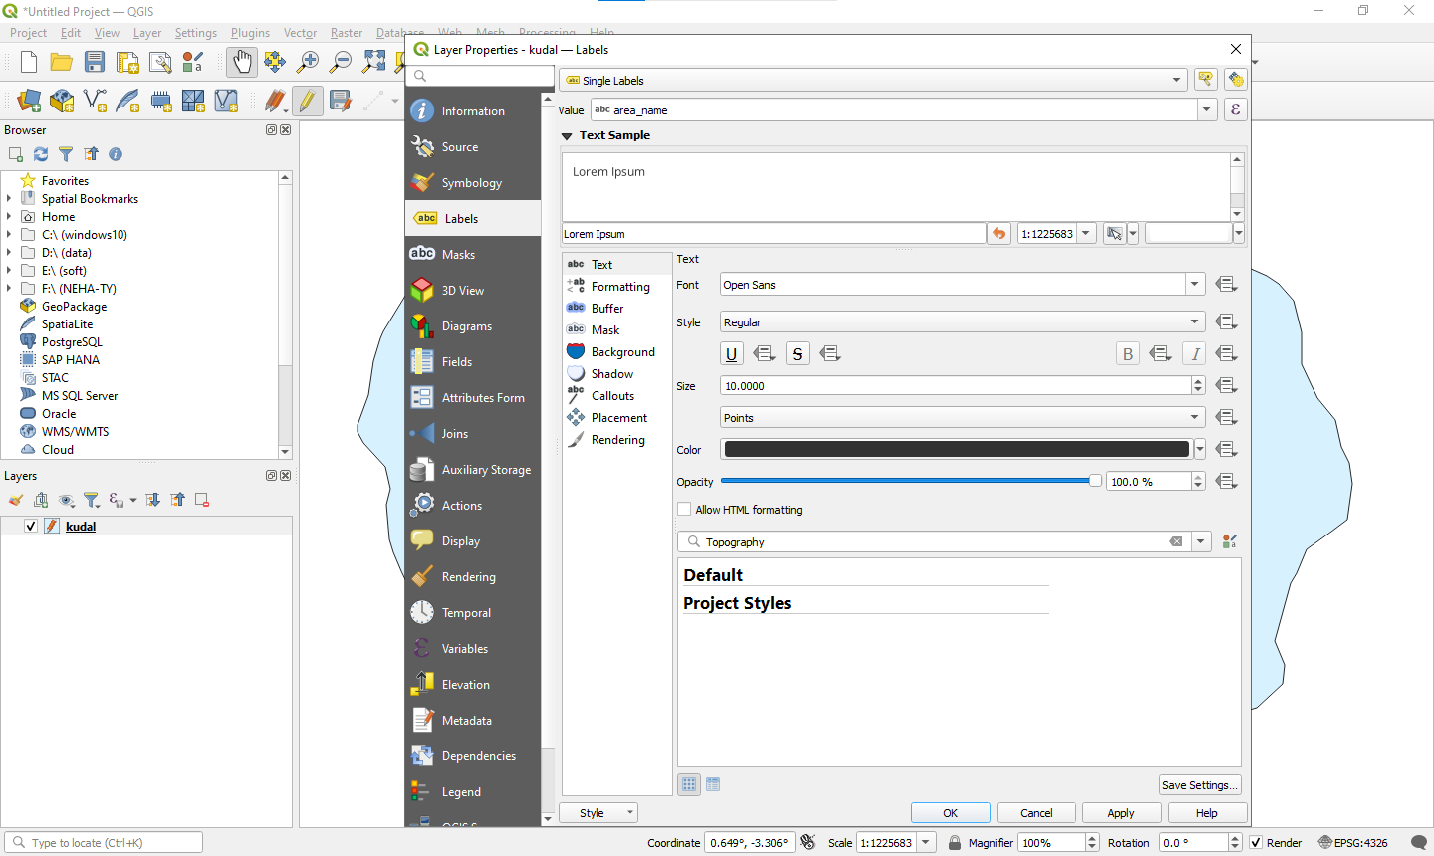

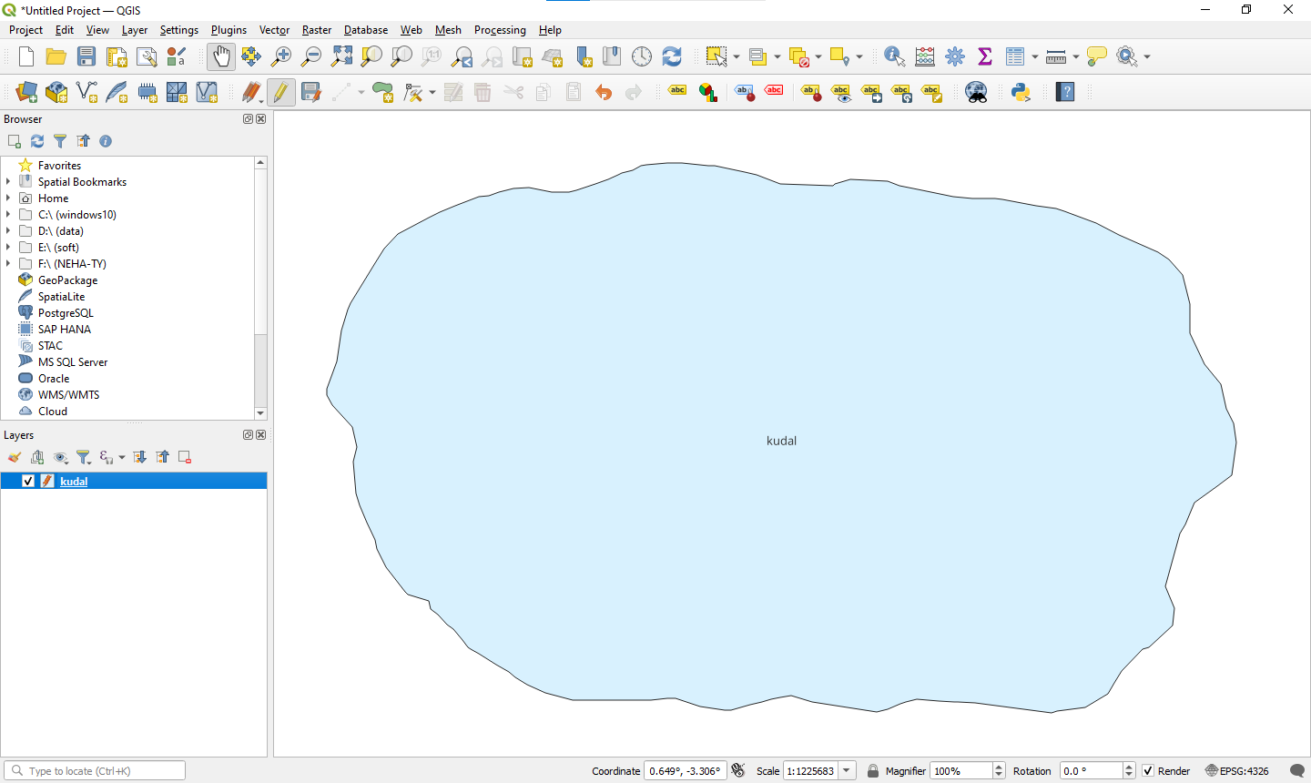

Step7:Repeating the same steps and creating a new shapefile layer

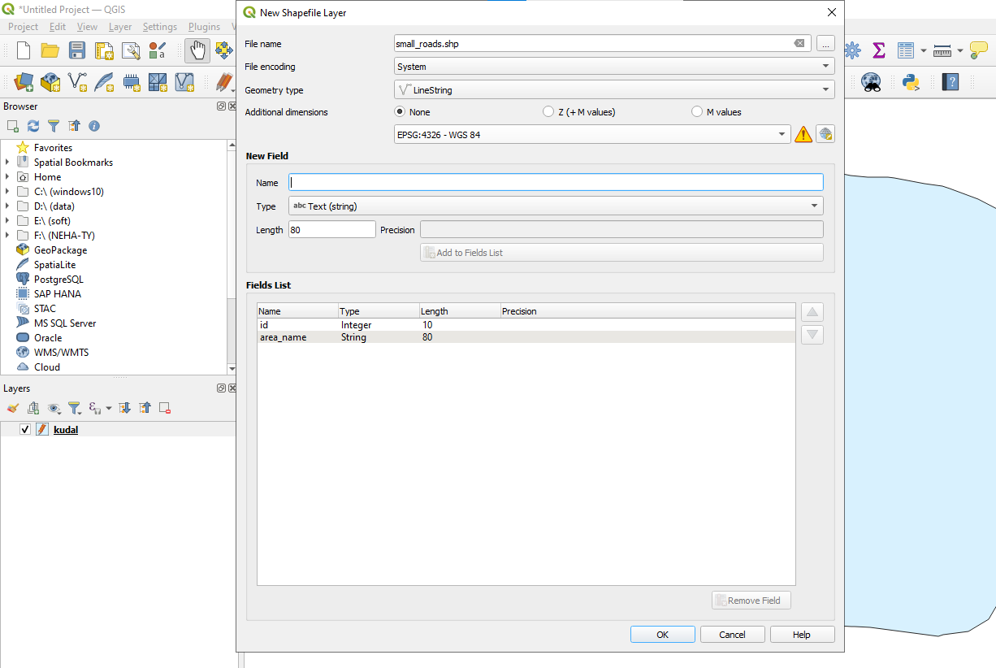

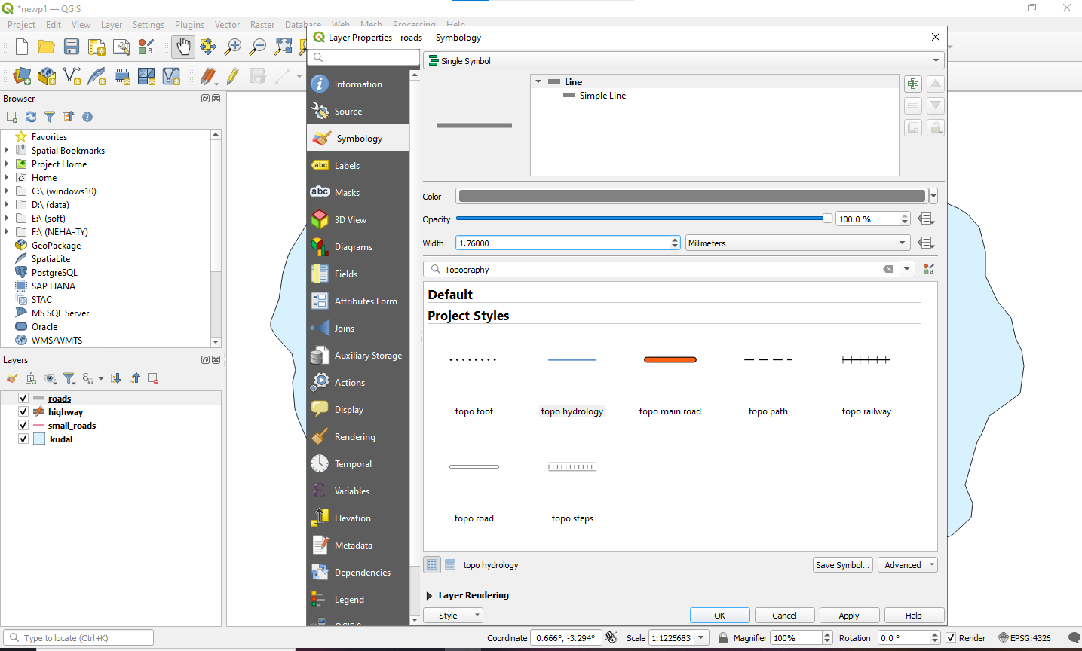

Step 8: Repeat same steps to add another line layers.

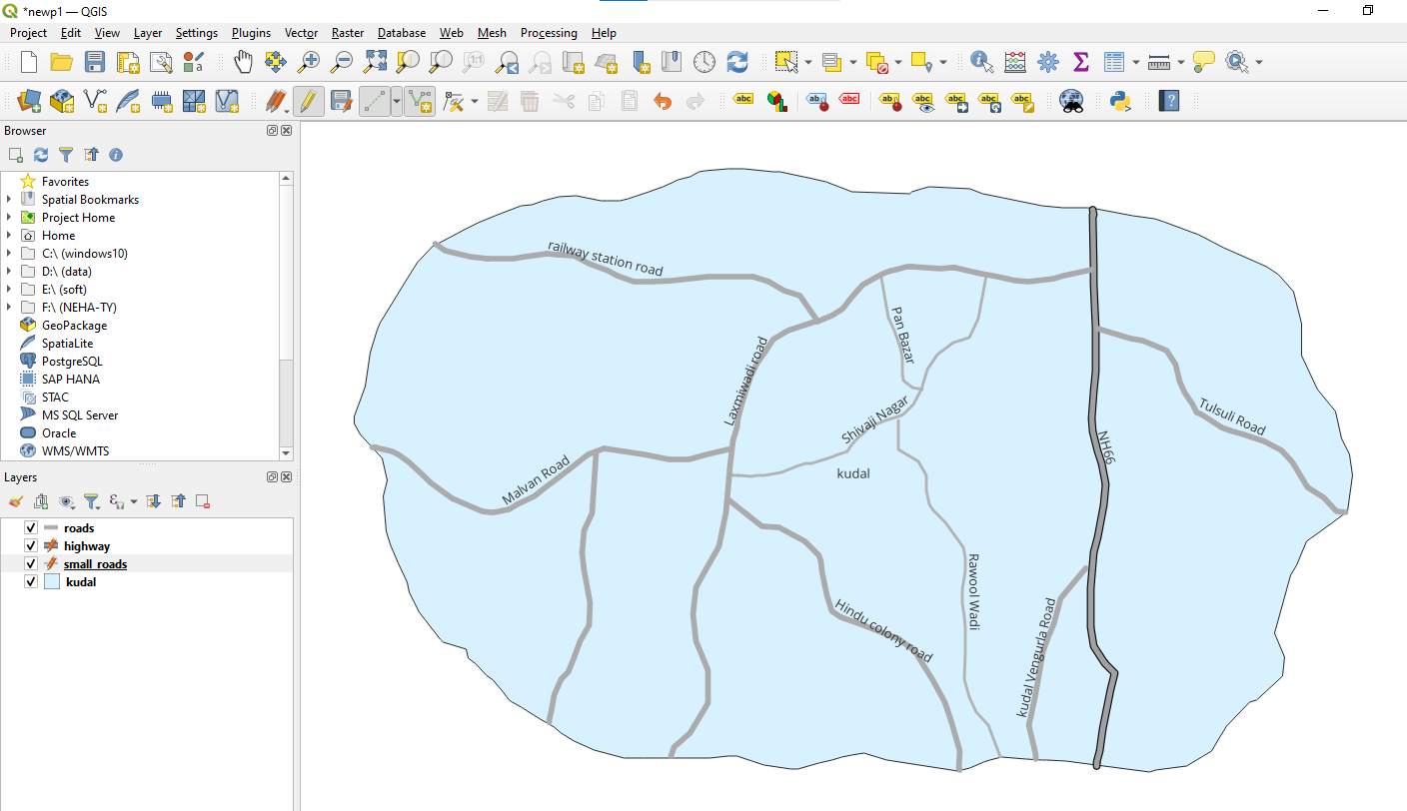

Step 9: add a new shapefile layer for point with the help of same steps

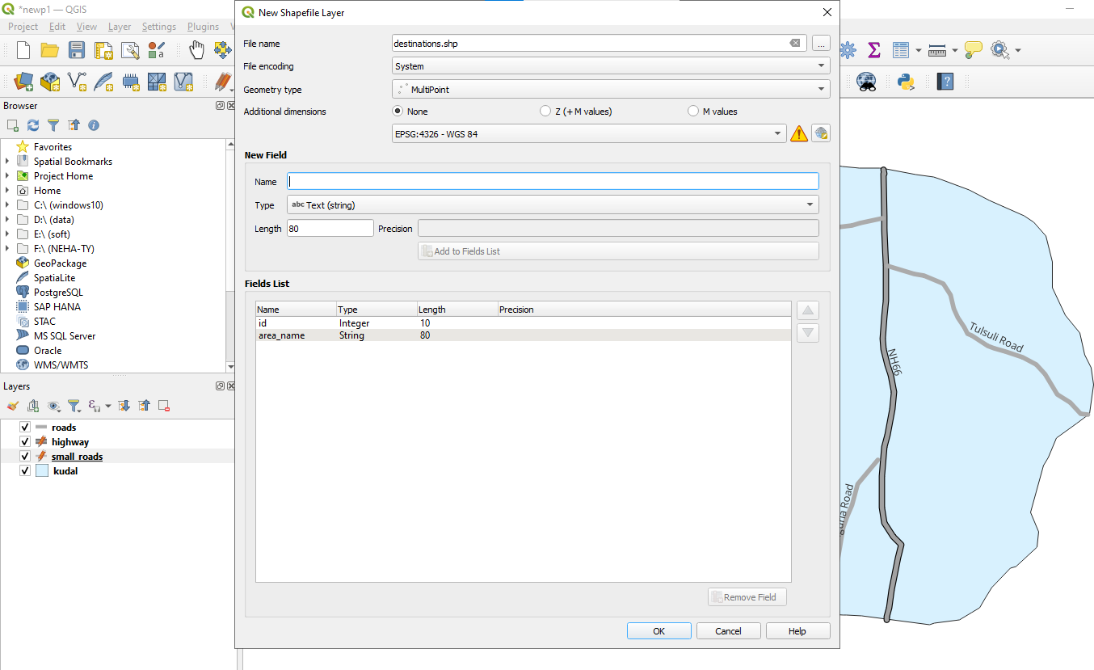

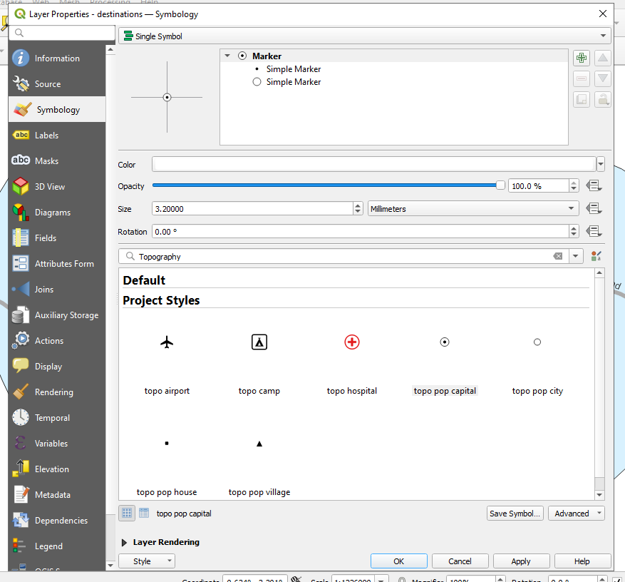

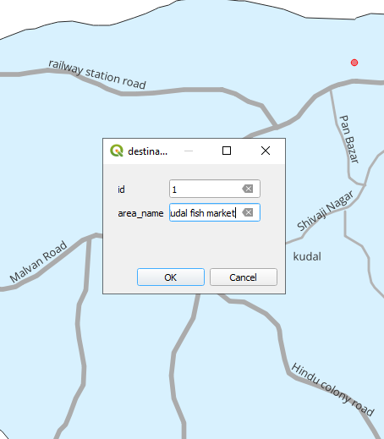

Repeat the same and add all the Places in kudal

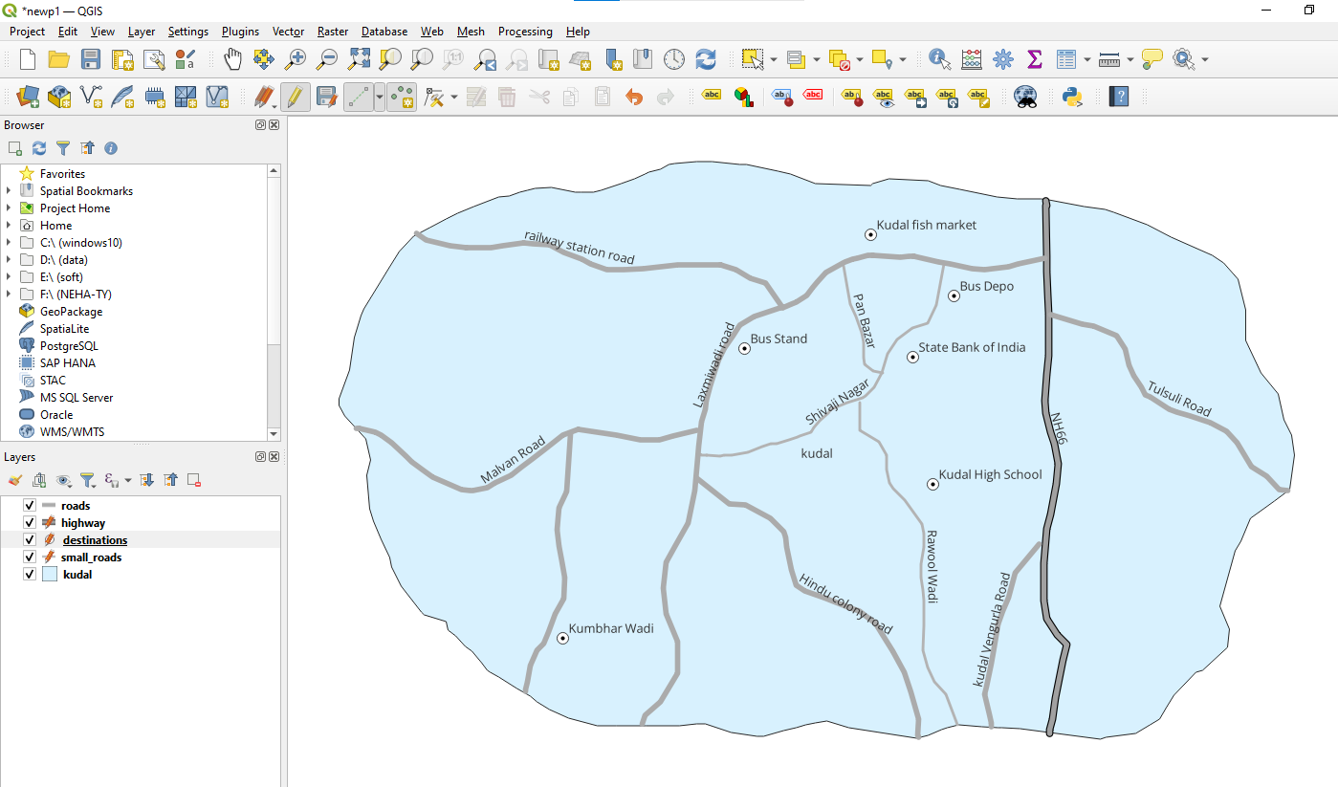

Now for the temples again add the line layer

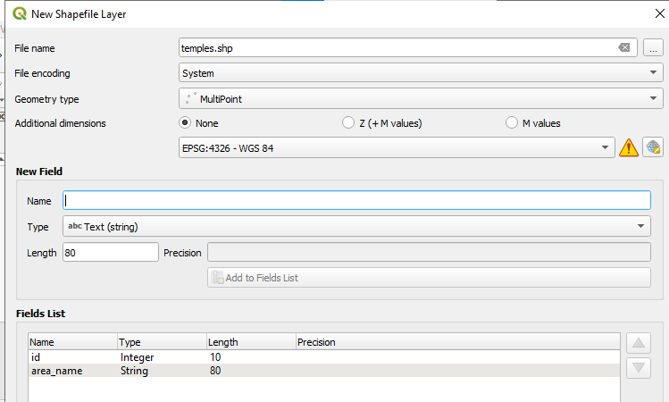

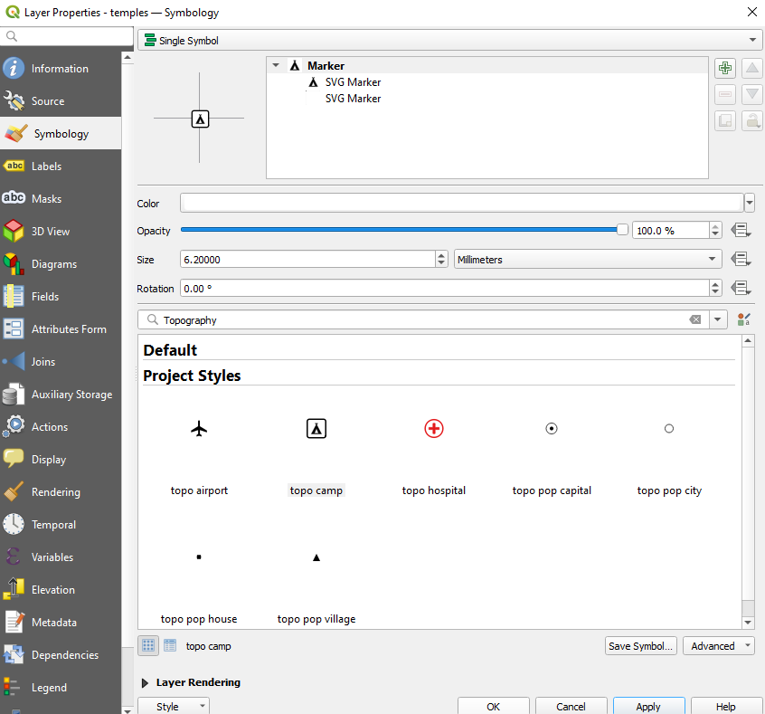

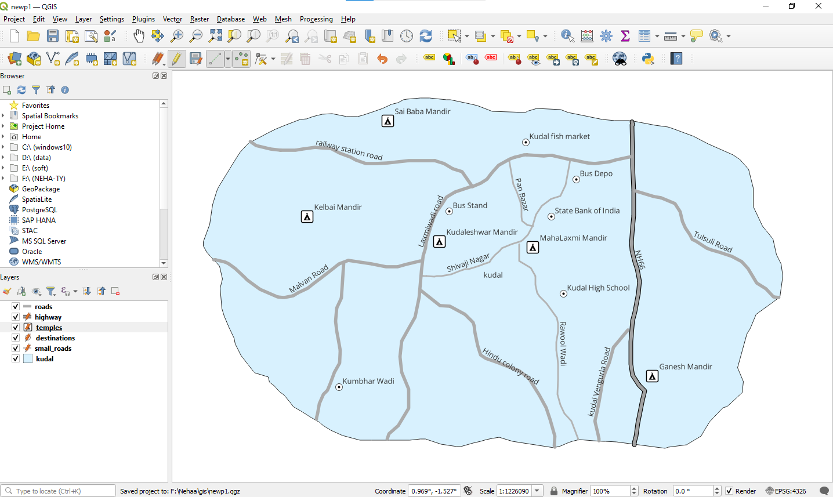

Step 10: repeat the same process and add the new point layer for hotels

