Practical No:2
- Creating and Managing Vector Data: Adding vector layers, settingproperties,formatting, calculating line lengths and statistics.

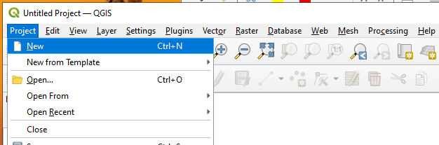
Step1: Open QGIS-> Select Project→ New Project

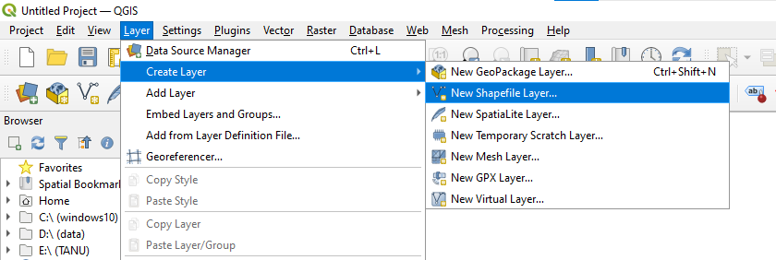
Step2: Select Layer → Create Layer → New Shapefile Layer.

Step 3: Set File name: Malvan , Select Geometry type:polygoan, Set CRS: EPSG:4326 – WGS 84 New Field- add column name, set data type and length.
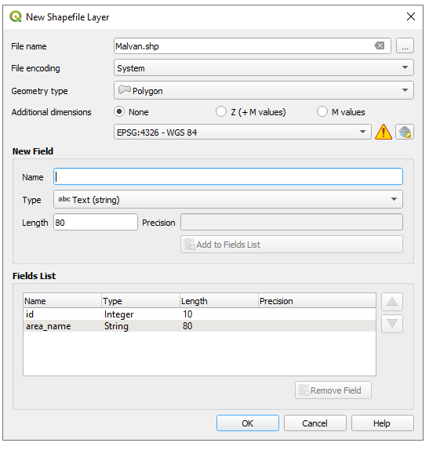

Step 4: To plot Polygon features -> Select the Polygon Feature from layer -> Click Toggle Editing Button → Click on Add Polygon-> set attribute values.

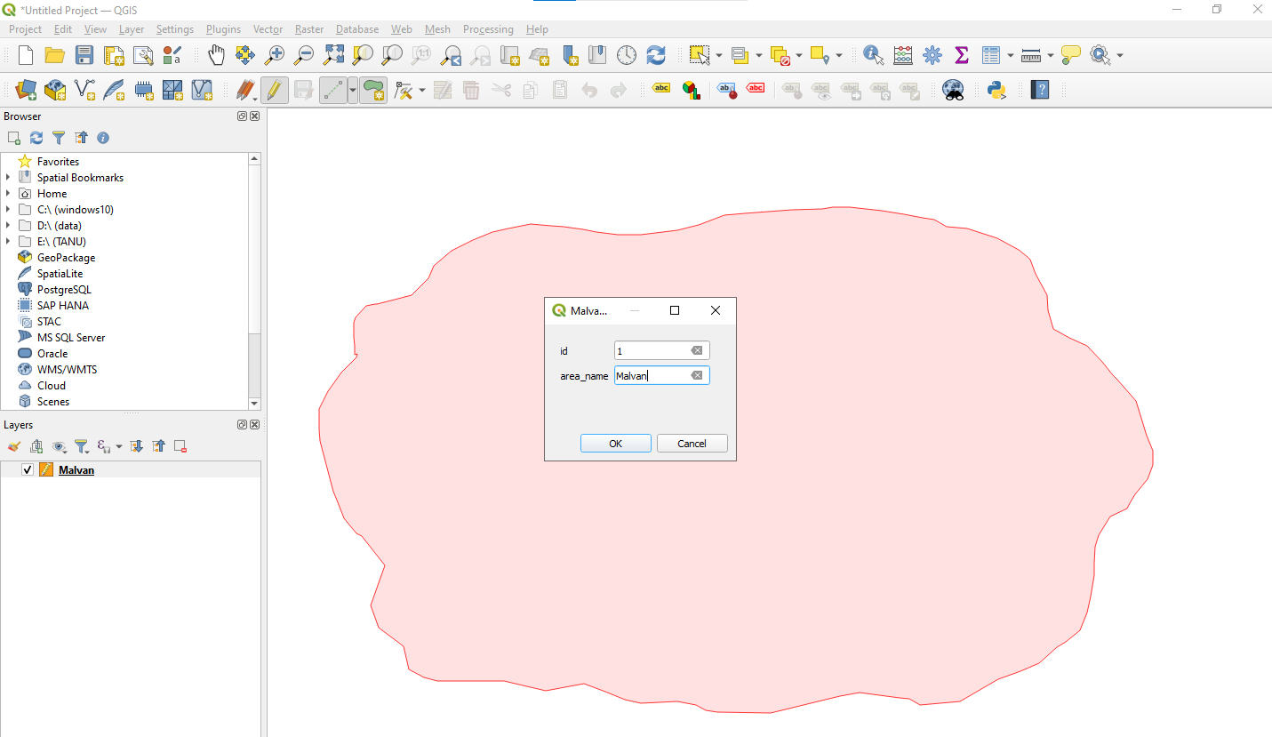

Step 5: To set Style property -> Right click on layer -> click on control feature Symbology -> select pattern or set color -> ok
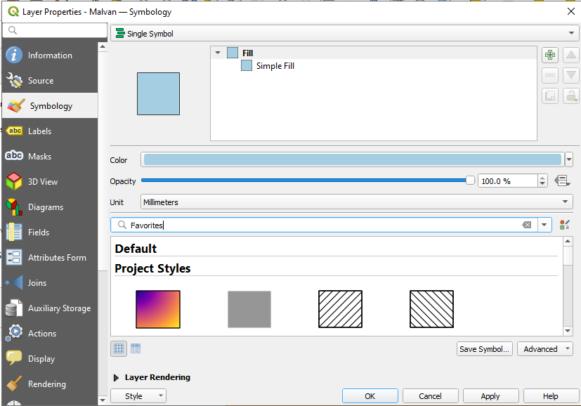

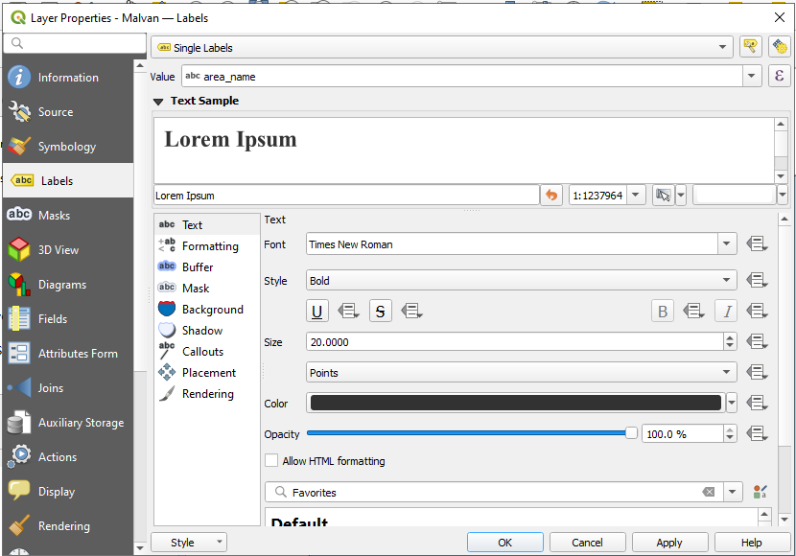
Step 6: Right click on layer -> click on control feature labeling -> select Single Labels -> set value=area_name ->ok

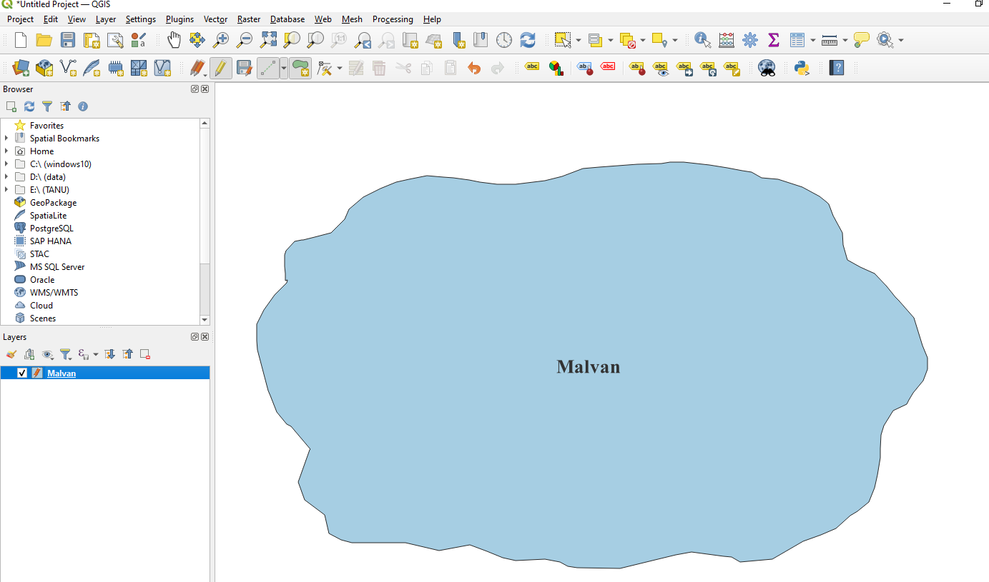

Step 7: Select Layer → Create Layer → New Shapefile Layer
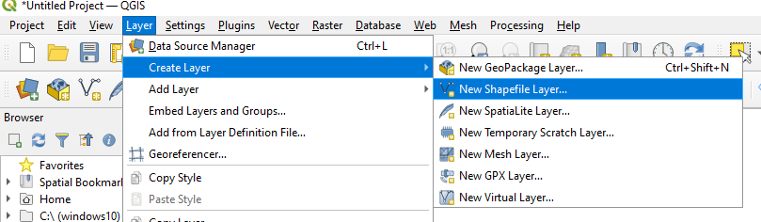

Step 8: Set File name: Highway, Select Geometry type:LineString, Set CRS: EPSG:4326 – WGS 84 New Field- add column name, set data type and length.
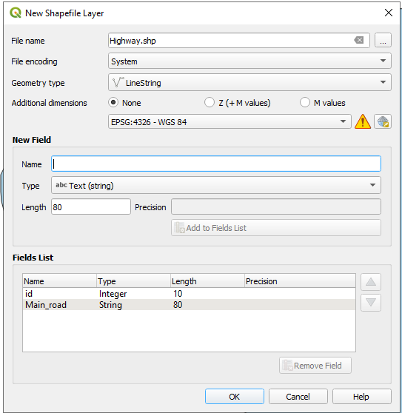

Step 9: To plot Line features -> Select the LineString Feature from layer -> Click Toggle Editing Button → Click on Add Line features-> set attribute values.

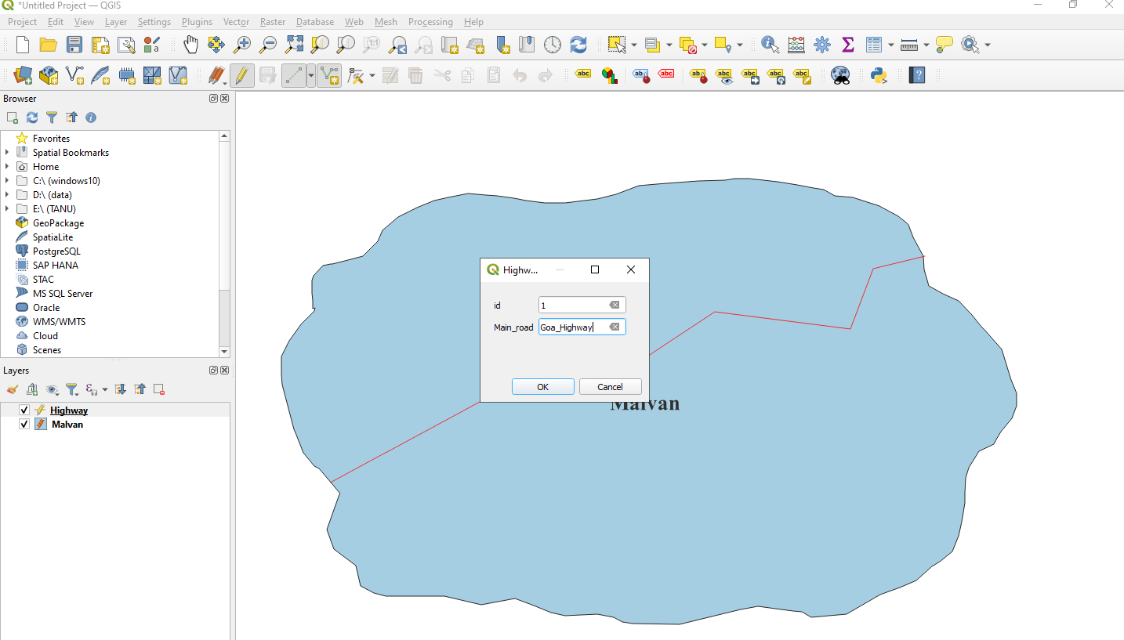

Step 10: To set Style property -> Right click on layer -> click on control feature Symbology -> select pattern or set color -> ok
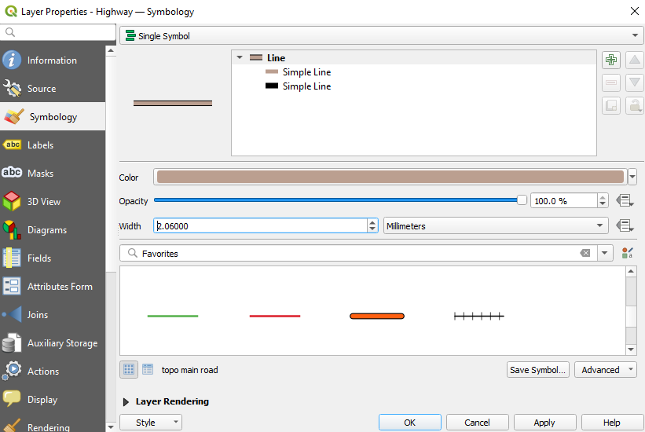

Step 11: Right click on layer -> click on control feature labeling -> select Single Labels -> set value=Main_name ->ok

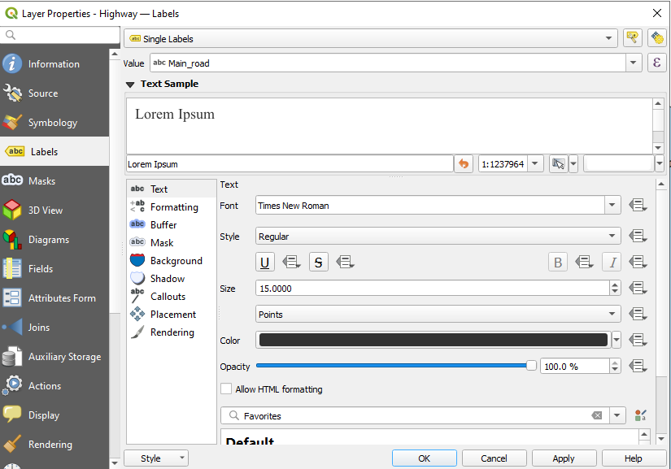

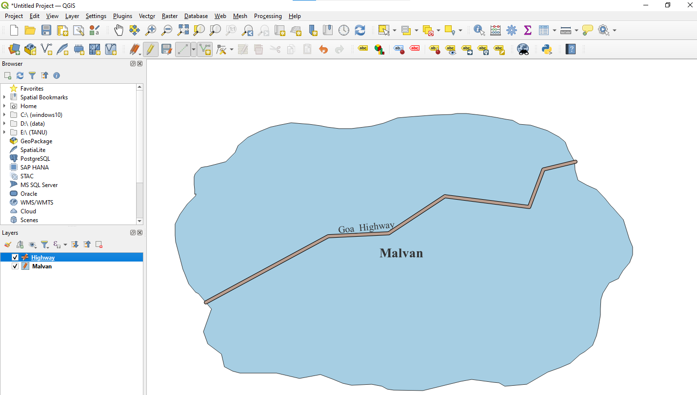

Step 12: Repeat step 7 to 11 to add new lines and set its properties

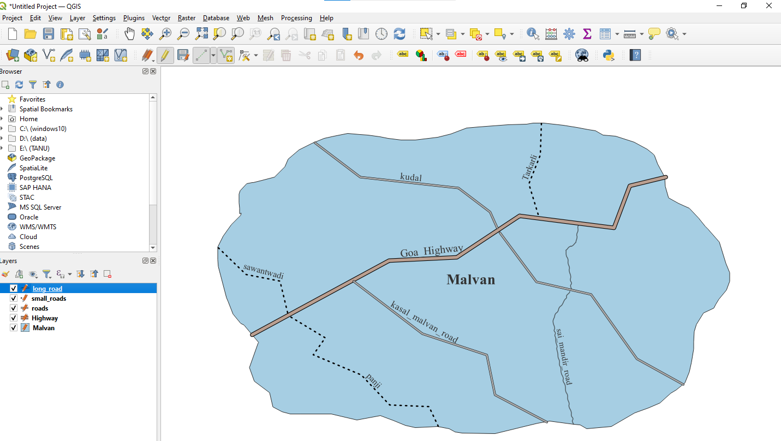

Step13: Select Layer → Create Layer → New Shapefile Layer
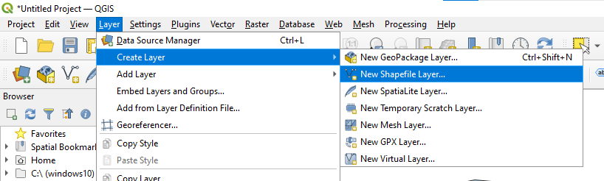
Step 14: Set File name: Hotel,Select Geometry type:point, Set CRS: EPSG:4326 – WGS 84 New Field- add column name, set data type and length.
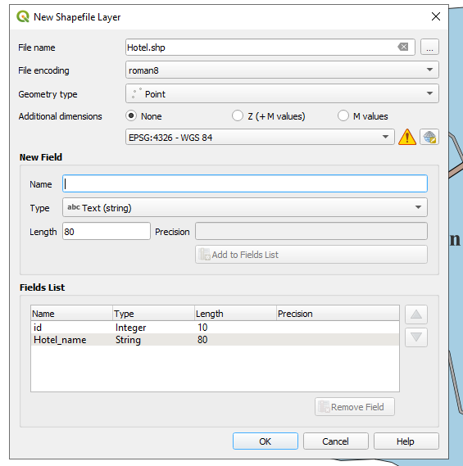

Step 15: To plot Point features -> Select the Point Feature from layer -> Click Toggle Editing Button → Click on Add Point-> set attribute values.
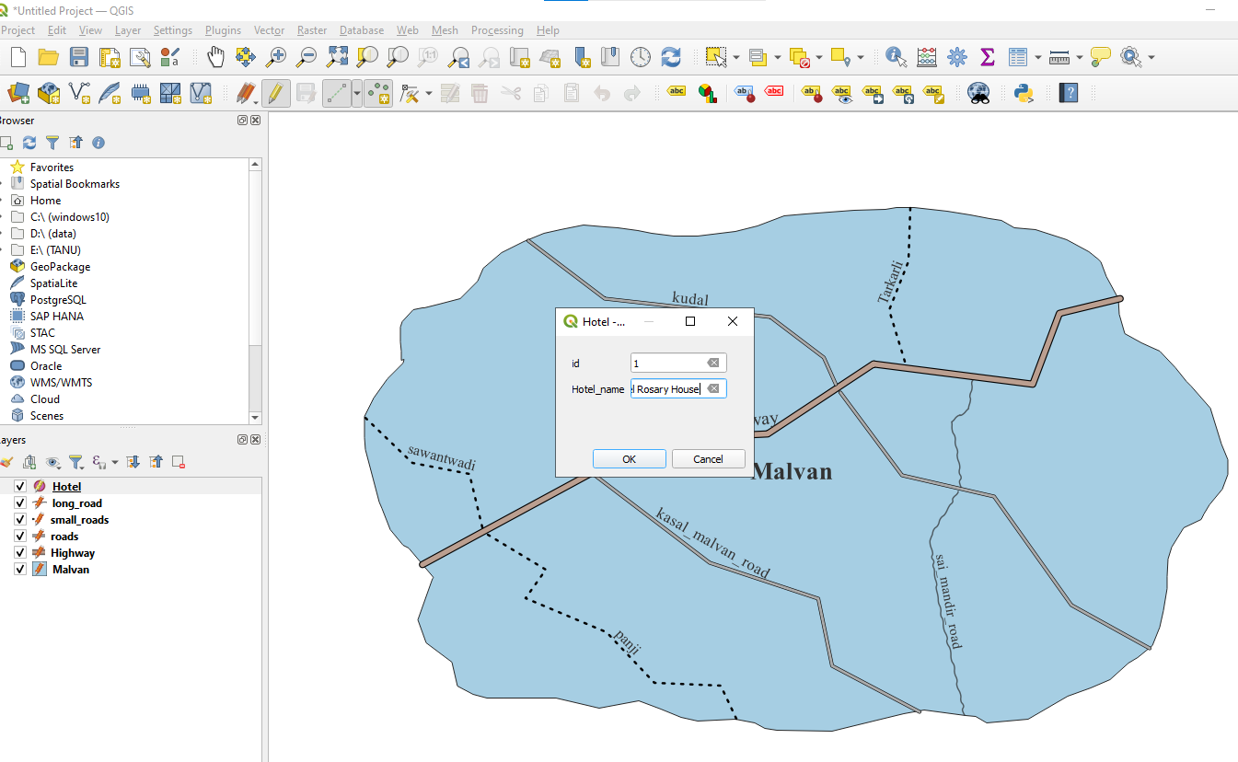

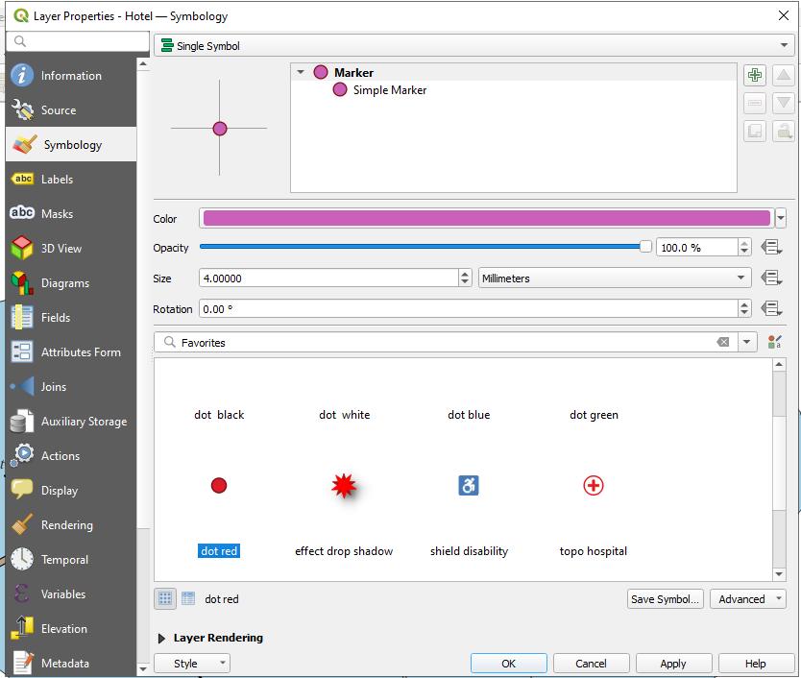
Step 16: To set Style property -> Right click on layer -> click on control feature Symbology -> select pattern or set color-> ok

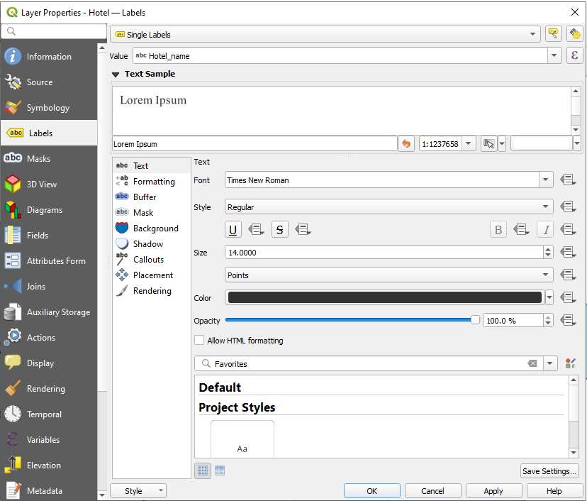
Step 17: Right click on layer -> click on control feature labeling -> select Single Labels -> set value=Hotel_name ->ok

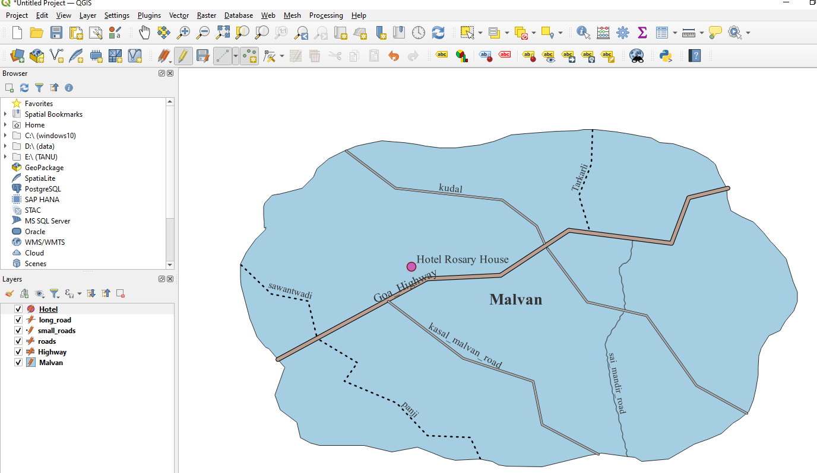

Step 18: Repeat step 13 to 17 to add new points and set its properties
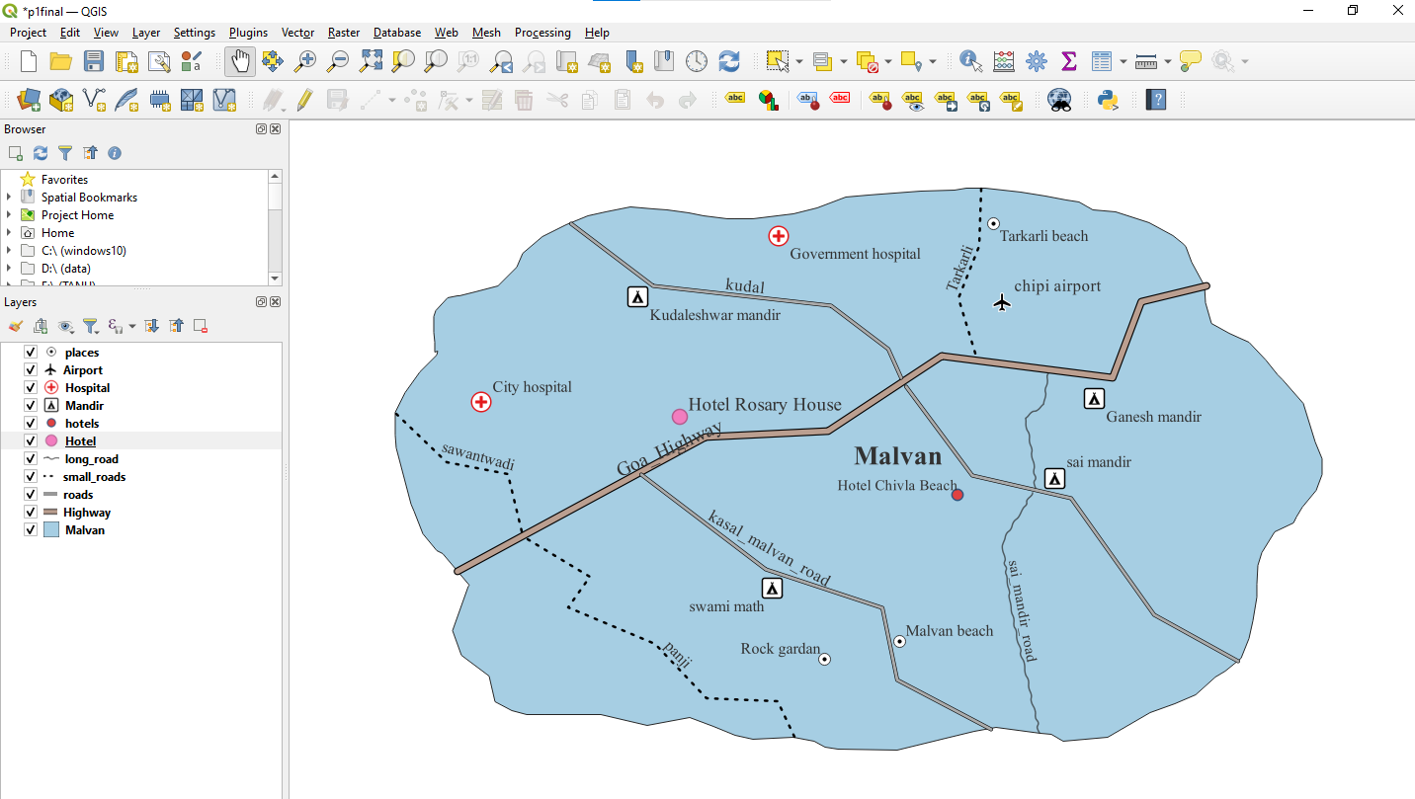

- Calculating line lengths and statistics
Add Layer>Add Vector Layer>Source> Addfile (IND_adm.zip )s
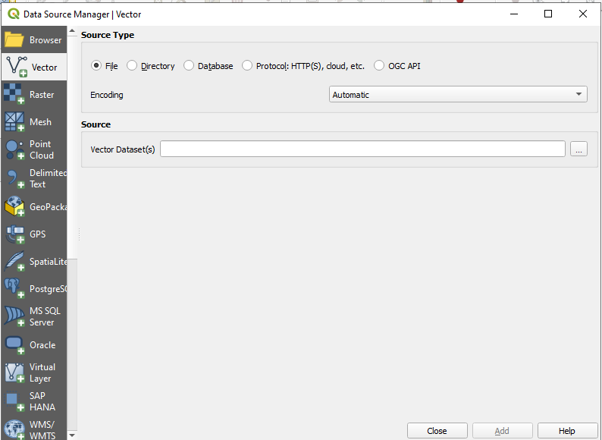
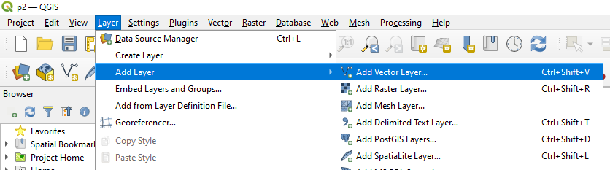

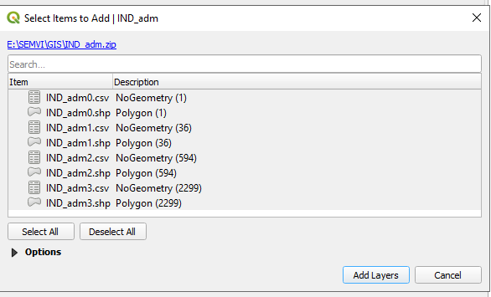

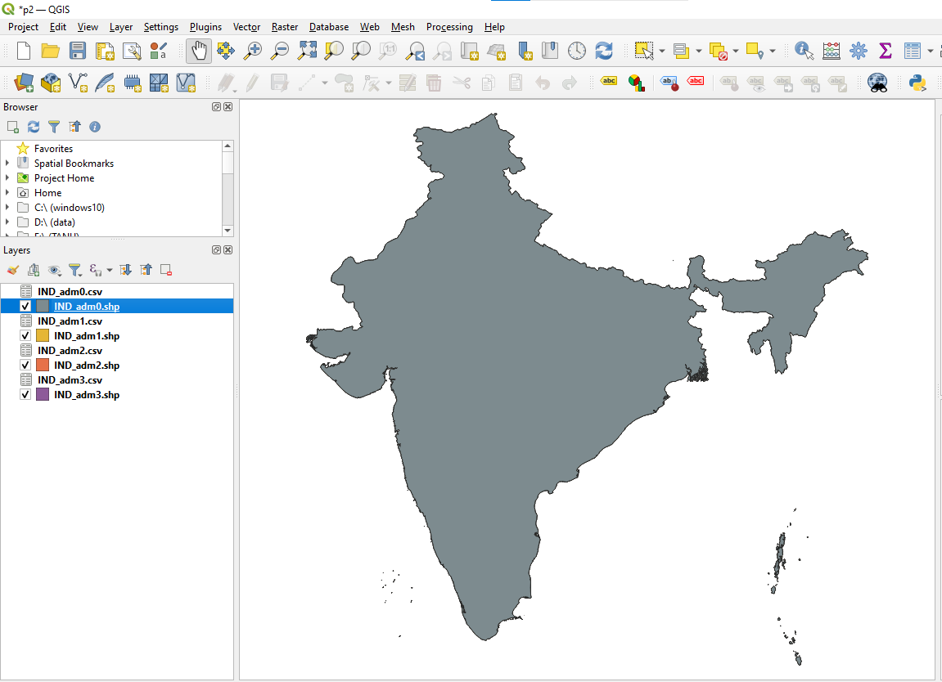
Topology selection
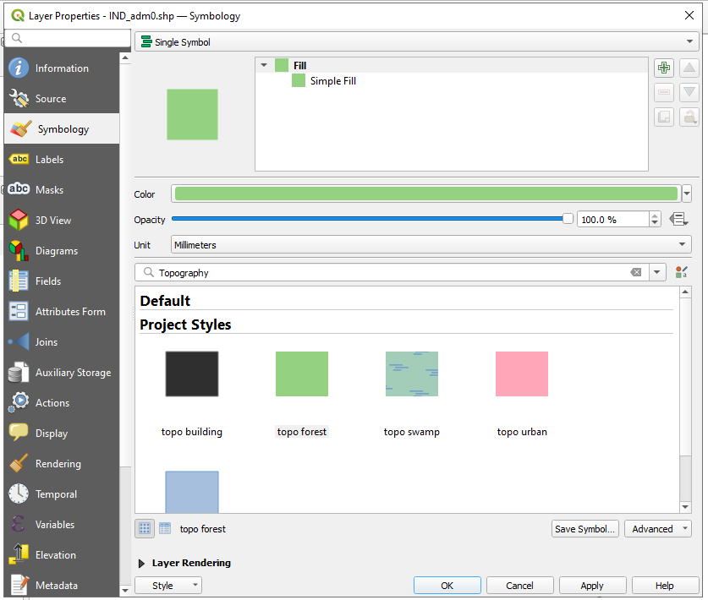
After adding (IND_adm.zip)
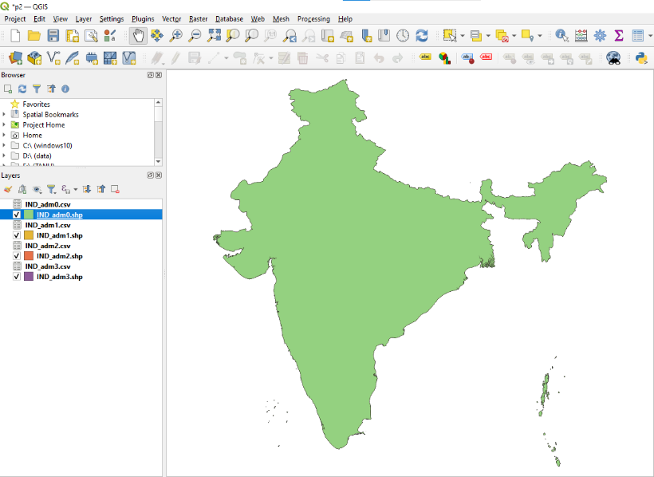

Add Layer>Add Vector Layer->Source->Add file(IND_rrd.zip)
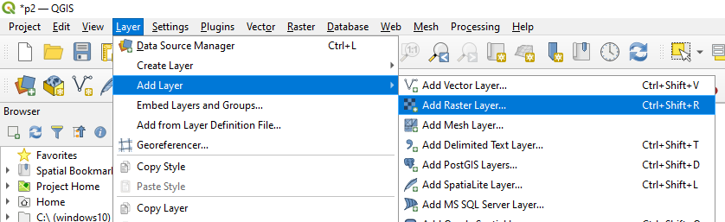
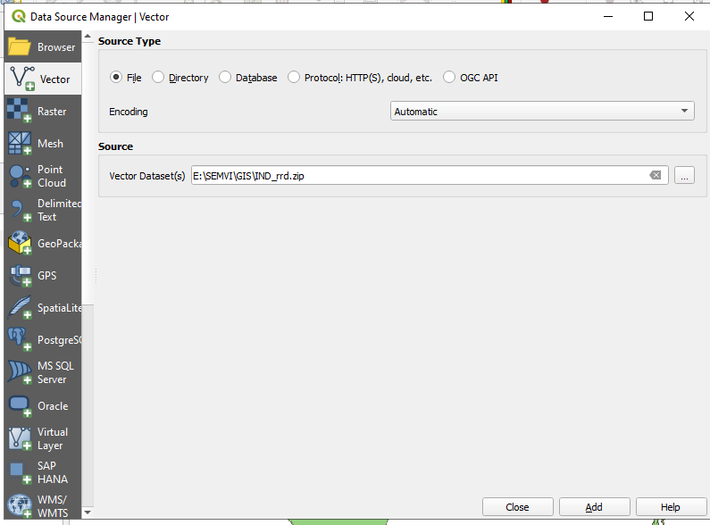
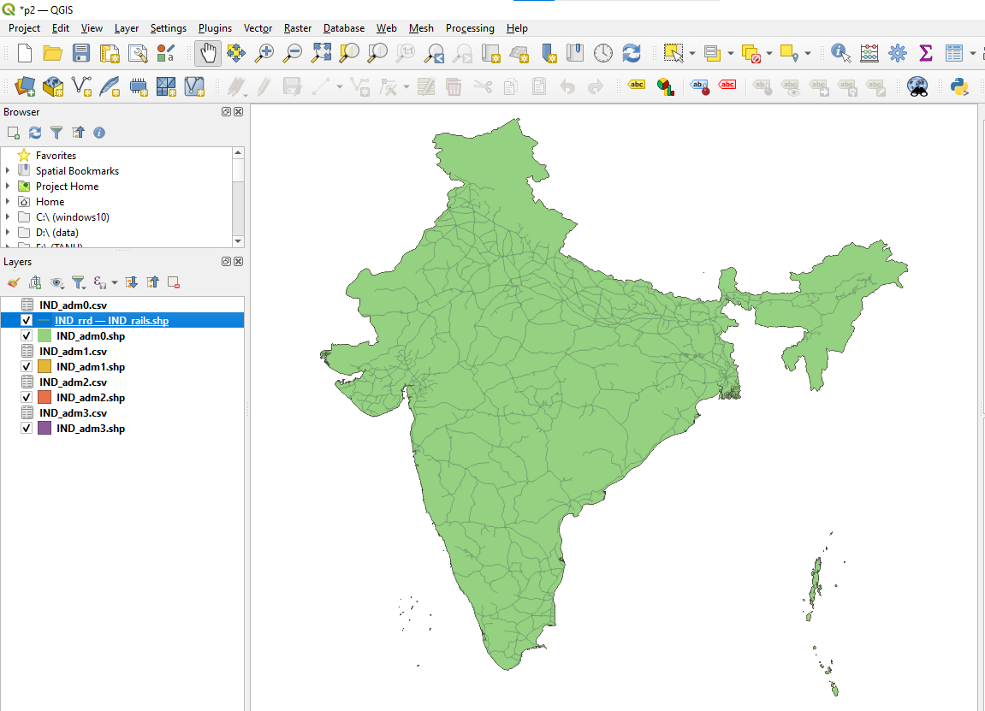
Topology selection
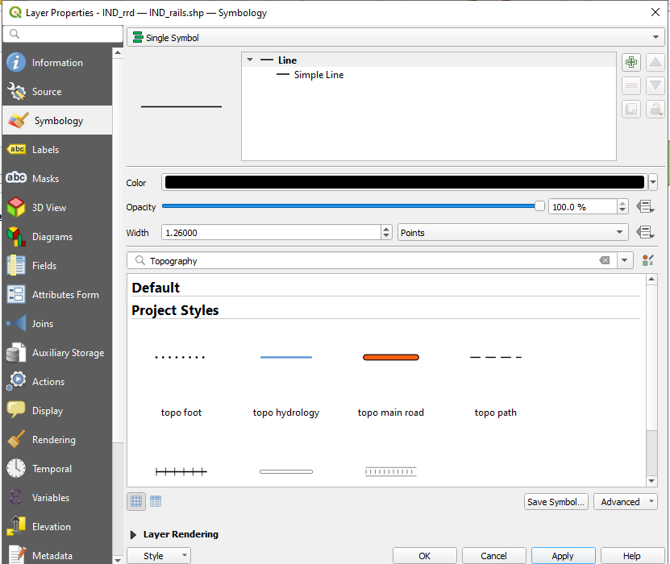
After adding (IND_rrd.zip)
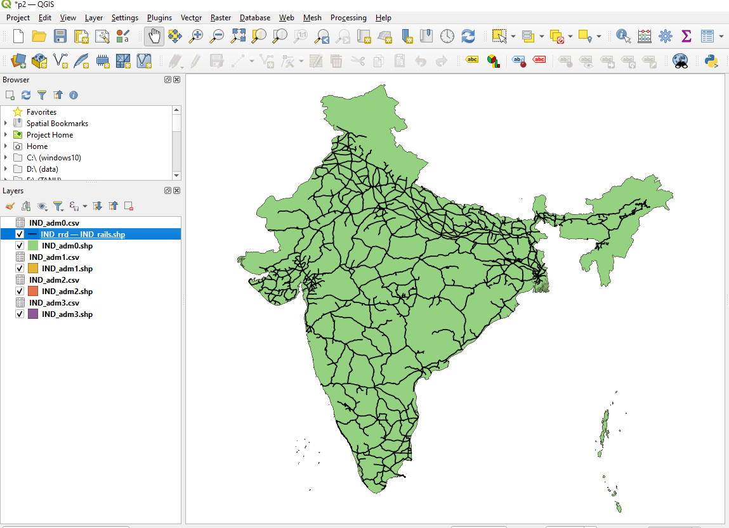

Opening attribute table
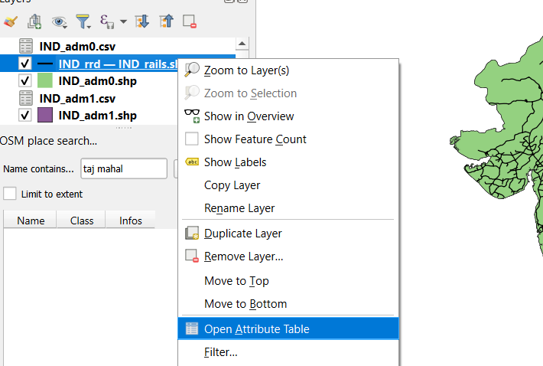
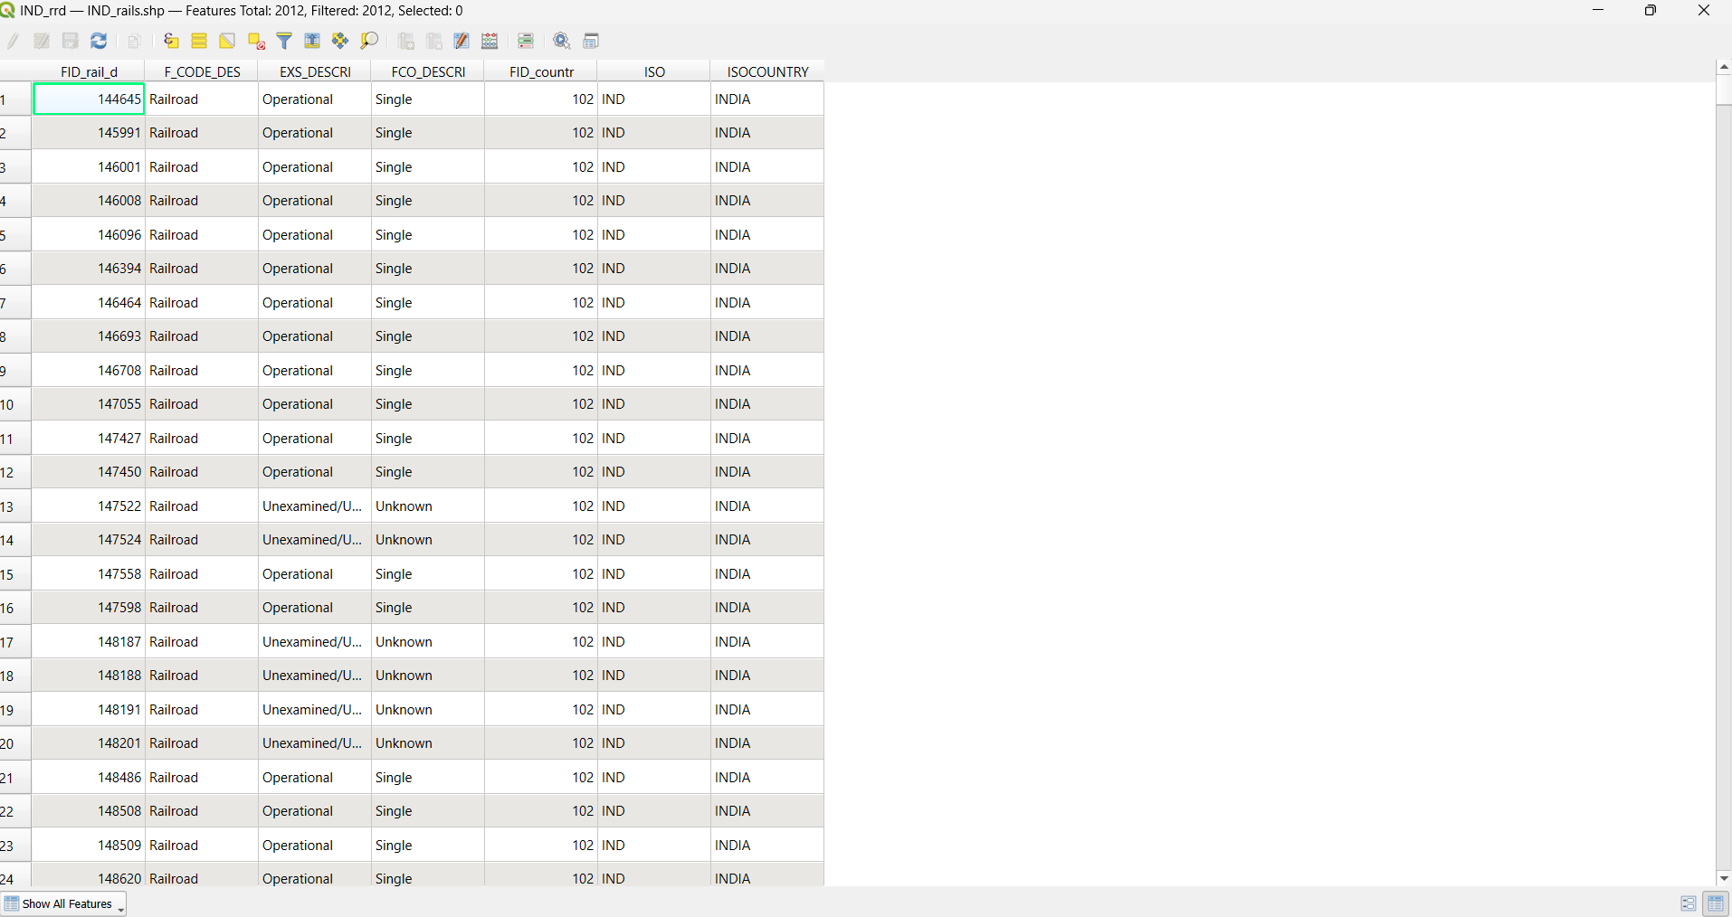

Adding new field to attribute table using ‘ field calculator’
Adding ‘road’ for calculating road length in kilometers(length / 1000)
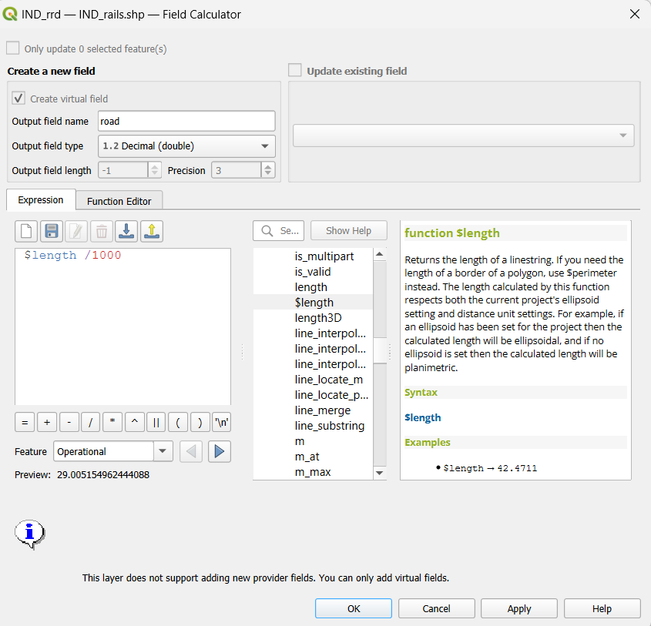
After adding road field
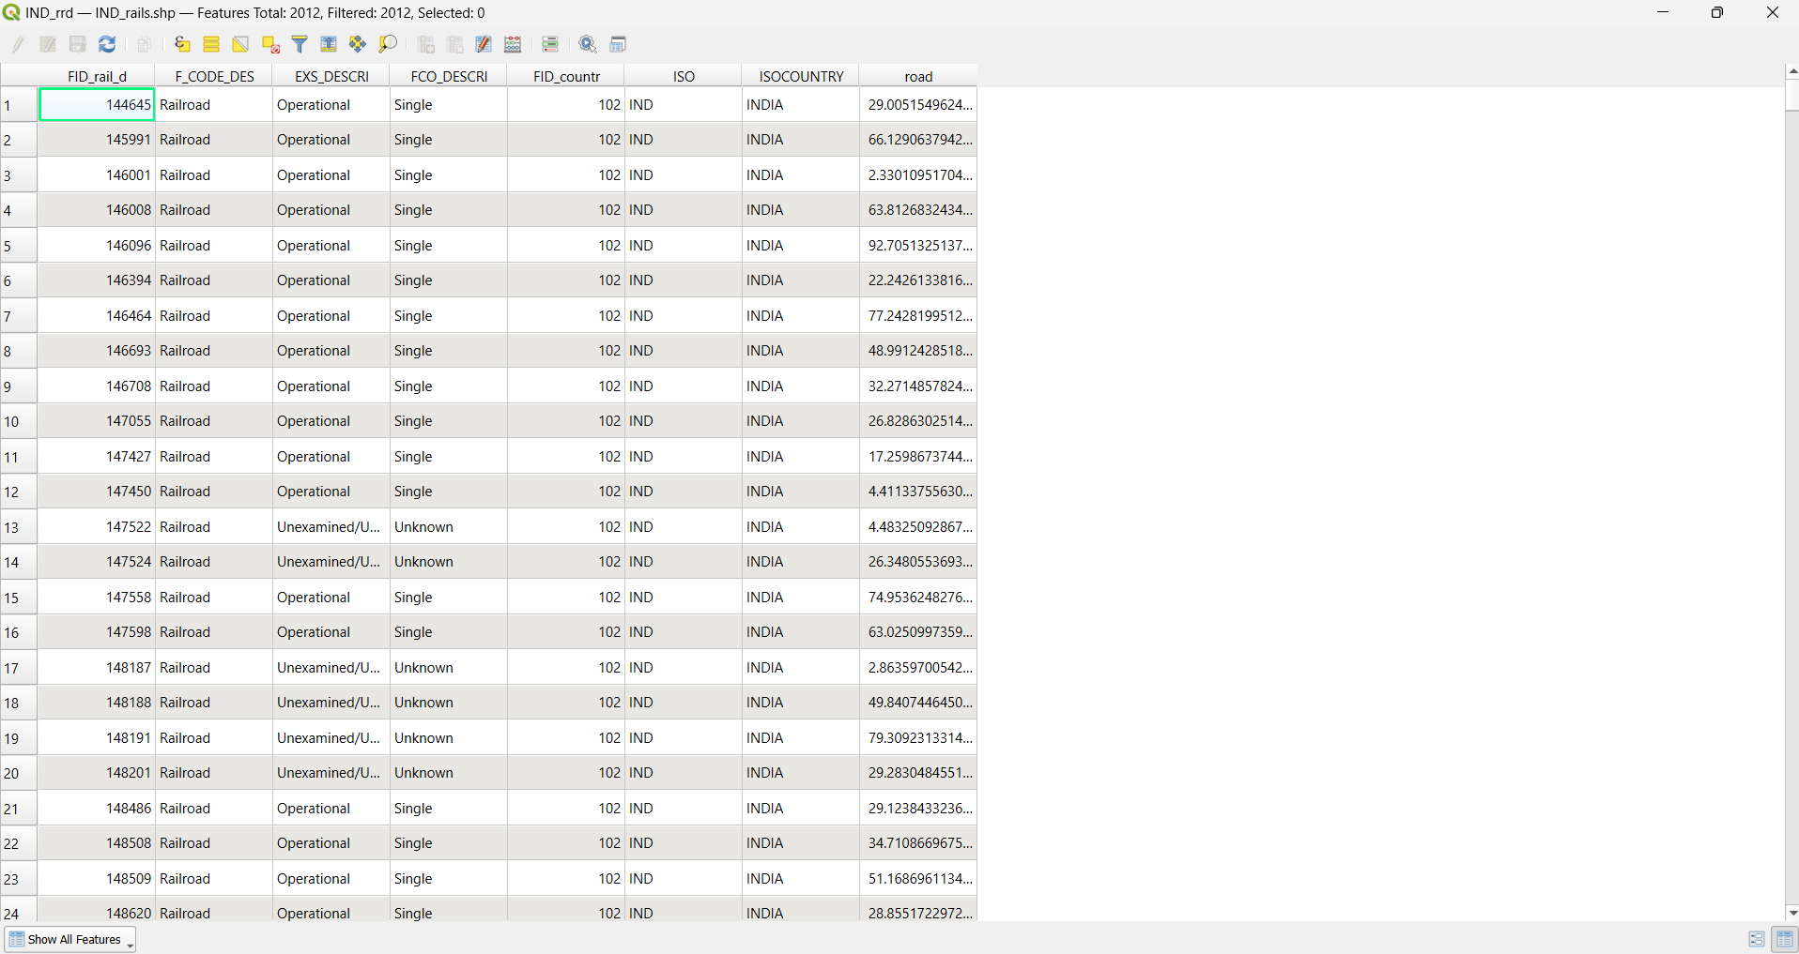
Using vector analysis tools vector->analysis tools ->basic statistics for fields
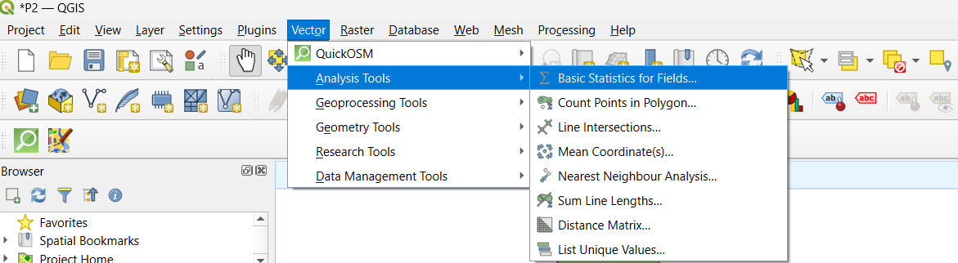

Select the field and hit run
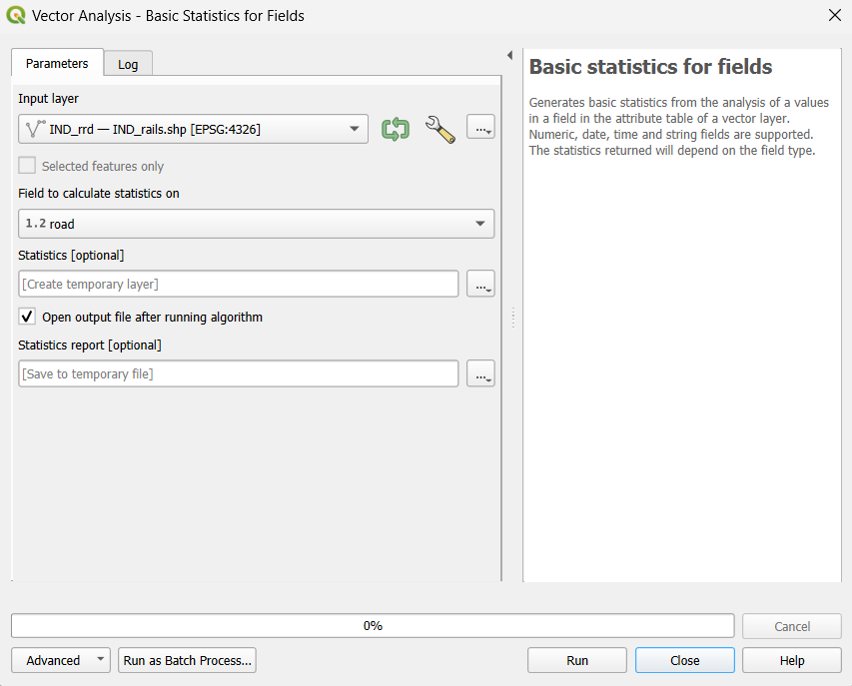
View the logs
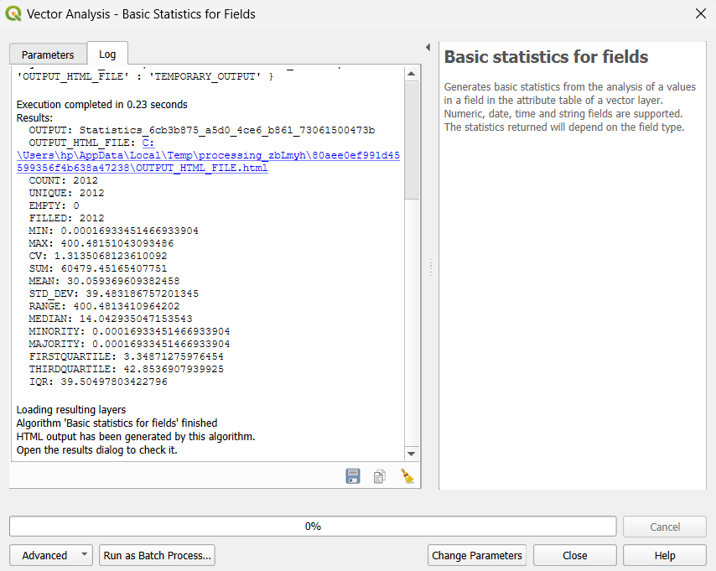

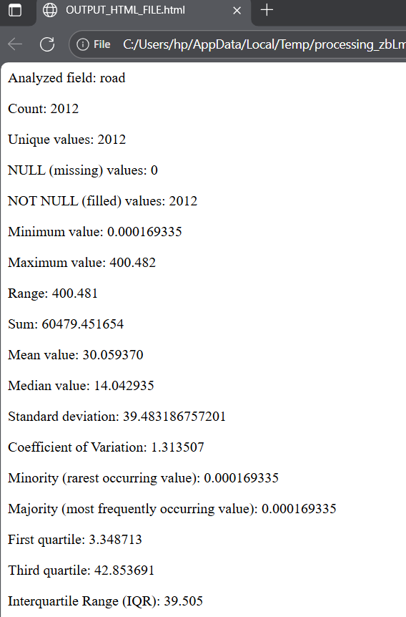
Final result

