Workforce Attrition Patterns and Risk Hotspot Analysis at Palo Alto Networks
Neha N. S.
Department of Computer Science and Engineering
Jawaharlal Nehru New College of Engineering , Shimoga,
Karnataka, India
Email: nehans0703531@gmail.com
Abstract— Employee attrition is a recurring workforce-management problem because frequent employee departures can affect continuity, productivity, recruitment effort, and organizational knowledge. This paper presents a dashboard-based human resources analytics approach for examining attrition patterns and identifying workforce risk hotspots. The study uses the public IBM HR Analytics Employee Attrition & Performance dataset, a fictional dataset containing 1,470 employee records and 35 attributes. The analysis combines Python-based data preparation, exploratory data analysis, group-wise attrition-rate calculations, interactive visualization, and business-intelligence reporting. Particular attention is given to department, job role, gender, overtime, business travel, age, monthly income, and years at company. A Streamlit dashboard provides filters, key performance indicators, interactive charts, a correlation heatmap, and filtered-data export, while a Power BI implementation provides a complementary reporting interface. In the dataset, 237 employees are recorded as having left and 1,233 as retained, corresponding to an overall attrition rate of 16.12%. The work deliberately treats risk hotspots as descriptive indicators rather than causal or predictive probabilities. The resulting dashboard is intended to help HR stakeholders move from isolated spreadsheet inspection toward a clearer, evidence-based view of where attrition is concentrated. The paper also discusses limitations of using a synthetic cross-sectional dataset and outlines future work using longitudinal organizational data, predictive models, and explainable artificial intelligence.
Index Terms— Employee Attrition, HR Analytics, Workforce Analytics, Data Visualization, Streamlit, Power BI, Employee Retention, Business Intelligence.
I. INTRODUCTION
Employee attrition refers to the reduction of an organization's workforce when employees leave and are not immediately replaced. Although employee movement is normal in any organization, repeated or concentrated departures can create practical problems such as recruitment costs, loss of experience, disruption to teams, and additional workload for remaining staff. For this reason, organizations increasingly use people analytics to understand workforce patterns rather than relying only on annual reports or informal observations.
The growth of human resources information systems has made it possible to study attrition using demographic, job, compensation, workload, satisfaction, and tenure variables together. Recent studies have also explored machine-learning approaches for attrition prediction and explainability. Govindarajan et al. compared several machine-learning models using the IBM HR Analytics dataset, while Al-Ali et al. combined predictive models with SHAP-based explanations and reported influential variables such as overtime, job level, and job satisfaction [1], [2].
This work focuses on the reporting and analytical layer of workforce attrition analysis. Instead of presenting the result as a black-box prediction system, the project converts employee records into understandable metrics and visualizations. The central idea is to identify groups whose observed attrition rate is above the overall dataset rate and treat them as potential risk hotspots for further HR investigation. This approach is intentionally descriptive: a high observed rate does not prove that a particular factor causes an employee to leave.
II. PROBLEM STATEMENT
HR data often contains enough information to reveal attrition patterns, but the information is distributed across many columns and is difficult to interpret through raw tables alone. A manager may know the total number of employees who left, yet still need answers to more specific questions: Which departments or job roles show relatively high attrition? Is attrition more visible among employees with overtime or frequent business travel? Are younger or early-tenure employees leaving at higher rates? Does monthly income appear different between retained and departing employees?
The problem addressed in this project is the design of a reproducible analytical workflow that answers these questions and presents the results in a form that can be explored without repeatedly writing code. The system combines data validation, preprocessing, descriptive analysis, visualization, filtering, and reporting while avoiding unsupported causal conclusions.
III. OBJECTIVES
The objectives are to measure overall attrition; compare departments and job roles; examine age, gender, overtime, business travel, income, and tenure; identify descriptive risk hotspots; develop an interactive Streamlit dashboard; create a complementary Power BI report; and translate observed patterns into practical, non-discriminatory retention recommendations.
IV. LITERATURE REVIEW
Employee turnover has been studied from organizational, behavioral, and analytical perspectives for decades. Earlier work emphasized job attitudes, organizational conditions, and the decision processes associated with leaving. More recent HR analytics research has increasingly used structured employee datasets to quantify patterns and support retention planning.
Machine learning has become a common research direction because attrition is a binary outcome and employee records contain mixed numeric and categorical variables. Govindarajan et al. evaluated Random Forest, Support Vector Machine, Decision Tree, Gradient Boosting, and a hybrid approach on the IBM HR Analytics dataset [1]. Al-Ali et al. extended this direction by combining several learning algorithms with explainable artificial intelligence and reported overtime, job level, stock option level, and job satisfaction among influential variables [2].
The present study takes a complementary position. The objective is not to compete with predictive models on accuracy. Instead, it emphasizes interpretability, interactive exploration, and communication of workforce patterns. This is useful when an HR team first needs to understand what is happening before deciding whether a predictive system is justified.
V. DATASET DESCRIPTION
The study uses the IBM HR Analytics Employee Attrition & Performance dataset. The dataset is widely used in educational and research work on employee attrition and contains 1,470 employee records with 35 attributes [2], [3]. It includes demographic variables such as age and gender; job variables such as department, job role, job level, and years at company; compensation variables such as monthly income; and work-related variables such as overtime, business travel, job involvement, satisfaction, and work-life balance.
The target variable is Attrition, recorded as Yes or No. In the standard dataset, 237 employees are classified as having left and 1,233 as retained, producing an overall attrition rate of 16.12%. The dataset is fictional rather than a confidential organizational HR database [2]. Consequently, the results should be interpreted as a case study of workforce analytics and should not be presented as evidence about the actual employees of any specific company.
Measure | Value
Employee records | 1,470
Attributes | 35
Employees who left | 237
Employees retained | 1,233
Overall attrition rate | 16.12%
Target | Attrition (Yes/No)
TABLE I. SUMMARY OF THE DATASET USED IN THE STUDY.
VI. PROPOSED METHODOLOGY
The proposed workflow follows data acquisition, validation, preprocessing, exploratory analysis, attrition-rate calculation, visualization, and reporting. Fig. 1 shows the overall system architecture. The same prepared data can feed both the Streamlit dashboard and the Power BI report.
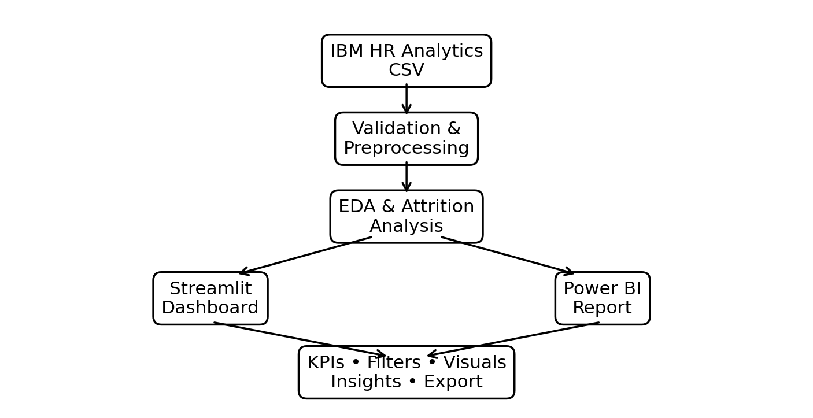
Fig. 1. System architecture of the workforce attrition analytics solution.
For a group g, the descriptive attrition rate is calculated as the number of employees in that group with Attrition = 1 divided by the total number of employees in the group. AttritionRate(g) = N(Attrition = 1, g) / N(g) × 100. A group whose observed rate is greater than 16.12% is treated as a potential hotspot for further investigation. This threshold is a project-defined descriptive benchmark, not an industry standard and not a prediction of individual behavior.
VII. SYSTEM ARCHITECTURE
The implementation contains two reporting paths. The first uses Python and Streamlit. Pandas loads and manipulates the CSV data; Plotly supports interactive charts; and Matplotlib/Seaborn can be used for the numerical correlation heatmap. Streamlit provides the web interface, sidebar filters, KPI cards, tabs, and download control. The second path uses Power BI Desktop, where DAX measures provide dynamic counts and rates and slicers allow report interaction.
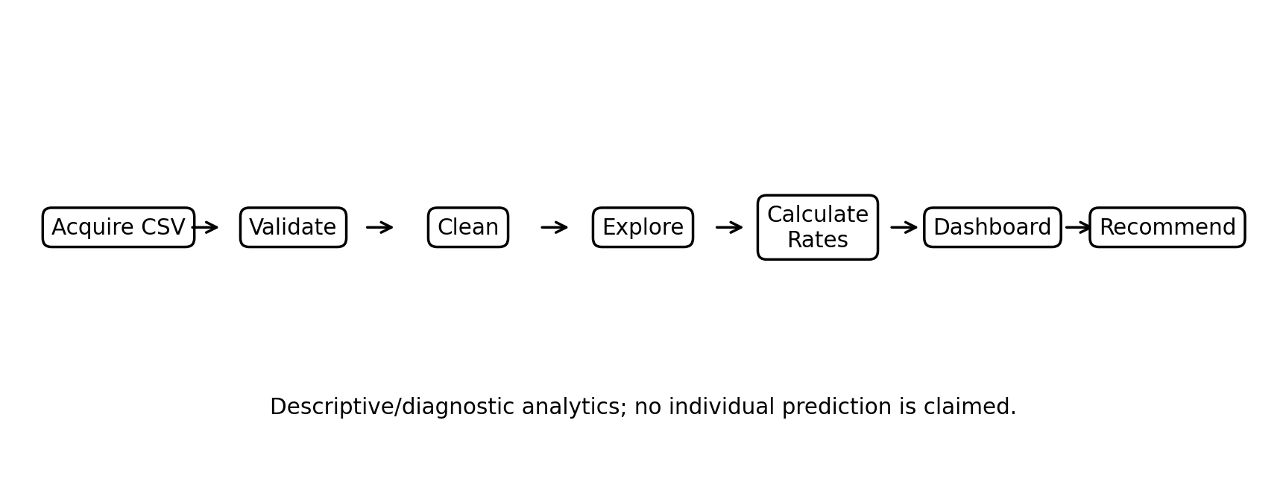
Fig. 2. Analytical workflow from raw employee records to dashboard-based recommendations.
The architecture deliberately avoids unnecessary complexity. Since the present project is a descriptive analytics application, it does not require a model-serving layer, training pipeline, or prediction API. This makes the workflow easier to reproduce and maintain. A future predictive extension can be added after the descriptive baseline has been validated.
VIII. DATA PREPROCESSING
The CSV file is first loaded into a pandas DataFrame. Basic validation checks include the number of rows and columns, data types, missing values, duplicate records, and distinct values of categorical variables. The Attrition field is converted to a binary representation when numerical calculations are required, with Yes mapped to 1 and No mapped to 0. The original categorical form can still be retained for reporting.
Constant or identifier fields are not useful for a correlation-based interpretation and should be excluded from the heatmap when appropriate. Examples include EmployeeNumber and constant fields such as EmployeeCount, Over18, and StandardHours. Numeric columns are checked for valid numeric types, while categorical columns are preserved for group-by analysis. When validation confirms the standard no-missing-value version of the dataset, imputation is not required; nevertheless, the dashboard should handle unexpected missing values.
IX. EXPLORATORY DATA ANALYSIS
Exploratory data analysis provides the first view of how attrition is distributed. The overall class balance is important because employees who remain are much more numerous than employees who leave. Fig. 3 summarizes the two outcome groups. The retained group contains 1,233 records, whereas 237 records correspond to attrition.
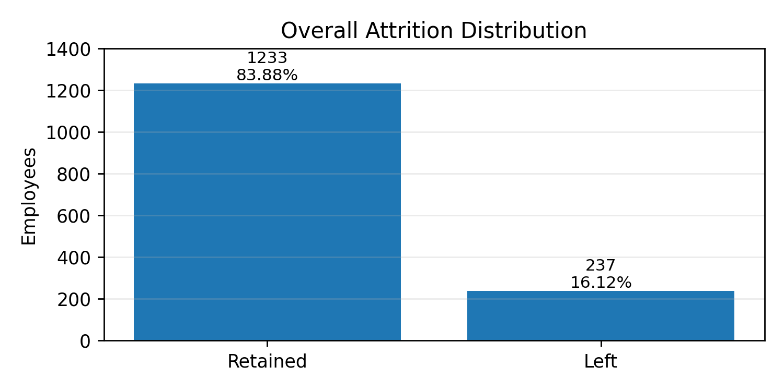
Fig. 3. Overall distribution of retained and departing employees.
The dashboard extends this initial view by examining department, job role, gender, overtime, business travel, age, monthly income, and years at company. Bar charts are used for categorical comparisons, while histograms or box plots are suitable for numerical variables. A correlation heatmap is included as a screening tool for numeric relationships. Correlation is interpreted cautiously because it indicates association rather than causation.
X. ATTRITION RISK ANALYSIS
The phrase risk hotspot is used here to describe a subgroup with an observed attrition rate that is comparatively high. The dashboard can identify departments, job roles, or work-condition categories whose rates exceed the overall dataset rate. This makes the analysis useful for prioritizing questions for HR teams without claiming that membership in a category causes attrition.
Overtime is useful as a workload indicator, while business travel provides a proxy for work mobility. Age and years at company help identify whether attrition is more concentrated among early-career or early-tenure employees. Monthly income provides a compensation-related lens. Job role and department show whether operational areas differ in their observed departure rates.
Dimension | Question | Suggested visual
Department | Where is attrition concentrated? | Bar chart
Job Role | Which roles show higher rates? | Sorted bar
OverTime | Do overtime groups differ? | Grouped bar
Business Travel | Do travel categories differ? | Bar chart
Age | Which age bands show departures? | Histogram
Monthly Income | How does income vary by outcome? | Box plot
Years at Company | Is attrition concentrated by tenure? | Histogram
TABLE II. ANALYTICAL DIMENSIONS USED TO IDENTIFY ATTRITION HOTSPOTS.
XI. DASHBOARD DEVELOPMENT
The Streamlit application is designed around a simple user journey. A professional header and banner introduce the dashboard, followed by KPI cards showing Total Employees, Employees Left, Retained Employees, and Attrition Rate. Sidebar filters allow selection of department, gender, job role, overtime, business travel, and years-at-company range. Every KPI and chart is recalculated from the filtered data.
The report is organized into overview, department and job-role analysis, employee demographics, workload, correlation analysis, and insights. A filtered-data download option allows export of the current subset. Error handling is used for missing or invalid image assets and for empty filter results.
The Power BI version provides the same analytical concepts using measures such as Total Employees, Employees Left, Retained Employees, and Attrition Rate. Because these are measures rather than hard-coded values, results respond to slicers and report interactions.
XII. RESULTS AND DISCUSSION
The baseline result is an overall attrition rate of 16.12%, calculated from 237 departures among 1,470 employees. This value provides the reference point for hotspot analysis. The dashboard does not treat the overall rate as a universal benchmark; it is used only to compare groups within the same dataset.
The main practical outcome is the ability to move from a single workforce-wide number to a segmented view. A department with a high count of departures is not automatically the highest-risk department, because its workforce size may also be large. For that reason, the dashboard emphasizes rates in addition to raw counts. Similarly, a small job role may show a high percentage based on relatively few employees, so the count should be considered alongside the rate.
The exploratory analysis supports careful interpretation of workforce variables. Overtime, tenure, age, income, travel, and job role may show different patterns across attrition groups, but these relationships should not be translated directly into causal claims. Recent predictive research using the same dataset has identified overtime, job level, and job satisfaction as influential features in machine-learning models [2]. The present dashboard complements that literature by showing how such dimensions can be examined interactively without hiding the underlying data behind a predictive score.
XIII. INSIGHTS AND RECOMMENDATIONS
Target hotspots rather than the whole workforce. Use the dashboard to identify departments and job roles whose observed attrition rate is above the overall rate, then investigate local causes before applying retention programs.
Review workload and overtime. Where overtime is associated with higher observed attrition, managers should examine workload distribution, scheduling, recovery time, and staffing.
Strengthen early-tenure support. If the dashboard shows elevated attrition among shorter-tenure employees, onboarding, mentoring, manager check-ins, and clearer role expectations can be reviewed.
Improve career visibility. Where job level, role, or promotion-related variables show concerning patterns, transparent career paths, mentoring, and internal mobility can be considered.
Use compensation analysis carefully. Monthly income can be compared across retained and departing groups, but compensation decisions should consider role, level, experience, location, and internal equity.
Treat demographic variables as monitoring dimensions. Gender and other demographic variables should be used to detect possible inequities and guide investigation, not to make individual employment decisions.
Combine dashboard evidence with qualitative information. Exit interviews, employee surveys, manager feedback, and longitudinal records can explain patterns that a structured dataset cannot reveal.
XIV. LIMITATIONS
Several limitations should be considered. First, the IBM HR Analytics dataset is fictional and cannot be treated as actual employee information from a particular organization [2]. Second, the data are essentially cross-sectional and do not provide a complete timeline of employee experiences, changes in managers, salary progression, or the sequence leading to departure. Third, the analysis is descriptive and does not establish causal relationships.
The target variable is also imbalanced because retained employees substantially outnumber departing employees. This is manageable for descriptive analysis but becomes important if predictive modeling is added. Finally, dashboard results depend on data quality and selected filters. The project should therefore be treated as a decision-support tool rather than an automated system for deciding which individual employees are likely to leave.
XV. FUTURE SCOPE
The next stage can introduce supervised machine learning using logistic regression, random forests, gradient boosting, or other suitable classifiers. Any predictive extension should use a proper train-test strategy, class-imbalance handling, cross-validation, and metrics such as precision, recall, F1-score, and area under the receiver operating characteristic curve. Explainability techniques such as SHAP could be added so predictions are accompanied by understandable feature contributions [2].
A stronger organizational version would use longitudinal employee data, including changes in compensation, promotion history, manager changes, engagement surveys, and exit-interview information. Survival analysis could model time-to-exit, while natural-language processing could summarize qualitative feedback. Automated alerts and role-based access could also be added. Before such a system is used in real HR decisions, privacy, fairness, security, and governance controls would be necessary.
XVI. CONCLUSION
This paper presented a dashboard-based approach to workforce attrition analysis using the IBM HR Analytics Employee Attrition & Performance dataset. The project combines data preprocessing, exploratory analysis, group-wise attrition calculations, interactive visualization, and business-intelligence reporting. The dataset contains 1,470 employee records, of which 237 are classified as departures and 1,233 as retained, giving an overall attrition rate of 16.12%.
The main contribution is practical rather than algorithmic: the system turns a multi-column employee dataset into interpretable views that help users locate potential attrition hotspots and investigate them interactively. The approach is intentionally cautious about causality and individual prediction. Used with organizational context and qualitative evidence, such a dashboard can support more focused retention discussions and reduce dependence on manual spreadsheet analysis.
Validation Strategy
A second level of validation is visual sanity checking. Category labels are inspected for unexpected spelling variants, numerical ranges are checked for impossible values, and charts are reviewed after filter changes. When a filter produces no rows, the application should display a clear message rather than render misleading empty statistics. Such validation steps do not prove that the dataset represents reality, but they improve the reliability of the software implementation.
Validation Strategy
Validation in this project is primarily analytical consistency rather than predictive accuracy. The first check is that the total employee count in the dashboard matches the number of rows in the source dataset. The second is that the sum of retained and departing employees equals the filtered total. The third is that the attrition rate equals Employees Left divided by Total Employees. Finally, the Power BI and Streamlit versions should return the same values when identical filters are applied. These checks provide a simple but useful guard against dashboard calculation errors.
Interpretation of Visual Analytics
The same caution applies to demographic analysis. If one demographic group has a different observed attrition rate, the result should trigger a question about workplace conditions, representation, or data coverage rather than a conclusion about individual employees. A responsible HR analytics system should support investigation of structural factors and possible inequities while avoiding automated decisions based on protected or sensitive characteristics.
Interpretation of Visual Analytics
The correlation heatmap is used as an exploratory screening device. It can reveal pairs of numeric variables that move together and may help explain why several workforce measures contain overlapping information. However, correlation does not establish direction of effect, and it does not directly measure the relationship between every categorical variable and attrition. Consequently, the heatmap is treated as one component of the analysis rather than the final source of conclusions.
Interpretation of Visual Analytics
Visual analytics can make subgroup differences easier to notice, but visual prominence should not be confused with statistical significance. A bar chart can make a small group appear extreme when only a few employees are represented. Therefore, the dashboard should be read using both the numerator and denominator. Where possible, users should inspect the employee count together with the percentage and avoid drawing conclusions from very small groups. This principle is especially important for job-role comparisons and demographic breakdowns.
Implementation and Reproducibility
The Power BI implementation follows the same analytical definitions. For example, Total Employees is a row count over the employee table, Employees Left counts records whose Attrition value represents departure, Retained Employees counts the complementary group, and Attrition Rate is calculated by dividing Employees Left by Total Employees. Because these are DAX measures, the values change automatically when a department, job role, gender, overtime category, business-travel category, or tenure range is selected. The agreement between the Python and Power BI calculations is an important validation step for the reporting layer.
Implementation and Reproducibility
For reproducibility, the project separates presentation logic from the analytical operations as far as practical. Data loading and validation occur before the dashboard is rendered. The filtering stage is applied once and the resulting subset is reused throughout the page. This avoids repeated filtering expressions that could produce inconsistent results. The project also includes error handling for missing image assets, invalid filter combinations, and empty filtered results. These details are important in a demonstration system because a dashboard that fails when a user selects an unusual combination of filters is difficult to use in practice.
Implementation and Reproducibility
The implementation is intentionally organized as a reproducible sequence rather than a collection of independent charts. The CSV file is treated as the single analytical source, which reduces the possibility that the Streamlit and Power BI reports are based on different snapshots of the data. In the Python workflow, the same filtered DataFrame is used to calculate the KPI cards and to generate the visualizations. This design ensures that the number shown in a KPI and the observations shown in the charts are based on the same selection state.
Dashboard Component | Purpose | User Action
KPI cards | Summarize workforce status | Read current totals/rate
Sidebar filters | Focus on a subgroup | Select one or more categories
Department chart | Compare organizational units | Sort/inspect rates
Job-role chart | Locate role hotspots | Compare roles
Workload views | Examine overtime/travel | Filter and compare
Age/income views | Inspect demographic/economic patterns | Explore distributions
Correlation heatmap | Screen numeric associations | Inspect related variables
CSV export | Support further analysis | Download filtered data
TABLE III. MAIN COMPONENTS OF THE INTERACTIVE DASHBOARD.
Power BI Measure | Definition
Total Employees | COUNTROWS(Employee Table)
Employees Left | Rows where Attrition = 1/Yes
Retained Employees | Rows where Attrition = 0/No
Attrition Rate | Employees Left ÷ Total Employees
Average Age | Average of Age
Average Monthly Income | Average of MonthlyIncome
TABLE IV. CORE BUSINESS-INTELLIGENCE MEASURES.
XVII. REFERENCES
[1] R. Govindarajan, N. Komal Kumar, S. Reddy P., S. Pravallika E., D. B., and P. Kumar G., “Predicting Employee Attrition: A Comparative Analysis of Machine Learning Models Using the IBM Human Resource Analytics Dataset,” Procedia Computer Science, vol. 258, pp. 4084–4093, 2025, doi: 10.1016/j.procs.2025.04.659.
[2] M. Al-Ali, M. Alwateer, S. A. Alsaedi, H. M. Balaha, M. Badawy, and M. A. Elhosseini, “Integrating machine learning and explainable AI for employee attrition prediction in HR analytics,” Scientific Reports, vol. 16, Art. no. 6344, 2026, doi: 10.1038/s41598-026-36424-2.
[3] IBM HR Analytics Employee Attrition & Performance Dataset, public synthetic dataset, 1,470 records and 35 attributes, accessed Sep. 2026.
[4] IEEE, “Structure Your Paper,” IEEE Author Center Conferences, 2026.
[5] IEEE, “Publishing Information for IEEE Conference Authors,” IEEE Conference Publications, 2026.
[6] Streamlit, “Streamlit Documentation,” Streamlit Documentation.
[7] Microsoft, “Power BI documentation,” Microsoft Learn.

