Practical 1 :
Aim : Configure Rip for Classful and Classless IPv4 Addressing along with password protection using SSH

Classful and classless IPv4 Addressing :
- Classful IP Addressing :
Old method of dividing IP addresses into fixed classes(A,B,C,D,E) based on the first few bits.
Classes :
- Class A: 1-126 255.0.0.0 (supports 16 million hosts)
- Class B: 128–191 255.255.0.0 (supports 65,000 hosts)
- Class C: 192–223 255.255.255.0 (supports 254 hosts)
- Class D: 224–239 multicast
- Class E: 240–255 reserved for research
Problem: Wasted IPs (e.g., if you need 300 hosts, Class C (254) is too small, but Class B (65,000) is too big).

- Classless IP Addressing :
Modern method of IP allocation, where subnet masks are flexible and not restricted to fixed classes.
Format: Uses prefix notation → 192.168.1.0/27
/27 means 27 bits for network, 5 bits for host → 32 total addresses, 30 usable.
Advantages:
- Efficient use of IP addresses (no wastage).
- Easier subnetting and aggregation.
- Solved IPv4 exhaustion problem (before IPv6 came).

RIP (Routing Information Protocol) → A distance-vector routing protocol that uses hop count to find the best path.
OSPF (Open Shortest Path First) → A link-state routing protocol that uses Dijkstra’s algorithm to find the shortest path.
SSH (Secure Shell) → A protocol that provides secure remote login and communication over an unsecured network.

Topology :
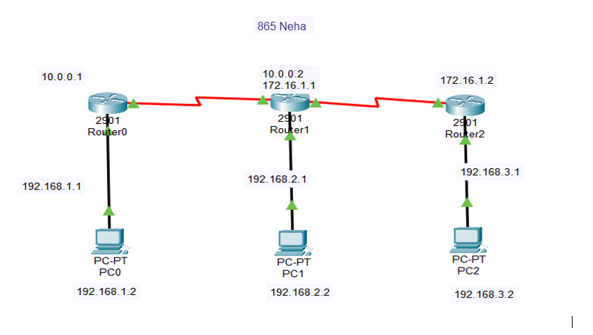
Router1:
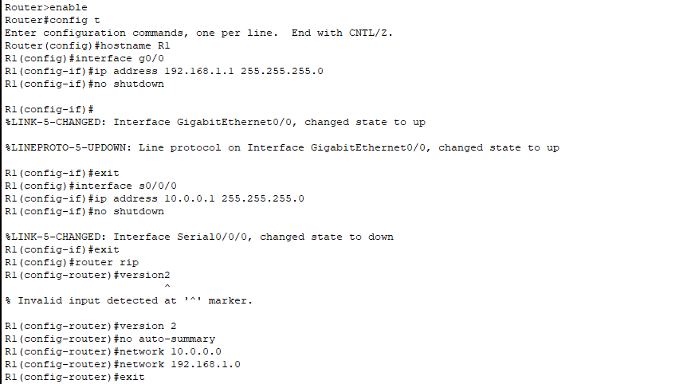

Router2:
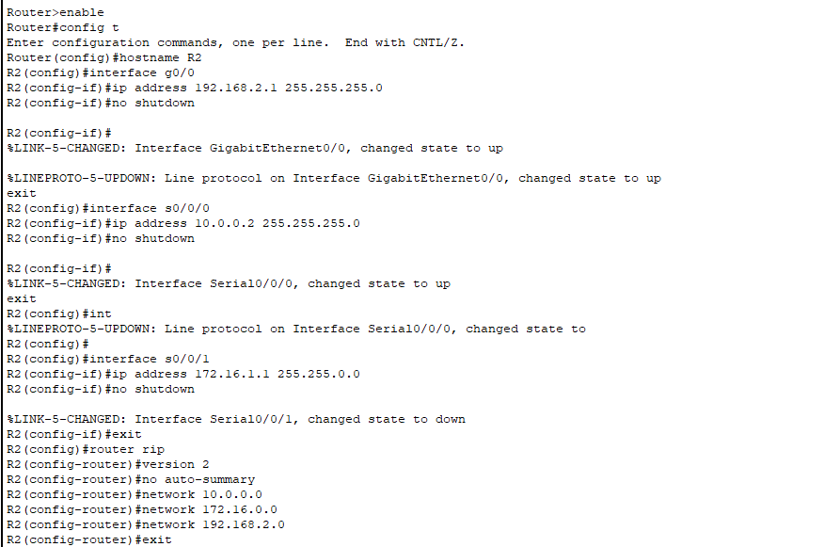
Router3:
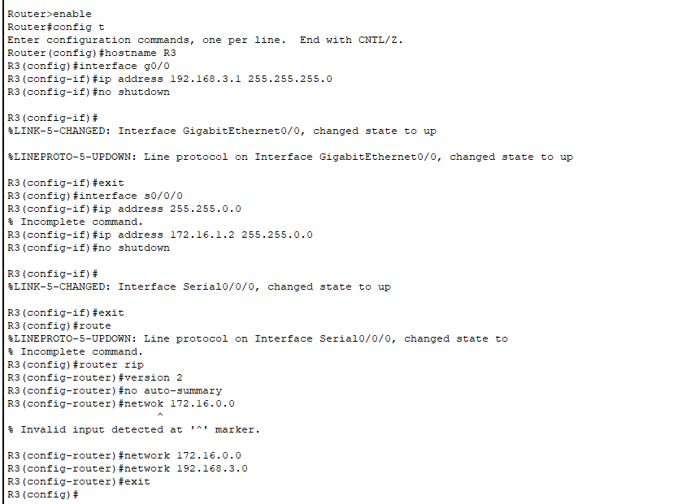
PC1:
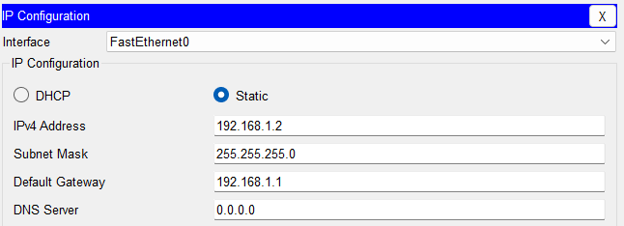
PC2:
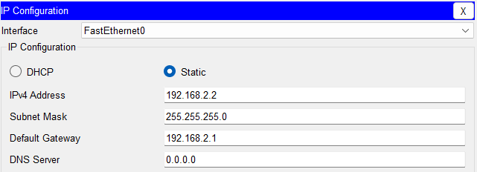
PC3:
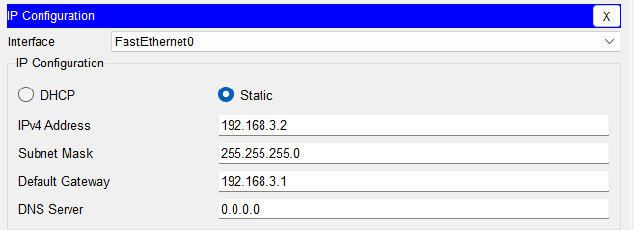

SSH configuration in all Routers :
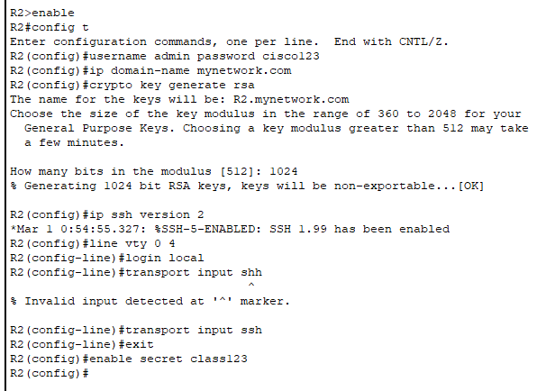

Output:
PC1:
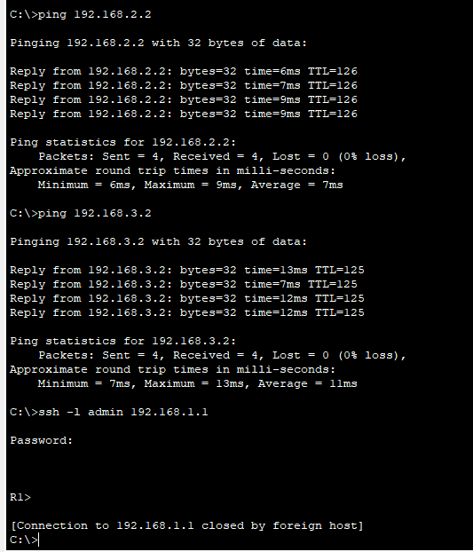

PC2:
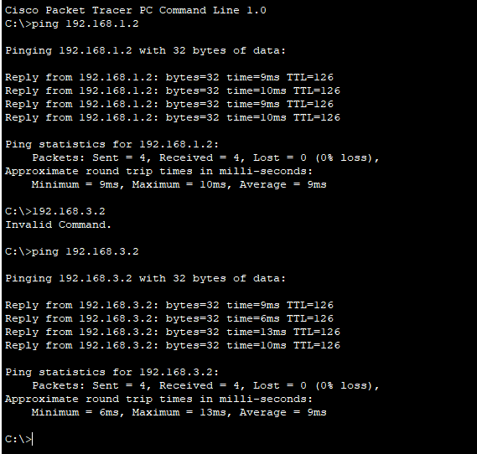

Practical 2 :
Aim: Configure OSPF and BGP for Classless IPv4 Addressing along with password protection.
- OSPF :
- A link-state interior gateway protocol(IGP).
- Supports Classless routing (uses VLSM and CIDR).
- Uses areas (usually Area 0 as Backbone).
- Uses authentication for security.
- BGP :
- A path-vector exterior gateway protocol(EGP).
- Used to route between autonomous system (AS)
- Also supports classless routing
- Uses MD5 authentication for password protection.
Topology :
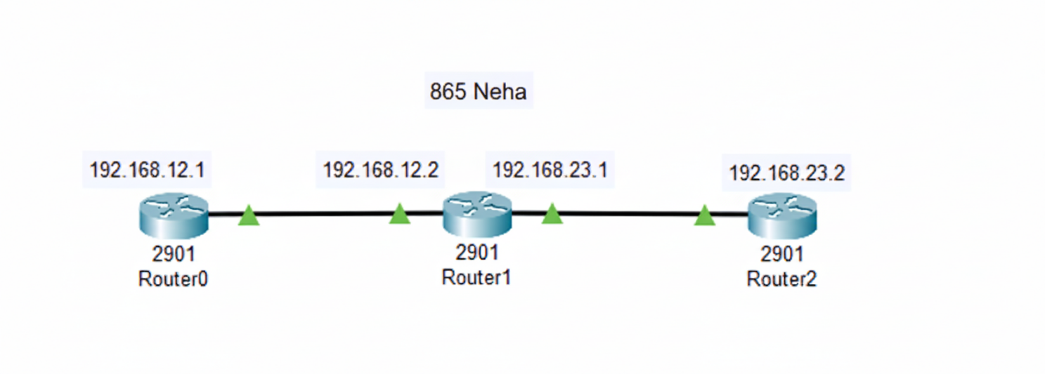

Router1:
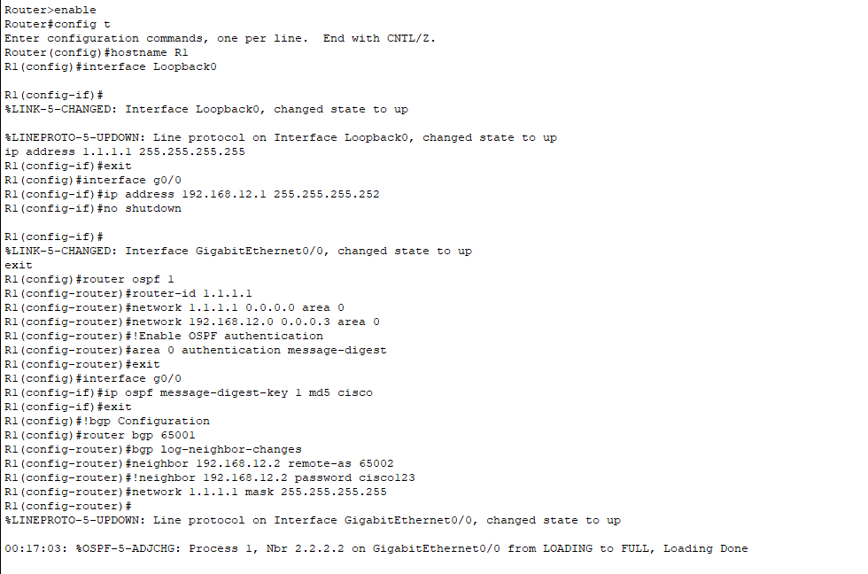

Router2:
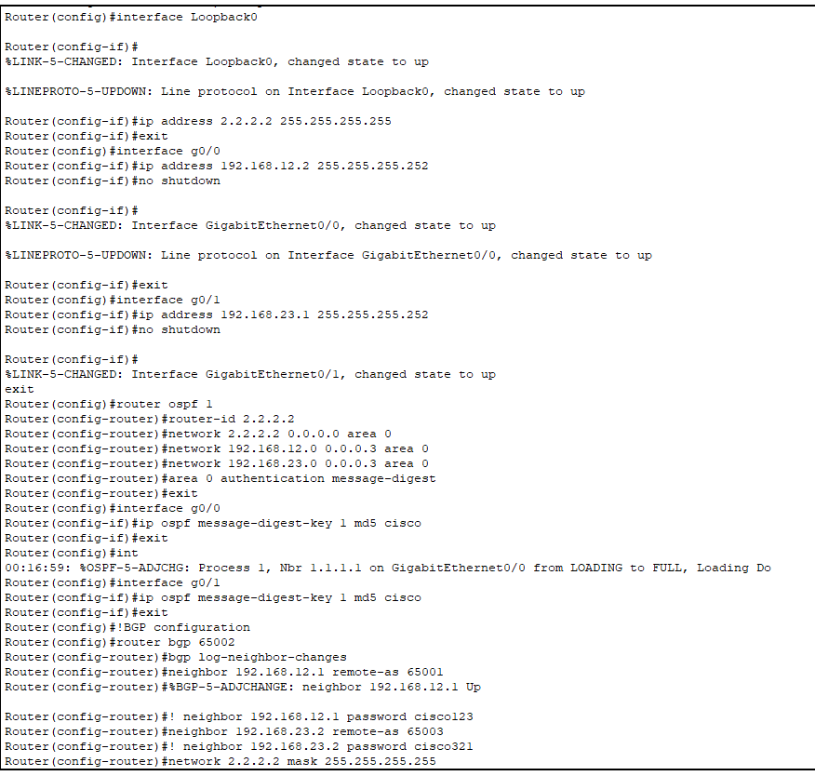

Router3:
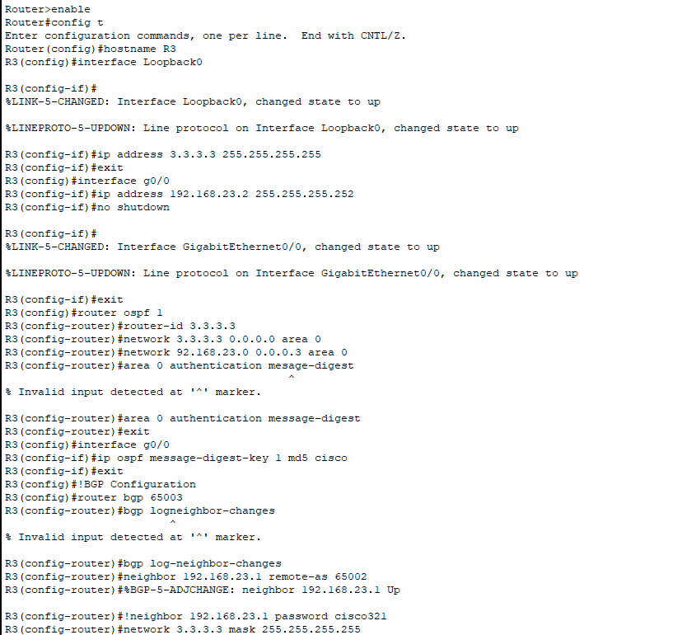

Output:
Router 1:
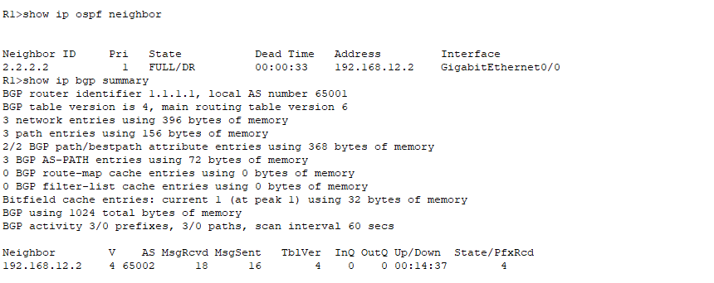
Router2:
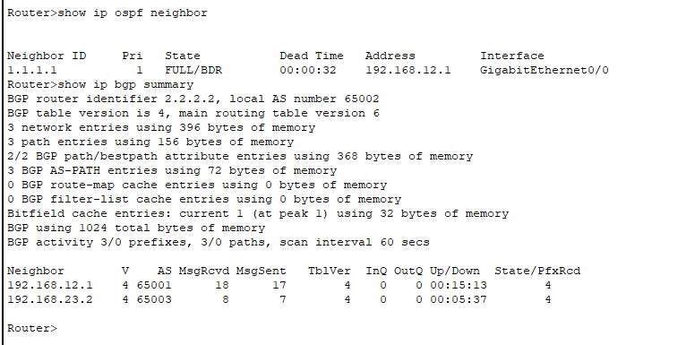

Practical 3 :
Aim: Configure Routers:
- OSPF MD5 authentication
- NTP
- To log messages to the syslog server

- OSPF:
Theory:
- OSPF (Open Shortest Path First) is a link-state routing protocol that helps routers determine the best path for data transmission based on network topology. OSPF operates by dividing networks into areas, with Area 0 serving as the backbone.

- Routers in the same area exchange link-state advertisements (LSAs) to share information, and each router independently calculates the best paths using the Dijkstra algorithm.

- OSPF supports fast convergence, making it well-suited for large, dynamic networks. ➢To secure OSPF routing updates, MD5 (Message Digest 5) authentication is used to ensure message integrity and prevent unauthorized routers from injecting false routing information.

- By applying an MD5 hash, OSPF ensures that the received routing updates are from legitimate sources and have not been tampered with.

- Both routers must have the same shared MD5 key configured for authentication. This enhances the security of OSPF communications, ensuring that only trusted routers can exchange routing updates.

- Set up the Topology :
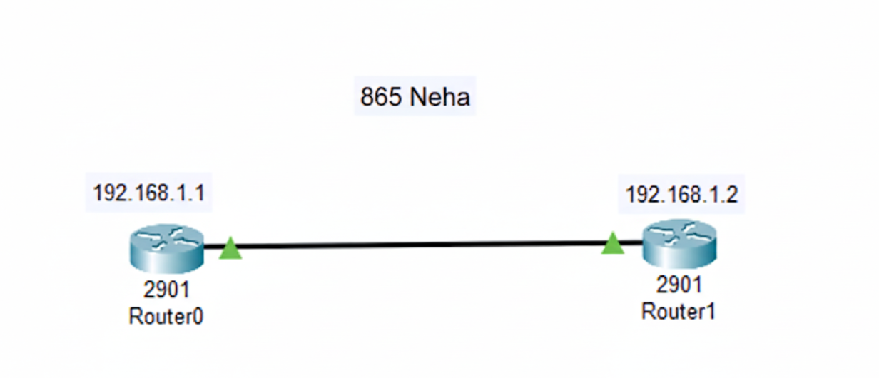
- Assign IP addresses (router 0 & router1 ):
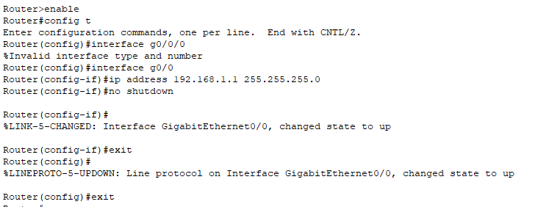
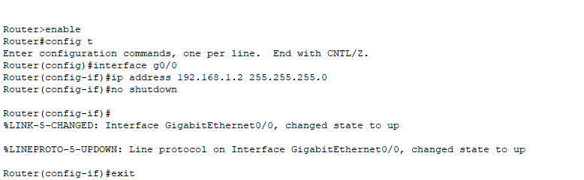

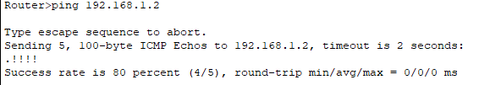

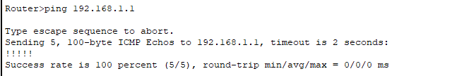

- Configure OSPF: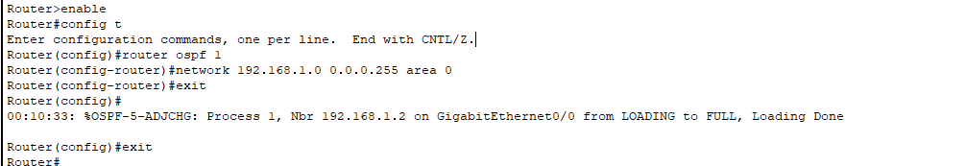
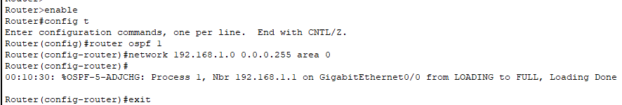

- Configure MD5 Authentication:
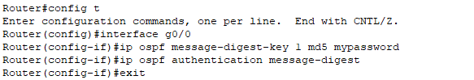
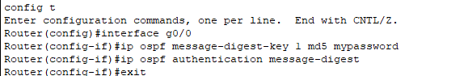

Output:
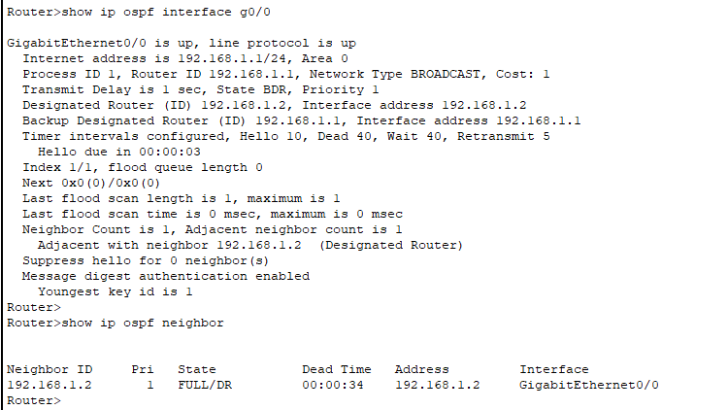

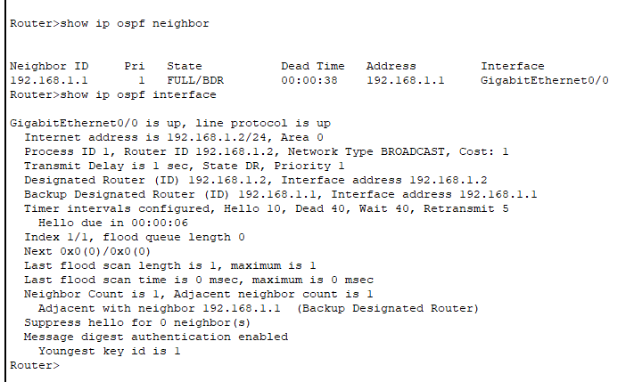

- NTP:
Theory:
- NTP (Network Time Protocol) is a protocol used to synchronize the clocks of computers and network devices over a packet-switched network.

- It helps maintain accurate time across all devices in a network, ensuring consistency in logging, event coordination, and scheduled tasks.

- NTP uses a hierarchical system of time sources, with servers classified in strata: Stratum 0 (highly accurate sources like atomic clocks) down to Stratum 15. Devices sync their clocks with a time server, which can be internal or external.

- Network setup:
Topology :

- Configure Basic IP connectivity :
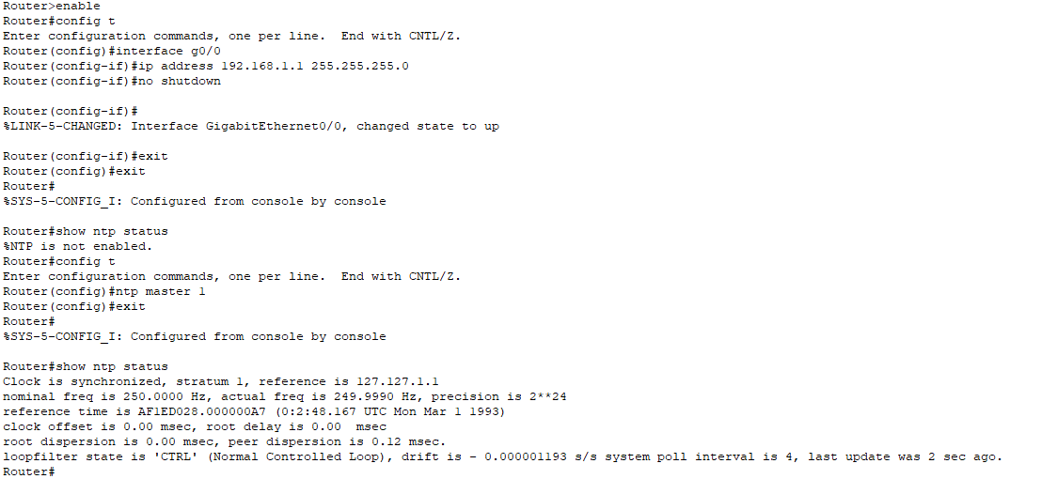
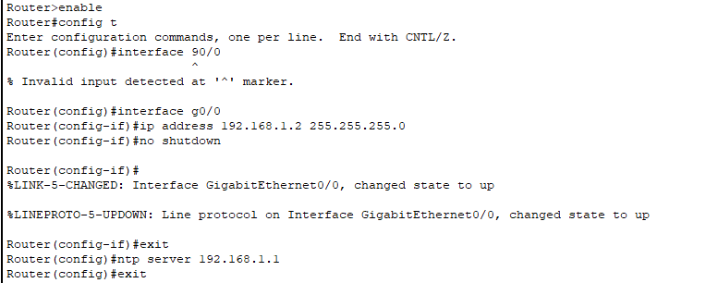

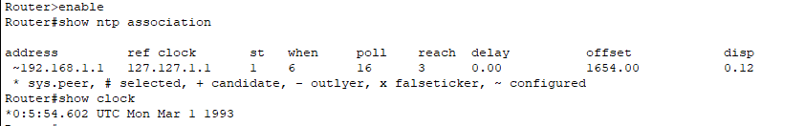

- Verify NTP Synchronization:
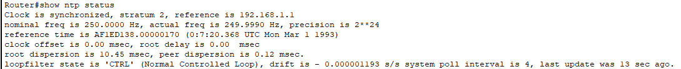
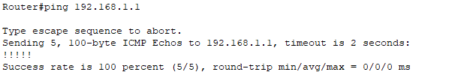

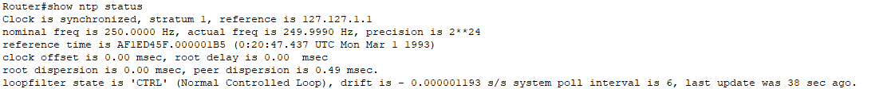

- To log messages to the syslog server:
Theory:
- A syslog server collects, stores, and manages log messages from network devices for monitoring, analysis, and troubleshooting.

- To log messages to a syslog server, a router or network device is configured to send log messages to a specific IP address of the syslog server, which collects and stores these logs.

- This is typically done by specifying the server's IP address using the command logging host <syslog-server-ip> and setting the logging level (e.g., logging trap informational).

- The router generates log messages for various events such as interface status changes,

- routing updates, or system errors, and sends them to the syslog server. The syslog server stores these logs, providing a centralized location for network monitoring, analysis, and troubleshooting.

- Network setup:
Topology:
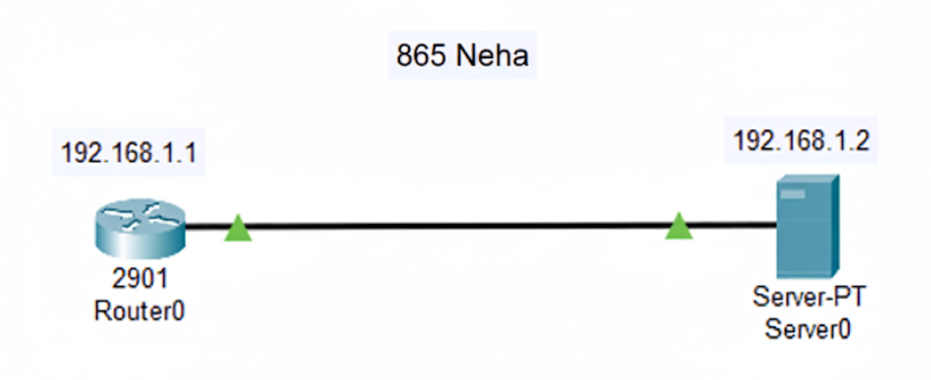

- Configure IP Addresses:
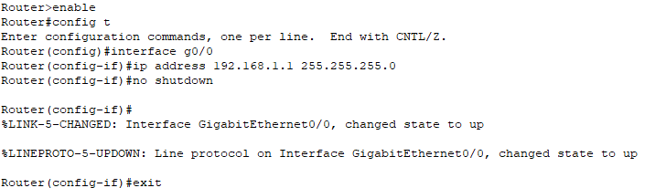
- On the Syslog Server:
- Assign an IP address to the Syslog server.
- Example: IP: 192.168.1.2, Subnet Mask: 255.255.255.0

- Configure the Router to send Logs to the Syslog Server:
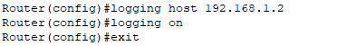
- Generate Log Messages:
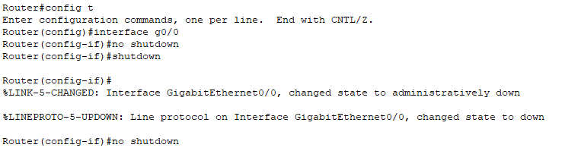

- Verify Configuration:
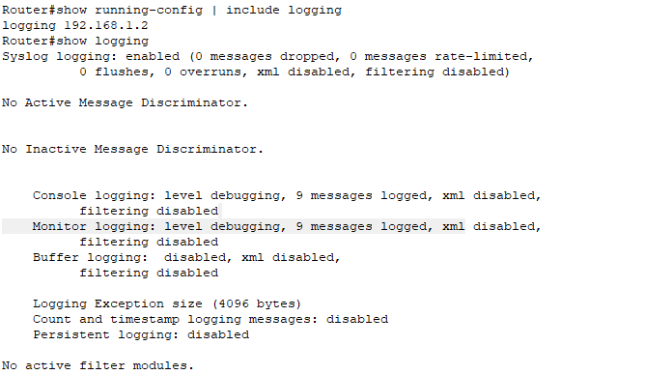

Practical 4 :
Aim : configure AAA Authentication
- Configure a local user account on Router and configure authenticate on the console and vty lines using local AAA
- Verify Local AAA authentication From the router
Theory :
- AAA stands for Authentication, Authorization, and Accounting, which are essential components of network security.
- Authentication is the process of verifying the identity of a user, device, or entity attempting to access a network or system.
- Authorization refers to the permissions granted to authenticated users, specifying what resources they can access and what actions they can perform.
- Finally, Accounting tracks the actions of users and devices during their session, maintaining logs that record activities such as login times, commands executed, and resource usage, which helps with auditing and troubleshooting.
- Local AAA means that the authentication, authorization, and accounting settings are configured locally on the device itself rather than relying on an external server like a RADIUS or TACACS+ server.
- Console and VTY (Virtual Terminal) lines are types of access methods for connecting to a router or switch.
- The console line refers to a physical serial connection that allows administrators to access the device directly through a console cable. It's typically used for out-of-band management, especially when remote access is unavailable.
- On the other hand, VTY lines are logical connections used for remote access via Telnet or SSH. VTY lines allow administrators to connect to the device over the network, providing more flexibility for management. Configuring authentication on both the console and VTY lines with AAA ensures secure access to the device by verifying user credentials before granting access.

- Network Setup:
Topology:
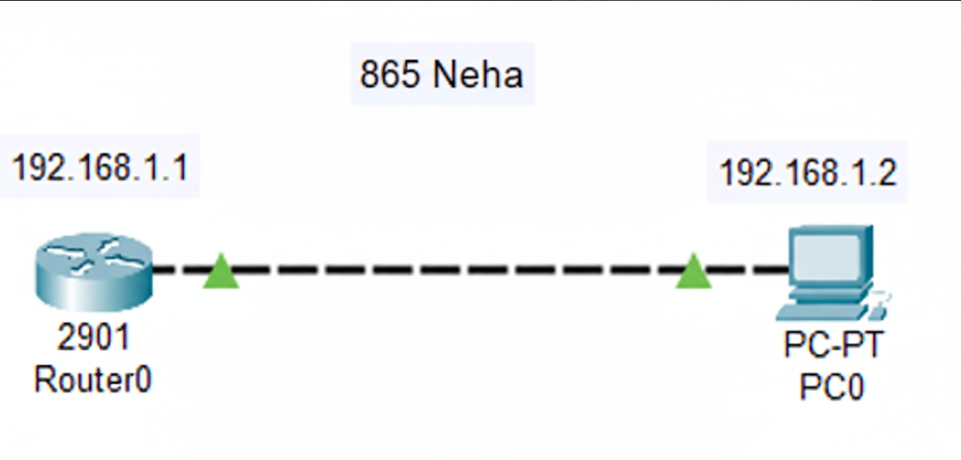

- Basic Router Configuration:
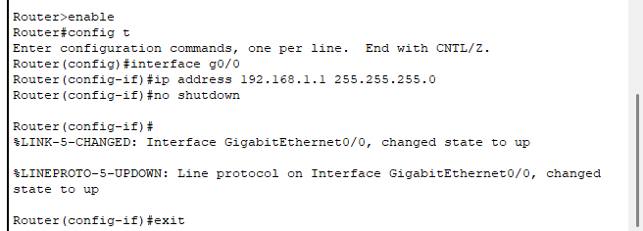
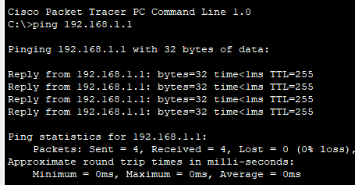

- Configure Local AAA on the Router:
1. Enable the AAA feature on the router:
2. Create a local user account for authentication:
3. Configure AAA authentication for console access:
4. Apply the AAA method to the console line:
5. Configure AAA authentication for VTY lines (Telnet/SSH):
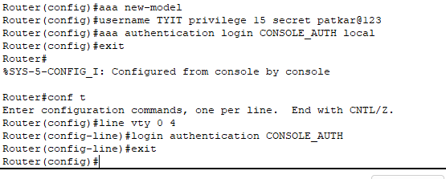
- Verify AAA Configuration:
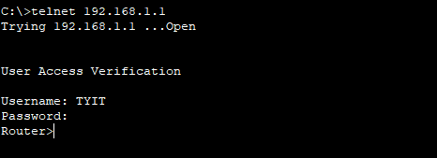

- Testing and Troubleshooting:
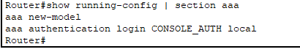

Practical 5 :
Aim : Configuring Extended ACLs.
Extended ACLs(Access Control Lists) :
Extended ACLS filter traffic based on multiple parameters like source IP, destination IP, protocol type (TCP, UDP, ICMP), and even port numbers. They are more powerful than standard ACLs because they provide fine-grained control over what traffic is permitted or denied. They are usually applied close to the source to save bandwidth.
- Configure PCs
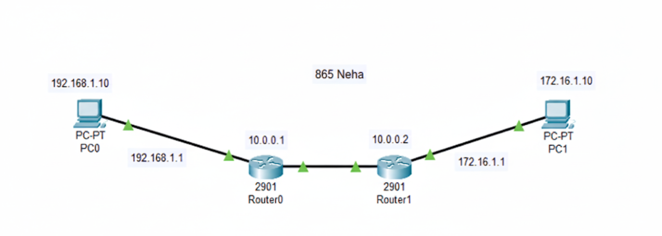
- Configure Router1
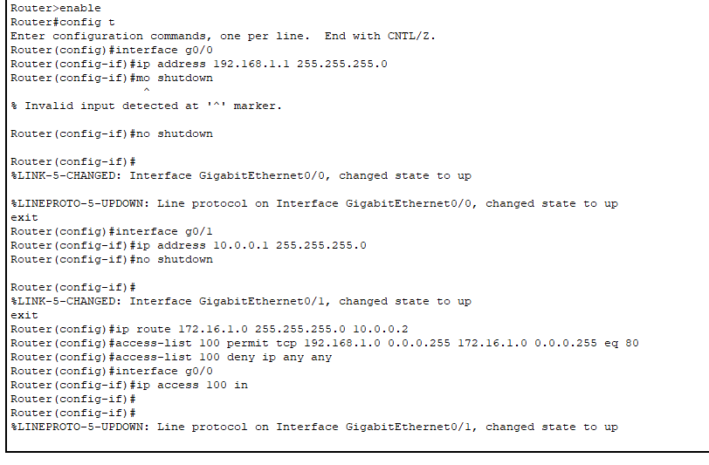
- Configure Router2:
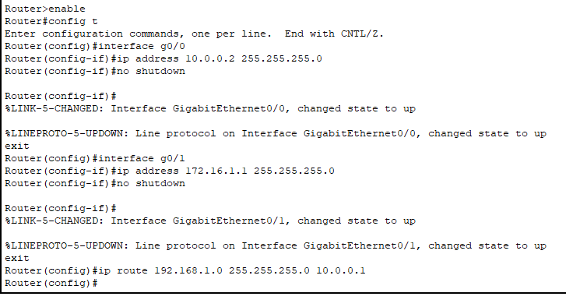
Output:
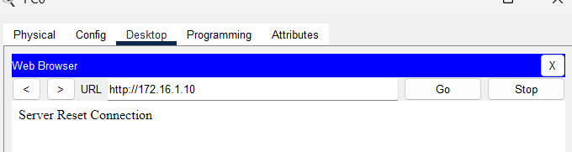
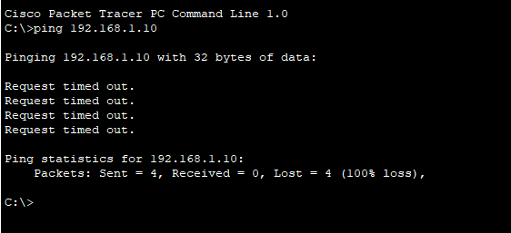

Practical 7 :
Aim : Configure IOS Intrusion Prevention System (IPS) Using the CLI
Cisco IOS IPS (Intrusion Prevention System) is a feature that acts as a router-based security measure, inspecting network traffic for malicious activity and taking action to prevent or mitigate attacks. It can detect threats using signatures, and respond by logging events, dropping packets, or even blocking traffic. IOS IPS is typically configured on Cisco routers and can be managed using various tools like Cisco Security Manager, Cisco Configuration Professional, or Cisco IPS Manager Express.
What it does:
- Intrusion Detection and Prevention: IOS IPS monitors network traffic, looking for patterns that match predefined attack signatures.
- Signature-based Detection: It relies on a database of signatures, which are essentially rules that identify specific attack types or vulnerabilities.
- Real-time Response: When a signature match is found, IOS IPS can take immediate action, such as dropping the malicious packet, logging the event, or even blocking the source of the attack.
- Configuration and Management: Cisco IOS IPS can be configured to respond to different types of threats based on severity, target, or other factors.
How it works:
- Traffic Inspection: IOS IPS examines network traffic as it passes through the router, analyzing packets and sessions.
- Signature Matching: It compares the traffic against its signature database to identify potential threats.
- Action Execution: Based on the signature match, IOS IPS takes the configured action, such as logging the event, dropping the packet, or sending an alert.
Tools for Management:
- Cisco Security Manager: A centralized management tool for configuring and managing multiple routers running IOS IPS.
- Cisco Configuration Professional: A GUI-based tool for managing individual routers, including IOS IPS.
- Cisco IPS Manager Express: A tool for monitoring IPS events on up to 10 routers.

Key Considerations:
- Signature Updates: IOS IPS relies on updated signature databases to stay effective against new threats. Cisco systems provides details on signature updates.
- Resource Usage: IOS IPS can consume router resources, so it's important to ensure the router has sufficient capacity for the traffic volume and configured IPS policies.
- False Positives: Like any signature-based system, IOS IPS can sometimes generate false positives, where legitimate traffic is mistakenly identified as malicious.
Network setup :
Topology :
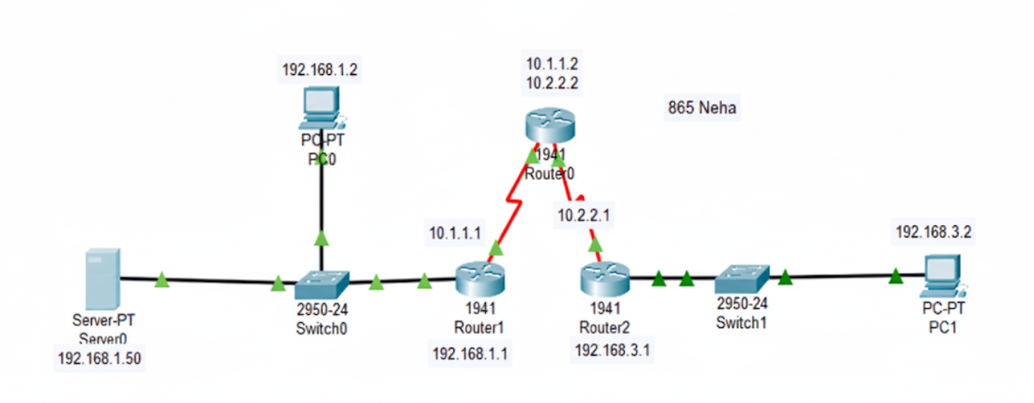
Router configuration :
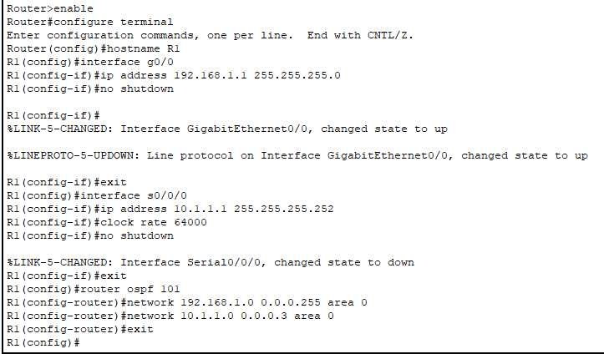
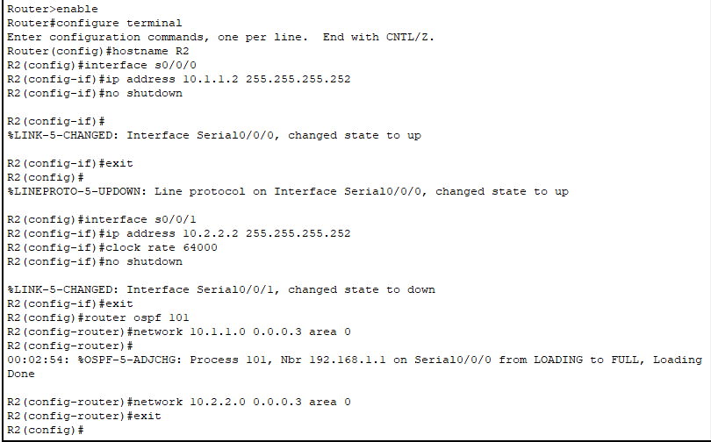
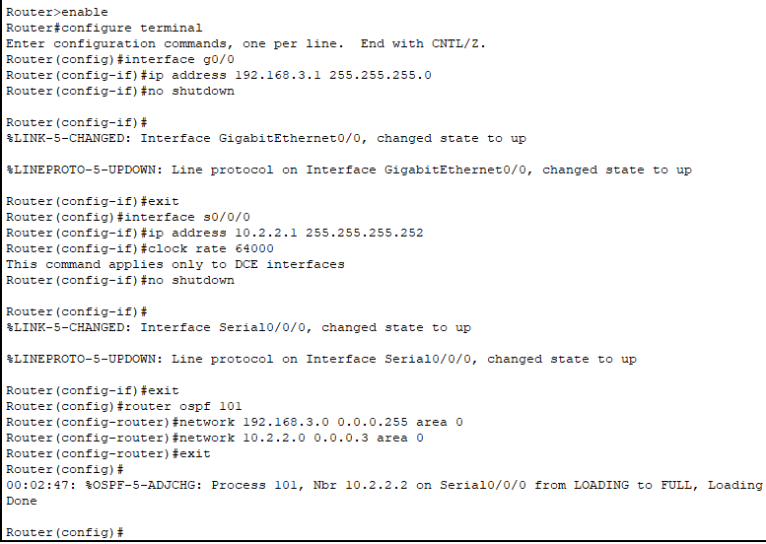
Verification Checklist:
Ping tests before IPS
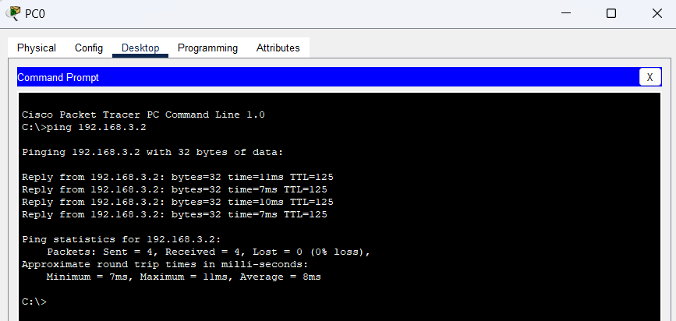
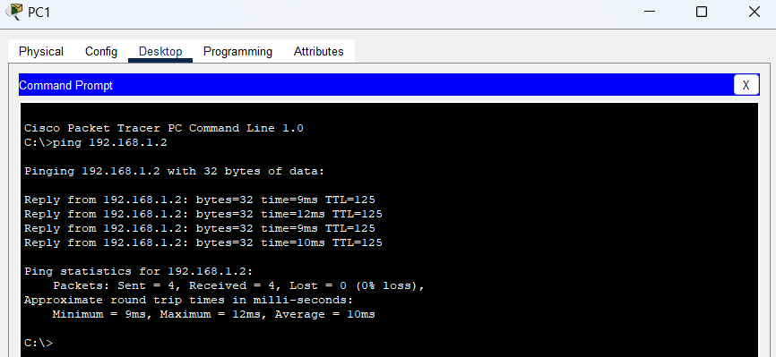
Detailed Configuration of IOS IPS on R1
Step 1: enable the security Technology Package
This is needed because IPS requires the securityk9 package.
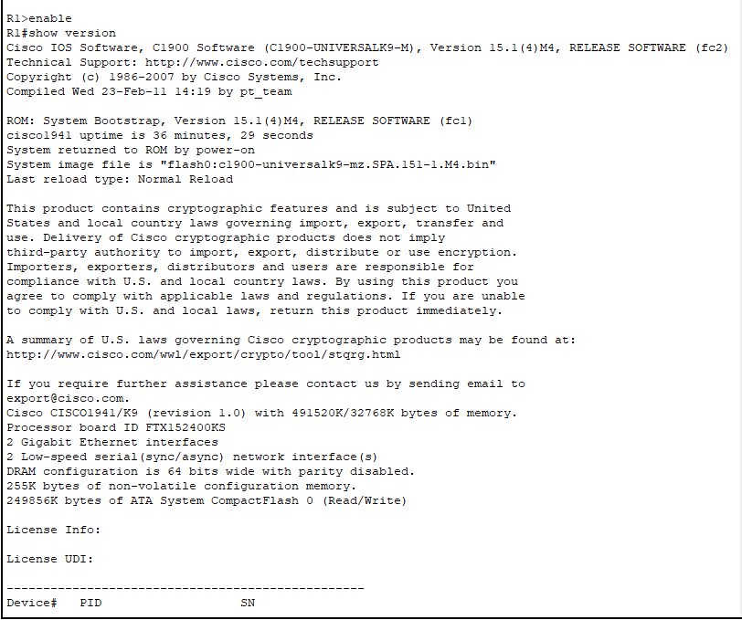
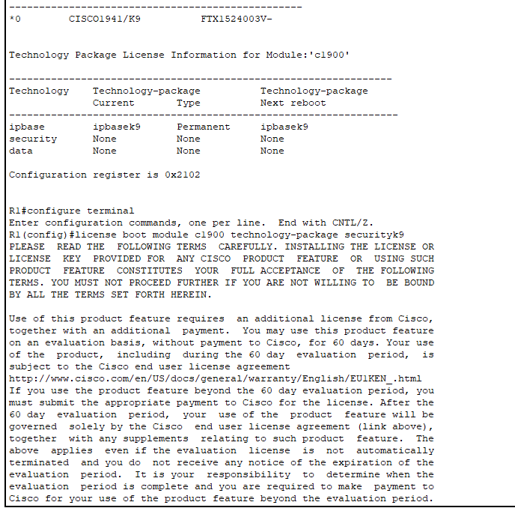

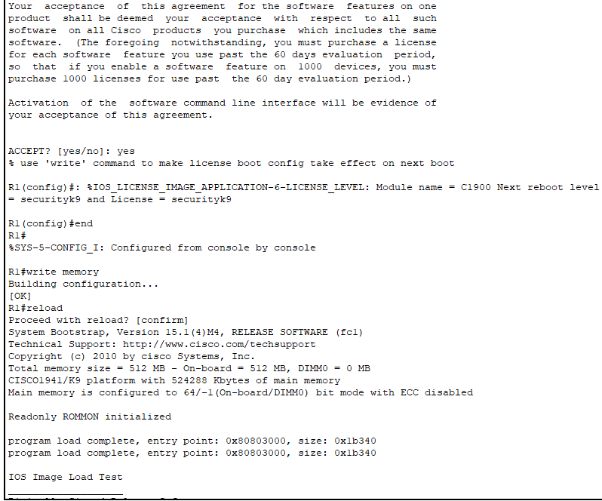

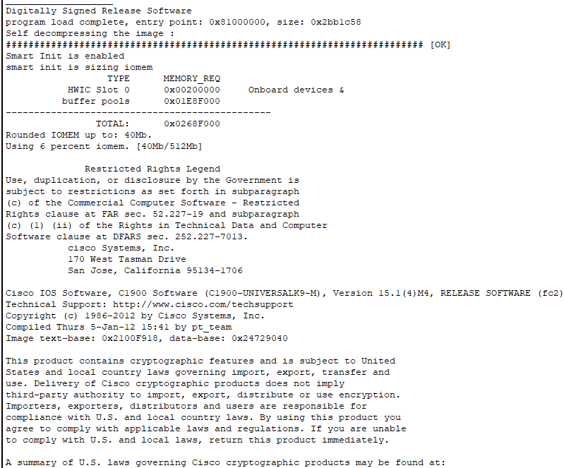

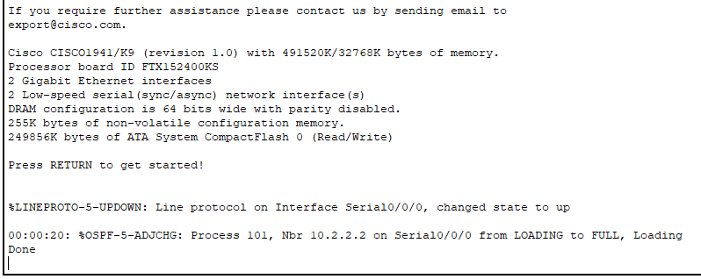

After reload, verify:
Step 2: Verify Network Connectivity
Before IPS setup, ensure devices can talk
From PC-c (192.168.3.2), ping PC-A (192.168.1.2).
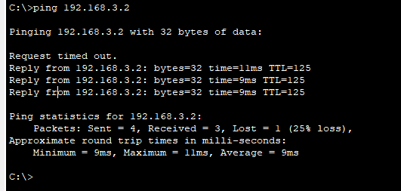
From PC-A (192.168.1.2), ping PC-C (192.168.3.2)
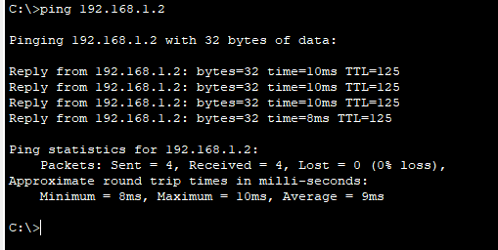
Both should succeed at this stage.
Step 3 : Create an IPS configuration Directry
Create a folder in R!’s falsh memory to store IPS signature.
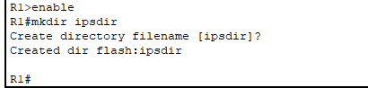
Step 4 : Configure IPS signature storage Location.
Tell R! where to store signature files.
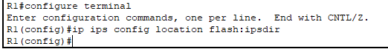
Step 5 : Create an IPS rule
Create a named IPS rule.
Step 6 : Configure Logging
IPS alerts should go to the syslog server.
Enables IPS notification Through Logging:
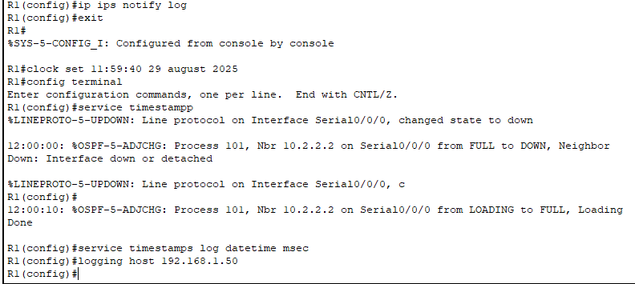
Step 7: Configure IPS Signature Categories
By default, all signatures are retired (disabled). You must:
Retire ALL signatures.
Activate only the IOS_IPS Basic category.
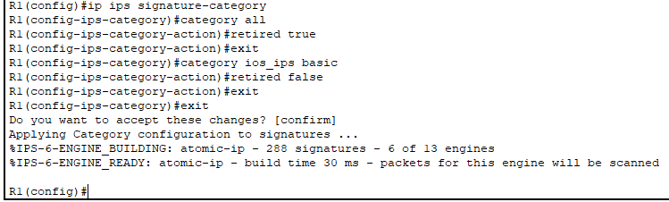
Step 8: Apply IPS Rule to Interface
Apply IPS rule outbound on G0/1 (192.168.1.1).
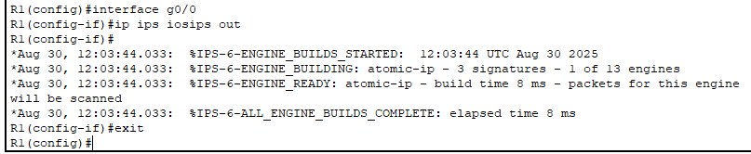
Now IPS is active on traffic leaving R1 towards 192.168.1.0/24.

Part 2: Modify the Signature
Step 1: Modify ICMP Echo Request (Signature 2004/0)
We want IPS to block ping requests (echo) but allow replies.
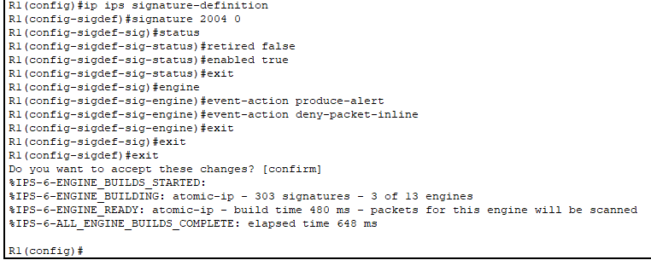
Step 2: Verification Commands

Check IPS summary:
R1# show ip ips all
1. 👉 It should show iosips applied to G0/0 outbound.
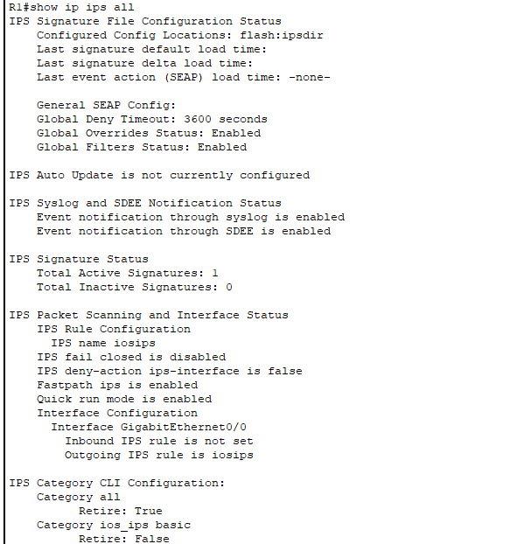
2. Test from PCs:
From PC-C → PC-A: Pings FAIL (blocked by IPS).

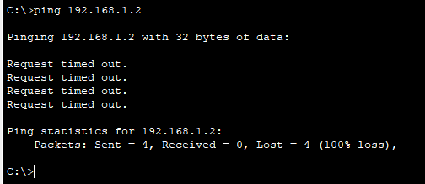

From PC-A → PC-C: Pings SUCCESS (because only echo request is blocked,
not echo reply).
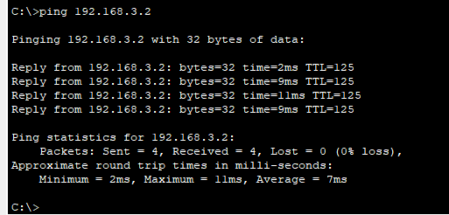
3. Check Syslog Server:
On Syslog server → Services → SYSLOG tab.
You should see logs for denied packets and alerts.

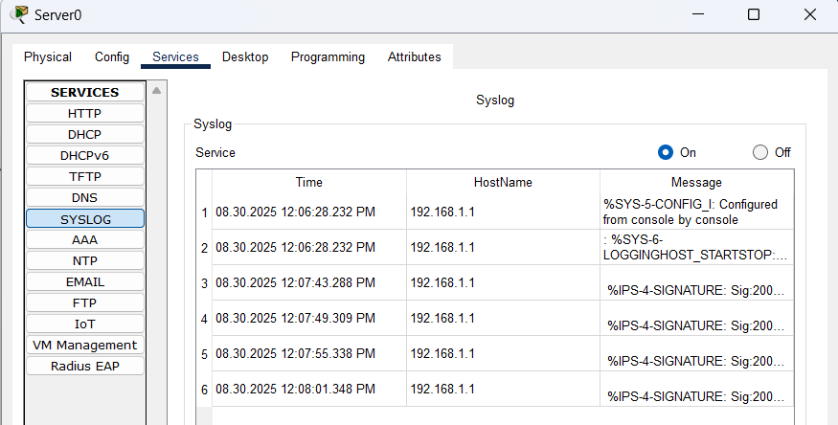

Practical 6 :
Aim : Configure IP ACLs to Mitigate Attacks.
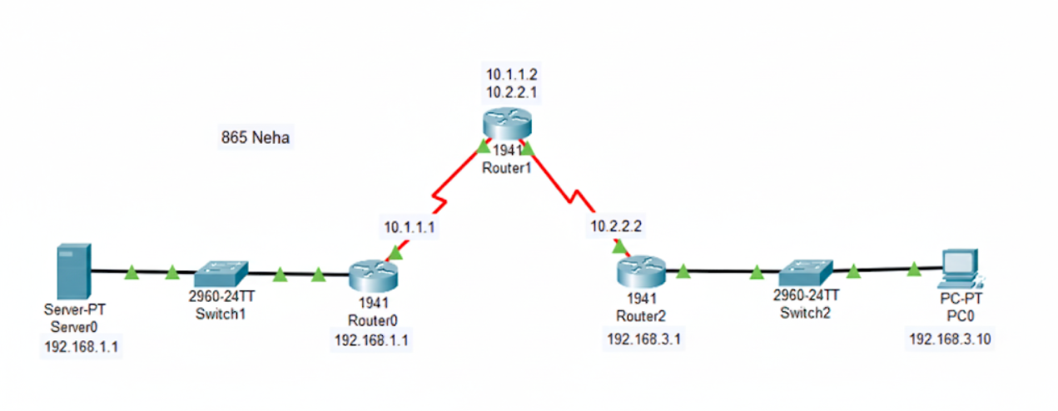

R1 configuration :
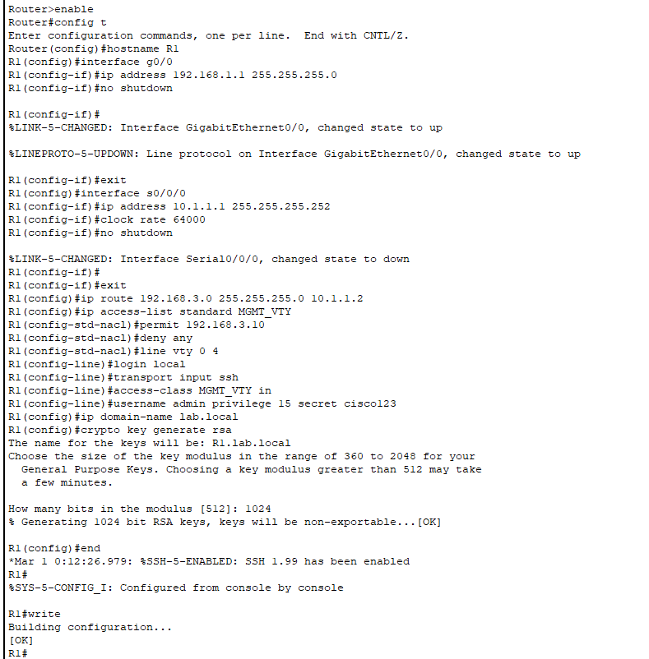
R2 Configuration :
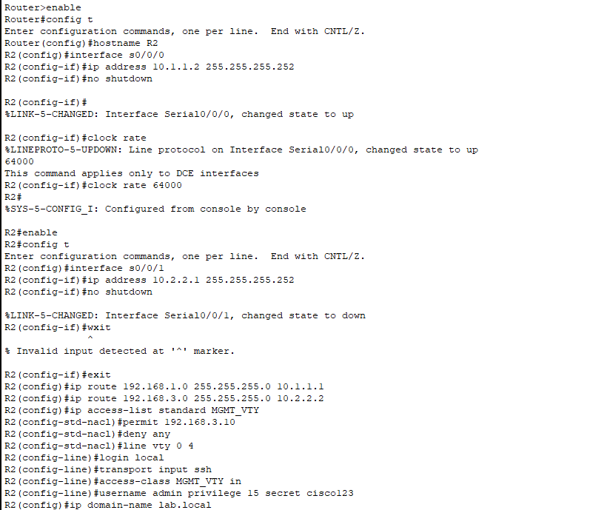
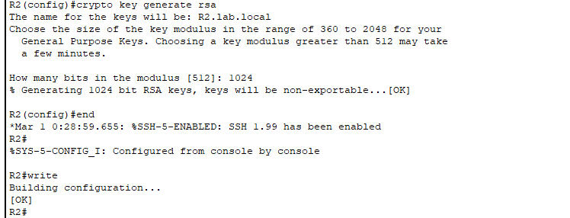

R3 Configuration :
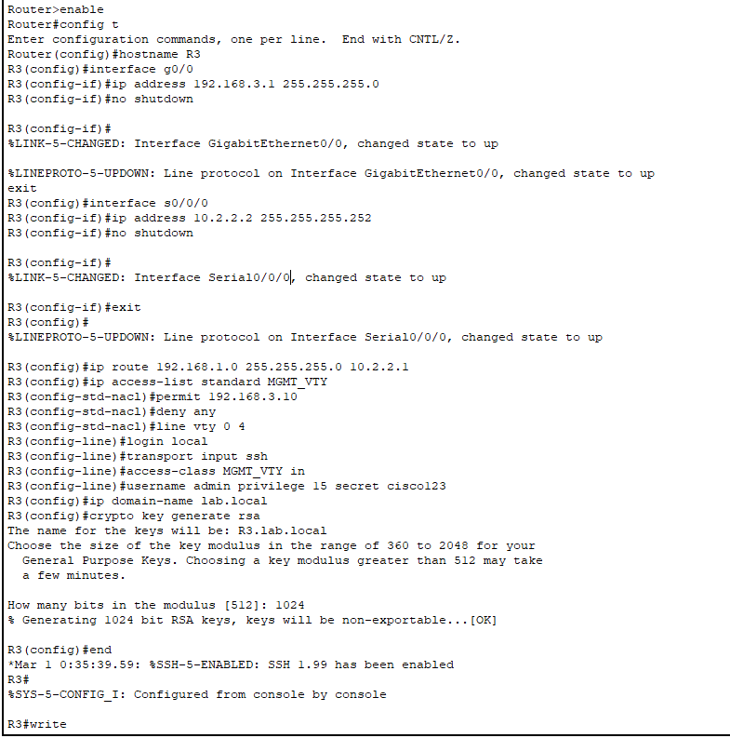
Test Connectivity :
- From Pc , ping server (192.168.1.10)
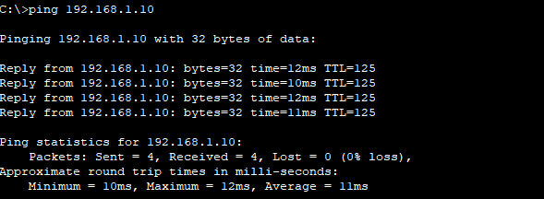

- From server, ping pc (192.168.3.10)

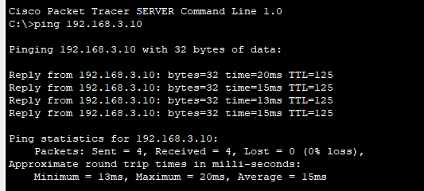

- From pc try to ssh into r1, r2, r3

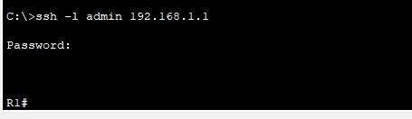

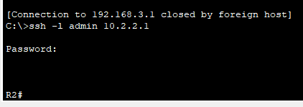

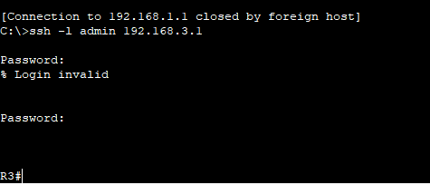

ACL setup for all three routers:
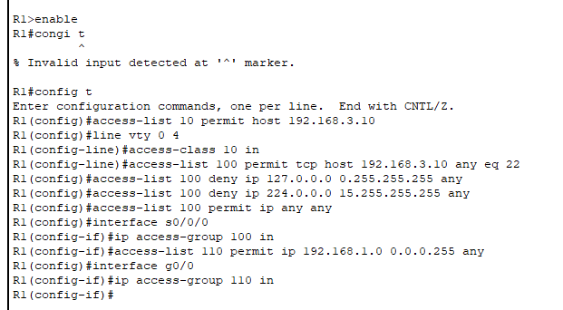
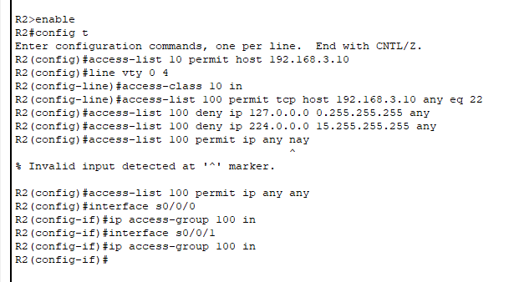
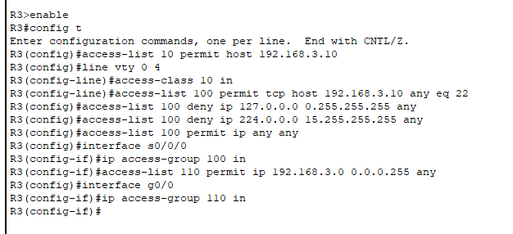
How this works
● Only PC-C (192.168.3.10) can SSH/Telnet to routers.
● Extended ACL blocks unwanted private/bogus IP traffic (loopback, multicast).
● WAN serial interfaces are protected with ACLs.
● LANs are explicitly permitted into their routers.
Output :
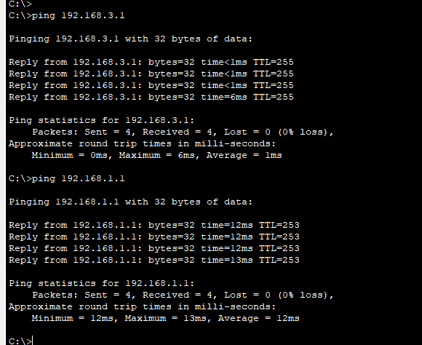
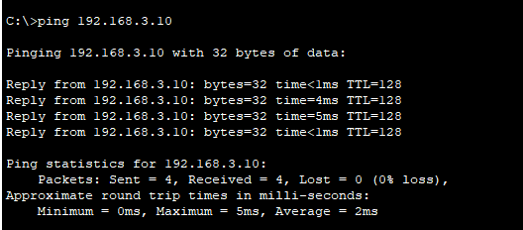

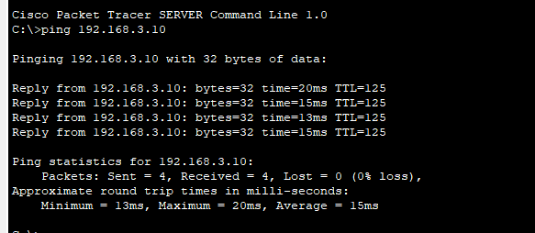
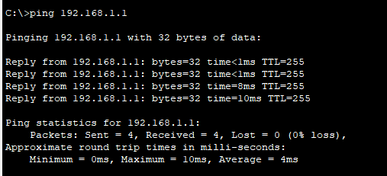
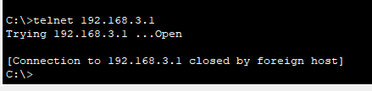

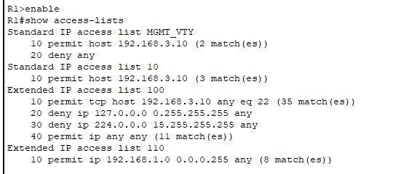

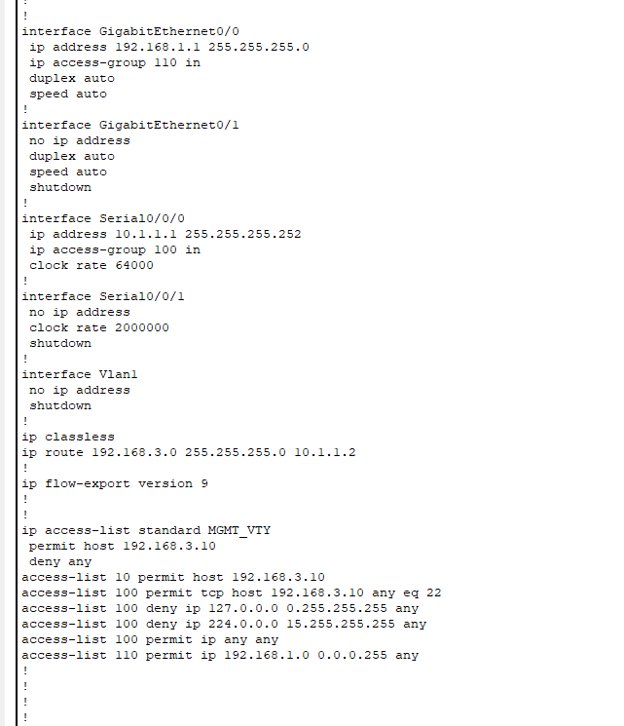
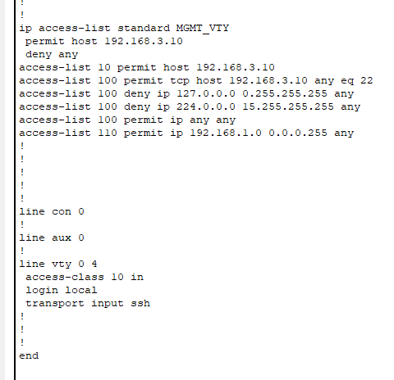
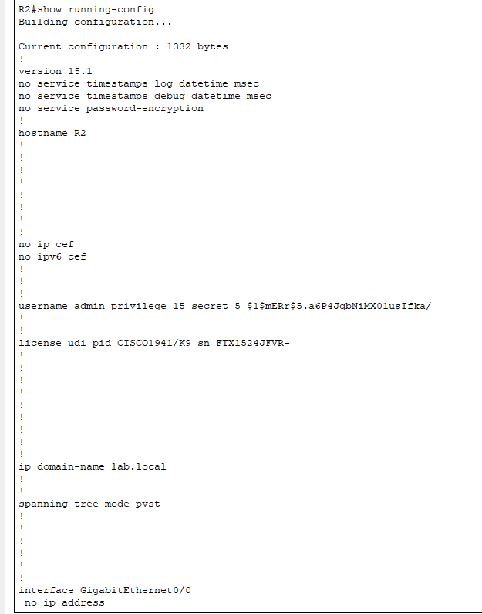
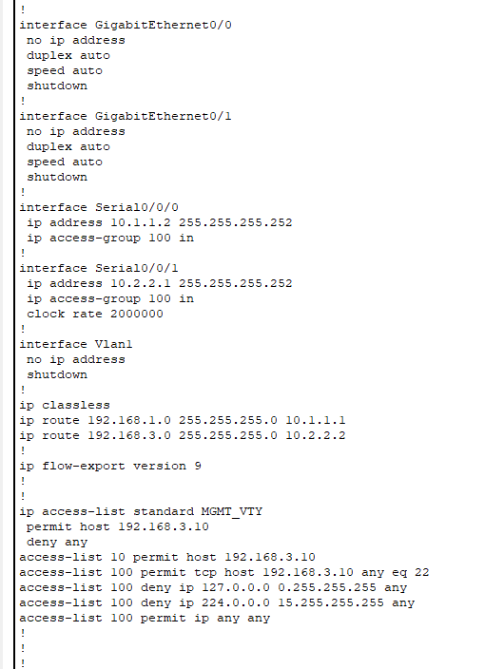
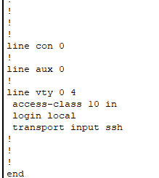
Practical 8 :
Aim : Configure IPv6 ACLs
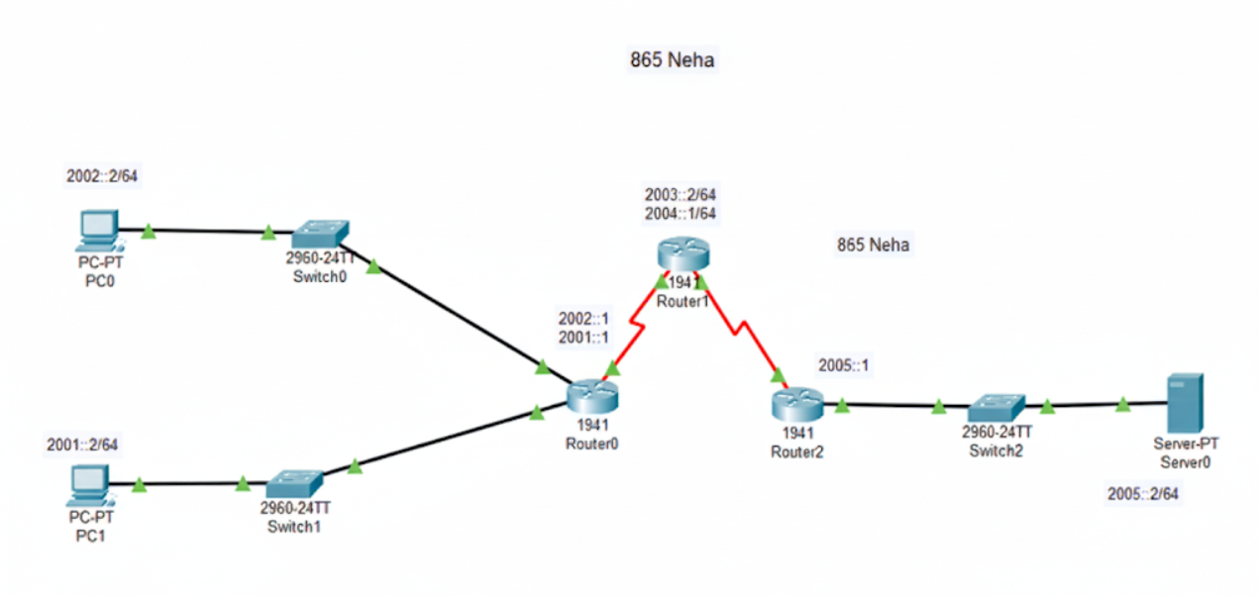
Routers Configuration :
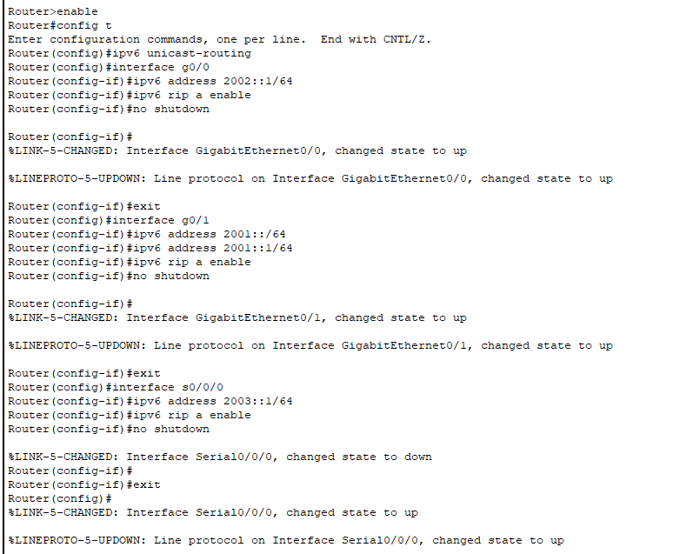
Router 2 :
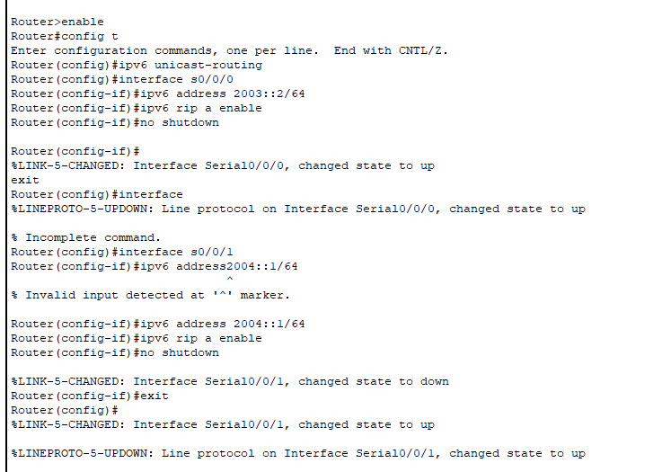
Router 3 :
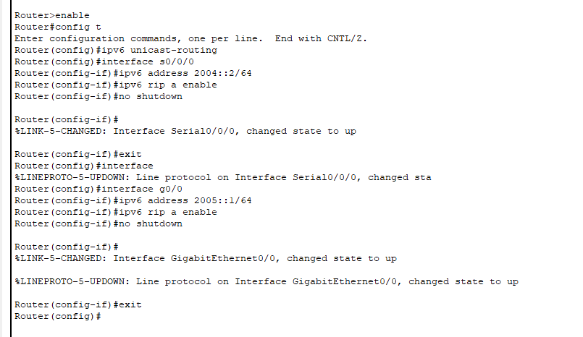

Test Connectivity :
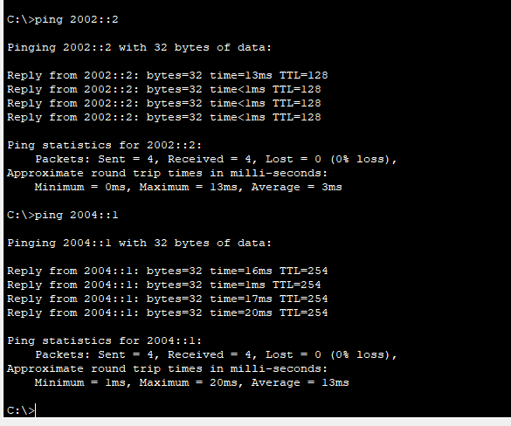
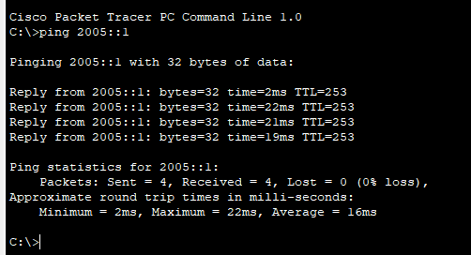

2. Web Test:
Open the browser on PC1 or the Server and access http://[2005::2].
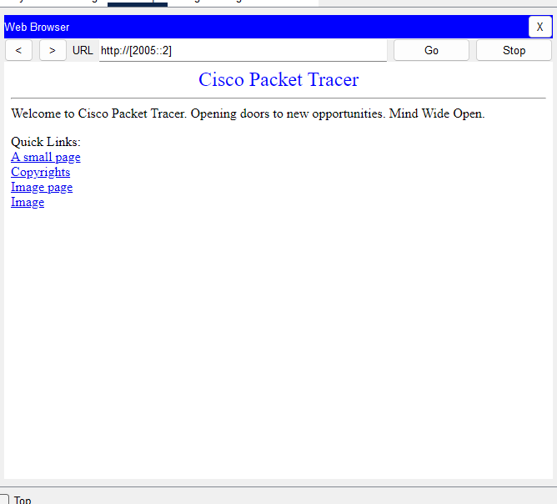
Result :
- PCs and Server can ping their respective gateways and devices in the network.

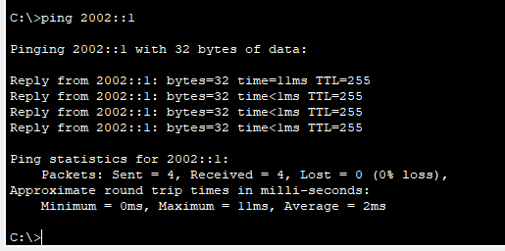

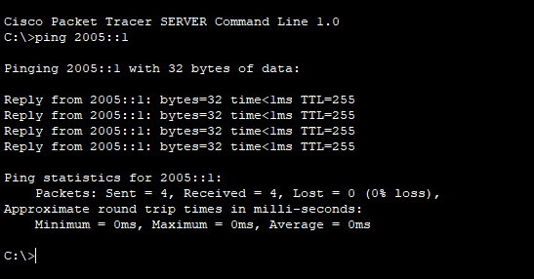

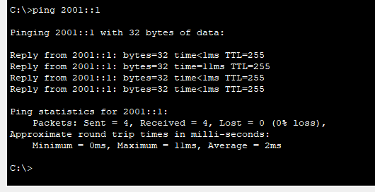

- RIP propagates routes, enabling communication across routers.

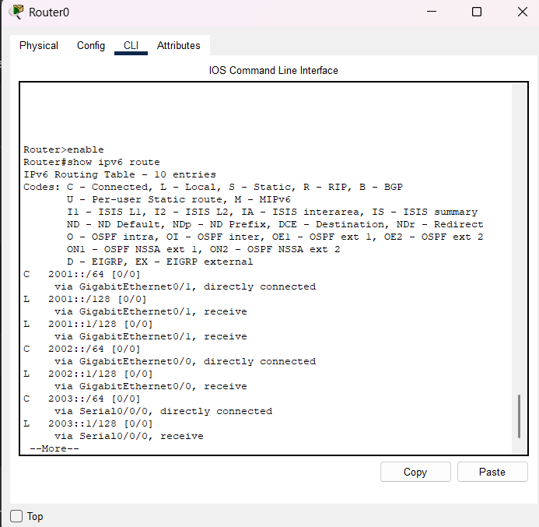

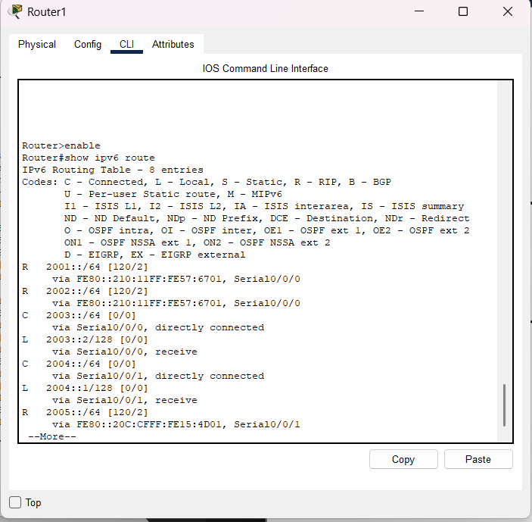

- HTTP/HTTPS traffic to the server (2005::2) is blocked.

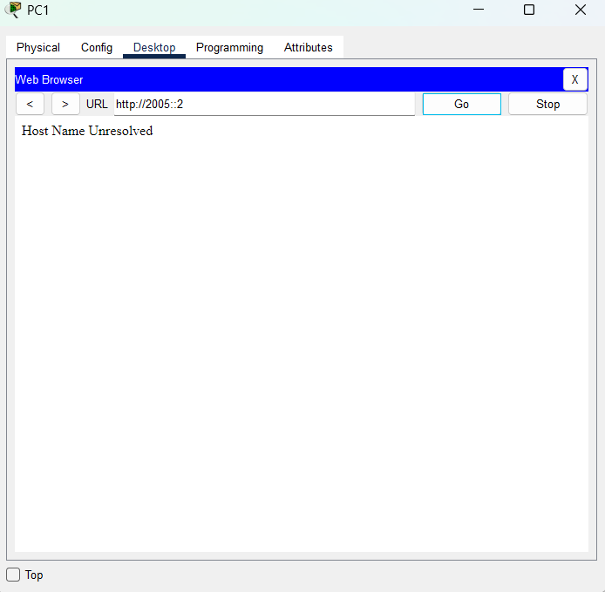

- Other types of traffic, including ICMP (ping), remain functional.
