

Smart Medicine Dispenser

Yingjie Qian, Neha Pathare, Navdeep Singh
Group Number: 01
School of Physics, Mathematics and Computing
University of Western Australia, Australia
CITS5506: The Internet of Things
Semester 1, 2025
Emails: 24262634@student.uwa.edu.au,
24350545@student.uwa.edu.au,
24496192@student.uwa.edu.au

Abstract
Medication adherence remains a critical challenge for elderly populations managing chronic conditions, with non-compliance often resulting in adverse health outcomes and increased healthcare utilization. The project presents the design and implementation of a Smart Medicine Dispenser, an automated system aimed at improving medication adherence through reliable scheduling, verification, and caregiver alert mechanisms. Central to the system is an ESP32 microcontroller, which manages precise pill dispensing aligned with individualized medication regimens. The device incorporates multi-modal reminder modalities, including LED indicators, auditory voice alerts, and web app reminders, to accommodate diverse sensory requirements among elderly users. An infrared sensor serves as a verification mechanism to detect medication retrieval, enhancing the accuracy of adherence monitoring. Upon detection of missed doses, real-time alerts are communicated to caregivers via a secure Firebase based platform, enabling prompt intervention. All medication events are securely logged within a cloud-based database, supporting adherence assessment and facilitating data-driven healthcare management. We did test the system within a controlled laboratory environment and took receiving user feedback regarding usability and reminder effectiveness. By integrating automation, real-time verification, and remote monitoring, the proposed solution supports medication self-management among elderly individuals, while mitigating caregiver burden. The Smart Medicine Dispenser offers a cost-effective, scalable approach to enhance medication safety and health outcomes, thereby contributing to improved quality of life in aging populations.

Index Terms—Smart medicine dispenser, ESP32, medication adherence, real-time alert system, elderly healthcare, cloud data logging, remote monitoring.

- Problem Statement
Medication non-adherence among elderly patients is a significant and widespread challenge that results in serious health complications, increased hospital admissions, and elevated healthcare costs [1]. Many elderly individuals face difficulties such as cognitive decline, sensory impairments, and complex medication regimens, which contribute to missed or incorrect doses. Current medication management solutions often lack either automation, reliable intake verification, or affordability and ease of use for elderly users. There is a critical need for a cost-effective, accurate, and user-friendly system that not only provides timely reminders but also verifies actual medication intake and offers real-time monitoring with caregiver alerts. This project aims to address this gap by developing a Smart Medicine Dispenser incorporating infrared sensor verification, multi-modal reminders, and cloud-based caregiver notifications to enhance medication adherence and improve healthcare outcomes for elderly populations.

- Introduction
The global increase in the elderly population has led to a rise in chronic diseases that require strict and timely medication regimens [2]. However, medication adherence among elderly patients is often compromised due to cognitive decline, physical impairments, and the complexity of multiple medication schedules. These factors contribute to missed or incorrect doses, posing serious health risks and increased healthcare costs. Traditional manual pill dispensers lack automation, reminders, and reliable monitoring capabilities, while many existing smart dispensers are expensive and rely on single-sensor verification methods that may reduce accuracy and reliability.
This project proposes a Smart Medicine Dispenser designed to address these shortcomings by combining automated pill dispensing with infrared sensor verification and multi-modal reminders. The system leverages an ESP32 microcontroller to manage dispensing according to personalized schedules and delivers reminders via LED indicators, voice alerts, and web app notifications, ensuring accessibility for users with sensory impairments. Real-time alerts are sent to caregivers when doses are missed, enabling timely intervention and improved patient safety.
The report details the design and implementation of the system’s hardware and software components, presents evaluation results from testing scenarios, and discusses the potential impact of this solution on medication adherence, elderly healthcare outcomes, and independent living. The aim is to demonstrate a cost-effective, reliable, and user-friendly medication management system suited to the needs of the aging population.

3. Existing Solutions and Gap Analysis

A. Current Technology Landscape
Medication management solutions for elderly users ranges from simple manual pillboxes to advanced smart dispensers. Manual pillboxes are inexpensive but offer no reminders or verification of medication intake. Electronic reminder boxes improve on this by providing visual and audio alerts but lack intake confirmation and remote connectivity. Advanced smart dispensers, such as Hero and TimelyMed, offer automated dispensing and mobile app integration but are often expensive and rely on single sensor types, which can reduce detection accuracy [7].

B. Comparative Analysis
The table below compares major products in terms of cost, reminder features, monitoring capabilities, connectivity options, storage solutions, and customization levels:
Product | Cost | Reminder Features | Monitoring | Connectivity | Storage | Customization
Manual Pillbox | ~$10 | None | None | None | None | Low
Med-Q | ~$40 | LED + Audio | None | None | None | Low
TimelyMed | ~$150 | LED + Voice alerts | IR sensor | Wi-Fi | Limited local | Medium
Hero | ~$400 | LCD + App + Audio | Gravity sensor | Wi-Fi + Mobile App | Cloud-based | Medium
Proposed System | $60-80 | LED + Voice + Web + LCD display | IR sensor | Wi-Fi | Cloud + Local | High

The proposed system addresses these gaps by offering a cost-effective solution with infrared sensor verification, multi-modal reminders (visual, auditory, and web-based), and robust cloud and local data storage. This design aims to provide reliable medication intake verification, enhanced user accessibility, and improved caregiver engagement.

- System Architecture
The Smart Medicine Dispenser system integrates hardware and software components to enable accurate medication dispensing, verification, and alerting. The block diagram in illustrates the key components and their interactions:
- ESP32 Microcontroller
The ESP32 microcontroller is the core of the system, managing the entire operation [3]. It controls the sensors and handles Wi-Fi connectivity for real-time communication with the cloud.
- Infrared Sensor
The IR sensor is used to detect when a medication has been removed from the dispenser, verifying that the user has taken the pill. It helps reduce errors in adherence monitoring by ensuring that the medication intake is confirmed.
- Output Devices
  - RGB LEDs: Visual reminders ensuring that users receive attention-grabbing notifications, especially for those with hearing impairments.
  - Buzzer: Audio reminders are delivered through a speaker.
  - LCD Display: The LCD display shows real-time notifications, providing users with additional context about their medication and time.
- Connectivity
  - Wi-Fi: These protocols are used to transmit real-time data from the IOT sensors to cloud and ensure that updates are synced. This enables caregivers to access medication logs and receive alerts remotely.
- Firebase Database
The cloud database stores medication logs, including details of when medication was dispensed and whether it was taken. The database is accessible by both users and caregivers via a web user interface, which provides real-time updates and notifications.
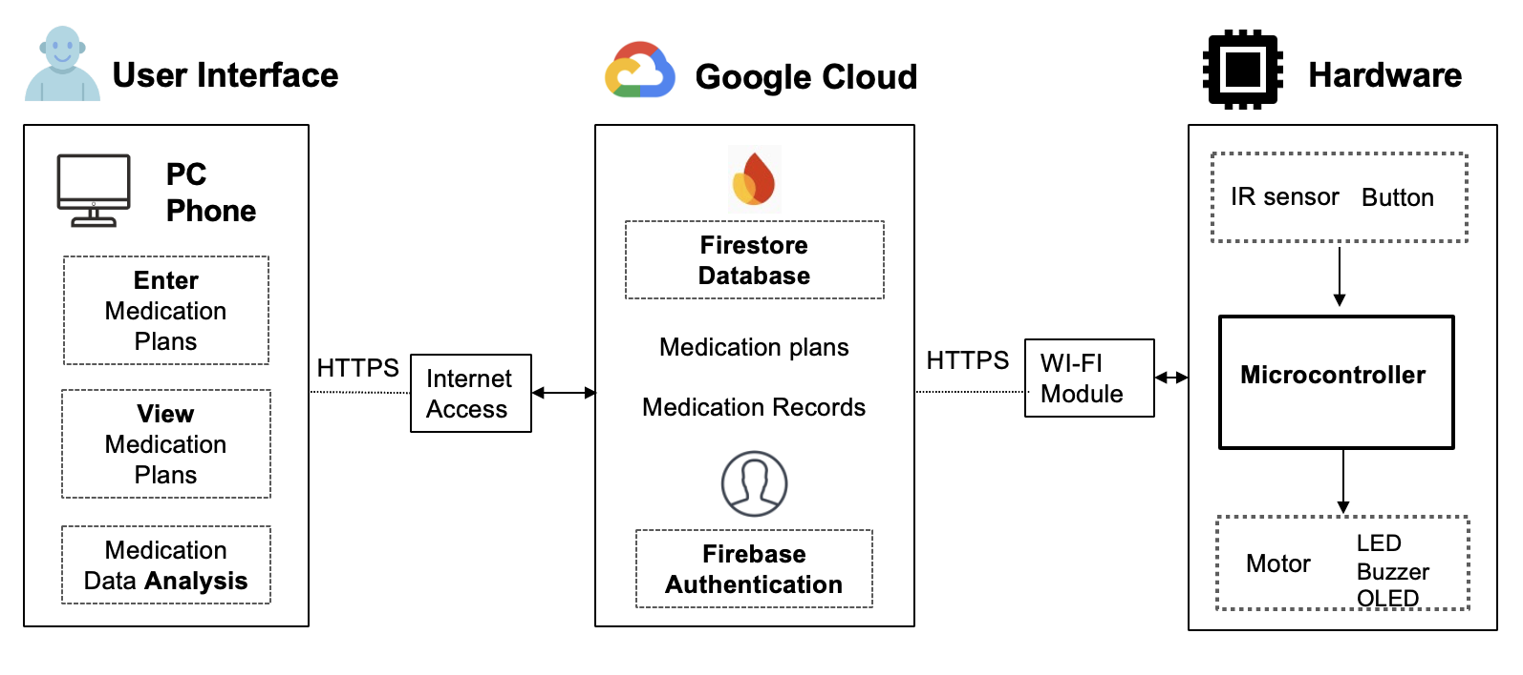
[Figure 1: System block diagram of Smart Medicine Dispenser]

5. System Design

A. Overview
The Smart Medicine Dispenser is designed to automate medication dispensing and enhance adherence monitoring through a combination of hardware and software subsystems. The main components include:
- Hardware: ESP32 microcontroller, infrared (IR) sensor, stepper motor, RGB LEDs, speaker, OLED/LCD display, and a push button for user interaction.
- Software: Web applications developed with React platform that enable medication schedule management, real-time alerts, and historical adherence visualization for users and caregivers.

B. Workflow

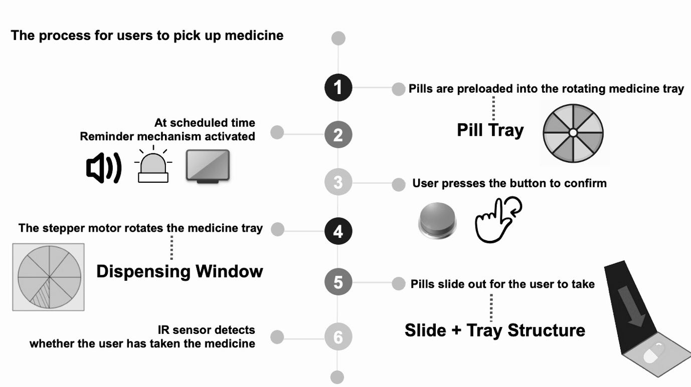

[Figure 2: Flow chart diagram of Smart Medicine Dispenser]

System Operation Flow
- Medication Preloading: Users load pills into a rotating medicine tray controlled by a stepper motor.
- Schedule Entry: Medication schedules are entered by users or caregivers via the mobile/web application and stored securely in the cloud database.
- Schedule Retrieval: The ESP32 microcontroller fetches the medication plan through Wi-Fi connectivity.
- Reminder Activation: At the scheduled time, the system activates multi-modal reminders, including LED flashes, buzzer sounds, and display notifications on the OLED/LCD screen.
- Medication Dispensing: The user presses a button to trigger the stepper motor, which rotates the tray and releases the correct medication dose.
- Intake Verification: The IR sensor detects pill removal by sensing beam interruption, while the load cell measures weight changes to confirm actual pill retrieval, minimizing false detections.
- Data Logging and Alerts: Medication intake data and sensor readings are transmitted via Wi-Fi to the local server and synchronized with the cloud. If a dose is missed or irregular, caregivers receive instant notifications via the website.
- Adherence Analytics: The cloud platform analyzes medication patterns and adherence trends to optimize schedules and support healthcare management.

C. Hardware Components
- ESP32 Microcontroller (FireBeetle ESP32-E): Manages sensor inputs, actuator control, reminders, and secure cloud communication.
- Stepper Motor (28BYJ-48 with ULN2003 driver): Precisely rotates the medicine tray for accurate dispensing.
- Infrared Distance Sensor (GP2Y0A02YK0F): Provides sensitive detection of pill removal.
- Output Devices: RGB LEDs (WS2812B) for visual alerts, buzzer for audio reminders, and an OLED/LCD display for real-time medication information.
- Push Button: Allows user confirmation of medication dispensing.

6. Development
The development process for the Smart Medicine Dispenser followed a modular integration approach, with iterative testing to ensure reliability and performance. The system was built in distinct phases, focusing on hardware integration, firmware development, backend setup, application development, and cloud integration.
Hardware Integration
The IR sensor was strategically positioned within the pill dispenser to detect pill removal by sensing the interruption of the infrared beam. This provided a effective mechanism for verifying that the user had retrieved the medication. All components were connected to the ESP32 microcontroller, which served as the central processing unit, responsible for managing sensor inputs, triggering reminders, and controlling other output devices.
Firmware Development
The firmware for the ESP32 was developed using the Arduino IDE. The program was designed to poll sensor data continuously, process the event of pill removal, and activate appropriate reminders. Key modules included:
Cloud Integration
To enable remote monitoring and ensure data redundancy, Firebase was integrated with the system [5]. Firebase allowed secure storage of medication logs and real-time syncing between the Iot devices and the cloud. This setup provided caregivers and users with a reliable, remote-accessible platform for monitoring medication adherence.

7. Testing Details
Testing was a crucial phase of the process to ensure that the Smart Medicine Dispenser functioned accurately and reliably across all components. To validate the accuracy of pill removal detection, the IR sensor was tested for false positive and negative triggers. This involved simulating pill removals and no-removal scenarios across 50 trials [9]. Other testing involved placing different pill types and quantities to ensure that the motor consistently registered changes, confirming the efficiency.
Different reminder scenarios, such as "take medication" and "missed dose," were simulated to ensure that visual cues were appropriately displayed and easily distinguishable by users. Different types of audio alerts were tested for volume levels and clarity to accommodate users with hearing impairments. The accuracy of medication details shown on the LCD display was verified. This included ensuring the correct display of medication names, doses, and times.

8. Results Analysis
The Smart Medicine Dispenser underwent rigorous testing, and the results demonstrated the system's effectiveness in meeting its objectives. We incorporated different reminder alerts, including LED visual cues, voice, and webapp notifications, which were delivered 100% on schedule during testing. Feedback from peers indicated that the multi-modal reminder system was highly effective, particularly for users with sensory impairments. The system’s ability to synchronize data from the sensors to the cloud (Firebase) was thoroughly tested. Data synchronization was consistently maintained with minimal latency of less than 2 seconds [5].

9. Limitations and Future Work
While the Smart Medicine Dispenser has demonstrated strong performance in improving medication adherence, there are limitations that must be considered. The current design of the pill compartment has a limited capacity, which restricts the system’s ability to dispense a one-week supply of medication. Future improvements could include designing a larger or modular pill compartment with lid to accommodate longer medication durations. The accuracy of the sensor may be affected by variations in pill size, shape, or packaging. This presents a challenge in ensuring consistent verification for all pill types. Future versions could incorporate multi-language support, allowing for more personalized and inclusive interaction with the system.

10. Conclusion
The Smart Medicine Dispenser project successfully developed an integrated system that automates medication dispensing and enhances adherence among elderly users through reliable intake verification and multi-modal reminder mechanisms. By combining infrared sensor verification with visual, auditory, and mobile notifications, the system addresses key challenges faced by seniors with sensory and mobility impairments. Its cloud-based data logging and real-time caregiver alerts enable timely interventions and promote independent living. The design balances affordability with advanced functionality, bridging critical gaps in existing medication management solutions. Future work will focus on hardware miniaturization to improve portability, expanding accessibility through multi-language support, and incorporating advanced analytics to personalize medication schedules and enhance healthcare outcomes. This project lays a strong foundation for scalable, user-friendly solutions aimed at improving medication safety and quality of life for the aging population.

References
[1] L. Jacob, J. Breuer, and K. Kostev, "Prevalence of chronic diseases among older patients," German Medical Science, vol. 14, no. 2, Doc03, 2016, doi: 10.3205/000230.
[2] W. Antoun, A. Abdo, S. Al-Yaman, A. Kassem, and M. Hamad, "Medication adherence in elderly patients study," University of Washington, Year.
[3] Espressif Systems, ESP32-WROOM-32E-N8R2 Datasheet, DigiKey. [Online]. Available: https://www.digikey.com/en/datasheets/espressif/esp32-wroom-32e
[4] Medialarm, "Medi Manager," [Online]. Available: https://www.medialarm.com.au/product/medi-manager/
[5] Firebase, "Firestore Documentation," [Online]. Available: https://firebase.google.com/docs/firestore
[6] D. W. Bates et al., "Effect of computerized physician order entry and a team intervention on prevention of serious medication errors," JAMA, vol. 280, no. 15, pp. 1311–1316, Oct. 1998.
[7] R. Santo et al., "Mobile phone apps to improve medication adherence: a systematic stepwise process to identify high-quality apps," JMIR mHealth and uHealth, vol. 5, no. 6, e135, 2017.
[8] M. Patel, R. Asch, and K. Volpp, "Wearable devices as facilitators, not drivers, of health behavior change," JAMA, vol. 313, no. 5, pp. 459–460, 2015.
[9] S. Ghasemi et al., "Development of a smart pill dispenser with notification and control system," in Proc. IEEE Int. Conf. Consumer Electronics, 2019, pp. 1–5.
[10] S. Mukhopadhyay, "Wearable sensors for human activity monitoring: A review," IEEE Sensors Journal, vol. 15, no. 3, pp. 1321–1330, 2015.

