**Steps to test Travel Boulevard**

**Step 1 : Download code from github path :** <https://github.com/shrutizoomie/HolidayPlanner/>

**Step 2 : Import the project in Netbeans and run the same**

**Step 3 : Home page is displayed as shown below**

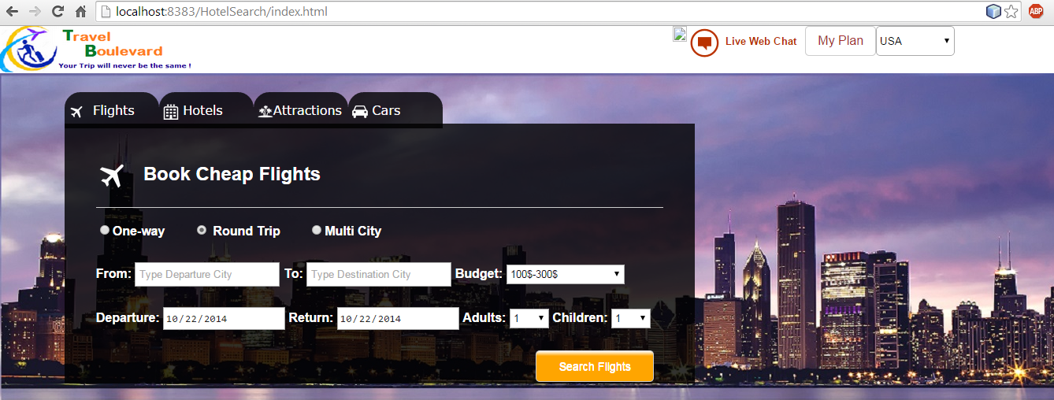

**Step 4 : Book a round trip flight from Los Angeles to San Francisco**

**Select Departure City : Los Angeles and Arrival City : San Francisco, Set budget 100-300$ and select the arrival and departure dates. Select the number of adults and click on Search flights**

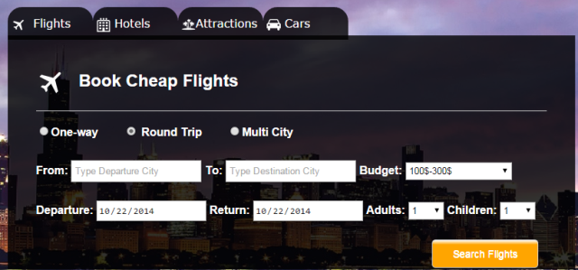 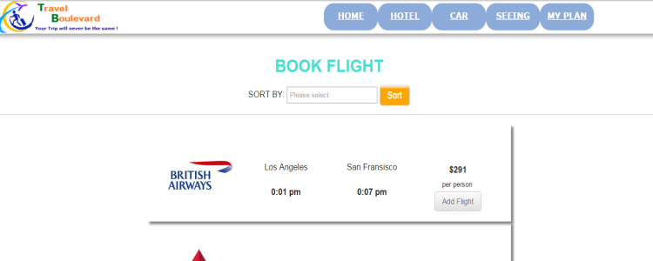

Click on Add Flight button and flight is added to plan

**Step 5 : Press home key and go back to the main page. Click on Hotels and try to book a hotel in San Francisco.**

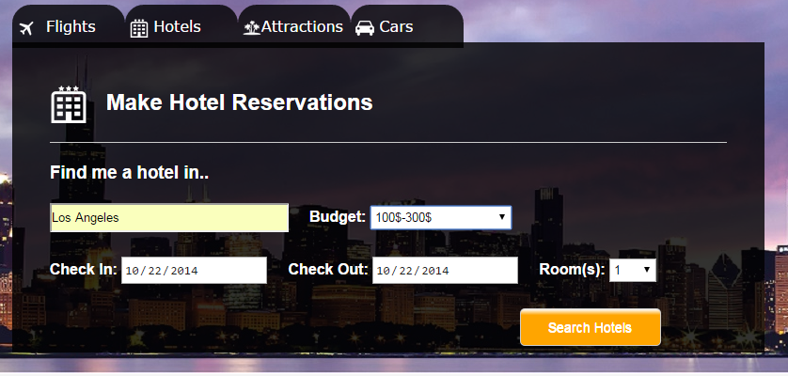

**Select City San Francisco, Set budget 100-300$ and select the checkin and check out dates. Select the number of rooms and click on Search hotels**

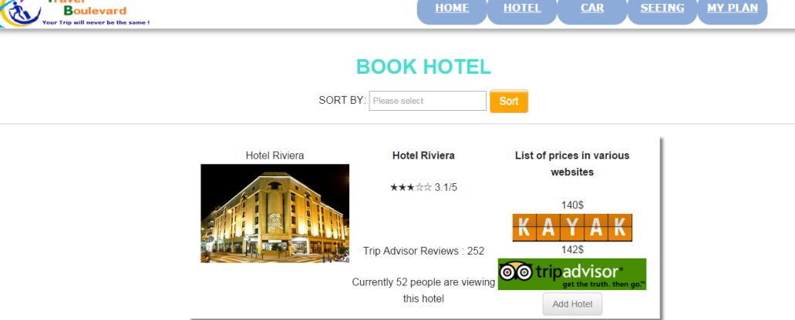

Click on Add Hotel button and Hotel is added to plan

**Step 6 : Add Attractions and Rental cars**

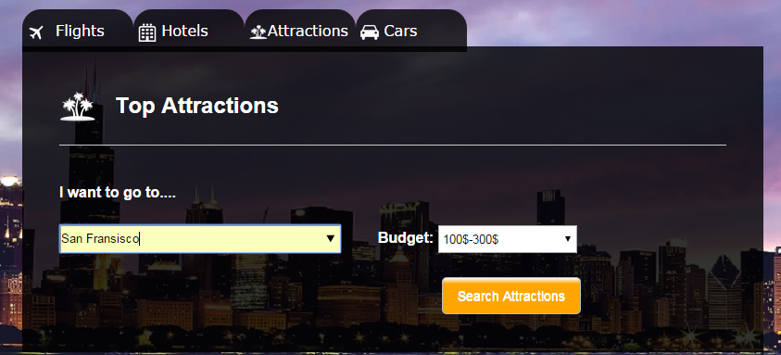

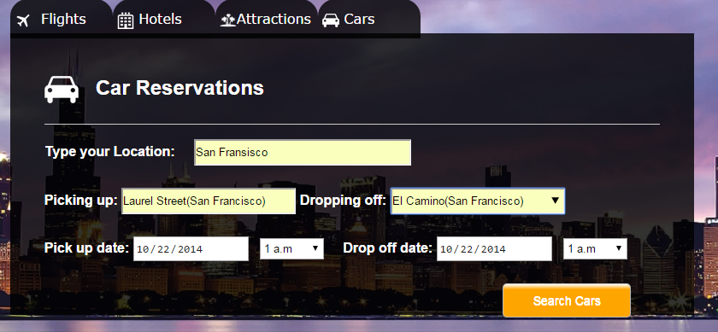

**Step 7 : View your travel itinerary : Click on MyPlan from any of the pages**

