LAB – SSRF (Server Side Request Forgery)
PortSwigger Web Security Academy
LAB 3 – SSRF with blacklist-based input filter
Difficulty: Practitioner | URL: portswigger.net/web-security/ssrf/lab-ssrf-filter-bypass-via-blacklisted-input
Step 1 – Confirm the normal behaviour:
The lab is an e-commerce style application where each product page has a "Check stock" button. Clicking it sends a POST request to /product/stock with a body parameter called stockApi, whose value is a full URL (e.g. http://weliketoshop.net:8080/product/stock/check?productId=1&storeId=1). This confirmed that the server itself makes an outbound HTTP request to whatever URL is placed in this parameter, which is the classic entry point for SSRF.
Step 2 – Identify the injection point and test for the filter:
I captured the "Check stock" request in Burp Suite and sent it to Repeater so I could edit and resend it without repeatedly clicking through the application. I first tried changing stockApi to http://127.0.0.1/ to see if the server would reach itself. The response came back as an HTTP 400 Bad Request with the message "External stock check blocked for security reasons", confirming the application has an input filter that blocks requests when it recognises a loopback address.
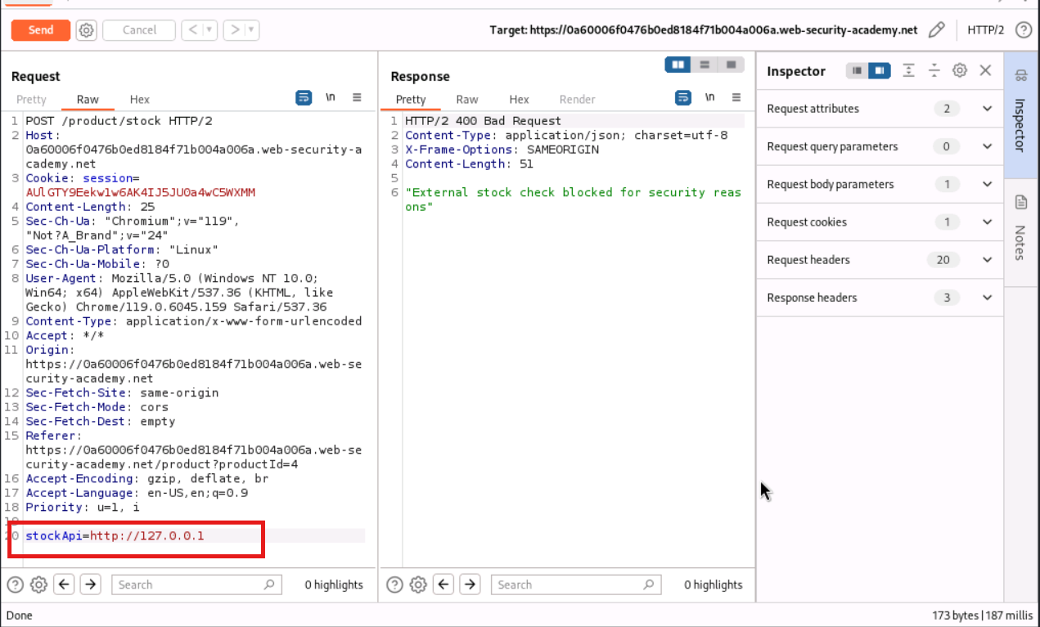
Figure 1 – Request to http://127.0.0.1/ blocked with "External stock check blocked for security reasons".
Step 3 – Bypass the IP-based block:
Since the filter appeared to match the literal string 127.0.0.1, I tried an alternative, functionally identical way of writing the loopback address: http://127.1/. This is a shorthand IP notation that resolves to the same address but is textually different, so a naive string-based blacklist would miss it. Sending this request returned a normal HTTP 200 response containing the application's own front-end HTML (product tiles), confirming the server had successfully reached itself and the filter had been bypassed.
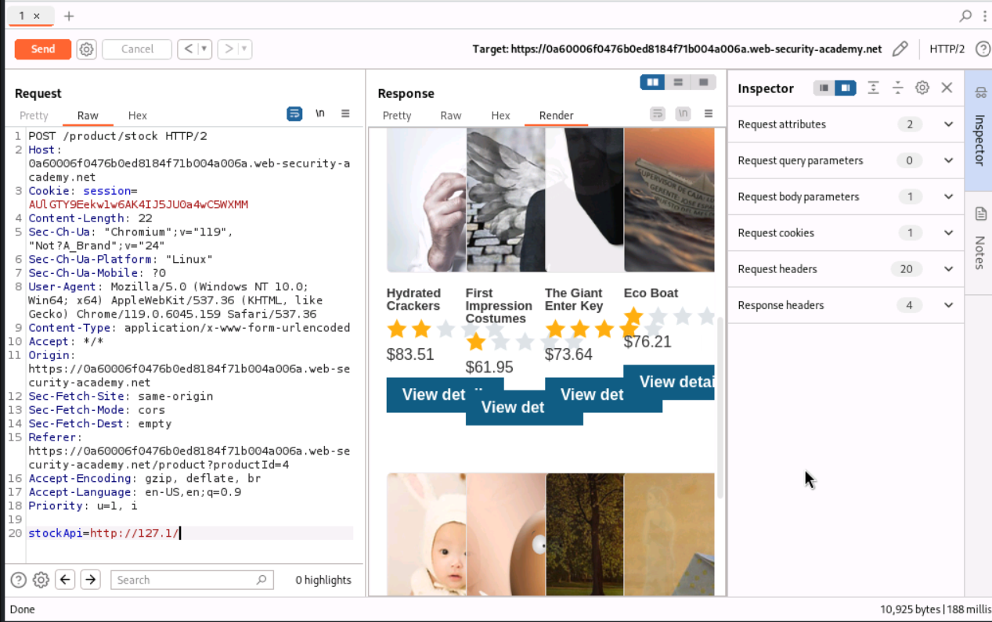
Figure 2 – http://127.1/ bypasses the filter; the server returns its own front page.
Step 4 – Attempt to reach the admin path:
With the IP filter bypassed, I extended the payload to target the admin interface directly: http://127.1/admin. This was blocked again with the same "External stock check blocked for security reasons" message, revealing that the filter is not only blacklisting the address 127.0.0.1 but is separately blacklisting the literal word "admin" anywhere in the URL.
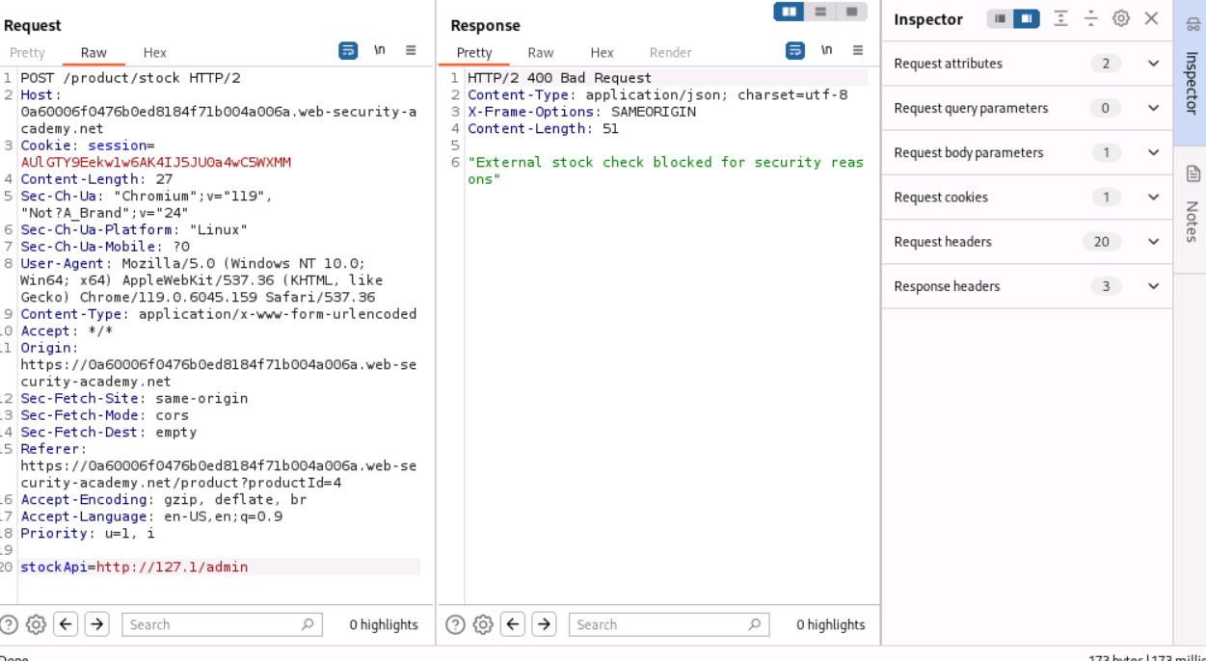
Figure 3 – Adding /admin to the bypassed IP triggers the block again, showing a second, keyword-based filter.
Step 5 – Bypass the keyword filter with double URL-encoding:
To get past the second filter without the literal string "admin" appearing in the request, I double URL-encoded the first letter of the word. The character 'a' is normally %61 when URL-encoded once; encoding it a second time (encoding the percent sign itself) produces %2561. Substituting this into the path gives http://127.1/%2561dmin. Sending this payload returned the full admin panel HTML, including a list of application users (wiener and carlos) each with a Delete link. This works because the filter inspects the URL only once, so it never sees the string "admin" (only %2561dmin), while the backend web server decodes the URL twice before routing the request, at which point %2561 resolves to "a" and the path becomes /admin — a mismatch between what the filter checks and what the server ultimately acts on.
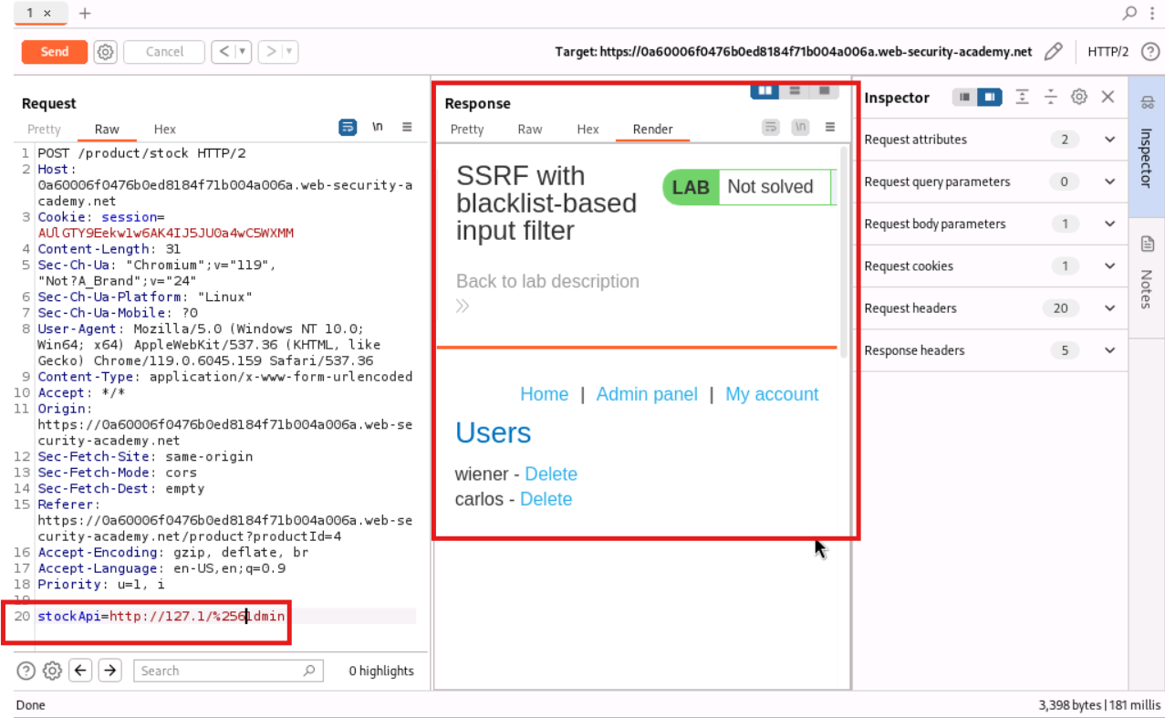
Figure 4 – Double-encoded payload http://127.1/%2561dmin reaches the real admin panel, listing users wiener and carlos.
Step 6 – Trigger the delete action through the same bypass:
The admin panel's delete links are only reachable through the server itself, so I could not click them directly in a browser. Instead I applied the same technique to the full delete URL and submitted it through the stockApi parameter: http://127.1/%2561dmin/delete?username=carlos. The response was an HTTP 302 Found redirecting to /admin, which is the application's normal behaviour after successfully processing an admin action.
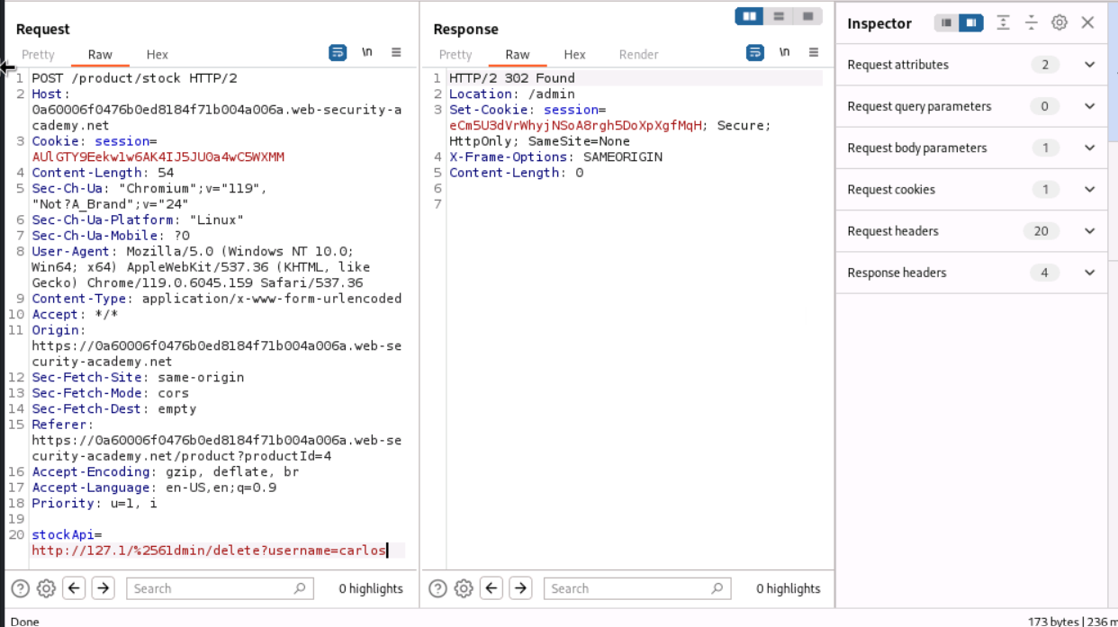
Figure 5 – Delete request for user "carlos" submitted through the same double-encoded SSRF chain; server responds 302 Found.
Step 7 – Verify the lab is solved:
OBSERVATION:
Refreshing the lab page in the browser showed the status banner change from "Not solved" to "Solved", with a "Congratulations, you solved the lab!" message confirming the target user carlos had been deleted via the SSRF chain.
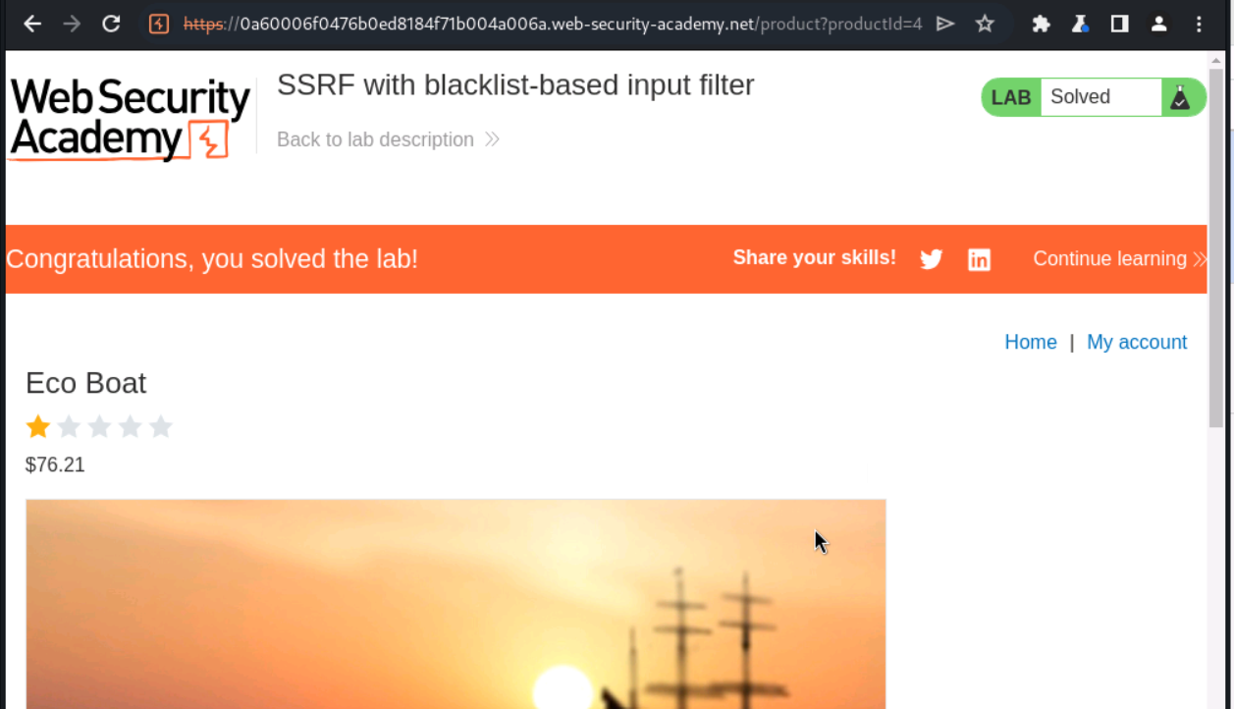
Figure 6 – Lab status confirmed as Solved after the delete action was executed via SSRF.
Step 8 – Root cause and remediation:
The vulnerability exists because the stock-check feature validates the destination URL using a blacklist of literal substrings (127.0.0.1 and admin) rather than validating the URL's actual structure or destination against a strict allow-list. This approach fails for two independent reasons demonstrated above: (1) there are many equivalent ways to represent the same IP address (e.g. 127.1 instead of 127.0.0.1) that a substring match will not catch, and (2) the filter and the backend disagree on how many times to URL-decode the request, so an attacker can hide a blocked keyword from the filter using encoding while the backend still resolves it to the sensitive path.
The correct fix is to avoid blacklisting known-bad values altogether and instead validate outbound requests against a strict allow-list of permitted hosts, resolved and compared at the network layer rather than as a raw string. Additionally, the filter and the request-routing logic should use a single, consistent URL-parsing and decoding implementation so that what is inspected is guaranteed to be identical to what is ultimately requested. Fundamentally, there is no proper input validation being performed on the value supplied by the client — the application relies on matching known bad substrings rather than genuinely validating and restricting what the server is allowed to request, which is why a simple alternate address format and one extra layer of URL-encoding were enough to defeat both filters independently.

